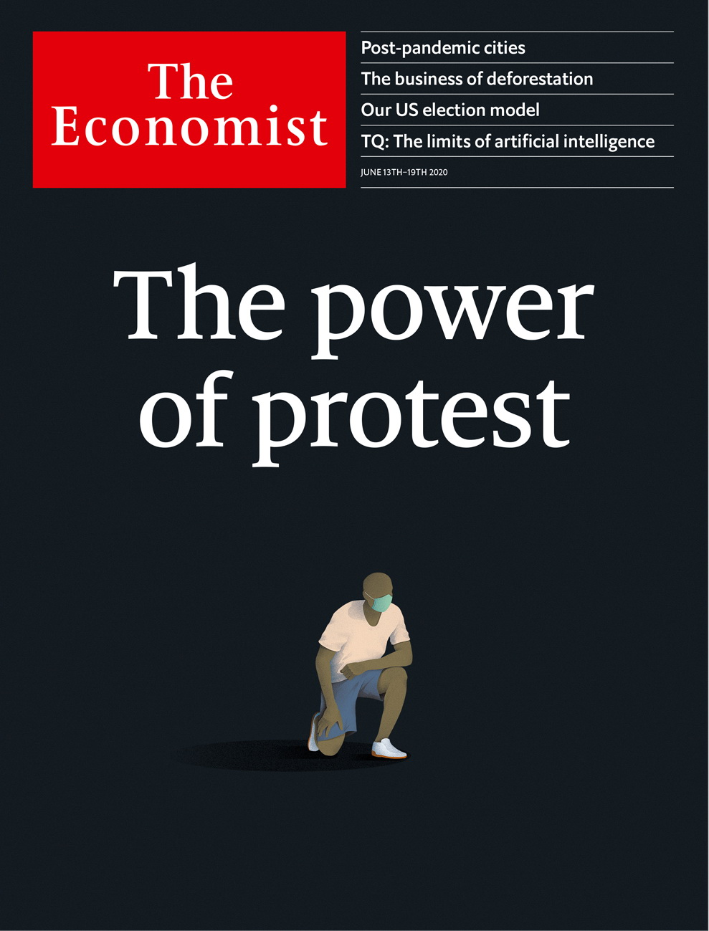

# Table of Contents

The world this week

Politics this week

Business this week

KAL’s cartoon

Leaders

Slavers’ statues: Marble monsters

The world economy: Achilles heal

Cities and the pandemic: After disaster

Britain and the European Union: Don’t pretend, extend

Letters

Letters to the editor: The European Union, the Thames, Peru, the classics, Kraftwerk

Briefing

Cities after covid-19: The destiny of density

United States

The protests: No justice, no peace

Police reform: The shifting ground

Identifying protesters: Supremacist safari

The presidential campaign: Model voters

Lexington: Lone Wolf

The Americas

The Amazon: Of chainsaws and supply chains

Bello: Brazil’s endangered democracy

Asia

Freedom of the press: Muffled cries

Renewable energy in Japan: No mill will

Politics in Taiwan: Han’s down

Banyan: Circulars, directives and rules

China

Urban society: On every street

Street life: Back peddling

Chaguan: Pondering America’s election

Middle East & Africa

Industry in Africa: Will it bloom?

Burundi: “The Champion of Patriotism”

Covid-19 in the Middle East: An unwanted guest returns

Libya’s civil war: A warlord retreats

Europe

German economics: Hey, big spenders

Italy: The not-so-dolce vita

France: Raoultmania

Sweden: Who killed Olof Palme?

Charlemagne: The Sinatra doctrine

Britain

Remembering slavery: Pillaried

Ozophilia: The Tories’ promised land

Quarantine rules: Mumbo jumbo

Sleep under lockdown: Bedtime story

Courts in a pandemic: Rough justice

The pee problem: Causing a stink

Social insurance: The great risk shift

Bagehot: Battle for the working class

International

Black Lives Matter: So other people would be also free

Autocrats denounce America: We love to see you burn

Technology Quarterly

Artificial intelligence and its limits: Reality check

Data: Not so big

The business world: Algorithms and armies

Brain scan: An AI for an eye

Computing hardware: Machine, learning

Automobiles: Road block

The future: Autumn is coming

Business

Business and race in America: The great awakening?

Hacking: Basin motives

Bartleby: Tale of the century

Japan’s bullying bosses: Anger management

Turkish companies: Hard landing

Virgin: Still smiling, captain?

Schumpeter: The great game

Finance & economics

Crude oil: After the fall

America’s jobs market: Acute or chronic?

India’s economy: Moody moment

The yuan: The 24-body problem

Bank provisions: Pandemic pendulum

Buttonwood: Pumping iron

Free exchange: Stony the road

Science & technology

Planetary monitoring: Something’s in the air

Laboratory mice: Here’s one I prepared earlier

Nasal probiotics: No entry!

The search for a covid-19 treatment: Testing times

Books & arts

Rethinking capitalism: Free but fair

Authenticity in architecture: Living wills

Johnson: Snide and prejudice

“Brideshead Revisited” at 75: The Flyte club

Home Entertainment: Pop goes postal

Home Entertainment: In the summer kitchen

Economic & financial indicators

Economic data, commodities and markets

Graphic detail

Deforestation in Brazil: The roots of the problem

Obituary

Larry Kramer: Shout loud, save lives



### Friday, June 12, 2020

|  |  |
| --- | --- |
| The world this week | 3 |
| Leaders | 5 |
| Letters | 1 |
| Briefing | 1 |
| United States | 5 |
| The Americas | 2 |
| Asia | 4 |
| China | 3 |
| Middle East & Africa | 4 |
| Europe | 5 |
| Britain | 8 |
| International | 2 |
| Technology Quarterly | 7 |
| Business | 7 |
| Finance & economics | 7 |
| Science & technology | 4 |
| Books & arts | 6 |
| Economic & financial indicators | 1 |
| Graphic detail | 1 |
| Obituary | 1 |

|  |  |  |
| --- | --- | --- |
|  | Sections | Leaders |

The world this week

Politics this week

.

Business this week

.

KAL’s cartoon

.

|  |  |  |
| --- | --- | --- |
|  | Sections | Leaders |

|  |  |  |  |
| --- | --- | --- | --- |
|  | Articles | Sections | Next |

# Politics this week

Jun 13th 2020 |

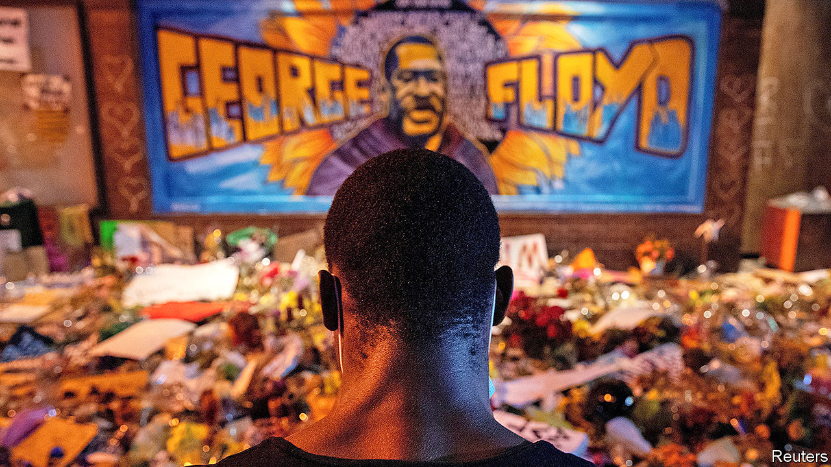

Democrats in the House of Representatives introduced legislation to reform policing in America in the wake of the killing of George Floyd. The measures, which will be resisted in the Senate, would simplify the process for prosecuting officers for misconduct and curtail the “qualified immunity” law that shields them from civil lawsuits. Mr Floyd was laid to rest in his home town of Houston. See [article](https://www.economist.com/leaders/2020/06/11/the-power-of-protest-and-the-legacy-of-george-floyd).

Protesters turned their energy to toppling statues. Among those torn down were effigies of Jefferson Davis in Richmond, Virginia, and Christopher Columbus in a number of cities. nascar, a car-racing tournament popular in the South, banned the Confederate flag from its events. See article.

Israel’s high court struck down a law that sought to legalise Jewish settlements built on private Palestinian land as long as the Palestinians are compensated. The law would have retroactively legalised thousands of homes built in the occupied West Bank. Meanwhile, the Palestinian prime minister, Muhammad Shtayyeh, said the Palestinian Authority would declare an independent state if the Israeli government follows through on its plans to annex parts of the West Bank.

Militias aligned with the UN-backed government in Libya ousted the forces of Khalifa Haftar, a renegade general, from areas around Tripoli, ending his 14-month siege of the capital. General Haftar’s forces, which are backed by Russia, retreated to areas in the south and east which are under his control. The government’s forces, supported by Turkey, have pursued them to Sirte, where the fighting continues. See [article](https://www.economist.com/node/21788007).

Russia was suspected of carrying out air strikes on the last rebel-held enclave in Syria. The bombing in Idlib province breached a ceasefire brokered by Turkey and Russia in March. Separately, protesters in the southern city of Sweida, fed up with a sinking economy, denounced President Bashar al-Assad in a rare show of dissent.

Pierre Nkurunziza, the president of Burundi, died, possibly of covid-19. Mr Nkurunziza, who was due to step down in August, had said that God would protect the country from the virus. See [article](https://www.economist.com/node/21787943).

Ali Kushayb, a militia leader who is wanted by the International Criminal Court to face charges of war crimes in the Darfur region of Sudan, surrendered to authorities in the Central African Republic.

Mali said it would investigate the army after men in uniform attacked two villages and killed 43 civilians in Mopti, in the centre of the country.

The British government conceded that plans to return children to school in England were unworkable. After weeks of resistance from teachers and local authorities, barely half of the pupils in primary-year groups that could have gone back have done so. The return of pupils to secondary schools has also been postponed until September.

Spain’s supreme court opened an investigation into a former king, Juan Carlos, over possibly illegal commissions linked to a rail project in Saudi Arabia.

Brazil’s ministry of health removed briefly from its website much of the data it had reported on covid-19. The country’s president, Jair Bolsonaro, says that cumulative totals do not reflect the current situation. The government complied with an order by a justice on the Supreme Court to resume reporting the data. See article.

A recount of votes in Guyana’s election, held in March, showed that it was won by the opposition People’s Progressive Party, a mainly Indo-Guyanese party. The government of President David Granger, who leads the mainly Afro-Guyanese A Partnership for National Unity, is to challenge the recount in court.

China reached a “positive consensus” with India over border scuffles between their two countries’ forces. India said they had agreed to “peacefully resolve” the matter.

The Chinese city of Mudanjiang, on the border with Russia, became the second in the country, after Wuhan, to test all of its residents for coronavirus. Among the 780,000 people examined, at least 19 were found to be infected, without symptoms. In April there had been a spike in cases in the city as Chinese citizens returned from Russia.

China warned its citizens to avoid travel to Australia, citing a “sudden rise in discriminatory and violent actions” against Chinese nationals. Australia said this description had “no basis in fact”. China is furious at Australian criticism of its initial cover-up of the new coronavirus.

North Korea shut down the hotlines it shares with South Korea’s leadership. The South’s defence department said the North was not answering calls on military lines for the first time since they were established in 2018. The North’s blood-drenched regime was upset because defectors in the South were flying insolent leaflets over the border by balloons.

Election officials in Singapore announced measures that make it safer for voters to cast their ballots during the pandemic, including time slots, stoking speculation that a poll will be called for July.

## Coronavirus briefs

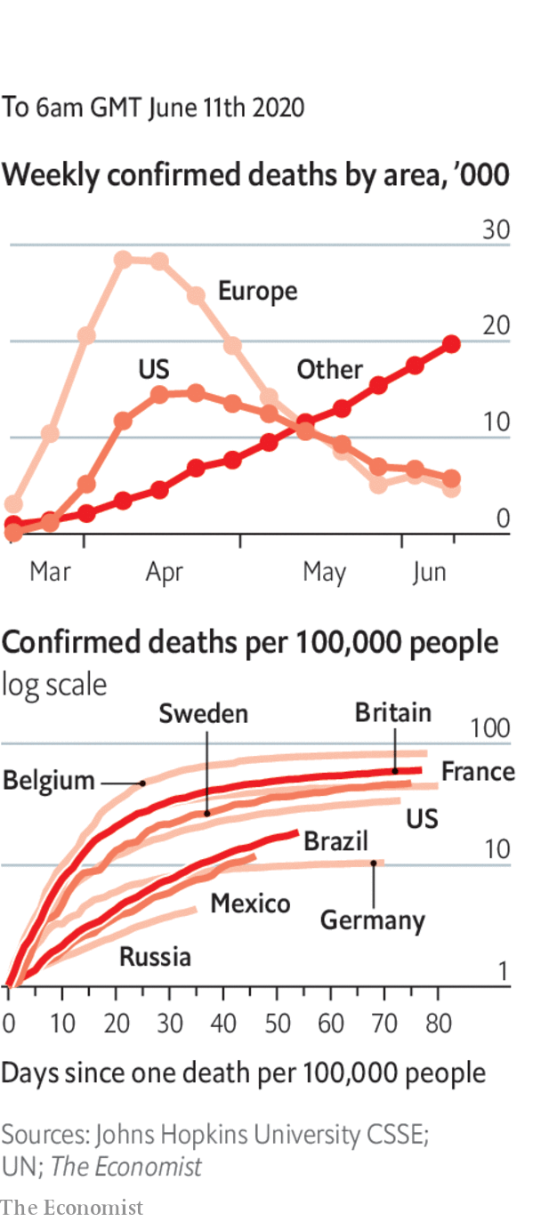

The World Health Organisation changed its advice and now recommends that people wear face masks on public transport and in other situations where social distancing is difficult.

Anthony Fauci, the chief scientist advising the American government about the virus, warned that the epidemic is far from over and that there was “no way” covid-19 would simply disappear.

India reported a surge in infections; it now has the world’s fifth-highest number of cases.

All workers in construction and manufacturing were allowed to return to work in New York City, and shoppers could pick up goods they ordered from stores.

Scientists in New Zealand proclaimed that the country was rid of covid-19 following a two-week absence of new cases. The country’s borders remain closed to foreigners.

This article was downloaded by calibre from <https://www.economist.com/the-world-this-week/2020/06/13/politics-this-week>

|  |  |  |  |
| --- | --- | --- | --- |
|  | Articles | Sections | Next |

|  |  |  |  |
| --- | --- | --- | --- |
| Previous | Articles | Sections | Next |

# Business this week

Jun 13th 2020 |



British Airways and other big airlines in Britain threatened the government with legal action over the quarantine for arrivals that came into force on June 8th. All passengers flying to Britain, including British citizens, must now complete a form stating where they will self-isolate for two weeks, subject to spot-checks and fines if they break the rules. The airlines, and the hospitality industry, are livid, believing more travellers will stay away, causing irreparable damage to their struggling businesses. See article.

## A ticket to fly

Cathay Pacific received a HK$39bn ($5bn) bail-out led by the government of Hong Kong, which will end up with a 6.1% stake in the airline. Swire Pacific remains the controlling shareholder but its holding has been reduced, as have the stakes of the other big investors, Air China and Qatar Airways. Cathay was in trouble before the outbreak of covid-19. Last year its chief executive was pushed out amid pressure on the airline from China over staff who had participated in pro-democracy protests.

Hot on the heels of an aid package for the car industry, the French government announced a €15bn ($17bn) rescue deal for companies working in aviation (including €7bn already earmarked for Air France). Bruno Le Maire, the finance minister, said that without the aid a third of jobs could be lost permanently in the industry. Airbus, for example, has slashed production.

Christine Lagarde defended the measures taken by the European Central Bank in response to the euro zone’s downturn, describing them as “temporary, targeted and proportionate”. The ECB’s president made her comments a few days after the bank expanded its bond-buying programme by €600bn ($683bn), taking the total amount to €1.35trn, and extended the scheme until at least June 2021. At its latest meeting the Federal Reserve said it did not envisage raising interest rates, which are near zero, before the end of 2022.

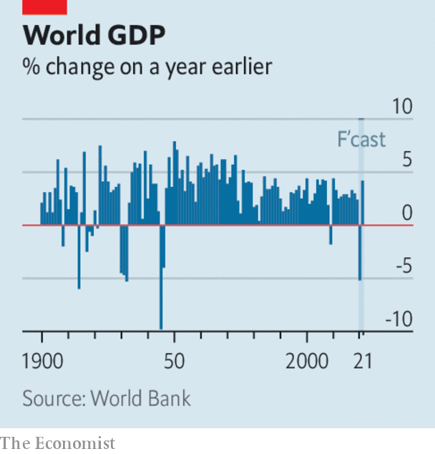

In a sobering assessment of the world economy, the World Bank said it expects global GDP to contract by 5.2% this year, bringing about the fourth- deepest recession since 1900 and the most severe since the end of the second world war. Rich-country economies are projected to shrink by 7% on average, and emerging markets by 2.5%, the first contraction for developing countries as a group in at least 60 years. Income per head will fall by 3.6%, pushing millions of people into extreme poverty. See article.

OPEC and Russia agreed to extend their deal on curbs to oil production until the end of July. With oil prices stabilising, Saudi Arabia will end its additional cut of 1m barrels a day this month. Brent crude was trading above $40 a barrel, double its price in mid-April. See article.

Stockmarkets continued on their upward streak for the most part. On June 8th the S&P 500 closed at 3,232, above its close on December 31st though still below mid-February’s record peak. The Nasdaq index hit the highest mark in its history.

Investors were buoyed in part by an unexpected drop in America’s unemployment rate in May to 13.3%, from April’s 14.7%. Some 2.5m people were added to the payrolls as lockdowns started to ease. See [article](https://www.economist.com/node/21787958).

Volkswagen shook up senior management following mishaps in the manufacture of some of its models, replacing Herbert Diess as head of the VW passenger-cars brand with Ralf Brandstätter. Mr Diess remains chief executive of the VW group, but only after apologising to the supervisory board for claiming it had been the source of leaks about the glitches in production.

In a second attempt to end its Anglo-Dutch dual structure, Unilever announced plans to make London its sole legal domicile. Two years ago its attempt to make Rotterdam its legal base caused a revolt among investors. Addressing what was a bone of contention in 2018, the conglomerate expects still to be included in share indices in both London and Amsterdam.

With the issue of race now firmly on the company agenda, Amazon said it would stop providing its facial-recognition technology to police forces for a year while it considers the issues. IBM is pulling out of the facial-recognition business altogether.

## A Slack of communication

Slack’s share price struggled to recover from the drubbing it received after the company’s quarterly earnings disappointed investors. Revenue was up by 50% year on year, but that was only a slight improvement in growth on the previous quarter, before offices turned en masse to remote working.

Just Eat Takeaway, a food-delivery service in Europe, sealed an agreement to buy Grubhub, one of America’s biggest operators in the market, for $7.3bn. Uber had reportedly approached Grubhub last month about a merger with Uber Eats, but had found there was little appetite for a deal.

This article was downloaded by calibre from <https://www.economist.com/the-world-this-week/2020/06/13/business-this-week>

|  |  |  |  |
| --- | --- | --- | --- |
| Previous | Articles | Sections | Next |

|  |  |  |  |
| --- | --- | --- | --- |
| Previous | Articles | Sections | Next |

# KAL’s cartoon

Jun 13th 2020 |

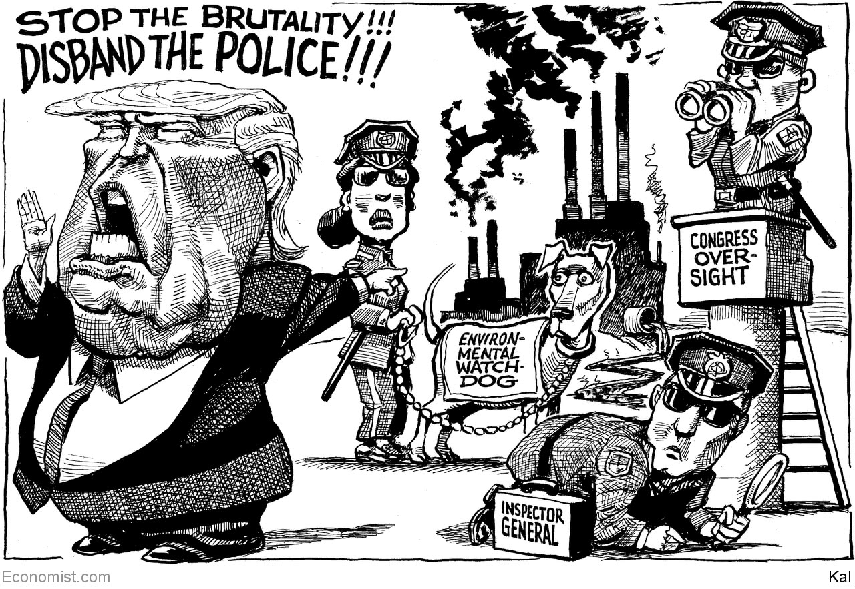

This article was downloaded by calibre from <https://www.economist.com/the-world-this-week/2020/06/13/kals-cartoon>

|  |  |  |  |
| --- | --- | --- | --- |
| Previous | Articles | Sections | Next |

|  |  |  |
| --- | --- | --- |
| The world this week | Sections | Letters |

Leaders

Slavers’ statues: Marble monsters

.

The world economy: Achilles heal

.

Cities and the pandemic: After disaster

.

Britain and the European Union: Don’t pretend, extend

.

|  |  |  |
| --- | --- | --- |
| The world this week | Sections | Letters |

|  |  |  |  |
| --- | --- | --- | --- |
| Previous | Articles | Sections | Next |

#### Reckoning with the past

# How to handle racists’ statues

Should they stay or should they go?

Jun 11th 2020 |

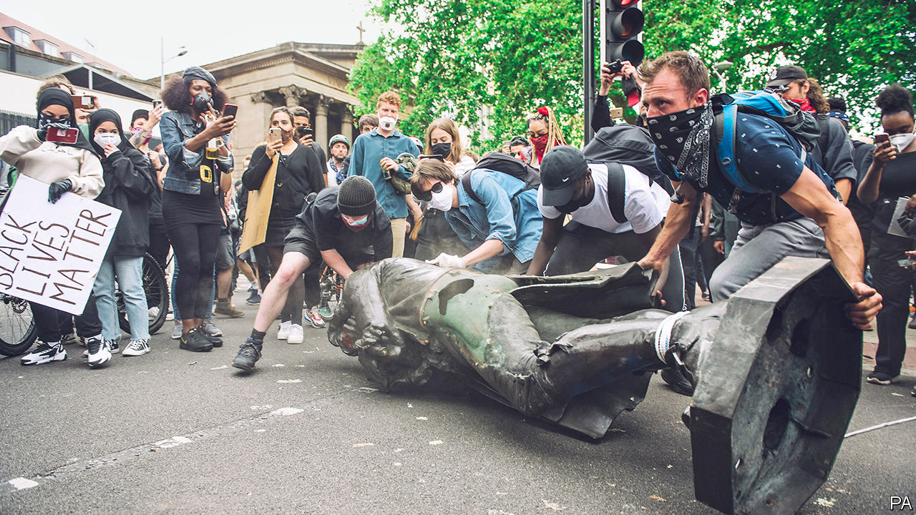

IN 1895 THE burghers of Bristol in south-west England, swept up by the Victorian fervour for celebrating city fathers, were casting about for a big historical cheese of their own. They settled on Edward Colston, a 17th-century merchant who had endowed charities that have lifted innumerable indigent Bristolians out of poverty and educated hordes of its young citizens over the centuries. But, by modern standards, they picked the wrong guy: Colston made his money largely through the Royal African Company, which shipped slaves from Africa to the West Indies. On June 7th protesters chucked his statue into the city’s harbour.

Statues become flashpoints at times of social change because they honour the values, and reflect the hierarchies, of the times in which they were erected. What some in one era celebrate, others then and later often reject—hence the battles over statues of Confederate heroes in the southern United States, many of which were put up long after the civil war to defend white supremacy. Yet statues also provide a record of a country’s past, and the desire to respect and understand that history of commemoration argues against dismantling them. It is these conflicting urges that make this area so tricky.

It would be foolish to throw overboard all those figures who have in any way offended modern morality, just as it would be to preserve every bronze villain just because he’s ancient. Great figures should have a place in public spaces, even when their record is tarnished. As a rule, someone whose failings were subordinate to their claim to greatness should stay, whereas someone whose main contribution to history was baleful should go.

These guidelines would allow most of those about whom Britain is now arguing to cling to their plinths. Colston has no claim to remain. Oliver Cromwell, by contrast, caused terrible suffering in Ireland, but his role in democracy’s development justifies his presence in Parliament Square. Cecil Rhodes is a harder case. He was not the worst imperialist, but he drove many black people off their land. He left a huge, grubby fortune to charity. His statue is on private property, so the choice rests with Oriel College, Oxford. It ought to put him in a museum.

America honours many people who happened to be slave owners—and so it should, in the case of such as Washington and Jefferson, known chiefly for their contribution to their country. But the pressure for change is forcing America to reassess its statuary. Many Confederate leaders have been removed in the past few years, and more should go, including Ben Tillman, a white supremacist still honoured outside South Carolina’s state house; and Nathan Bedford Forrest, a slave trader and Klansman whose bust is in the state capital in Tennessee.

In the Netherlands Jan Pieterszoon Coen, who massacred thousands of Indonesians, does not deserve his plinth, any more than Stepan Bandera, murderer of many Jews, should be honoured in Lviv and other Ukrainian cities.

Yet it matters not just that the undeserving are taken off their pedestals, but also how they go. The indignation of those who brought down Colston may have been righteous, but they were wrong to topple him themselves. Statues should be taken down, just as they ought to be put up, by social consensus; and even if the authorities dither for years—as Bristol’s council has done over the erection of a plaque explaining Colston’s sins—that is no excuse for the mob to take charge.

Prosecuting the topplers would not, however, be a good use of the state’s resources; nor should Colston be reinstated. He has now been dredged out of the river, and the council is planning to put him in a museum. Other countries with difficult histories have found more imaginative solutions. Hungary put its collection of communist-era statues in the rather weird Memento Park, for day-trippers to wonder at. Paraguay crushed Alfredo Stroessner with a vast block of concrete. And Mumbai, with a pleasing touch, consigned Edward VII to the zoo. ■

This article was downloaded by calibre from <https://www.economist.com/leaders/2020/06/11/how-to-handle-racists-statues>

|  |  |  |  |
| --- | --- | --- | --- |
| Previous | Articles | Sections | Next |

|  |  |  |  |
| --- | --- | --- | --- |
| Previous | Articles | Sections | Next |

#### Achilles heal

# Most investors and some firms are upbeat about the world economy

They won’t be if stimulus cheques dry up or the virus surges again

Jun 13th 2020 |

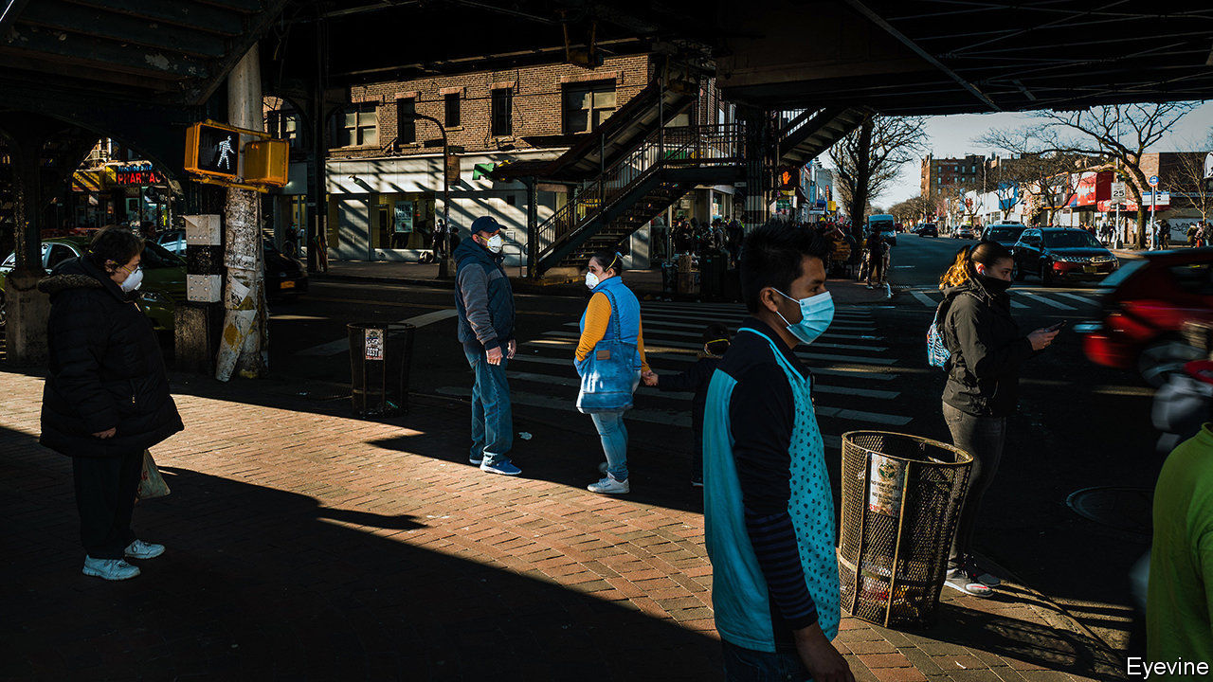

ACCORDING TO the theory of cognitive dissonance it is stressful to dwell on contradictions. Pity, then, anyone trying to reconcile the miserable mood of many economic forecasters with booming stockmarkets and the increasingly bullish mood in many boardrooms. This week the OECD, a club of mostly rich countries, predicted “dire and long-lasting consequences” in the rich world from the recessions caused by the covid-19 pandemic. As it did so, the S&P 500 index of American shares was almost back to its level at the start of the year, when to most people “corona” still meant something to be drunk with a slice of lime. For a while the strength of America’s stockmarket, which recently enjoyed its biggest 50-day rally in history, looked like a global exception. But since the end of April European and Japanese markets have outperformed even a jubilant Wall Street.

To some this is a clear sign of spreading irrational exuberance. Shares, it is argued, have been pumped to unsustainable highs by monetary and fiscal stimulus, and, perhaps, by a wave of speculation by idle workers who have been punting on the stockmarket with their stimulus cheques (TD Ameritrade, a retail broker, says trading activity is four times the level of a year ago). In fact, investors have not lost their minds. A stream of positive corporate and economic data provides some grounds for optimism. The trouble is that it would not take much bad news—whether about the withdrawal of stimulus or the pandemic—to throw the rally into reverse.

Start with the good news. Most analysts had thought that America’s unemployment rate would rise from 14.7% to around 20% in May. Instead it fell to 13.3% as millions of Americans were recalled to work (see article). Real-time data on credit-card spending, e-commerce and consumer mobility suggest that American consumer spending reached a trough in April and has now recovered to around 90% of its pre-pandemic level. The recession that was only this week officially declared to have started in March already looks to have bottomed out.

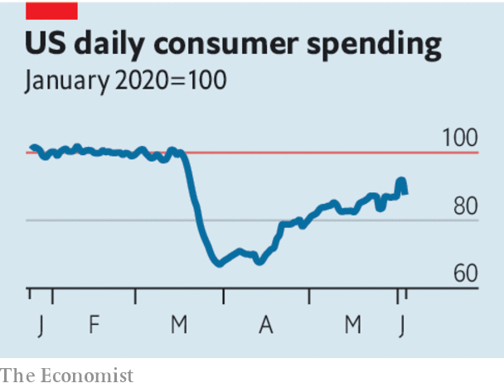

Like the market rally, the green shoots are not confined to America. In May Chinese goods exports were only 3.3% lower than a year ago—analysts had expected almost twice that fall. Labour markets have beaten expectations in Canada and South Korea. In Europe surveys of business sentiment remain depressed but have rebounded strongly from record lows in April. It helps that the euro zone has embraced stimulus. This month the ECB has expanded its bond-buying programme and Germany has fired a fiscal bazooka (see article).

Indeed, one conclusion to draw from this turn in the data is that stimulus works. Governments have successfully shielded firms from bankruptcy and protected consumers’ incomes. America’s banks say that fewer debts are turning sour than you might expect from looking at the unemployment rate alone; household incomes are higher than they were before the pandemic. Meanwhile many investors and firms have persuaded themselves that lifting lockdowns will not cause an immediate second spike in covid-19 infections. All this has led them to look past the evisceration of corporate profits in 2020 to a rapid economic rebound in 2021 and 2022.

Yet each prong of the argument also carries a warning. Stimulus will not last for ever. America’s emergency $600 weekly boost to unemployment insurance payouts, for example, expires at the end of July. Were Congress to continue to support the jobless so generously, it could slow the economic restart by discouraging people from working. But an abrupt withdrawal of benefits would slash incomes and leave many unable to spend. America’s headline unemployment rate may be falling but the number of workers who report that they are jobless because they have been permanently (rather than temporarily) laid off continues to rise ominously. Nobody yet knows how many will join their ranks as the economy changes for good in response to the pandemic. That makes it hard to judge for how long policymakers should keep the pedal to the metal. And for as long as the labour market looks damaged, households will save more than they otherwise might, slowing the recovery.

The second risk stems from the virus itself. It is still poorly understood and, as it spreads through developing countries, the global daily count of new cases is trending higher than ever. Another wave of infections still remains possible, especially during the winter, when its transmission may be easier. That could bring on another round of lockdowns or, failing that, lead consumers to choose to stay at home for their own protection, limiting the extent of the rebound. In February markets were caught out by the speed with which the outlook shifted. Though the world economy has begun to recover, do not rule out a relapse. ■

This article was downloaded by calibre from <https://www.economist.com/leaders/2020/06/13/most-investors-and-some-firms-are-upbeat-about-the-world-economy>

|  |  |  |  |
| --- | --- | --- | --- |
| Previous | Articles | Sections | Next |

|  |  |  |  |
| --- | --- | --- | --- |
| Previous | Articles | Sections | Next |

#### Urban living

# Great cities after the pandemic

How much harm has covid-19 done to large Western cities?

Jun 13th 2020 |

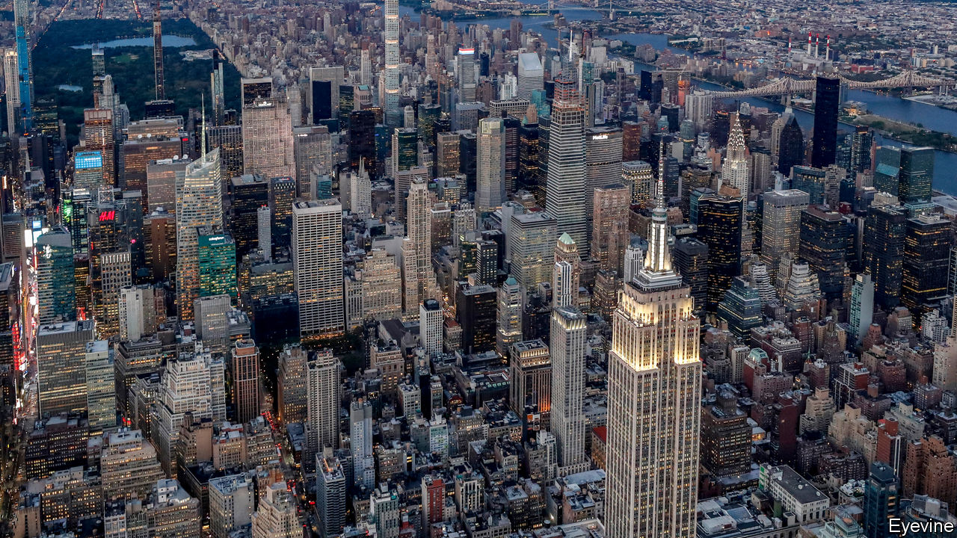

UNTIL RECENTLY big cities were unstoppable. Year after year places like New York, London and Paris grew richer and busier. Since the turn of the century they have shrugged off a dotcom crash, a financial crisis, terrorist attacks and political populism caused partly by resentment at their prosperity and arrogance. Could their magical run possibly be coming to an end?

There are reasons to worry. Covid-19 struck the most exciting, global cities hardest—the ones you find on the side of bags full of designer clothes. With 3% of America’s population, New York has suffered 19% of deaths attributed to the disease (see [Briefing](https://www.economist.com/node/21787962)). One in four French deaths was in Paris and its region. Even as lockdowns lift, international travel restrictions and fear of infection will linger: London is only 15% as busy as normal.

Such quietness poses a grave threat to cities, especially the big, global ones. Much of the joy of suburban life derives from the houses and gardens that are more affordable there. The pleasure of village life is the peace and the countryside. But cities thrive on their busy streets, restaurants and theatres, which are now quiet or closed. That is a loss for urban consumers, and a calamity for the many people, often immigrants, who sell services.

The virus has attacked the core of what makes these cities vibrant and successful. They prosper not so much because of what they do for businesses, but because they cram together talented people who are fizzing with ideas. Americans in cities with more than 1m people are 50% more productive than those elsewhere.

But crowding people in offices and bars now seems irresponsible. And, in contrast to when Spanish flu struck a century ago, many workers have alternatives. People are learning to toil from home; some have discovered that they like it. Facebook, until recently a heroic office-builder, has announced that it will let many employees keep working remotely even after the virus is seen off. Commercial- and residential-property markets could slump as jobs move out of cities, even if only for part of the week. High-street shops and cafés are likely to go under as they adjust to the cut in office workers, tourists and students.

If they lose people, cities will run into a fiscal crunch, too. Their income from things like hotel taxes and bus fares has evaporated. New York’s independent budget office reports “absolute gloom and uncertainty” and frets that tax revenues may fall by $9bn in the next two fiscal years. The great danger is that cities enter a spiral of budget cuts, deteriorating services, rising crime and middle-class flight. It would be the 1970s all over again.

And yet cities are stronger and more resilient than they seem. As with so much else, the fate of cities hangs on the development of treatments and vaccines. But their magic cannot be woven from afar as easily as some suppose.

Cities remain invaluable as places where people can build networks and learn how to collaborate. The brain-workers now logging into Zoom meetings from commuter towns and country cottages can do their jobs because they formed relationships and imbibed cultures in corporate offices. Their heads are still in the city, though their feet are not. Even a socially distanced, half-full office is essential for teaching new hires how a company works. If offices facilitate chit-chat and gossip, they are functioning well. Answering emails can be done from home.

The hope is that, even if bankers and programmers stop coming into town, cities will adjust. Young people, who are at less risk from covid-19 and less worried about crime, could suddenly discover that life in the big smoke is affordable again.

To encourage that, cities need to run themselves for the post-covid era. They are already grappling with how to move millions of people when nobody wants to squeeze onto crowded buses and trains. Some have bold plans for expanded networks of bike paths, and have erected plastic barriers to encourage walkers to occupy the roads. This is encouraging. But cities that fear commuters will drop trains and buses for private cars, clogging the roads, would do even better to manage demand by pricing driving and parking more highly.

Cities also need more autonomy. New York’s hapless mayor, Bill de Blasio, has been a poor advertisement for muscular local government. But Seoul’s world-beating coronavirus response has been organised largely by the metropolitan government and by local officials. By contrast, the mayor of London, Sadiq Khan, had to lobby the national government to insist on face masks on public transport. It agreed two months too late.

## Bright lights

National governments and states will need persuading that cities should have more power, especially as many will also be begging for money. They should step back anyway. Great cities are obnoxious, but they are normally big contributors to national budgets. And the trick they perform for their countries is not just economic. Cities are where people learn to live in a modern, open society. They are machines for creating citizens. ■

This article was downloaded by calibre from <https://www.economist.com/leaders/2020/06/13/great-cities-after-the-pandemic>

|  |  |  |  |
| --- | --- | --- | --- |
| Previous | Articles | Sections | Next |

|  |  |  |  |
| --- | --- | --- | --- |
| Previous | Articles | Sections | Next |

#### Britain and the European Union

# Boris Johnson’s government should prolong the Brexit transition

Britain needs a trade deal more than the EU does

Jun 13th 2020 |

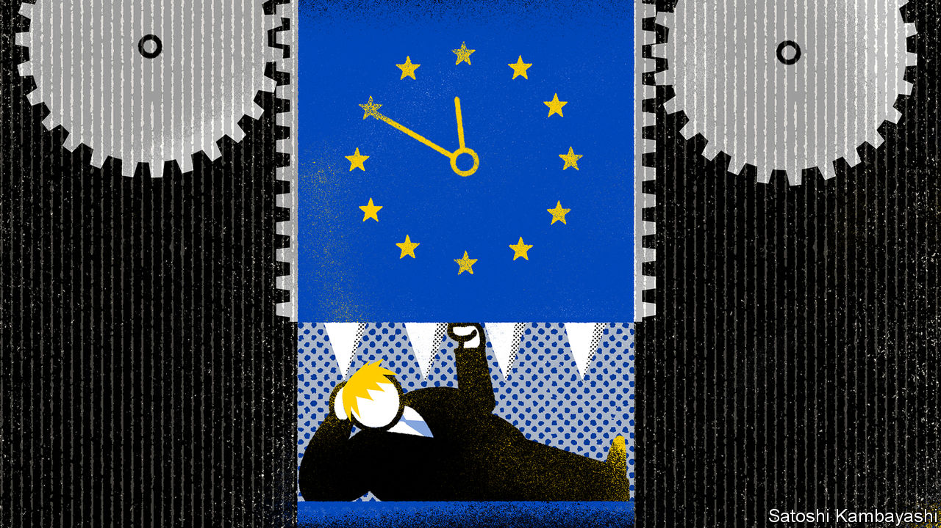

CAUGHT UP IN covid-19, Britons have largely forgotten the crisis that preoccupied them for three-and-a-half years. But Brexit has not gone away. A crunch is approaching, and unless the prime minister, Boris Johnson, acts swiftly, its damaging economic consequences will compound those of the pandemic.

Britain formally left the EU on January 31st, and is now in a transition period until the end of the year, during which time a deal on future relations is meant to be thrashed out. If it is not, and Britain ends that transition without a trade deal, the impact on the economy is likely to be painful.

The prospects are not good. Talks are deadlocked. The two sides have taken extreme positions on fisheries, governance and competition. The chances of sealing a deal in six months look slim. The first, supposedly easier, stage of Brexit talks on withdrawal took 30 months to finish. Negotiating this stage remotely is an unwelcome complication.

Under the withdrawal treaty, the two sides can choose before the end of June to extend the transition for up to two years. After that, any extension would need a fresh treaty and the approval of all 27 national and some regional parliaments. That makes brinkmanship risky. The obvious solution is for Mr Johnson, when he meets EU leaders virtually next week, to ask for an extension. Voters think he should, according to most polls. Yet he refuses to do so.

Mr Johnson says that to extend transition would betray those who voted for Brexit. Yet Brexit happened in January: the only question now is whether it is orderly or disorderly. Mr Johnson also says Britain may have to pay vast extra sums into the EU budget, and even contribute to its new rescue fund. But though there would be a bill to pay, the treaty says it is negotiable; and since Britain is no longer in the common agricultural policy, the bill should be a lot smaller than were its dues as a member.

Would staying in transition constrain Britain’s response to covid-19 through state subsidies, as opponents of an extension also argue? No, because the EU’s state-aid rules are suspended. Claims that transition would stop new free-trade deals are misleading, as negotiations with other countries can continue, and in any case none is ready to come into force soon. Suggestions that an extension would prolong uncertainty for businesses are wrongheaded. It is the risk of leaving without a trade deal that troubles firms. They are already hit by covid-19, and unprepared for tariffs, quotas and customs checks.

Mr Johnson thinks the EU caves in only under the pressure of time. He believes that his renegotiation of the withdrawal treaty last autumn, after he became prime minister, shows the benefits of going up to the wire. Yet it was not the EU, but Britain, that made the big concession then, by accepting a customs border between Great Britain and Northern Ireland. And once again, as last time, Britain needs a deal more than the EU does.

Privately, the government believes that covid-19 has reduced the political risk of leaving without a deal, since its costs will be hidden by the greater damage from the pandemic. Yet this argument is not only improperly self-serving but also fallacious. Covid-19 has severely affected non-tradables, such as restaurants and bars, whereas Brexit without a trade deal would hit big exporters such as carmakers (goodbye, Nissan?) as well as creating visible chaos in Dover.

A sensible, responsible government would treat an extension of the transition not as a political weapon but as an option contract, for use only if a deal cannot be struck in time. If Mr Johnson continues to reject it out of hand he will show his government to be, on the matter of Brexit, neither sensible nor responsible.■

This article was downloaded by calibre from <https://www.economist.com/leaders/2020/06/13/boris-johnsons-government-should-prolong-the-brexit-transition>

|  |  |  |  |
| --- | --- | --- | --- |
| Previous | Articles | Sections | Next |

|  |  |  |
| --- | --- | --- |
| Leaders | Sections | Briefing |

Letters

Letters to the editor: The European Union, the Thames, Peru, the classics, Kraftwerk

.

|  |  |  |
| --- | --- | --- |
| Leaders | Sections | Briefing |

|  |  |  |  |
| --- | --- | --- | --- |
|  | Articles | Sections | Next |

#### The European Union, the Thames, Peru, the classics, Kraftwerk

# Letters to the editor

A selection of correspondence

Jun 13th 2020 |



## Europe’s common purpose

There is nothing new about differences in national views about the purpose of the European Union, but the pandemic has indeed highlighted these (“[On the blink](https://www.economist.com/leaders/2020/05/14/the-european-union-is-having-a-bad-crisis)”, May 16th). At the same time, this crisis has underlined just how interconnected Europe is in many ways and this is vital to our ability to recover from the huge hit that our economy is taking.

There may well be ambiguity about what Europe stands for at the political level, but among businesses there is broad consensus. European business chambers and their 20m firms want a Europe that is based on a fully functioning single market. This is crucial to Europe’s prosperity, solidarity and influence in the world. Restrictions introduced at internal EU borders in response to covid-19 impede the movement of goods, services and workers and undermine supply and value chains. These measures were considered necessary in flattening the epidemic’s curve, but they must continue to be rolled back if we are also to flatten the curve of the economic crisis.

Now is not the time to overthink the EU or reflect on possible reforms. We must focus on the basics of tackling the virus and helping our business community survive and rebuild. Feedback from our members suggests that 3m businesses across the EU are in jeopardy and with that around 10m jobs.

The Recovery Fund, part of a front-loaded new EU budget, is a positive development. But our businesses require more and immediate help in overcoming acute financial liquidity challenges and need a fully restored single market without delay.

CHRISTOPH LEITL  
President  
Eurochambres  
Brussels

I doubt that bigger transfers from northern European countries to southern ones and debt mutualisation will “avert catastrophe” as you claim. On the contrary, these transfers will continue to discourage Italy, France and other southerners from carrying out overdue reforms, leading to catastrophe in the not-too-distant future instead of averting it. Italy and others should be made to abandon the euro, thereby saving the EU.

You quoted Konrad Adenauer’s saying that “German problems can only be solved under a European roof”. But Ludwig Erhard, Germany’s minister of the economy and architect of the Wirtschaftswunder, said in 1957 that it is impossible to move Sicily to the Ruhr without causing economic difficulties. For too many years we have been confronted with the problems Erhard predicted in widely different economies bound together by monetary union.

GERALD SCHERIAU  
Vienna

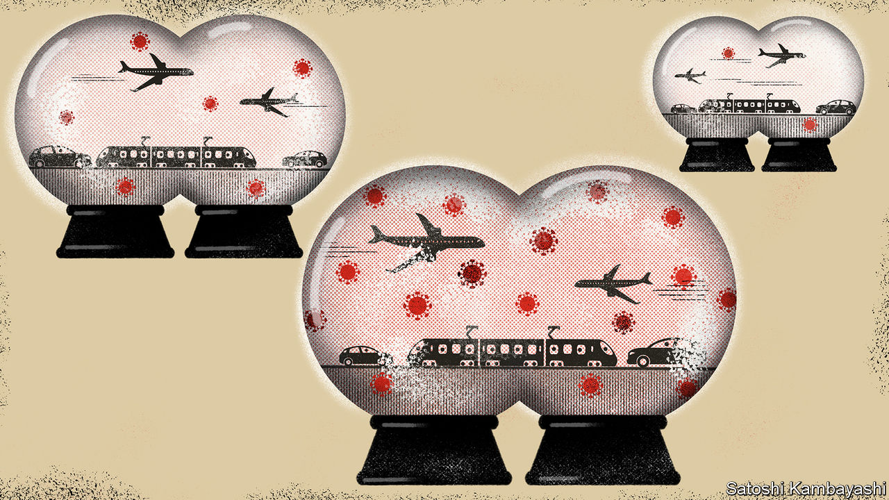

“[A good kind of bubble](https://www.economist.com/finance-and-economics/2020/05/14/could-travel-bubbles-offer-a-route-to-economic-recovery)” (May 16th) mapped out travel bubbles linking places where the pandemic has been quashed. This idea should go beyond the coronavirus. Even enthusiasts for individual liberty should now see that health is a public good as well as a private good. In contrast with other single EU policies, which have a political and sentimental price, there would be no emotional losers from a united EU medical-care policy with well-policed borders. Such a bubble of wellness might tempt in outsiders like Iceland, Switzerland and Norway. And on a cold winter’s day, even an ardent English nationalist might long to stroll safely on a Spanish beach rather than shiver in Brighton.

PETER WHITE  
Glencullen, Ireland

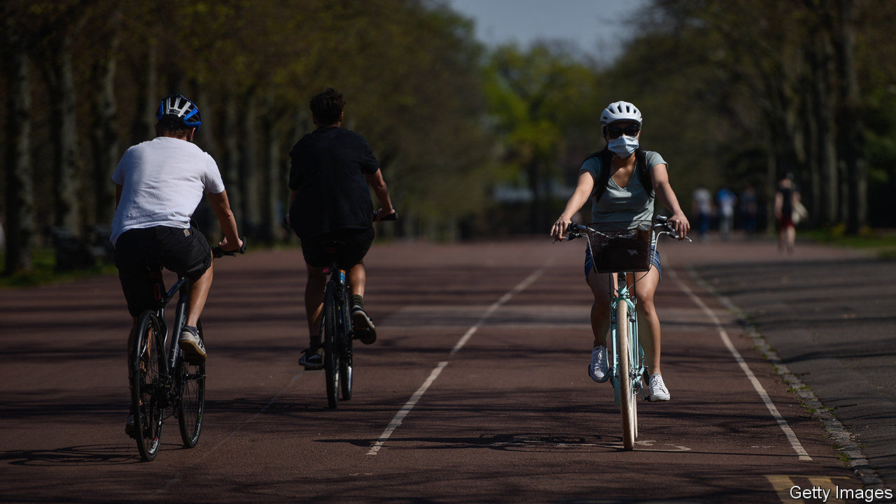

## Messing about on the river

It is not only roads that are seeing an increase in a different type of user during Britain’s lockdown (“[The great land grab](https://www.economist.com/britain/2020/05/23/walkers-and-cyclists-are-using-the-covid-19-crisis-to-swipe-road-space)”, May 23rd). Swimmers, kayakers, stand-up paddle boarders and people messing about in a variety of self-powered craft have taken over the Thames, at least between Hampton Court and Teddington Lock. And I doubt they will want to give it back either.

In normal times on a sunny holiday hundreds of pleasure boats, as well as a few noisy party boats, might chug up and down, a possible hazard for a swimmer or unpowered boat. They have almost entirely vanished and the river is more tranquil and pleasant because of it. I’m sure wildlife has benefited too. I’ve seen more ducklings, goslings and cootlings than usual. A stately, if bedraggled-looking heron observes our swims. I’ve even spotted a harbour seal.

The water feels cleaner, the surface has lost its rainbow sheen of oil and there is less rubbish. I know we will have to share the river with powered boats again soon, but I hope it doesn’t push away the many new river users who are enjoying one of the unexpected joys of lockdown.

SIMON GRIFFITHS  
Founder and publisher  
Outdoor Swimmer  
London

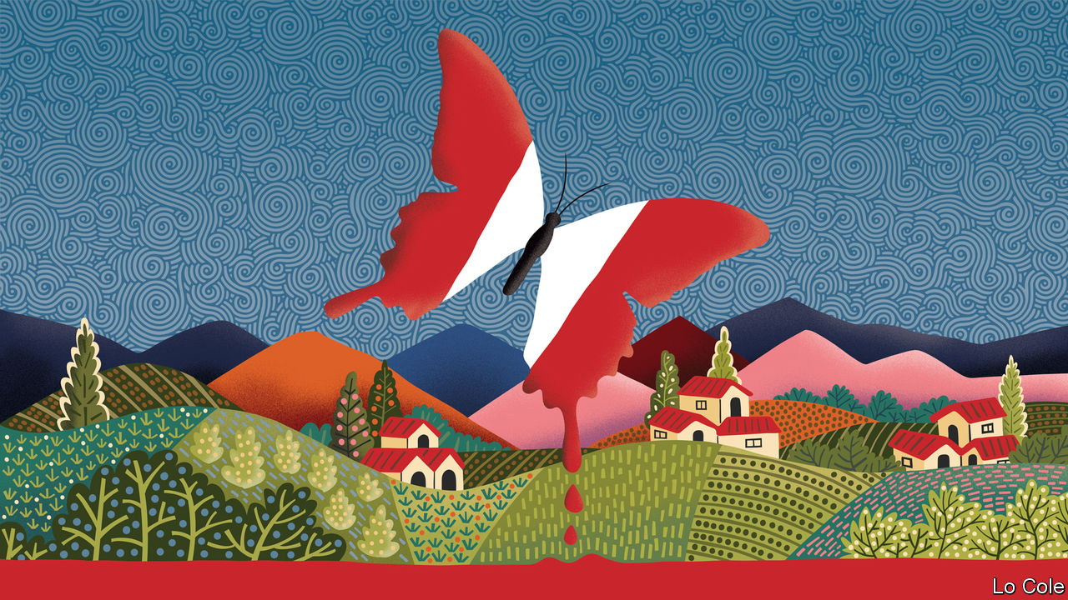

## Peru’s terrible conflict

Regarding [Bello’s](https://www.economist.com/the-americas/2020/05/16/looking-back-on-perus-shining-path) column (May 16th) on Peru’s vicious terrorist movement, Shining Path, it should be pointed out that the figures for the number of those killed and displaced in the conflict that come from the Truth and Reconciliation Commission were determined using a very debatable method. It lacks all seriousness to use them for calculating the final number of deaths. It is also excessive to call Alberto Fujimori a dictator. Mr Fujimori was a typical Latin American authoritarian president, in the same vein as Hugo Chávez, Rafael Correa, or Evo Morales. Moreover, it is no surprise that 75% of the victims were Quechua Indians, given that the Andes was the main theatre of terrorist operations.

I don’t see any kind of collective trauma in 99% of Peruvians. Instead, those of us who suffered Shining Path are more worried about Peruvians under the age of 30 forgetting about terrorism. Older people get on with their lives, though they will never forget the dreadful bath of blood.

ALDO MARIÁTEGUI  
Lima

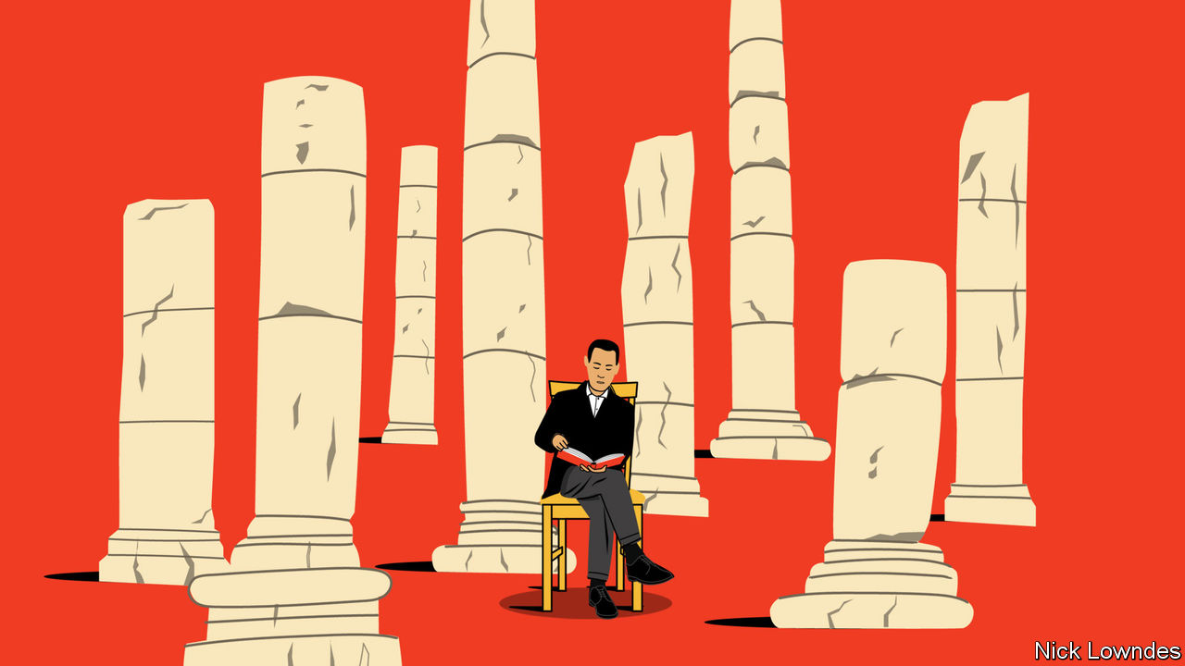

## Data and antiquity

As a teacher and researcher in classics, I care profoundly about the subject’s purpose ([Johnson](https://www.economist.com/books-and-arts/2020/04/30/the-real-reason-to-study-the-classics), May 2nd). Too many of my colleagues rely on the guff that it teaches grammatical rigour or fall back onto vague assertions about the origins of Western civilisation. Although it is good to have a knowledge of ancient societies, the study of classics or indeed any ancient peoples offers one important transferable skill. When studying any ancient civilisation, one quickly brushes up against the reality that 99.9% of the information one would like to have is already lost. This forces any student or researcher to reflect hard on what data can be used. We must carefully analyse and argue over every scrap, while avoiding the temptation to come to conclusions that the data do not justify. In an age where we are faced with a glut of data, knowing what they can or cannot be used to say is vital.

ROBERT MACHADO  
Cambridge, Cambridgeshire

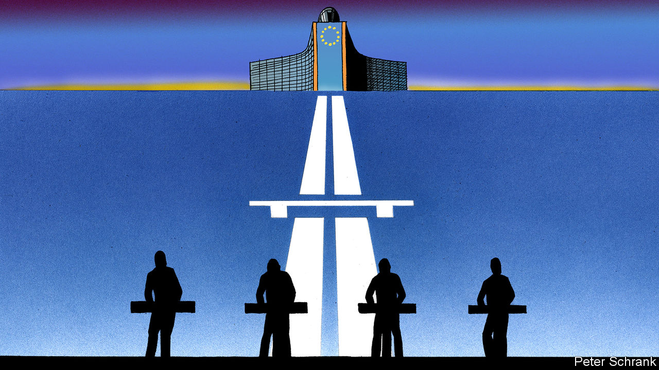

## Europe endless

[Charlemagne’s](https://www.economist.com/europe/2020/05/16/the-enduring-influence-of-kraftwerk) recognition of Kraftwerk’s contribution to modern European identity was electrifying (May 16th). As for choosing one of their tunes as a new anthem for the European Union, “Trans-Europe Express” is the obvious choice for my Interrail generation. But I guess in this era of restrictions, we will have to make do with “Computer Love”.

JOHAN NORBERG  
Stockholm

This article was downloaded by calibre from <https://www.economist.com/letters/2020/06/13/letters-to-the-editor>

|  |  |  |  |
| --- | --- | --- | --- |
|  | Articles | Sections | Next |

|  |  |  |
| --- | --- | --- |
| Letters | Sections | United States |

Briefing

Cities after covid-19: The destiny of density

.

|  |  |  |
| --- | --- | --- |
| Letters | Sections | United States |

|  |  |  |  |
| --- | --- | --- | --- |
|  | Articles | Sections | Next |

#### Centres of excellence

# Covid-19 challenges New York’s future

Cities around the world, take heed

Jun 13th 2020 |

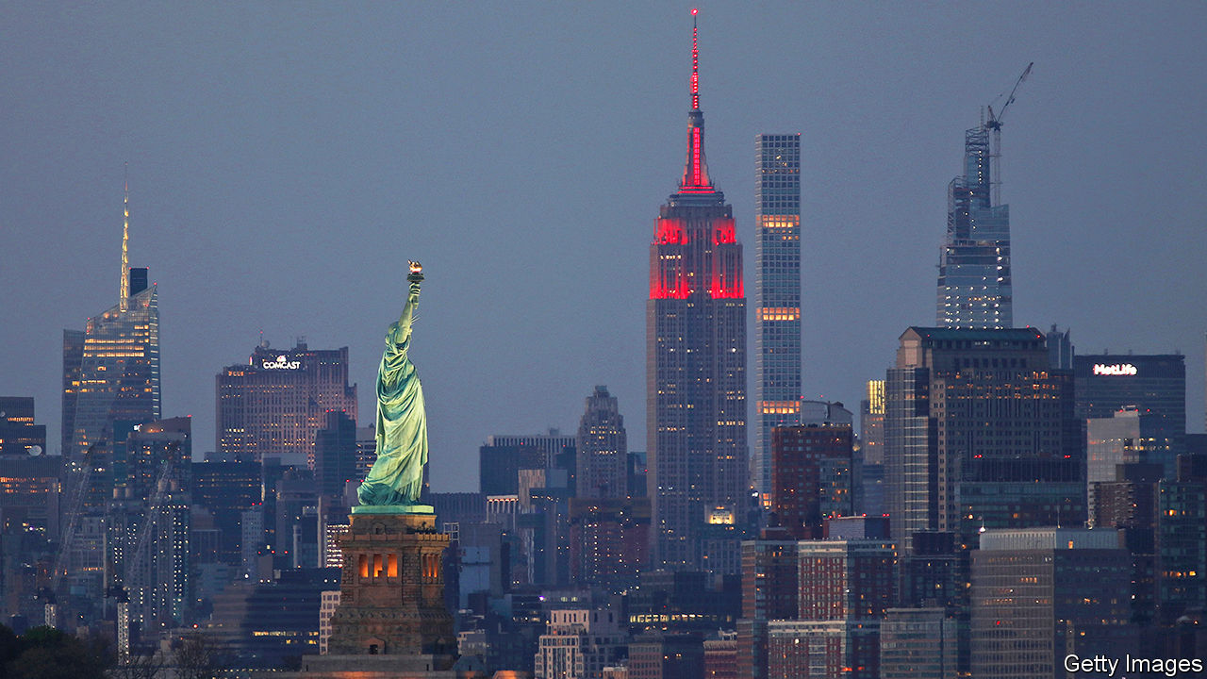

Editor’s note: Some of our covid-19 coverage is free for readers of The Economist Today, our daily [newsletter](https://my.economist.com/user#newsletter). For more stories and our pandemic tracker, see our [coronavirus hub](http://www.economist.com/coronavirus)

BY NIGHT, Manhattan holds 1.6m souls, a large number for a small island. In the morning over twice as many more rush in like a tide, filling up office blocks, coffee shops and spin classes. In the evening this tide drains back out over bridges and through tunnels, leaving just a thin residue of small-hours stop-outs and shift workers. The ebb and flow is shallower at weekends, and in summer. But it has held its rhythm for more than a century.

In mid-March the tide stopped. Following stay-at-home orders issued by Andrew Cuomo, New York’s governor, workplaces shut down as hospitals filled. The city became one of the deadliest hotspots of the covid-19 pandemic, with 20,000 dying over three months. Times Square emptied, the museums and concert halls closed.

At the end of May the streets came to fitful life as thousands protested against racism and police violence in the wake of the death of George Floyd under the knee of a Minnesota police officer. Bill de Blasio, the city’s mayor—and, as a newly enthusiastic backer of the police department, one of the targets of the protests—instituted a curfew which lasted until June 6th, two days before the city began its official reopening.

Construction and manufacturing have now restarted; shops offer pavement pickups. But many businesses are still shut, and most office workers at home. Broadway will stay dark until at least September. The schools’ chancellor has said that there is a 50-50 chance schools will reopen in the autumn. The city that never sleeps looks as if it will be sedated for much of the rest of the year. If covid comes back in a big way, or if workers stay in front of screens at home, it could become moribund.

## All the mystery and beauty

Nowhere represented the 20th century’s love affair with the idea of the city better than New York. In size—surpassing London, the previous top dog, in 1925—grandeur, cultural attainment and animal spirits of all sorts it was for decades the toast of the world and a model to emulate.

Over the century more and more cities grew large, dense and rich. By 2016 more than a fifth of humankind was living in cities of 1m people or more. The largest 300 metropolitan areas now generate half the world’s GDP and two-thirds of that GDP’s growth. And New York remains at the tip of the top tier. At almost $1.8trn its GDP is the largest of any city in the world. It is home to as dense a cluster of globally important firms as you can find anywhere.

Workers and firms have continued to pile into cities like New York, even as travel and telecommuting have become easier, because there is so much to be gained by proximity to other human beings, especially when it comes to the “knowledge economy” reliant on highly skilled, highly educated and highly productive workers. Geoffrey West, a physicist at the Santa Fe Institute, has shown that these benefits in terms of wages and innovation grow faster than the cities which provide them.

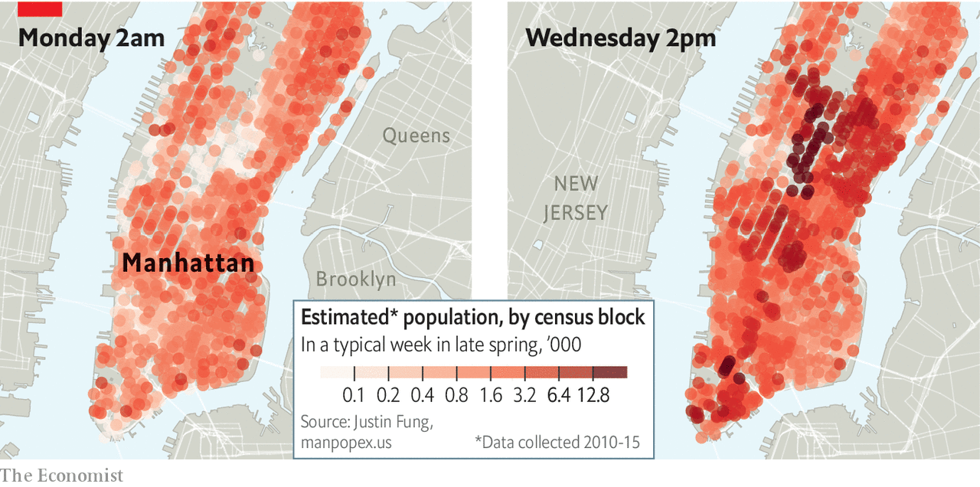

Edward Glaeser, an economist at Harvard University, has shown that urban density increases workers’ productivity and minimises their carbon footprints. Americans who live in big metropolitan areas are, on average, more than 50% more productive than those who live in smaller metros. This holds true even for workers with the same education, experience, working in the same industry and boasting the same IQ. Much the same is true in other rich countries. In poorer ones the advantages of city life are even greater.

Closing down such powerhouses in the face of covid-19 was a dramatic and expensive step for the governments that did so. But it was at least conceptually simple. Reopening them is harder, in large part because of the conflicting requirements of amenity and transport. For almost all cities reopening will see increased congestion as people who previously used mass transit commute by car and on their own. New York—big by European standards, uniquely mass-transit dependent by American ones—will have those problems on a scale all of its own. “A 1% decline in transit use into Manhattan would translate into a 12% increase in car traffic,” says Nicole Gelinas of the Manhattan Institute, a think-tank. Corey Johnson, the city-council speaker, warns of “Carmageddon”.

But making mass transit safe in a world of social distancing is hard. The Metropolitan Transportation Authority (MTA), which is run by the state, is responsible for the city’s buses and a subway system which boasts more stations than any other in the world. It was already in poor financial and physical shape before the pandemic; during the covid closure it lost 90% of its riders and more than $2bn in revenue. Though it is working on new ways to clean subway cars and distance passengers, it cannot put on enough services to keep commuters safely distanced. Indeed, if it does not get a substantial bail-out—which the state says it cannot afford—it is likely to have to cut jobs and services, worsening the problem.

## Very careless and confused

Mr de Blasio has done little to help. Asked for 100km (60 miles) of new bus lanes to help with the situation he has provided just 30km. He has also been grudging when it comes to pedestrianising streets so that people can keep a respectful distance from each other while getting around and increasing provision for the use of bicycles.

This all means that New Yorkers cannot safely return to work in one fell swoop. But the point of a dense city is that it needs density to work. According to Enrico Moretti, an economist at the University of California, Berkeley, each of the “knowledge jobs” that make cities like San Francisco or New York so successful supports five service jobs, some high paying—lawyers—some much less so—baristas. If office workers stay at home, the workers who depend on them being in town have no income. If, faced with half-empty offices, such service workers do not come back for want of custom, that will add to the commuters’ disinclination to return. If the businesses providing services actually go bust waiting for the tide to turn things will go even worse.

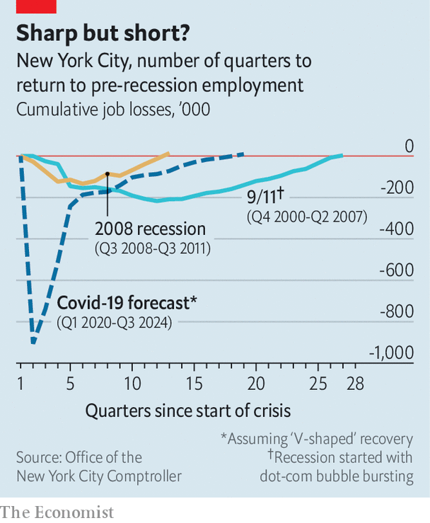

Even if reopening goes well, the hole in the city’s finances will be vast. The declines in sales, income and property taxes that came with the shutdown will result in a $9bn tax-revenue hit over the next two fiscal years, according to Mr de Blasio. The city’s independent budget office, which said on May 18th that the city’s fiscal situation is one of “absolute gloom and uncertainty”, thinks employment will not return to pre-pandemic levels until 2024 (see chart). Without federal support, Mr de Blasio has said “any and all options will be on the table” for spending cuts, including laying off city workers. The state is unlikely to be able to bail out the city, given its own shortfalls.

Despite these dire straits, there are two good arguments for expecting New York to come back after covid. First, cities in general have proven inordinately resilient to enormous shocks. In 2002 Donald Davis and David Weinstein, both professors at Columbia University, looked at Japanese cities bombed during the second world war and found that “temporary shocks, even of frightening magnitude, appear to have little long-run impact on the spatial structure of the economy.” It took just 20 years for Nagasaki’s population growth to get back to the trend line it had been on before America dropped an atom bomb on it.

And if cities are resilient in theory, New York has also proved so in practice. The attacks which brought down the World Trade Centre in 2001 were estimated by the city’s comptroller to have cost $83bn-95bn in lives and property. Lower Manhattan, where the twin towers had stood, lost almost 30% of its office space, temporarily displacing 100,000 workers.

But in 2002 Michael Bloomberg, the city’s newly elected mayor, began offering incentives to companies to move downtown, and commercial occupancy rebounded. The population in the area has more than doubled since the attacks. By 2007 the employment rate had recovered to what it had been before. The next year Lehman Brothers collapsed, and the city’s flagship industry, financial services, looked hugely vulnerable. But though by 2018 it accounted for just over a third of jobs in lower Manhattan, down from 55% in 2001, it is still there. Even the $19bn of damage done by Hurricane Sandy in 2012 amounted to only a glancing blow. Property values on the Manhattan waterfront now stand 70% above the pre-Sandy level: on the Queens waterfront they are 128% higher.

What, though, if covid is not just the latest in a series of shocks? Cities that can shrug off a disaster can still fade if their economic base—and with it their tax revenues—suffers a structural shift. Again, New York has the history to prove it.

Like other American cities, New York saw rioting in the 1960s. Between 1969 and 1974 two recessions saw New York City lose almost 300,000 manufacturing jobs. Most American cities experienced some “white flight” during that period. New York saw a lot. The city lost 1.3m net residents during the 1970s, almost all of whom were white, more than the number lost by Los Angeles and Chicago combined.

Its tax base shrinking, by 1975 the city could not pay its bills or service its debt. Asked for help, Gerald Ford, then president, demurred. “FORD TO CITY: DROP DEAD” the front page of the Daily News bellowed in 144-point type.

## Can’t repeat the past?

In the budget cuts which followed 13,000 teaching jobs were lost. For four years no police officers were hired; arrests fell by a fifth as crime, already bad, got worse. The subway was unsafe, there were graffiti everywhere, parks became drug dens. Today, St Mark’s Place is lined with busy bars, chic coffee shops and yoga studios. Then it was grimy enough to supply an album-cover image of urban decay for Led Zeppelin and hosted crimes that ranged from mugging through murder to cannibalism.

But the city still had the advantages that come from packing knowledge workers together. In the 1980s Michael Milken of Drexel Burnham Lambert invented the junk bonds that enabled Henry Kravis, a co-founder of KKR, a large private-equity firm, to pull off the first leveraged buy-outs, revolutionising corporate finance. This was not without its controversies—some of Mr Milken’s financial activities landed him in prison—but it did help the city regain solvency, not to mention pizzazz.

New York is in far better shape now than it was in the 1970s. But some 900,000 workers are expected to file for unemployment by the end of June, a level far higher than that seen in the Great Recession or after the attacks of 2001. Many businesses have closed thanks to covid-19; some may never reopen. And the workers to start new ones might be sorely lacking. Immigrants make up almost half of small business owners in New York, and it is unclear when restrictions on immigration will be lifted.

Even if the federal government is generous—the $7.5bn provided so far has not been seen as such by Mr Cuomo, who thinks almost ten times that amount is needed—there are sweeping budget cuts to schools, health care and local government on the way. Poorer services may keep those who have fled the virus from coming back. One in 20 New York City residents have left the city in the past months, taking up residence in single beds in childhood homes in all America’s contiguous states. For Manhattan, the richest borough, the proportion is a sixth: in its swankiest zip codes it is more than a third, for all that most of the deaths have been in poorer neighbourhoods in the outer boroughs.

A further outbreak of disease would both worsen the economy and weaken the urge to return. Mr Glaeser thinks that an enduring threat from SARS-CoV-2, the virus which causes covid-19, “could lead to a serious and long-standing reorientation—at least for those that could afford it—towards de-urbanising of people’s lives.” It is worth noting that, pandemics apart, diseases generally tend to spread well in cities; Mr West finds that a city’s propensity for infection tends to grow faster than the city itself, just like wages and productivity.

And in a future where the virus remains under control the economic benefits of being packed tight, a boon in the city’s renaissance, might still be lost if some mixture of personal convenience and corporate strategy sees distance working turned from a temporary expedient to a lasting change in the way the urban economy works.

Take financial services, which account for a third of the Manhattan payroll. Barclays, JPMorgan Chase and Morgan Stanley, three banks, employ more than 20,000 workers in Manhattan and occupy more than 930,000 square metres (10m square feet) in its office blocks, an area roughly equivalent to all the office space in downtown Nashville. James Gorman, the boss of Morgan Stanley, which occupies much of a tower that looms over Times Square, has said that the company has “proven we can operate with no footprint. That tells you an enormous amount about where people need to be physically,” though he has since stressed that most of the firm’s jobs will still be in offices. Jes Staley, the chief executive of Barclays, has said that “the notion of putting 7,000 people in a building may be a thing of the past.” In an internal memo JPMorgan Chase, one of the largest office tenants in New York, said the firm was reviewing how many workers would be allowed to return.

“Office space is where the biggest debate is,” says Ken Caplan, who runs the property investment arm of Blackstone, a New York-based private equity firm. Compliance with social-distancing measures seem likely to require more space per worker for many months. That will give companies a reason to encourage some workers to stay away some or all of the time while not changing the demand for office space much; Mr Caplan is confident in long-term demand.

## Borne back ceaselessly

If workers can conduct their jobs from home permanently, some will leave the city for good. According to a survey conducted by Redfin, a property platform, more than half of those currently working from home say they would move away from their city if given the opportunity to work from home permanently. This may be an exaggeration. Thinking you might like to move and moving are quite different; searches on property websites do not show an immense appetite for life in the boondocks (which, to true New Yorkers, basically means all parts of the country outside the city’s limits). Scott Stringer, New York City’s comptroller, for one, thinks flight to places like Austin, Texas, is unlikely. “You know why?” he laughs. “Because they’d have to live there.”

What is more, an entirely decentralised workforce, however Slacked, Teamed, Hung-out and Zoomed it might be, cannot capture all the benefits the city has to offer, either for its members (in terms of finding better jobs) or its employers. Paco Ybarra, an executive at Citigroup, another bank, has said that firms might be able to work remotely now because they have already built up client and team relationships face-to-face in the past, but that this would “erode over time”.



Supposing you brought the light inside?

There may thus be a new balance to be found as individuals and companies seek to meld continuous online connections with an adequate exposure to the physical serendipities and contacts of city life. Office attendance will become a memory for some, a daily delight for others and a movable feast for most.

This will encourage a new sort of sprawl. Living near the heart of the city has long seemed worth it—in terms of high property prices and rents, and therefore small apartments—because the job opportunities and amenities are so valuable. If the daily tide of commuters weakens, so will some of those benefits, because the customer base will have shrunk, and the attraction of moving somewhere larger will grow. “If you only need to commute two or three days a week, you can spend the same total amount of time commuting but live much farther out in a bigger house with space for an at-home office,” says Taylor Marr, an economist at Redfin.

For their many flaws, cities have been an engine of prosperity, as well as a way of reducing the damage modern lifestyles do to the environment. In prior episodes of turmoil cities like New York have bounced back because their people have been drawn together more than they have been pulled asunder. Stepping onto a crowded subway or elevator was an act of defiance in the face of terrorism fears.

This time around the city’s leaders will not be able to rely on the gritty resilience of its inhabitants to restart the city. They will need to create inventive schemes that help workers travel safely and make sure the city has the contact-tracing and testing capacity to prevent a second outbreak. They will also need to keep a close eye on how the ways in which people work, and the places where they do so, may change. If New York can increase its telecommuting while keeping its vibrancy, it may again be a model to cities around the world. If it cannot, density will return—either there, or, if the city fails this latest test, elsewhere. ■

This article was downloaded by calibre from <https://www.economist.com/briefing/2020/06/13/covid-19-challenges-new-yorks-future>

|  |  |  |  |
| --- | --- | --- | --- |
|  | Articles | Sections | Next |

|  |  |  |
| --- | --- | --- |
| Briefing | Sections | The Americas |

United States

The protests: No justice, no peace

.

Police reform: The shifting ground

.

Identifying protesters: Supremacist safari

.

The presidential campaign: Model voters

.

Lexington: Lone Wolf

.

|  |  |  |
| --- | --- | --- |
| Briefing | Sections | The Americas |

|  |  |  |  |
| --- | --- | --- | --- |
|  | Articles | Sections | Next |

#### No justice, no peace

# America’s protests turn jubilant

Democrats are not organising them, but they do stand to gain

Jun 11th 2020 | WASHINGTON, DC

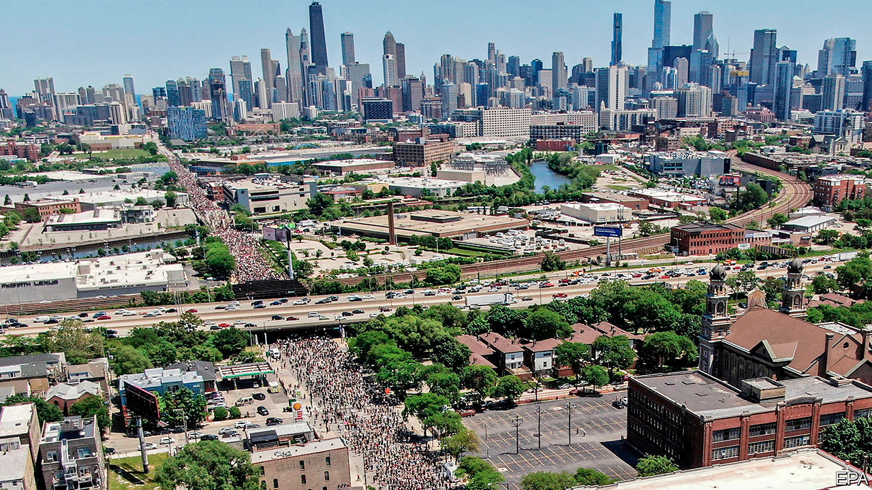

A WEEK AFTER the Trump administration ordered riot police to charge a peaceful crowd in Lafayette Square, it was transformed. The leafy park in front of the White House was enclosed by a steel fence, through which police could be seen loitering. The streets alongside it—including newly named “Black Lives Matter Plaza”, at the bottom of 16th Street, in direct view of the White House—had been colonised by protesters and were far more fun.

Late into the sultry evening, the chanting throng that had filled the plaza for much of the day—and most days since George Floyd’s murder—was winding down. Black musicians and street artists performed for a thinning crowd. A young woman had set up a stall offering free deodorants, tampons and fruit: “Take what you need—just know you are loved,” she carolled. Well-wishers ambled along the fence-line, perusing the banners, drawings and personal messages plastering it.

They offer a cultural history of America’s recent decades of racial injustice, including prayers for many of its victims. “I’m still crying for Emmett Till”, read one note decorated with hearts, beside a sketch of the 14-year-old child lynched in 1955. They also included more overtly political messages, such as “Who do you call when the police murders?” and, in reference to the White House’s well-guarded chief resident, “Bunker bitch”.

This potpourri also reflects the diffuse and largely spontaneous nature of the protests. A minority, especially in the early days after Mr Floyd’s death, have seen violence, first by protesters, then increasingly also by the police (though it is not clear that any of this was caused by the shadowy anarcho-leftists William Barr, the attorney general, has pointed to). The vast majority of the multiracial gatherings have been peaceful, however. Many have been organised by groups of friends and neighbours in small towns. By one count there have been protests in 1,280 places—including such hotbeds of left-wing militancy as Sister Bay, Wisconsin, and Sheridan, Wyoming.

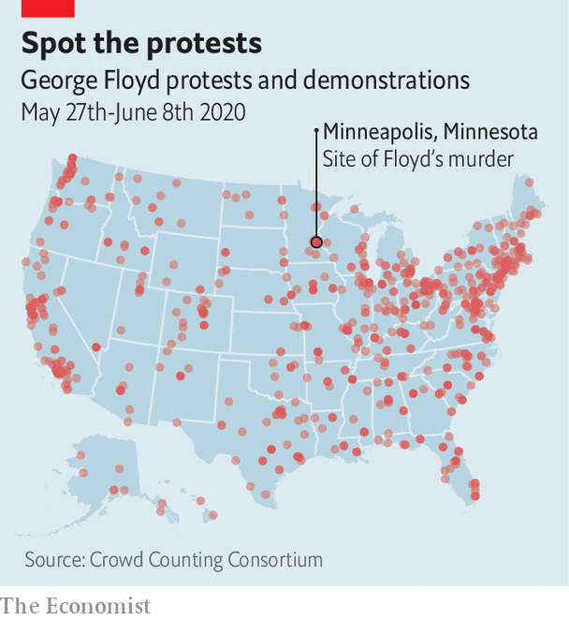

In big cities such as Washington, DC, black activist groups have played a significant organising role. Many are members of a national coalition, the Movement for Black Lives, which was formed in 2014 and has 150 constituent parts. Its best-known, Black Lives Matter (BLM), which came to prominence over police killings during Barack Obama’s second term, has been especially influential, in part by rallying left-leaning whites, whose mass participation in these protests is their most novel feature. “The political weather has shifted,” says Makia Green of Black Lives Matter DC, “We now have widespread multiracial, multi-generation support.”

A broader growth of centre-left activism during Mr Trump’s tenure has probably also played a role. Much of it is rooted in the Women’s March that drew millions onto the streets shortly after the president’s inauguration to protest against misogyny. Indeed, some of the many grassroots groups spawned by that protest have been involved in organising demonstrations in recent days. One such in Pennsylvania, a state-wide organisation called Pennsylvania Stands Up, which campaigns on voting rights, immigration reform, racial justice and other centre-left issues, helped boost turnout and marshal crowds in Lancaster and Philadelphia.

Where is this headed? Perhaps not to the radical reforms many of the protesters demand. The current Congress has passed little except coronavirus stimuli. It is not about to start defunding the police. Yet academic research into the long-term political effects of the Women’s March and Tea Party movement of 2009 suggests such protests do not merely reflect public opinion. They also increase voter turnout. That sounds like more bad news for the president’s overwhelmingly white voting base.

“A lot of people who don’t normally vote say they’re going to vote now,” said Elena, a Hispanic property manager from Fairfax, Virginia, who had spent a long hot day at the plaza, “to be part of history” with her daughter and black boyfriend. “People can argue about whichever party is better for this or that,” she said. “But on this issue, it’s completely clear.”■

This article was downloaded by calibre from <https://www.economist.com/united-states/2020/06/11/americas-protests-turn-jubilant>

|  |  |  |  |
| --- | --- | --- | --- |
|  | Articles | Sections | Next |

|  |  |  |  |
| --- | --- | --- | --- |
| Previous | Articles | Sections | Next |

#### The shifting ground

# In America protests have already brought policy changes

Congress, cities and states have all suggested changes since George Floyd’s killing

Jun 13th 2020 | WASHINGTON, DC

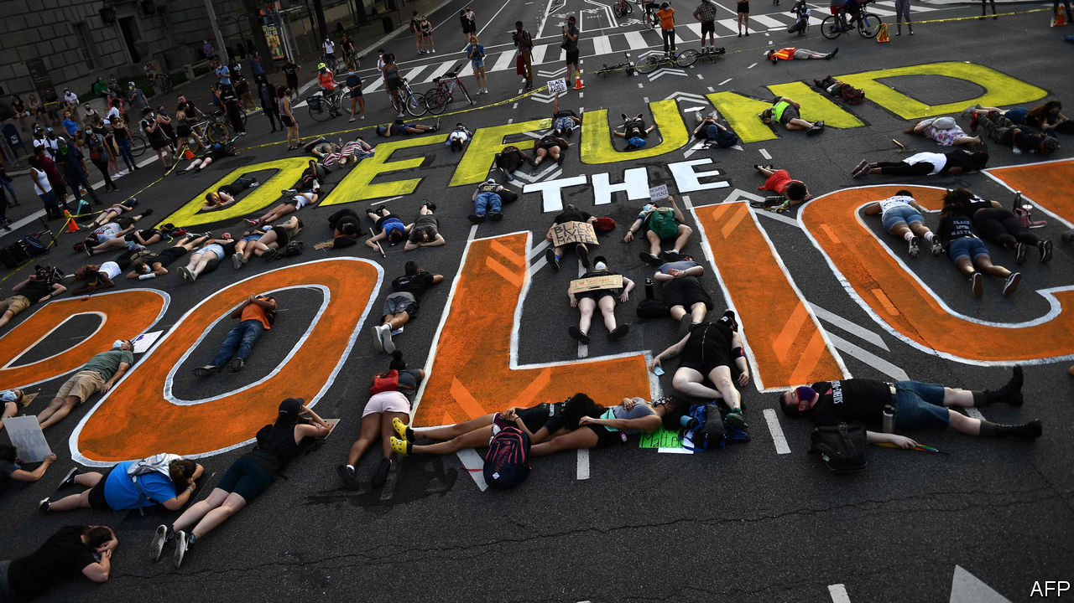

FOR YEARS, reformers have advocated a host of policies to make police more accountable to the people they serve, to little avail. But over the past two weeks, police have made better cases for reform than advocates ever could by brutalising journalists and peaceful protesters in broad daylight. Across America the political ground has shifted, as legislators long reluctant to take on the police have started to act.

On June 8th House Democrats unveiled a sweeping reform bill, which would, among other things, make prosecuting and suing police easier, create a national registry of police-misconduct complaints, mandate more extensive data collection, ban chokeholds for federal officers and no-knock warrants in federal drug cases (and require state and local agencies which want federal grant money to do the same) and limit the transfer of military equipment to police. Democrats plan to bring the bill up for a vote by the end of June.

Congressional Republicans, meanwhile, say they are working on their own reform proposal. Tim Scott, the Senate’s lone black Republican and a longtime advocate for police reform, proposed requiring states to report data on no-knock warrants and deadly use of force and increasing funding for body cameras and for hiring “officer candidates who have racial and ethnic characteristics similar to their community”.

While legislators in Washington talk, some in cities and states have acted (as they should: most of America’s 18,000 law-enforcement agencies are locally governed). Many police departments have banned or restricted chokeholds and “carotid restraints”—the neck-compression technique that killed George Floyd—though without clear consequences the bans risk being hortatory and ultimately ignored.

The New York Police Department has banned chokeholds since 1993, and that did not stop officer Daniel Pantaleo from choking Eric Garner to death in 2014. So on June 8th New York’s legislature created the crime of “aggravated strangulation”, punishable by up to 15 years in prison, for officers whose chokehold “or similar restraint” kills or seriously injures someone.

New York is also poised to pass bills creating an investigative office to look into deaths caused by police officers, requiring courts to publish racial and demographic data on low-level offenders, requiring state-police to wear cameras and repealing a statute that shielded officers’ disciplinary records from the public. Washington, DC’s city council has passed measures that forbid the police department from hiring officers with a history of misconduct and require it to disclose the names of any officers who use force.

More radical measures, such as defunding—which in practice can mean something less alarming, like rethinking how police departments function and redirecting some of their budgets—are also getting a hearing. Minneapolis’s city council vowed to disband the city’s police department, though how, when and what might replace it remain unclear. And the mayors of Los Angeles and New York said they would take money from police budgets for social-service programmes.

Along with this flurry of activity have come two important cultural shifts. First, the shares of Americans who support Black Lives Matter and believe that police treat whites better than African-Americans have soared. Second, prosecutors have shed some of their traditional reluctance to go after the police, and have charged officers in several cities who were caught on camera assaulting unarmed people. Perhaps this shift is temporary. Or perhaps a lot of Americans have seen officers act as if they are above the law, and they do not like it.■

This article was downloaded by calibre from <https://www.economist.com/united-states/2020/06/13/in-america-protests-have-already-brought-policy-changes>

|  |  |  |  |
| --- | --- | --- | --- |
| Previous | Articles | Sections | Next |

|  |  |  |  |
| --- | --- | --- | --- |
| Previous | Articles | Sections | Next |

#### Supremacist safari

# A birdwatchers’ app inspires a field-guide to protesters’ symbols

Struggling to sort your odal runes from your blood-drop crosses? There’s an app for that

Jun 13th 2020 |



AMERICA’S CITIES teem with protesters and counter-protesters. But who are they? Among the crowds that have turned out for anti-lockdown “reopen” rallies and marches against police racism, various obscure insignia have been spotted. Members of the far-right, in particular, like to adopt symbols whose meaning is clear only to those in the know. Others may struggle to distinguish their odal runes from their blood-drop crosses. Now there’s an app for that.

VizPol, developed by researchers at Columbia University, uses machine learning to identify political symbols. Open the app, photograph the banner—or T-shirt, belt-buckle, tattoo or anything else that may contain a logo—and VizPol will tell you whether you are looking at a supporter of Antifa or the Aryan Nations. Most of the 50-plus symbols it recognises belong to the far right, whose insignia tend to be more cryptic and quicker to evolve than those of the left, says Ishaan Jhaveri, one of the app’s developers. But it can also spot left-wing logos, like the encircled arrows of the anti-fascist American Iron Front and the hourglass of Extinction Rebellion.

The idea was born at a “Unite the Right” rally in Washington, DC, in 2018. Nina Berman, a professor at Columbia, photographed a protester with the number 1488 tattooed on her arm. Only later did she learn that this was a white-supremacist reference (14 is the number of words in a popular slogan, “We must secure the existence of our people and a future for white children”, and 88 stands for HH, as in “Heil Hitler!”). Ms Berman drew up a crib-sheet of symbols, which colleagues at the Tow Centre for Digital Journalism helped to turn into an app.

Mr Jhaveri, an amateur birdwatcher, borrowed features from Merlin Bird ID, a twitchers’ app, such as the ability for users to upload their photos to improve and expand the database. Around 100 beta-testers have taken advantage of the protests this week to shovel more food into VizPol’s machine-learning algorithm. (The latest slogan it has learned is “ACAB”, which stands for “All Cops Are Bastards”.) If funding can be found, it may expand to cover more countries.

The developers stress that someone displaying a symbol does not necessarily subscribe to the beliefs associated with it. A Hawaiian shirt may indicate support for far-right extremism, but is more often evidence of nothing more serious than a crime against fashion. The potential for misuse and misunderstanding means that at present the app is available only to journalists. Perhaps that is just as well. During a field test in London, your correspondent’s children were identified as possible white-supremacists after VizPol mistook Peppa Pig, a cartoon character of unknown political leanings, for Pepe the Frog, an alt-right mascot.

This article was downloaded by calibre from <https://www.economist.com/united-states/2020/06/13/a-birdwatchers-app-inspires-a-field-guide-to-protesters-symbols>

|  |  |  |  |
| --- | --- | --- | --- |
| Previous | Articles | Sections | Next |

|  |  |  |  |
| --- | --- | --- | --- |
| Previous | Articles | Sections | Next |

#### Model voters

# Meet our US 2020 election-forecasting model

In early June, it gives Donald Trump a one-in-five shot at re-election

Jun 11th 2020 |



FOUR MONTHS ago, Donald Trump’s odds of winning a second term had never looked better. After an easy acquittal in his impeachment trial, his approval rating had reached its highest level in three years, and was approaching the upper-40s range that delivered re-election to George W. Bush and Barack Obama. Unemployment was at a 50-year low, setting him up to take credit for a strong economy. And Bernie Sanders, a self-described socialist, had won the popular vote in each of the first three Democratic primary contests.

But even by Mr Trump’s frenetic standards, the tumble in his political stock since then has been remarkably abrupt. First, Joe Biden, Barack Obama’s moderate and well-liked vice-president, pulled off a comeback for the ages, surging from the verge of dropping out to presumptive nominee. Then covid-19 battered America, claiming at least 110,000 lives and 30m jobs. And just when deaths from the virus began to taper off, protests sparked by the killing of George Floyd convulsed cities across America. Mr Trump’s callous response has widened the empathy gap separating him from Mr Biden into a chasm.

Even at the president’s high-water mark in February, he trailed Mr Biden by five percentage points in national polling averages. That deficit has now swelled to eight. Polls of swing states tell a similar tale. Mr Biden is not only ahead in the midwestern battlegrounds that elected Mr Trump the first time, but also in Florida and Arizona. Even states that Mr Trump won easily in 2016, such as Georgia, Texas, Iowa and Ohio, look competitive. There is little question that if the election were held today, Mr Biden would win in a near-landslide.

The election, of course, will not be held today. In fact, more time remains between now and November 3rd than has passed since Mr Trump’s impeachment trial. And given the devotion of the president’s base, Mr Biden is probably approaching his electoral ceiling, whereas Mr Trump has plenty of room to win back soft supporters.

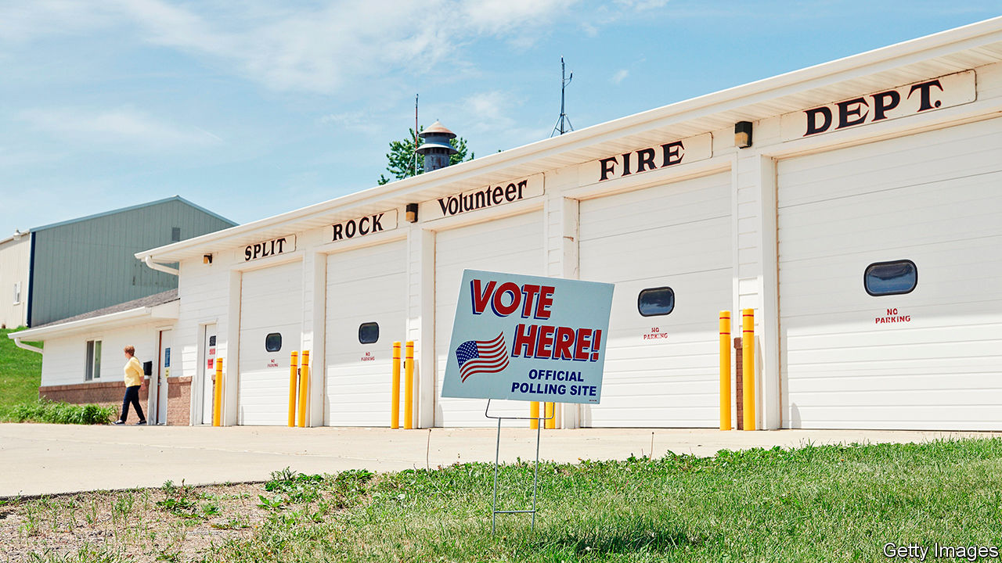

Burning down the House

Indeed, there are good reasons to expect he will. First, the latest jobs report suggests that the economy may have bottomed out. In 1984 Ronald Reagan trounced Walter Mondale by declaring “Morning in America”, though unemployment remained high by historical standards. Mr Trump plans to make the same argument. The Black Lives Matter protests could also backfire on Democrats if they rally white voters behind the “law and order” candidate, as they are thought to have done in 1968.

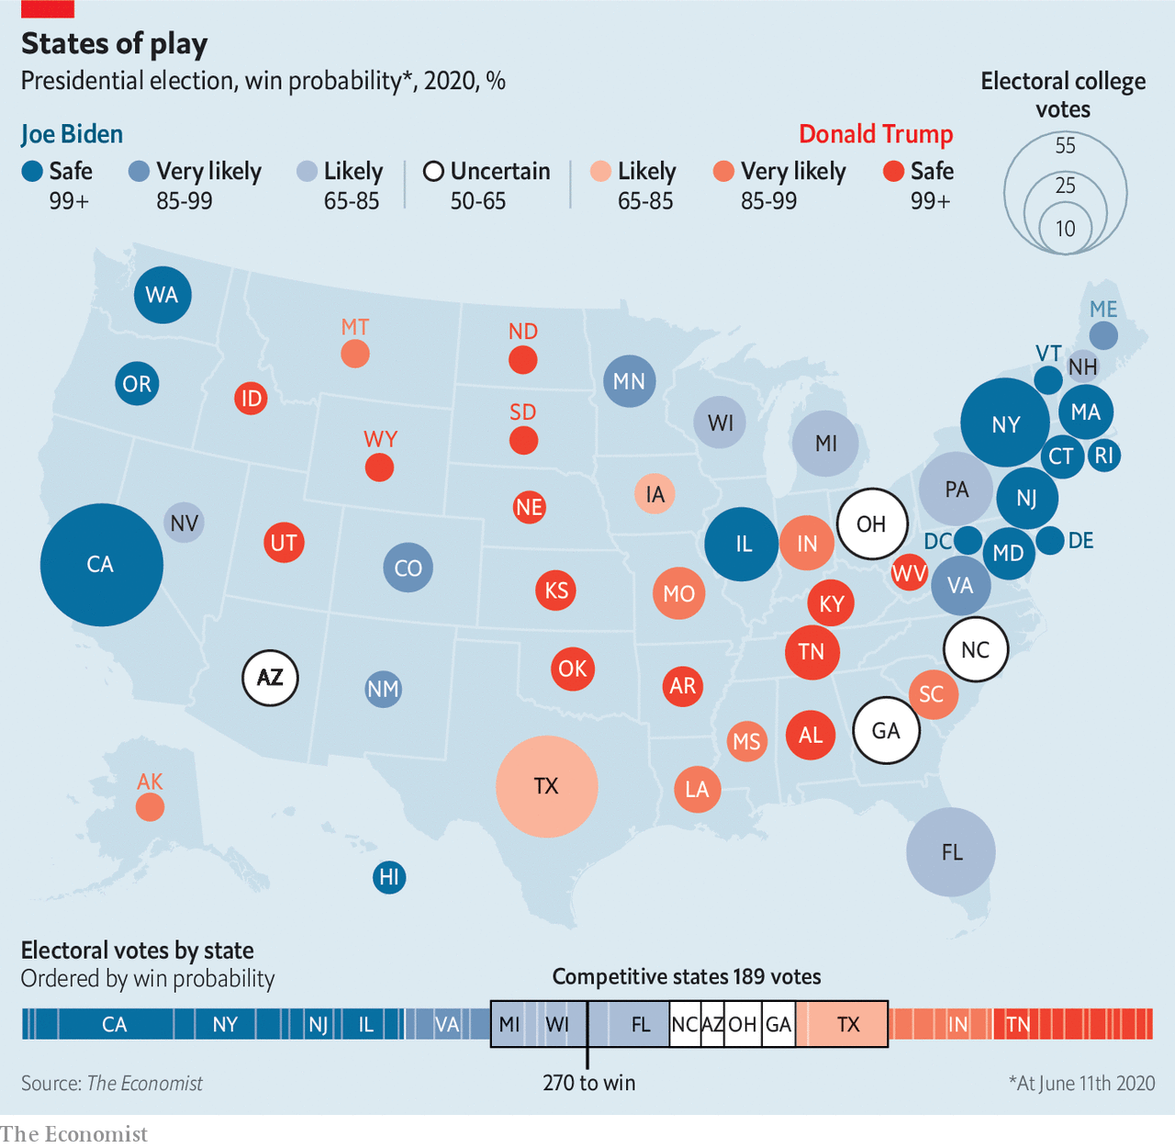

Given all this uncertainty, it is tempting to conclude that it is too early for predictions, and call the election a virtual toss-up. That is the view of bettors, who currently make Mr Biden a bare 55-45 favourite. Yet a hard look at the data and at history suggests that this is too generous to Mr Trump. [The Economist’s first-ever statistical forecast](https://projects.economist.com/us-2020-forecast/president) of an American presidential race, which we launch this week and will update every day until the election, gives Mr Biden an 82% chance of victory.

Mr Trump’s unlikely triumph in 2016 left many quantitative election forecasters looking silly. Sam Wang, a professor at Princeton, vowed to eat a bug if Mr Trump, whom he said had just a 1% chance of victory in November 2016, came even close to winning. (He chose a cricket.)

However, statistical models that used a historically accurate amount of polling error, and factored in the tendency of such errors to benefit the same candidate in similar states, actually fared rather well. Given that Hillary Clinton led polls both nationwide and in a sufficient number of states to deliver her the electoral college, no rigorous forecast on the day of the election could have anointed Mr Trump the favourite. But numerous models put her chances at below 85%, and some were as low as 70%. (When applied retroactively to 2016, our own election-day forecast would have given Mrs Clinton a 71% shot—roughly the same probability it would have assigned to Mr Obama beating Mitt Romney on election day in 2012.) Just as solid number-crunching revealed the brittleness of Mrs Clinton’s position, we hope it will shed similar light on this year’s race.

Like most forecasts, our model, built with the aid of two academics from Columbia, Andrew Gelman and Merlin Heidemanns, applies past patterns of voters’ behaviour to new circumstances. Its stated probability of victory answers the question: “How often have previous candidates in similar positions gone on to win?” If those historical relationships break down, our forecast will misfire. But one of the paradoxes presented by Mr Trump’s unprecedented presidency is that voters have mostly treated him as they would handle any other Republican.

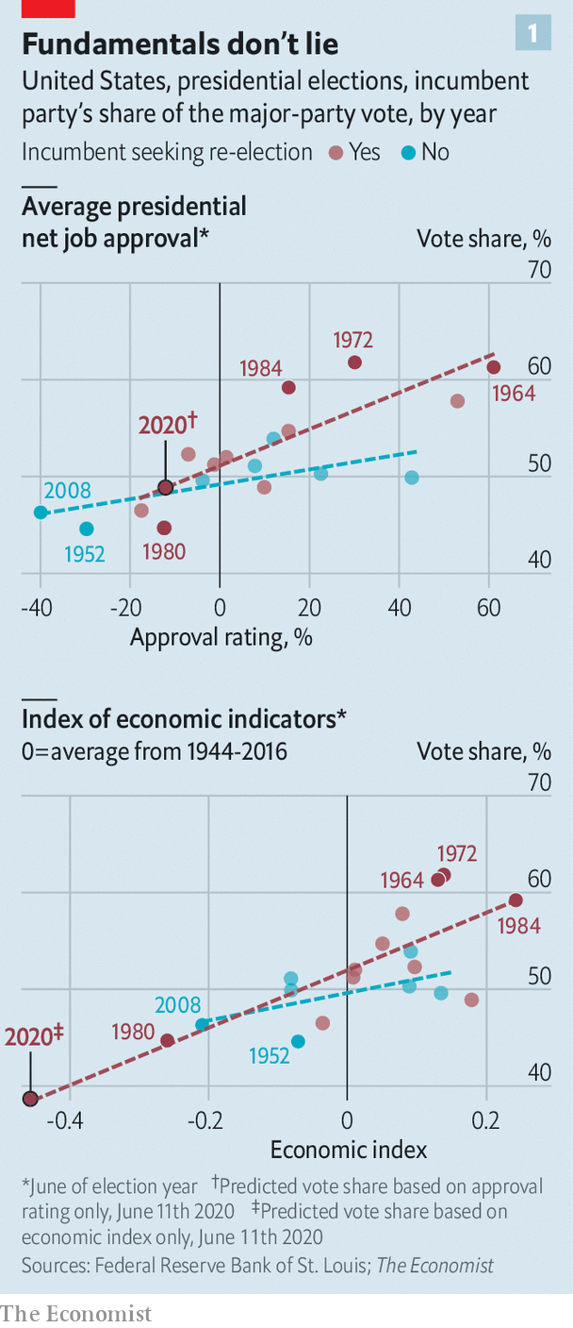

Our analysis begins with “fundamentals”, or structural factors that shape the public’s choices. Predictably, when presidents have high approval ratings, their parties’ candidates tend to get more votes (see chart 1). Incumbents seeking re-election also fare better if the economy does well, though growing partisan polarisation has shrunk this effect. And voters seem to have an “eight-year itch”: only once since term limits were enacted in 1951 has the same party won three times in a row.

Because of the two-term penalty, these factors correctly predicted Mr Trump’s victory in 2016. Until recently, they were poised to favour him again: a typical modern incumbent with a good-not-great economy and bad-not-terrible approval ratings should win around 51% of the vote. However, the recession set off by covid-19 has turned the fundamentals against him.

Just how much this hurts Mr Trump is hard to estimate. First, no post-war president has been saddled with an economic crash this deep. Does moving from 10% unemployment to 15% hurt an incumbent as much as moving from 5% to 10%? Second, whereas recovery from previous economic calamities has been slow and grinding, the easing of lockdowns is likely to put millions of Americans back to work before the election. Come November, will voters punish Mr Trump for the big decline since February, or reward him for a smaller gain since April? Finally, voters may not treat a recession caused by a pandemic the same as one with economic roots. Despite mass unemployment, Mr Trump’s approval rating remains above its lows of 2017.

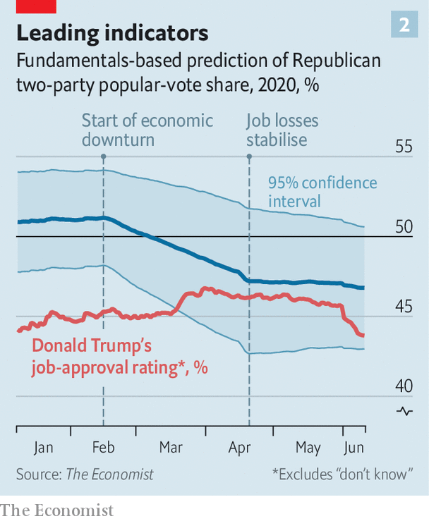

Our model acknowledges these unknowns by increasing the uncertainty in its predictions when economic conditions differ vastly from their historical norms, and dampening the impact of unusually large booms and busts (see chart 2). As a result, it treats the current downturn as merely 40% worse than 2009, rather than twice as bad. This is consistent with Mr Biden winning 53% of votes cast for either him or Mr Trump—a margin halfway between Mr Obama’s in 2008 and 2012, and one similar to his lead in the polls before the Floyd protests began.

Such fundamentals, however, are only a starting-point. Early in a campaign, they tend to predict final results far more reliably than polls do. Eventually, polls reveal whether voters are indeed reacting to the candidates as the fundamentals imply.

Polls are prone to biases, above and beyond their stated margins of error. Their results vary based on whether they are conducted by phone or online, which demographic categories they use to weight responses and how they seek to predict who will turn out to vote. Their results can also oscillate if one side’s partisans become unusually eager or disinclined to answer survey questions—a phenomenon known as “partisan non-response bias”.

Rather than analysing polls individually, our model considers them collectively. It assumes that particular survey methods, weighting schemes, adjustments for partisan non-response bias and the like influence reported results in unknown ways. Using a statistical method called Markov Chain Monte Carlo, it then estimates the impact of these factors, by finding the values for them that best explain the differences in results between pollsters surveying similar places at similar times. Finally, it blends the resulting polling average with a forecast based on fundamentals, placing greater weight on polls as time goes on.

With the election five months away, the model now relies mostly on fundamentals. These are sufficiently grim for Mr Trump that it gives him just a 5% chance of getting more votes than Mr Biden does. However, his overall odds of victory are about four times higher than that, thanks to a healthy chance that he once again wins the electoral college while losing the popular vote.

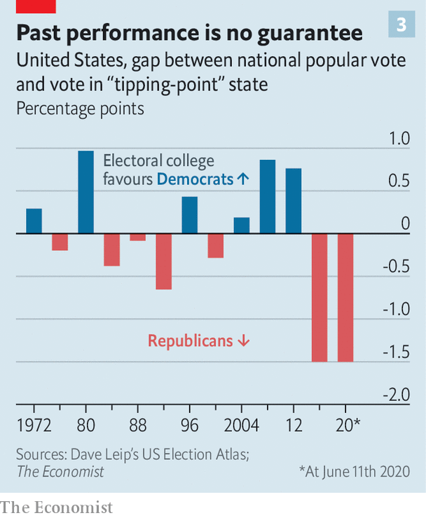

Reports of Mr Trump’s vice-like grip on the battleground states are a bit premature. States’ partisan leans relative to each other shift frequently. For example, in 2012 Barack Obama won Iowa by six percentage points while losing Texas by 16. Four years later, Mrs Clinton came closer to winning Texas than Iowa. Such volatility means advantages in the electoral college can be short-lived. Had the national popular vote been tied every year, the college would have delivered the presidency to Democrats in four of the five elections from 1996 to 2012 (see chart 3).

There is no guarantee that the electoral college will continue to favour Mr Trump. Mr Biden has fared well in polls of Arizona, whose Republican lean has shrunk since 2016. The state could provide him with another path to victory if he cannot wrest back Wisconsin—or, along with Florida, a sunbelt alternative to the entire rustbelt.

At the same time, there is also no evidence that Mr Trump’s electoral-college advantage has dwindled. In 2016 his vote share (excluding third parties) in Wisconsin, the state that delivered him the election, was 1.4 percentage points higher than his performance overall. Today, our model puts Mr Biden on track to win 53.5% of the nationwide two-party vote, and 52% in Pennsylvania, the most likely decisive state—a nearly identical gap of 1.5 points.

An electoral-college advantage of this size would not save Mr Trump if Mr Biden’s lead remains near its current level. But if Mr Trump were to cut Mr Biden’s edge in half, the current state of the electoral map would make him highly competitive. In such a scenario, Mr Biden would win the popular vote by as much as Mr Obama did in 2012—and be rewarded with a near-tie and possibly a disputed election.

The eerie resemblance between our estimate of Mr Biden’s chances and many calculations of Mrs Clinton’s odds four years ago may give Democrats a sense of déjà vu. Now as then, Mr Trump has a clear path to victory. An accelerating economic recovery, a continuing edge in battleground states, and an ill-timed gaffe, senior moment or scandal from Mr Biden could do the trick. Our model does not account for the impact of covid-19 on voter turnout (or, potentially, on the health of the two geriatric male nominees). As the underdog, Mr Trump should welcome this uncertainty. His chances of re-election are far greater than Mr Biden’s were in late February of winning the Democratic nomination.

But just as it was wrong to count Mr Trump out four years ago, it is wrong to regard him as invincible now. In 2016 polls favoured Mrs Clinton, whereas fundamentals favoured Mr Trump.

This time, history suggests that the electorate will punish an unpopular incumbent saddled with a depressed economy, and voters are currently telling pollsters they plan to do just that. What Mr Biden needs to do is run out the clock. ■

Dig deeper:

* Sign up and listen to Checks and Balance, our [newsletter](https://www.economist.com/checksandbalance/) and p[odcast](https://www.economist.com/podcasts/2020/06/05/checks-and-balance-our-weekly-podcast-on-american-politics) on American politics
* Explore the full presidential election [forecast](https://projects.economist.com/us-2020-forecast/president), and read about [how we built it](https://projects.economist.com/us-2020-forecast/president/how-this-works)

This article was downloaded by calibre from <https://www.economist.com/united-states/2020/06/11/meet-our-us-2020-election-forecasting-model>

|  |  |  |  |
| --- | --- | --- | --- |
| Previous | Articles | Sections | Next |

|  |  |  |  |
| --- | --- | --- | --- |
| Previous | Articles | Sections | Next |

#### Lexington

# How Pennsylvania’s governor is battling the pandemic

A day on the frontline with Tom Wolf is an unnerving experience

Jun 11th 2020 |

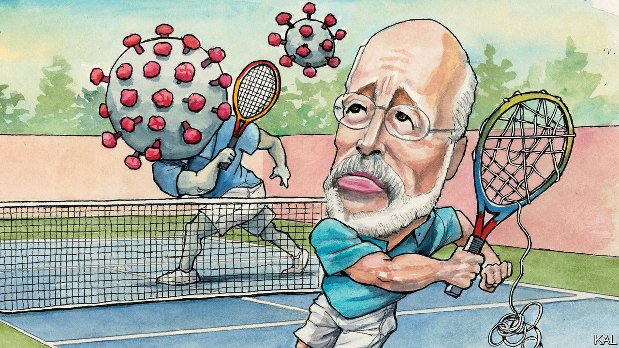

IN RELAXED pre-9/11 days, your columnist was once permitted to sit in the cockpit for a flight from Delhi to London. The experience left him with mixed feelings about flight safety. On the one hand, the two Canadian pilots who generously included him in their competition to get through the first-class dessert menu were experienced and relaxed. On the other, the plane was on autopilot almost the whole way. And the only time one of them was called upon to intervene—when a coil of wiring suddenly let off sparks—he didn’t seem to know what he was doing. Even the most technically proficient operations can look all too human up close.

Lexington experienced something similar during a rainy day in Harrisburg, shadowing Governor Tom Wolf and his covid-19 team.

The 71-year-old Democrat’s evidence-based handling of the crisis has been justly admired. Though over 6,000 Pennsylvanians have succumbed to the virus, the early lockdown he instituted probably helped avoid the greater tragedies seen in New York and New Jersey. It was therefore all the more unnerving to hear the governor describe the large assumptions and insufficient resources that—three months into this emergency—one of America’s better-governed states is still labouring under. As Lexington listened to Mr Wolf and his team fix the details of Pennsylvania’s reopening and defence against the second wave of infections they expect, he could not help but recall the image of a pilot trying to rewire his cabin with a wrench at 35,000 feet.

The amiable governor might even be considered an ideal leader for this crisis. An MIT PhD who eschewed academia to turn his family kitchen-cabinet business into one of America’s biggest, he is by turn cerebral and pragmatic. To underline his many points about the plague realities confronting America, Mr Wolf, wearing a home-made blue face mask, cited Adam Smith, John Maynard Keynes, Lord Beaverbrook, the novels of Hilary Mantel and this newspaper. Yet he is by no means doctrinaire.

Pennsylvania adopted strict criteria to determine which industries could function through the lockdown. It also put in place a flexible process for companies to challenge them—as over 6,000 did. “I recognise the legitimacy of the argument that we can easily hurt ourselves by overdoing it,” the governor says. “You’ve got to be right down the centre.”

Centrism is a dying art in Pennsylvania—James Carville’s description of it as Philadelphia and Pittsburgh with Alabama in between has never seemed truer. Mr Wolf has been attacked from the left ever since he won election in 2014 as a pragmatic outsider. Inspired by Donald Trump, the local Republican Party has meanwhile gone insane—as illustrated by the angry protests against social distancing its leaders took part in. At the time of Lexington’s visit, one of those Republican state representatives was revealed to be in quarantine, a Republican colleague having tested positive for the virus. When the governor noticed the story playing on muted televisions in his war-room, he permitted himself a small smile.

One of America’s foremost patricians—he had driven in that morning from his ancestral home in Mount Wolf, a town founded by a forebear—he prefers to avoid partisanship. He is correspondingly reluctant to criticise the Trump administration. He says the president’s tweeted encouragement to the crazies (the “great people of Pennsylvania want their freedom”) was merely “not helpful”. He considers it “a lame exercise to be too critical of how prepared the administration was”. Yet such carefulness makes his account of its pandemic response all the more devastating.

He describes the federal distribution of medical supplies to the states as an enthusiastic mess. The six private companies charged with this task do not tell states what they have delivered, leading to confusion and potential hoarding. The administration’s failure to co-ordinate the states’ own purchasing has meanwhile locked them in a mutually destructive bidding war for additional resources. Mr Wolf gives your columnist’s suggestion that such state proactiveness has nonetheless compensated for the absence of presidential leadership short shrift. Not since the second world war has the indispensability of a strong centre been so apparent, he suggests. He is additionally damning of the administration’s failure to launch a big push for better testing, or for a vaccine, or to reincentivise health-care providers to prepare for future viral waves. “No state has the capacity to do such things,” he says.

How can America return to a semblance of normality without them? Mr Wolf does not claim to know. The idea of population-wide testing-tracing is a fiction, he says. To test every Pennsylvanian once a month would require over 3m tests a week. The state can currently do 80,000, a figure it is striving to double by the autumn, when Mr Wolf expects falling temperatures to bring the feared second wave. And he means to devote most of that capacity to vulnerable populations, including minorities and residents of Pennsylvania’s 2,000 care homes, which have been especially ravaged. That will not leave much for everyone else. “We’re so far from testing being at the heart of restoring confidence that we’re going to have to come up with something else,” he says.

Like thermometers, perhaps? “That’s nothing.” Then like self-reporting any possible exposure to the virus—a system Amazon and other big firms are adopting? “Something like that could work,” he muses. “But the trouble is you’re trusting people to tell the truth. If I were in fifth grade there’d be someone sick in my family every week so I didn’t have to go to school.”

## Howlin’ good sense

Pennsylvanians seem to appreciate Mr Wolf. His ratings have risen during the pandemic as Mr Trump’s have dropped. Hopefully they have heeded his frankness, too. Through luck and solid leadership at every level below the presidency, America seems to be emerging from the first wave of the pandemic less scathed than it might have been. But it is largely unprepared for the virus’s resurgence.■

Editor’s note: Some of our covid-19 coverage is free for readers of The Economist Today, our daily [newsletter](https://my.economist.com/user#newsletter). For more stories and our pandemic tracker, see our [coronavirus hub](https://www.economist.com/news/2020/03/11/the-economists-coverage-of-the-coronavirus)

This article was downloaded by calibre from <https://www.economist.com/united-states/2020/06/11/how-pennsylvanias-governor-is-battling-the-pandemic>

|  |  |  |  |
| --- | --- | --- | --- |
| Previous | Articles | Sections | Next |

|  |  |  |
| --- | --- | --- |
| United States | Sections | Asia |

The Americas

The Amazon: Of chainsaws and supply chains

.

Bello: Brazil’s endangered democracy

.

|  |  |  |
| --- | --- | --- |
| United States | Sections | Asia |

|  |  |  |  |
| --- | --- | --- | --- |
|  | Articles | Sections | Next |

#### Of chainsaws and supply chains

# How big beef and soya firms can stop deforestation

They don’t chop down Amazonian trees, but their suppliers do

Jun 11th 2020 | SÃO PAULO

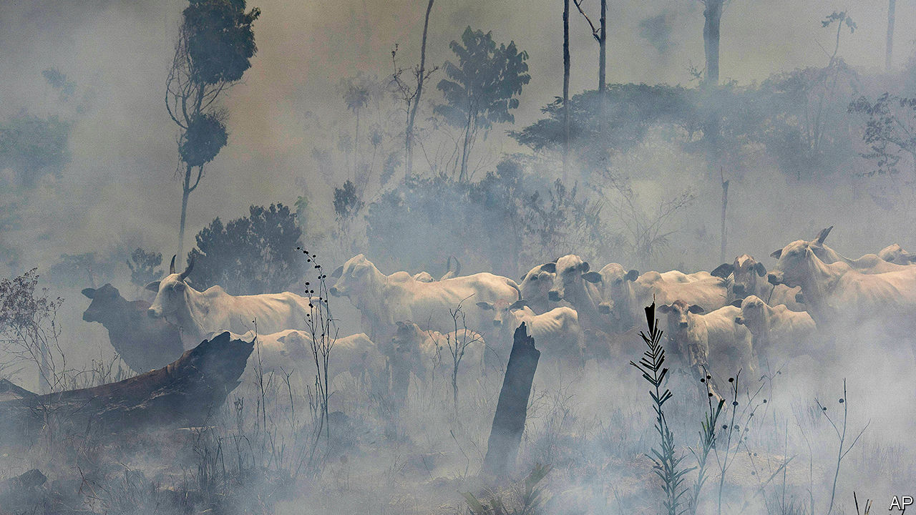

THE WORLD’S emissions of carbon dioxide may fall by 7% this year because of lockdowns in response to the pandemic, according to Nature Climate Change, a journal. Brazil is a glaring exception. Its emissions will rise by 10-20% from 2018, when they were last measured, says the Climate Observatory, a consortium of research outfits. The culprit is deforestation. In the first four months of 2020 an estimated 1,202 square km (464 square miles) were cleared in the Brazilian Amazon, 55% more than during the same period in 2019, which was the worst year in a decade. Come August, when ranchers set fire to cleared areas to prepare them for grazing, runaway blazes could outnumber those that shocked the world last year. Scientists say tree loss is nearing a “tipping point”, after which trees will dry out and die, releasing billions of tonnes of carbon into the atmosphere.

Environmentalists blame Brazil’s populist president, Jair Bolsonaro, for the catastrophe. He favours deregulation to allow logging, mining and farming in the forest and has weakened enforcement of environmental laws. Less attention has been paid to the role of big firms like JBS and Cargill, global intermediaries for beef and soya, the commodities that drive deforestation (see Graphic detail).

The companies do not chop down trees themselves. Rather, they are middlemen in complex supply chains that deal in soya and beef produced on deforested land. The process begins when speculators, who tend to operate outside the law, buy or seize land, sell the timber, graze cattle on it for several years and then sell it to a soya farmer. Land in the Amazon is five to ten times more valuable once it is deforested, says Daniel Nepstad, an ecologist. Not chopping down trees would have a large opportunity cost. In 2009 Mr Nepstad estimated that cost (in terms of forgone beef and soy output) would be $275bn over 30 years, about 16% of that year’s GDP.

Under pressure from public opinion, the big firms have made attempts to control the problem. In 2009, a damning report from Greenpeace led JBS, Marfrig and Minerva, meat giants which together handle two-thirds of Brazil’s exports, to pledge to stop buying from suppliers that deforest illegally. (The forest code allows owners to clear 20% of their land.) JBS, which sources from an area in the Amazon larger than Germany, says it has blocked 9,000 suppliers, using satellites to detect clearing. Soya traders such as Cargill and Bunge have used such systems to enforce a zero-deforestation agreement for the region since 2008, when retail firms like McDonald’s and Tesco said they would no longer buy Amazonian soya harvested on deforested land.

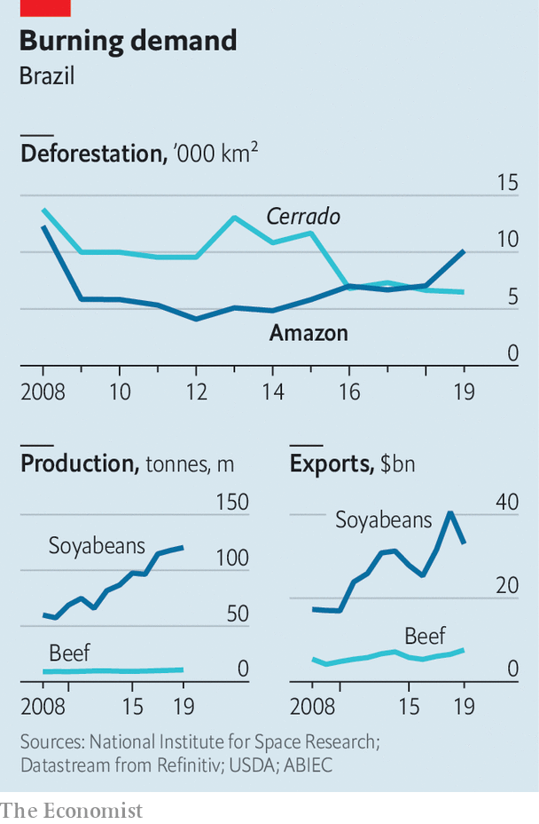

These agreements contributed to a sharp decline in the rate of tree loss until 2012 (see chart). Before the “soya moratorium”, 30% of new fields in the Amazon involved clearing forests. In the eight years after it was signed, 99% of soya expansion was on land that was already treeless. But, warns André Vasconcelos from Trase, a research organisation that tracks commodity supply chains, the frenzy of deforestation under Mr Bolsonaro could reverse this trend.

The deforestation surge shows that the agreements have an Achilles’ heel, says Mr Nepstad. The big firms are still not exerting the control they could over all their suppliers. And even if they did, large amounts of soya, and especially beef, are traded by smaller firms with weaker incentives to persuade farmers to change behaviour.

The problem is especially acute in ranching, which accounts for roughly 80% of deforestation in the Amazon, nearly all of it illegal. “Cows move around,” explains Paulo Pianez of Marfrig. Every fattening farm the big meatpackers buy from has, on average, 23 of its own suppliers, says Holly Gibbs of the University of Wisconsin. Current monitoring doesn’t cover ranchers who breed and graze cattle, so it misses 85-90% of deforestation. Rogue fattening farms can also “launder” cattle by moving them to lawful farms—perhaps their own—right before selling them. A new Greenpeace report alleges that through this mechanism JBS, Marfrig and Minerva ended up selling beef from farms that deforested a protected Amazon reserve on the border between Brazil and Bolivia. They said they had not known about any illegality.

Soya-driven deforestation more directly affects the cerrado, the tropical savannah southeast of the rainforest. In Mato Grosso, a state that straddles the Amazon and the cerrado, 27% of deforestation between 2012 and 2017 took place on soya farms, according to a new report by Imaflora and Instituto Centro de Vida (ICV), Brazilian research institutes, and Trase. The state provides a third of the EU’s soya imports from Brazil. Ninety-five per cent of clearing on soya farms was illegal. A third occurred in the Amazon, revealing a gap in the soya moratorium. Since it only covers land where soya is planted, a farmer who illegally clears another part of his farm—say, for cattle—can continue selling to traders, who crush and export the soya.

André Nassar of Abiove, a soya-industry lobby, points out that the area of new soya fields planted on deforested land in the cerrado has fallen: from 215,000 hectares (530,000 acres) a year in 2000-06 to 79,000 hectares in 2013-18. The industry should distinguish legal from illegal deforestation, he says—it doesn’t do annual monitoring in the cerrado—but embargoing farms is the responsibility of the government. Nonetheless, Bunge and Cargill have vowed to source only from land that has not been deforested, legally or illegally. They missed their 2020 deadline but plan to succeed by 2025 and 2030, respectively.

Perhaps they would move faster if they felt more pressure from customers and investors. One reason that soya giants seem more serious than meat producers about reducing deforestation, says Maria Lettini of FAIRR, a network of investors concerned about sustainability, is that most soya is exported. The EU is the second-top destination after China. But companies struggle to get people to pay more for a “hidden commodity”, says Juliana Lopes of Amaggi, a Brazilian soya behemoth. “You know your clothing is made of cotton and your chocolate comes from cacao,” she says. But few people will pay extra for chicken made with sustainable soya, which explains why just 2-3% is certified deforestation-free. Better labelling could help, she says.

Four-fifths of Brazilian beef, by contrast, is eaten in Brazil. Exports go mostly to China, Russia and the Middle East, where feeding people is a higher priority than saving trees. Investors, for their part, see beef firms as unsexy businesses with thin margins. They haven’t demanded huge efforts to reduce deforestation, says João Paulo Dibo of Rio Bravo Investimentos, an asset manager in São Paulo. Sexy or not, beef producers are doing well. While Brazilian share prices overall are down by 18% this year, Marfrig has seen its share price rise by 27% and Minerva has recovered what it lost at the start of the pandemic. JBS, the world’s largest meatpacker, said 2019 was the most profitable year ever.

Morgan Stanley, Itaú and Santander declined to discuss soya and meat companies with The Economist. A new 58-page report by Itaú recommends investing in JBS, Marfrig and Minerva. (It doesn’t contain the word “deforestation”.) This reflects “myopia” at a time when investing in sustainable industry is rapidly expanding, says Fabio Alperowitch of FAMA Investimentos. It is one of 230 funds with more than $16trn in assets that signed a letter in the wake of last year’s fires calling on firms to end deforestation. BlackRock, one of JBS’s top-ten shareholders, did not sign, even though it is divesting from coal.

Economic turmoil makes it unlikely that companies will soon spend a lot to combat deforestation, says Marcello Brito of the Brazilian Agribusiness Association. “Shareholders won’t want it,” he says.

Despite these discouragements, the firms say they are making progress. The meatpackers claim they are working towards their promise, made in 2009, to expand tracing to indirect suppliers. One idea is to use animal-transit permits, which track vaccinations as cattle are passed between ranchers, to flag deforestation. But the agriculture ministry has yet to agree. Minerva is considering using a tool developed by the University of Wisconsin, called Visipec, to map suppliers, identify regions with high deforestation and prioritise suppliers in other areas. Minerva gets 30% of its beef via full-cycle breeding, which it can guarantee is deforestation-free. Commercial restrictions could actually benefit the top firms, says its sustainability director, Taciano Custodio. “We’re better positioned to adapt.”

But change from the top three meatpackers won’t guarantee a reduction in deforestation, because they account for less than half of the market. “When we block a supplier, he can cross the road and sell to another slaughterhouse,” says Márcio Nappo of JBS. Industry-wide progress will require better enforcement and incentives for ranchers. “We have to make production sustainable as a whole,” says Mr Pianez.

That sentiment is echoed in the soya industry, where cracking down on deforestation is logistically simple but politically tough. According to the Mato Grosso study, 80% of illegal deforestation took place on 400 farms, 2% of the total. They are “low-hanging fruit” for action, says Mr Vasconcelos. But two years of talks about expanding the moratorium to the cerrado stalled. According to soya growers, multinational firms failed to raise $250m to launch a fund for compensating farmers who retain woodland. “They demand, demand, demand, but don’t offer anything in return,” complains Ricardo Arioli.

Cargill says it will spend $30m on ways to stop deforestation industry-wide. Marfrig and Amaggi are backing an initiative launched by the government of Mato Grosso in 2015 to reduce deforestation through a “landscape approach”. Fernando Sampaio, the director of its committee, which includes NGOs and companies, says municipalities that reduce deforestation will receive technical assistance and credit and more business from the big firms, incentivising others to follow. But although the rate of deforestation in the state between August 2018 and July 2019 decreased by 4% from a year earlier, the initiative looks set to fall far short of its goal of ending illegal deforestation by 2020: 85% of the 1,685 square km cleared were done so illegally.

Among the biggest obstacles to progress is the lack of co-operation from the federal government. In a video of a cabinet meeting in April released by the Supreme Court, the environment minister, Ricardo Salles, called on the government to “push through” deregulation while people are distracted by the pandemic. A rule change in the indigenous agency allows landowners to claim chunks of indigenous territories that are awaiting official demarcation. Even the Amazon soya moratorium appears shaky. Aprosoja, a growers’ lobby, threatened to abandon it (because it forbids legal deforestation). The agriculture minister, Tereza Cristina, called it “absurd”.

Reducing deforestation will require consensus on tricky issues like the fate of tens of thousands of poor settlers on public lands in the Amazon, where half of deforestation takes place. However, environmentalists say that the “land regularisation” bill currently in Congress would also grant titles for big deforested tracts to “land-grabbers”, sending the message that further clearing might also get a pass. An earlier version of the bill was rejected on May 20th after British supermarkets threatened to boycott Brazilian products.

Though still faint, such noises are growing louder. They add to the argument that companies should make changes not just for ethical reasons, but also for business reasons. Supermarkets could speed things up by telling consumers where their beef and soya come from. Getting farmers and ranchers on board will require the right balance of pressure and incentives. The companies have leverage, Ms Gibbs insists. A decade ago, after JBS, Marfrig and Minerva pledged to purge suppliers who deforested, more than 30 other beef firms signed similar agreements. “If you could get a big company to take the first step, others would follow,” she predicts. ■

This article was downloaded by calibre from <https://www.economist.com/the-americas/2020/06/11/how-big-beef-and-soya-firms-can-stop-deforestation>

|  |  |  |  |
| --- | --- | --- | --- |
|  | Articles | Sections | Next |

|  |  |  |  |
| --- | --- | --- | --- |
| Previous | Articles | Sections | Next |

#### Bello

# Does Jair Bolsonaro threaten Brazilian democracy?

And would the army support him if he tried something rash?

Jun 13th 2020 |



MOST WEEKENDS since covid-19 hit Brazil, supporters of President Jair Bolsonaro have rallied in Brasília and São Paulo. They demand the reopening of a partially locked-down economy, the shutting down of the Supreme Court and Congress and a return to the military rule of 1964-85. A few are armed. In the capital Mr Bolsonaro often joins them, dispensing hugs and handshakes in defiance of health regulations. Neither he nor they wear face masks.

Since Mr Bolsonaro, a former army captain with far-right views, took office in January 2019 many Brazilians have been sanguine about the threat he poses to democracy. Some argue that the country’s institutions are strong enough to restrain him. True, the president has stuffed his government with military officers. But they have been seen as a moderating influence. And the demonstrations are small.

Tensions have risen in the past few weeks. Mr Bolsonaro has become more intimidating, saying of Congress, “The time of villainy is over, now it’s the people in power,” and of the court, “It’s over, for fuck’s sake.” Some of the military ministers, starting with Vice-President Hamilton Mourão, a retired general, have issued veiled threats against the court, Congress and the media.

In a WhatsApp message leaked last month, Celso de Mello, the senior justice of the court, wrote: “We must resist the destruction of the democratic order to avoid what happened in the Weimar Republic,” which was overthrown by Hitler. “Brazilian democracy is under serious threat,” agrees Oscar Vilhena Vieira, the dean of the law school at the Fundação Getulio Vargas (FGV), a university. “The president is not just trying to create an institutional conflict, [but also] trying to stimulate violent groups.”

A backbench congressman for 28 years, Mr Bolsonaro has never shown much respect for democracy. He has now become more confrontational for two reasons. First, the Supreme Court has launched investigations that involve him. One is into his sacking of the federal police commander, to protect one of his sons from prosecution, say his critics. Another is into supporters (including another two of his sons) suspected of orchestrating slurs and threats towards the court’s justices.

The second reason is that Mr Bolsonaro shows little ability to govern. The pandemic has dramatised that. His refusal to support lockdowns and social distancing has contributed to covid-19’s severe toll in Brazil, with nearly 40,000 deaths, the world’s third-highest number. He is losing popular support, although he retains a core of around 30% of voters.

It is a sign of his weakness that he increasingly relies on the army. Ten of his 22 ministers are now military men and 3,000 others are in government jobs. “De facto we have a military regime,” says a former officer. That carries risks for the armed forces as well as for democracy. Mr Bolsonaro has exacerbated the army’s internal division and politicisation, which began earlier. Its discipline and hierarchy are fraying. Many junior officers voice their support for Mr Bolsonaro on social media. Four generals with jobs in the presidential palace, two on active service, have more power than the army commander, their nominal superior.

The army also runs a grave risk to its reputation. It is now in charge of the health ministry (where it briefly tried to halt publication of full covid-19 data), political co-ordination and protecting the Amazon. “They really believe they know how to do things,” says the former officer. They may learn the hard way, as during the dictatorship, that they don’t.

Mr Bolsonaro does not look strong enough to pull off a coup. He is opposed by most of Brazil’s state governors. Although the virus has temporarily disabled Congress, Mr Vieira notes that the Supreme Court is acting in an unusually united way. Nevertheless, “democracy can die even if you don’t have a strongman”, warns Matias Spektor of the Centre for International Relations at FGV. If Mr Bolsonaro is eventually impeached Mr Mourão would succeed him, bringing the army still closer to power.

Another threat, notes Mr Spektor, is Mr Bolsonaro’s hollowing out of Brazil’s democratic institutions and fomenting of conflict. He has installed a friendly prosecutor-general, and has influence over the state police forces as well as the federal police. A police raid has silenced Rio de Janeiro’s governor, recently a critic of Mr Bolsonaro’s. Brazilian democrats, often adversaries, are starting to unite in opposition to the president. They are right to be alarmed.

This article was downloaded by calibre from <https://www.economist.com/the-americas/2020/06/13/does-jair-bolsonaro-threaten-brazilian-democracy>

|  |  |  |  |
| --- | --- | --- | --- |
| Previous | Articles | Sections | Next |

|  |  |  |
| --- | --- | --- |
| The Americas | Sections | China |

Asia

Freedom of the press: Muffled cries

.

Renewable energy in Japan: No mill will

.

Politics in Taiwan: Han’s down

.

Banyan: Circulars, directives and rules

.

|  |  |  |
| --- | --- | --- |
| The Americas | Sections | China |

|  |  |  |  |
| --- | --- | --- | --- |
|  | Articles | Sections | Next |

#### Muffled cries

# Governments all over Asia are silencing critical journalists

They have used covid-19 to justify a crackdown that was already under way

Jun 13th 2020 | SINGAPORE

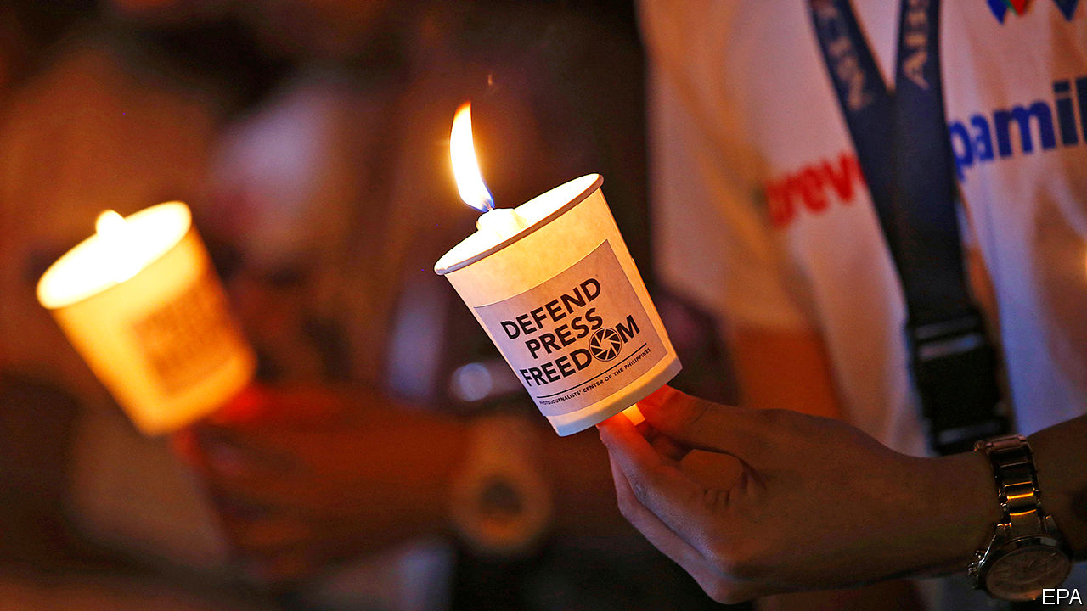

IT IS OVER a month now since the screen went dark. At 7:52pm on May 5th ABS-CBN, the biggest broadcaster in the Philippines, ceased transmission. In theory, its licence simply expired—nothing to do with a years-long feud with President Rodrigo Duterte. But his administration had warned the regulator against giving the company a temporary extension, and Congress, which is dominated by the president’s allies, had dawdled for months over renewing its 25-year franchise (it still offers online programming and a cable channel). The Supreme Court may yet allow ABS-CBN to resume broadcasting until Congress makes up its mind. But even if it does, a clear signal has been sent to journalists and their commercial backers about the consequences of criticising the government too fiercely.

The story will not surprise Asia’s journalists and media firms. All over the continent, they are under pressure from the withdrawal of government advertising, unwarranted tax investigations, spurious criminal charges, hostile takeovers, suspect fake-news campaigns, online trolling and old-fashioned thuggery. Since 2018 press freedom has declined in more than a dozen Asian countries, according to Reporters Without Borders, a watchdog. The backsliders include Bangladesh, China, India, Myanmar, Pakistan and Singapore, as well as the Philippines. The group ranks 180 countries by the leeway granted journalists; about a third of the most repressive regimes are in Asia, led by North Korea, which came rock bottom in the latest index, Turkmenistan, which placed 179th, China (177th) and Vietnam (175th).

In many countries where press freedom is declining, there was never much of a tradition of it. The prime minister of Cambodia, Hun Sen, has held power since the demise of the genocidal Khmer Rouge regime some 40 years ago. He has worked methodically to undermine international efforts to turn the country into a democracy. The closure in recent years of several independent radio stations and a critical newspaper, Cambodia Daily, were only part of a broader campaign that also saw the main opposition party banned.

By the same token, it was perhaps too much to hope that the authorities in Myanmar would slough off the legacy of decades of military dictatorship overnight. Over the past four years the armed forces have filed 52 legal complaints against their critics, more than half of them in the past year alone. Two journalists from Reuters, a news agency, were jailed for over a year after they exposed a massacre of civilians by soldiers. The soldiers themselves spent far less time in prison.

It is worrying, nonetheless, that governments which have always manhandled the press are getting rougher. In Pakistan critics of the army are intimidated and attacked, at home and abroad. A popular but spiky news channel, Geo, found itself off the air for months in 2018, as cable firms mysteriously dropped it. The government does little to protect reporters, meanwhile, from Islamist militants. Of 33 murders of journalists in Pakistan from 2013 to 2019, not a single one has resulted in punishment for the killers. Sluggishness also besets investigations into violence against journalists in Sri Lanka and Bangladesh.

More alarming still, countries with a long history of press freedom have begun to pick on journalists. Narendra Modi, India’s prime minister since 2014, rarely deigns to talk to the media. Whereas he is merely aloof, his underlings are downright hostile. It has become more common for reporters to face lawsuits filed by private citizens in response to criticism of the government. On June 8th, for example, the Editors Guild of India released a statement decrying Delhi’s police for investigating a journalist based on a complaint submitted by a spokesman for Mr Modi’s party. Armies of trolls, meanwhile, attack critical reporters online, sometimes publishing their addresses or other personal details. Rana Ayyub, a journalist who has investigated anti-Muslim violence in the state of Gujarat when Mr Modi was its chief minister, has endured her face being superimposed onto pornographic videos, not to mention threats of gang rape.

There is commercial pressure, too. Unfriendly newspapers seem to miss out on government advertising. And since the conglomerates that own most television channels and newspapers are sprawling businesses that depend on the government for umpteen licences, approvals and loans, it is easy for those in power to press them for favourable coverage.

The Philippines is another place where freedoms thought to be firmly established are eroding. Condemning Mr Duterte’s policies, such as his campaign of shooting suspected drug dealers, carries risk for reporters online and in person. Maria Ressa, the boss of a needling news site, faces up to 12 years on a libel charge. “Just because you’re a journalist you are not exempted from assassination, if you’re a son of a bitch,” Mr Duterte declared in 2016.

His latest threat to media freedom appears within a sweeping new anti-terrorism act. It passed the Senate in February and the House of Representatives this month, awaiting only the president’s signature to become law. The bill’s critics ask why it is such a priority, when the country is battling the coronavirus and an unemployment rate of 18%. They fear its broad scope and hazy definitions could be used to target critics of the government. “The only way that government can curtail freedom of expression is if there is a clear and present danger that the state has a right to prevent,” is the far from reassuring response of Mr Duterte’s spokesman. “Never since the Marcos dictatorship has press freedom been so in danger of being suppressed as under the Duterte administration,” counters Nonoy Espina of the National Union of Journalists in the Philippines.

Covid-19 is accelerating Asian governments’ attacks on journalists. In Indonesia 51 people have been arrested for allegedly spreading falsehoods about the disease. In Malaysia, too, where a new government has abandoned the more relaxed attitude to the press of its predecessor, some 29 people have appeared in court for supposedly spreading fake news about the epidemic. A correspondent there for the South China Morning Post is under investigation for reporting on the authorities’ efforts to arrest and test illicit migrants. Sweeping emergency powers in Thailand, Cambodia and beyond, ostensibly introduced to help fight the pandemic, give governments freer rein to squash detractors.

In India, Mr Modi told reporters in a video conference to focus on positive coverage during the country’s battle with the coronavirus. The police in Mumbai went further. They passed an order banning “any person inciting mistrust towards government functionaries and their actions taken in order to prevent spread of the covid-19 virus”. Needless to say, the actions India’s government functionaries have taken during the outbreak have not been beyond reproach (see [Banyan](https://www.economist.com/node/21788006), albeit discreetly if you happen to be in Mumbai).

These sinister developments have largely escaped international censure. When Michelle Bachelet, the UN’s human-rights commissioner, took a dozen countries to task this month for exploiting the covid epidemic “to restrict dissent or the free flow of information and debate”, they simply shrugged off her criticism. Eight of them, including India, the Philippines and Vietnam, retorted that the epidemic “requires extraordinary and unprecedented measures”. It is indeed extraordinary and unprecedented that those three countries would find themselves in agreement about the proper role of the media. It is sadly predictable, though, that their governments, without a vigorous press to hold them to account, will manage the epidemic worse than they otherwise would have. ■

This article was downloaded by calibre from <https://www.economist.com/asia/2020/06/13/governments-all-over-asia-are-silencing-critical-journalists>

|  |  |  |  |
| --- | --- | --- | --- |
|  | Articles | Sections | Next |

|  |  |  |  |
| --- | --- | --- | --- |
| Previous | Articles | Sections | Next |

#### No mill will

# The reinvention of Japan’s power supply is not making much headway

The government is timid and big utilities are resistant

Jun 13th 2020 | TOKYO

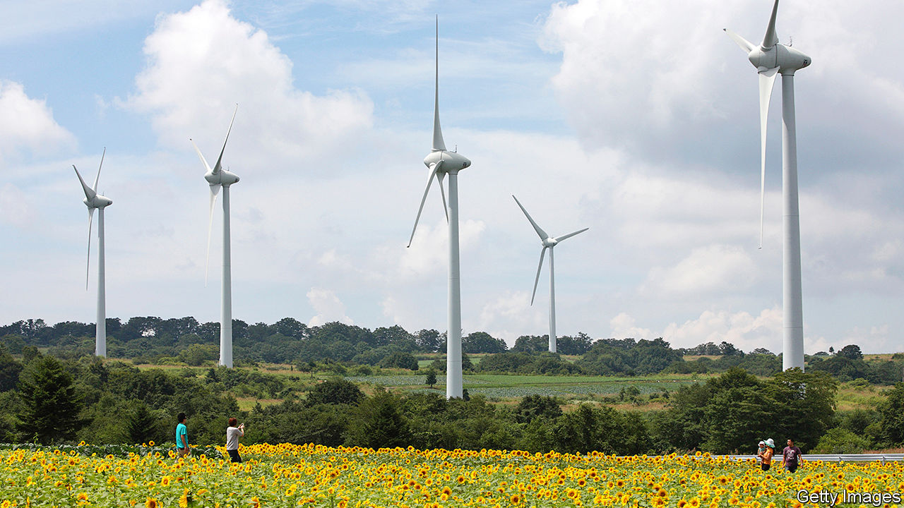

IN THE WAKE of the Fukushima nuclear disaster in 2011, an IT expert, a restaurant owner, an agribusiness manager and a sake brewer, all from the afflicted prefecture, hatched a plan. Japan needed to generate more electricity from renewable sources, they believed, so they founded Aizu Electric Power Company to speed the transition. Yamada Jun, the IT expert, became the CEO and travelled to Germany to swot up on renewables. He spent two winters studying the effects of snowfall on solar panels. In 2014 Aizu Electric installed its first solar farm on the edge of a mountain overlooking terraced rice paddies, 125km west of the ruined nuclear plant. “At the time, we were fairly optimistic,” Mr Yamada says.

He was not alone. Enthusiasm for renewable energy swelled after the disaster. Kan Naoto, the prime minister at the time, declared that Japan would draw up a new energy strategy “from scratch” and “elevate” renewables. One of his government’s last acts before losing power was to pass a law to stimulate renewable energy. Dozens of small firms like Aizu sprang up. Fukushima prefecture itself pledged to get all its power from renewable sources by 2040.

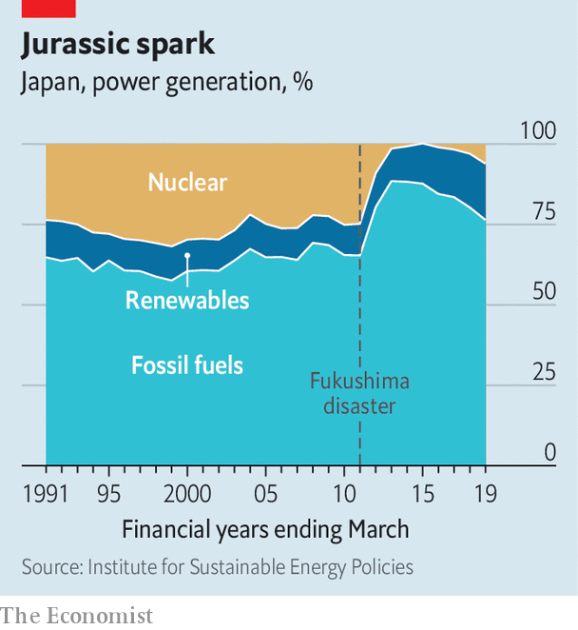

The hoped-for transformation, however, has been “slow and almost invisible”, Mr Yamada laments. Renewable generation has grown from 10% of the power supply in 2010 to 17% in 2018, almost half of which comes from old hydropower schemes. Most nuclear plants, which provided more than a quarter of the country’s power before the disaster, have been shut down, at least for the time being (see chart). But for the most part they have been replaced not by wind turbines and solar panels but by power stations that burn coal and natural gas. The current government wants nuclear plants to provide at least 20% of electricity by 2030. It also wants coal’s share of generation to grow, and has approved plans to build 22 new coal-fired plants over the next five years. The target for renewables, by contrast, is 22-24%, below the current global average, and far lower than in many European countries.

“Why can’t Japan make a really significant energy transition?” asks Tanaka Nobuo, the former head of the International Energy Agency (IEA). Geography and geology provide part of the answer. Japan is densely populated and mountainous. That makes solar and onshore wind farms costlier to build than in places with lots of flat, empty land. The sea floor drops away more steeply off Japan’s coasts than it does in places where offshore wind has boomed, such as the North Sea. And although geothermal power holds promise, the most suitable sites tend to be in national parks or near privately owned hot springs.

Government policies also help stifle the growth of renewable energy. Since the end of the second world war, privately owned, vertically integrated regional utilities have dominated the electricity market. These ten behemoths provide stable power within their regions, but do little to co-ordinate supply and demand across their borders. As one official puts it, “Each company is like a separate country.” Power is not transmitted at the same frequency throughout the country: the west runs at 60 hertz and the east at 50, a legacy of competition in the late 19th century, when some power companies imported equipment from America, while others bought from Germany. The limited transmission between regions makes it even harder than usual to cope with intermittent generation from wind turbines and solar panels. It also reduces competition, which suits the incumbent utilities just fine.

Recent reforms have attempted to promote renewables both directly and indirectly. Mr Kan’s government introduced a “feed-in tariff”, obliging utilities to pay a generous fixed price for certain forms of renewable energy—a policy that has prompted investors to pile into solar and wind in other countries. In 2016 the current government fully liberalised the retail electricity market. It has also set up new regulatory bodies to promote transmission between regions and to police energy markets. In April a law came into force that requires utilities to run their generation, transmission and distribution units as separate businesses. Taken together, says Llewelyn Hughes of the Australian National University, these reforms constitute a policy of “radical incrementalism”.

Critics say the steps have been too incremental and not radical enough. Utilities continue to make it time-consuming and costly for new entrants to get access to the grid, imposing rules that are “not fair for newcomers”, according to Takahashi Hiroshi of Tsuru University. Existing power plants are favoured over new facilities, and the share of renewables is limited, on the ground that their intermittency threatens the grid’s stability.

This resistance spooks investors. The government’s relatively paltry targets for renewables compound the worries. “When we look at investment opportunities in different countries, government targets are key,” says Aizawa Yumi of Copenhagen Offshore Partners Japan, an offshore wind firm. “In that respect, Japan has not been ambitious.”

But even if the government is timid, investors can still make a difference, Mr Tanaka argues. Several of Japan’s big multinationals have pledged to switch to clean power on a scale and schedule that put the government’s targets to shame. Environmental activism has made banks and businesses wary of investments in coal. Even big utilities have come to see business opportunities in renewables, especially in the government’s imminent auction of sites for offshore wind plants. Two of them, Tohoku Electric Power and Tokyo Electric Power (TEPCO), have announced plans this year to issue “green bonds” to finance renewables projects. In March TEPCO established a joint venture with Orsted, a Danish oil firm that has become a pioneer in offshore wind. Despite the sluggish pace of change, Mr Yamada remains sanguine. Japan is like a tortoise, he suggests, which may eventually catch up with the hare. ■

This article was downloaded by calibre from <https://www.economist.com/asia/2020/06/13/the-reinvention-of-japans-power-supply-is-not-making-much-headway>

|  |  |  |  |
| --- | --- | --- | --- |
| Previous | Articles | Sections | Next |

|  |  |  |  |
| --- | --- | --- | --- |
| Previous | Articles | Sections | Next |

#### Han’s down

# A China-friendly politician is humiliated in Taiwan

Events in Hong Kong have made voters wary of anything that smacks of closer ties

Jun 13th 2020 | TAIPEI

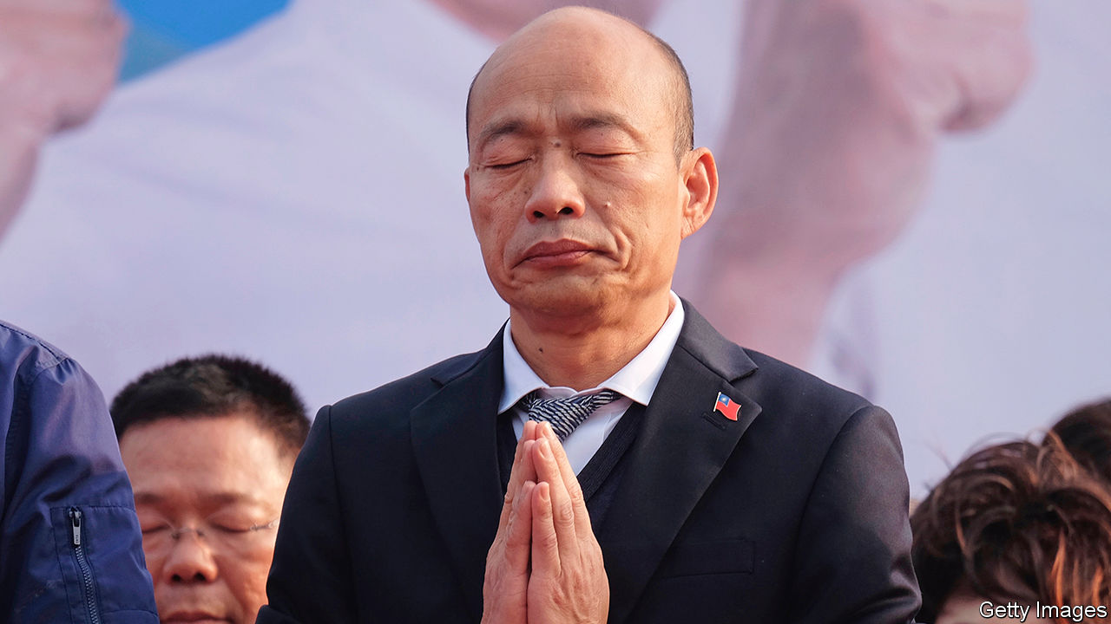

“KAOHSIUNG PEOPLE are writing their own history” and “God bless Taiwan” read the yellow bandannas worn by many in the crowd that had gathered in the southern port city of Kaohsiung on June 6th, to wait for the results of a vote to recall their China-friendly mayor, Han Kuo-yu (pictured). On hearing that he would be sacked, they burst into loud applause.

Almost 1m residents, 97% of those who went to the polls, voted against the mayor, the first recall of a senior politician in Taiwan’s history. Mr Han was once the golden boy of the opposition Kuomintang (KMT), having wrested control of Kaohsiung from the ruling Democratic Progressive Party (DPP) in 2018 for the first time in a generation. Encouraged by his strong showing in a DPP stronghold, the KMT chose him as its candidate to take on Tsai Ing-wen, the incumbent, in January’s presidential poll. Many expected the folksy Mr Han to defeat the dour Ms Tsai. Instead, the would-be toppler has himself been toppled.

This reversal of fortune reflects a sea-change in Taiwanese politics over the past two years. Mr Han became mayor by promising wealth through stronger economic ties with China. That struck a chord with voters disillusioned with Ms Tsai’s handling of the torpid economy. But as the presidential race got under way last year, so did protests in Hong Kong in favour of greater democracy and autonomy from China. Ms Tsai switched the focus of her campaign from the economy to protecting Taiwan from the menace of China, which claims Taiwan as part of its territory and threatens to retake it by force. She portrayed Mr Han’s desire for closer ties with China as a threat to Taiwan’s independence, and won hands down.

Mr Han did not help his cause by holding private meetings at the offices of the Chinese government in Hong Kong and Macau. He also once described Taiwan and China as partners in an arranged marriage that had fallen madly in love. But pursuing less tetchy relations with China, the policy of the KMT for decades, is becoming ever less marketable. Fan Shih-ping of National Taiwan Normal University thinks China’s recent imposition on Hong Kong of a national-security law that could be used to suppress dissent may help explain the resounding slap Kaohsiung’s voters gave Mr Han. The KMT’s chairman, Johnny Chiang, has been trying to tone down the party’s pro-China image. When the results were announced, he reiterated that the KMT opposes communism; its members had always put Taiwan first, he said.

Several more mundane factors contributed to Mr Han’s downfall. Many Kaohsiung residents disapproved of him for breaking a promise not to run for president and were infuriated when he took a leave of absence to focus on his campaign after only ten months as mayor. The impression that he was neglecting his day job was reinforced in November when he missed the city council’s review of the municipal budget, prompting fisticuffs in the council chamber. Mr Han also failed to lure a Disney theme park to the city—one of his more ambitious campaign pledges.

There will now be a fresh election for mayor. Mr Han is not eligible to compete, and the KMT has not yet selected a candidate to run in his stead. But whenever it does, its choice is certain to sound much warier of China. ■

This article was downloaded by calibre from <https://www.economist.com/asia/2020/06/13/a-china-friendly-politician-is-humiliated-in-taiwan>

|  |  |  |  |
| --- | --- | --- | --- |
| Previous | Articles | Sections | Next |

|  |  |  |  |
| --- | --- | --- | --- |
| Previous | Articles | Sections | Next |

#### Banyan

# India’s bureaucrats are fighting covid-19 with red tape

It is not going very well

Jun 13th 2020 |



IN MID-MAY, seeking to reflate his political buoyancy after weeks of covid-19 lockdown, Narendra Modi announced a new ideology. Henceforth, said India’s prime minister, the nation would strive for atmanirbharta, or self-reliance. It may be that North Korea’s unlamented Great Leader, Kim Il Sung, got there first with his slogan of juche, which means much the same thing. Yet the clunky Hindi word does seem to have caught on, albeit less with the Indian public than with their bureaucratic overlords.

Perhaps this is because Indian officialdom, ensconced in government housing and enjoying lifetime jobs with perks such as office peons and drivers, access to top schools and hospitals, and memberships of the best clubs, has a long tradition of insouciant independence from the mundane world of tradesmen, farmers, parents or other voters. Yet the current crisis has cast this divine detachment in even starker light than usual.

India’s bureaucrats issued well over 4,000 different rules during the two long months that they kept India’s 1.3bn other citizens shut indoors. Most of this torrent of instruction was well meant. Yet many of the rules caused as much trouble as they resolved. This is most obvious regarding tens of millions of migrant workers who were left without subsistence when Mr Modi imposed an instant and total nationwide lockdown on March 25th. As their desperation grew, many attempted to walk back to their villages, braving not just heat, hunger and exhaustion, but beatings from the police. By mid-May the bureaucrats changed tack and scrambled to arrange transport for stranded migrants, many of whom then carried covid-19 to the remotest corners of the country.

With the lockdown lifted and the economy restarting, the migration has already reversed, with workers trickling back to jobs in cities. Yet India’s Supreme Court has only just taken notice of their earlier plight. Enhancing a reputation as perhaps the most otherworldly of all the country’s institutions, on June 9th it issued a suo moto ruling (meaning one taken on its own initiative, in the spirit of atmanirbharta) ordering India’s states to transport migrants home within 15 days.

Some of the government’s lofty contradictions concern petty matters. Upon reopening parks, for instance, India’s capital decreed that citizens should be allowed in only from 7am to 10am and 3.30pm to 6.30pm, ensuring more crowding and less social distance. Residents of Uttar Pradesh, India’s most populous state, recently read this cryptic announcement: “All shopping malls will open but all shops in the malls will remain closed.” On the very day that Haryana, a state that abuts Delhi, reopened its border with the capital, Delhi closed its border with Haryana. Some 2m daily commuters between the big city and its suburbs have repeatedly been stuck in monster jams, caught out by such petal-plucking changes of mind.

The rules can prove deadly as well as irritating. Perhaps hoping to prevent crowding, Delhi’s government has banned some hospitals from testing for covid-19. Doctors say this is mad. It means they cannot tell, for example, if a baby born to a mother with covid needs to be kept isolated from other newborns, or if a patient being treated for another disease might have covid, too. Medical associations, including one of epidemiologists, have repeatedly condemned the government for hiding information and failing to consult experts, to no avail.

The authorities’ atmanirbharta can also have sinister implications. The Supreme Court earlier this month blithely delayed yet another attempt to secure the release of a former government minister who has been held without charge under house arrest for ten months. He is 82 years old, but has the misfortune to come from the restive Kashmir valley. Lower courts, for their part, have repeatedly denied bail to Varavara Rao, an 81-year-old poet awaiting trial in Mumbai with ten other elderly activists for supposedly inciting those at the bottom of the caste ladder to riot two years ago.

Even Amit Shah, the home minister, who as Mr Modi’s campaign wizard is reputed for sensing the national pulse, seems to be infected with atmanirbharta. Showing unusual detachment in a recent online election rally, he admitted that the government may have fallen short in its handling of covid-19. Then he added a question that rang particularly tuneless after six years in power with a crushing parliamentary majority: “But I want to ask the opposition, what did you do?”

Editor’s note: Some of our covid-19 coverage is free for readers of The Economist Today, our daily [newsletter](https://my.economist.com/user#newsletter). For more stories and our pandemic tracker, see our [coronavirus hub](https://www.economist.com/news/2020/03/11/the-economists-coverage-of-the-coronavirus)

This article was downloaded by calibre from <https://www.economist.com/asia/2020/06/13/indias-bureaucrats-are-fighting-covid-19-with-red-tape>

|  |  |  |  |
| --- | --- | --- | --- |
| Previous | Articles | Sections | Next |

|  |  |  |
| --- | --- | --- |
| Asia | Sections | Middle East & Africa |

China

Urban society: On every street

.

Street life: Back peddling

.

Chaguan: Pondering America’s election

.

|  |  |  |
| --- | --- | --- |
| Asia | Sections | Middle East & Africa |

|  |  |  |  |
| --- | --- | --- | --- |
|  | Articles | Sections | Next |

#### On every street

# China’s Communist Party worries about its grassroots weakness

It wants to extend its presence deeper into neighbourhoods

Jun 13th 2020 | BEIJING

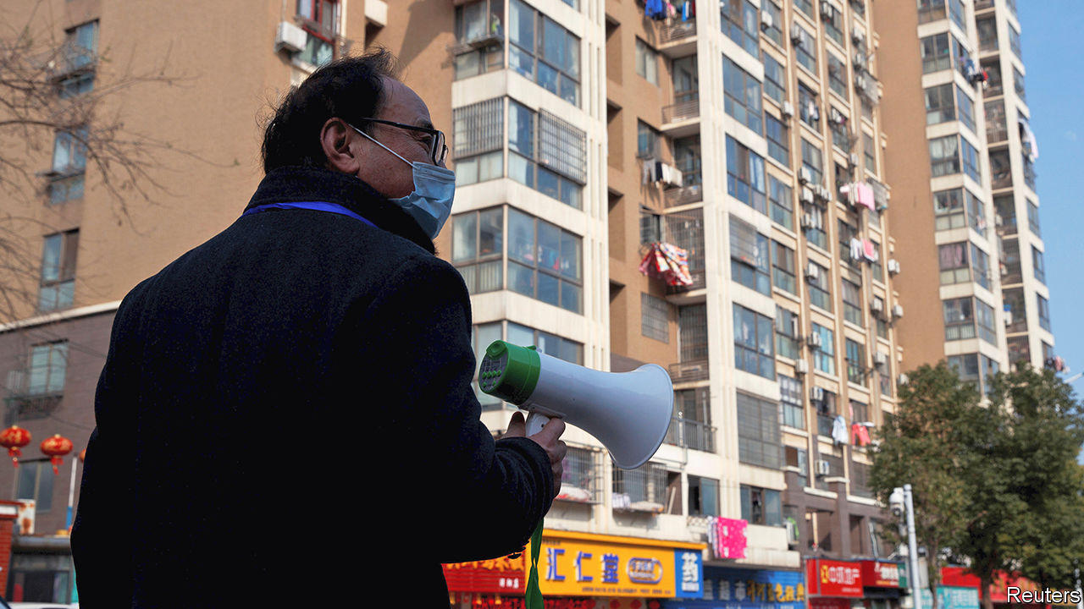

MANY CHINESE are familiar with a poem by Mao Zedong called “Farewell to the god of plague”. It was written in 1958 to celebrate the country’s victory over snail fever, a disease that blighted the lives of many millions of people in China (and still afflicts thousands). Today that poem is recalled by officials in their fight against covid-19, because this, too, has involved mobilising citizens on a massive scale, and also to great effect. Life is gradually returning to normal, but the pandemic’s impact on the way urban society is organised at the grassroots may be long-lasting. Features of the Mao era are enjoying a revival.

Since China launched its economic reforms in 1978, two years after Mao’s death, life in urban neighbourhoods has been transformed. Housing, once almost entirely owned by the state, has been privatised. Many long-established communities have been scattered as bulldozers have moved in. Gated compounds have sprung up, providing homes for a new middle class. Migrants from the countryside have flooded in, occupying run-down buildings that have yet to be flattened by developers. Amid this flux, the party has struggled to maintain its once ever-watchful presence. Its mobilisation efforts during the pandemic, however, have strengthened its resolve to do so, and taught it that it can.

Lockdown in the neighbourhoods, now all but lifted in most cities, was not a matter simply of telling residents to stay at home. It involved deploying armies of people to act as guards, health monitors, helpers for the infirm and procurers of supplies. Central to these efforts were two organisations: residents’ committees and neighbourhood party committees (their memberships are often the same). The “two committees”, as they are often called, had their heyday in the Mao era as enforcers of the party’s will. Since then they have become less visible, focusing mainly on registering new residents, administering local clubs, distributing welfare payments and providing proof-of-address and other useful documents.

But during the height of the lockdown, between late January and mid-March, these committees played a prominent role. Their staff stood guard at entrances to housing compounds in China’s more than 100,000 neighbourhoods, policing who could leave or enter. They supervised self-isolators, sometimes using webcams and alarms. They organised deliveries of food and other essentials for residents and transmitted the government’s latest instructions via WeChat.

But with each neighbourhood having only a handful of permanent staff to monitor and help hundreds of people, manpower was far from adequate. So the party called in reinforcements, including party members, local officials and volunteers. In many neighbourhoods “temporary party committees” were created to oversee these efforts, headed by officials from higher levels of the urban bureaucracy. The new committees established numerous other bodies: temporary party branches for each neighbourhood “grid” (an area often comprising a single residential compound) and party cells for each building.

The party now trumpets this mobilisation as evidence of its strength and that of China’s political system. But it is clear from official documents and reports in the party-controlled media that the party also sees many weaknesses in its grassroots network. It was often the temporary committees that got the job done. The neighbourhoods’ existing structures not only lacked sufficient staff, but also clout.

This has long been a worry. In the 1990s, when many state-owned enterprises (which had once owned much of urban China’s housing) closed down, so too did the firms’ party branches. Alongside the neighbourhood party committees, these had played a vital role in maintaining the party’s grip. Most of the new private firms that began to spring up did not have party organisations embedded within them. Neither did the homeowners’ associations that formed in the middle-class blocks of flats. These associations interact mainly with the property-management companies that look after common areas in their compounds, rather than with the old residents’ committees (which are supposed to be democratically elected, but mostly are installed by higher-up government).

The pandemic has prompted debate about how to give the neighbourhood committees more muscle. State media quoted one scholar as saying that the party must “thread” them together with landlords’ associations and property-management firms. In recent years the party has been laying the groundwork for this by forming cells within these groups. The central city of Hefei wants at least half of those sitting on landlords’ committees to be party members, according to Legal Daily. State media often use the term “red property-management” to refer to firms that use their party cells to interact with property owners and try to keep them happy.

That is an important aim. Resolving local disputes before they erupt into street protests is one of the main tasks of the neighbourhood committees. Many such disputes involve property, including shoddy service by property-management firms. The police use the committees to watch for trouble. In recent years they have installed officers as deputy chiefs of many of them. This has helped the police to nip problems in the bud, the authorities claim.

One idea is to promote the creation of “big party committees” in neighbourhoods. These would have a clearer mandate to wield authority over other party branches at the same level, including those in firms. Experiments with this have been praised in the party’s press. “A solo has become a chorus,” as one local government put it. Mao would be proud. ■

Editor’s note: Some of our covid-19 coverage is free for readers of The Economist Today, our daily [newsletter](https://my.economist.com/user#newsletter). For more stories and our pandemic tracker, see our [coronavirus hub](https://www.economist.com/news/2020/03/11/the-economists-coverage-of-the-coronavirus)

This article was downloaded by calibre from <https://www.economist.com/china/2020/06/13/chinas-communist-party-worries-about-its-grassroots-weakness>

|  |  |  |  |
| --- | --- | --- | --- |
|  | Articles | Sections | Next |

|  |  |  |  |
| --- | --- | --- | --- |
| Previous | Articles | Sections | Next |

#### Back peddling

# China once banned street vendors. Now it welcomes them

Some cities, however, are not so sure

Jun 11th 2020 | SUZHOU

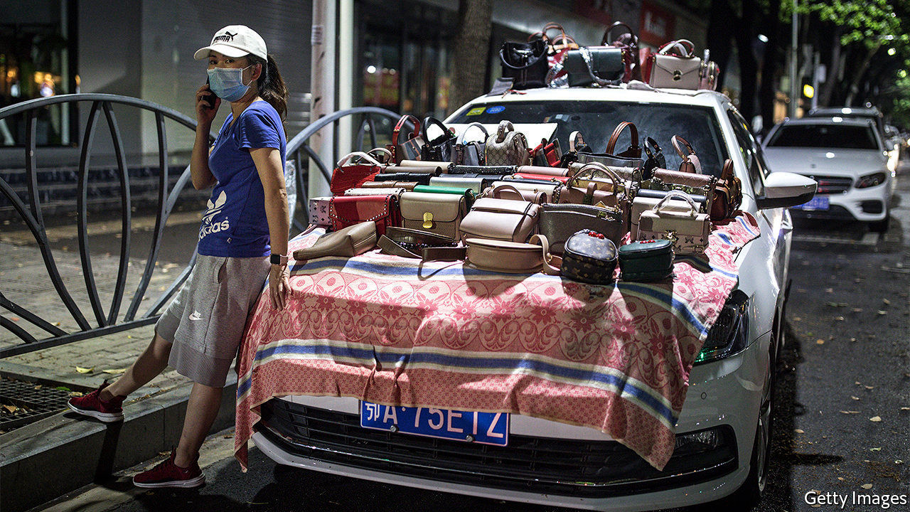

IN A COUNTRY of high-tech factories and giant state-owned firms, you might not expect street hawkers to attract much attention. But in China these days, people like Shui Jin, an old lady pedalling a wooden cart laden with apricots and cherries through the narrow lanes of Suzhou, an eastern city, are in the spotlight. Both of her daughters-in-law recently lost their jobs, among the tens of millions in China hurt by the coronavirus slump. Her family needs the money she can scrape together. Whether the country needs her on the streets has become a matter for debate.

For years, municipal officials pushed out hawkers, trying to tidy up the colourful hubbub that once characterised China’s cities. In the name of “civilising” urban life, they wanted to see steamed dumplings and plastic toys sold inside shopping malls, not from the back of carts. On June 1st Li Keqiang, the prime minister, seemed to signal a change, declaring that street vendors were vital to the economy. “Only when the people are in good shape can the nation be in good shape,” he said.

That generated much buzz about the revival of China’s “street-stall economy”, as it has been called. At least 27 provinces and cities said they would welcome hawkers. Chengdu, a bustling city in Sichuan province in the south-west, was seen as a shining example. Firms there started setting up street stalls in March, creating more than 100,000 jobs, the local government says. China certainly needs to boost employment. Between 60m and 100m people—perhaps as many as 20% of non-farm workers—were out of work in April, according to Ernan Cui of Gavekal, a research firm.

In small towns, officials are excited about the street-stall idea. For instance, Zhangye, a poor western town, says it will create spaces for 4,120 hawkers in its markets. But for Ms Shui, the fruit vendor in Suzhou, change has not been radical. Last year the officers who enforce urban rules would often seize her cart and fine her. Now they just tell her to move on.

Officials in China’s richest cities are afraid that encouraging street vendors will lead to a mess. “It is not for Beijing,” declared the capital city’s main newspaper. Shanghai has made it clear that it will not allow vendors to set up stalls willy-nilly. Licences must be obtained and, for those selling food, hygienic standards met.

Can the stalls, such as they are, really help the economy? Some investors see a business opportunity. The price of shares in Wuling Motors, which makes a new van that can double as a mobile kiosk, has doubled since Mr Li’s comments. Other firms that might benefit, including Yindu Kitchen, which makes portable cooking equipment, also saw their shares surge.

The direct impact on job creation, alas, is unlikely to be so spectacular. The demise of street stalls in recent years is only partially the result of government restrictions. It also reflects the rise of e-commerce platforms, where products are often both better and cheaper. Whether online or on the street, the main concern for vendors now is weak demand. On one historic street in Suzhou, a 62-year-old woman walks back and forth with flashing glow-sticks for sale. With few tourists, there are few buyers. She has cut her asking price from ten yuan ($1.40) to five.

But the street stalls do dovetail with a separate policy, launched last year, to develop China’s night-time economy. Suzhou and Shanghai, among other cities, have recently opened glitzy outdoor night markets. Though far more orderly and corporate than the hawkers’ free-for-all of old, they are lively. And they help the government to deliver an important message. Officials cautiously avoid proclaiming that covid-19 has been beaten in China. But the reinvigoration of street life looks like a declaration of victory.

Late one recent evening in Suzhou, thousands of people flocked to its official night market. Most were not wearing face masks, a sight unthinkable just a month ago. “I was cooped up at home for a long time,” says Cao Yunqiang, 19, visiting from Henan province, further inland. “Things aren’t fully back to normal, but it’s the right time to come out and have some fun.” ■

Editor’s note: Some of our covid-19 coverage is free for readers of The Economist Today, our daily [newsletter](https://my.economist.com/user#newsletter). For more stories and our pandemic tracker, see our [coronavirus hub](https://www.economist.com/news/2020/03/11/the-economists-coverage-of-the-coronavirus)

This article was downloaded by calibre from <https://www.economist.com/china/2020/06/11/china-once-banned-street-vendors-now-it-welcomes-them>

|  |  |  |  |
| --- | --- | --- | --- |
| Previous | Articles | Sections | Next |

|  |  |  |  |
| --- | --- | --- | --- |
| Previous | Articles | Sections | Next |

#### Chaguan

# Elites in Beijing see America in decline, hastened by Trump

But they are not sure whether it would suit China for Trump to be re-elected

Jun 13th 2020 |

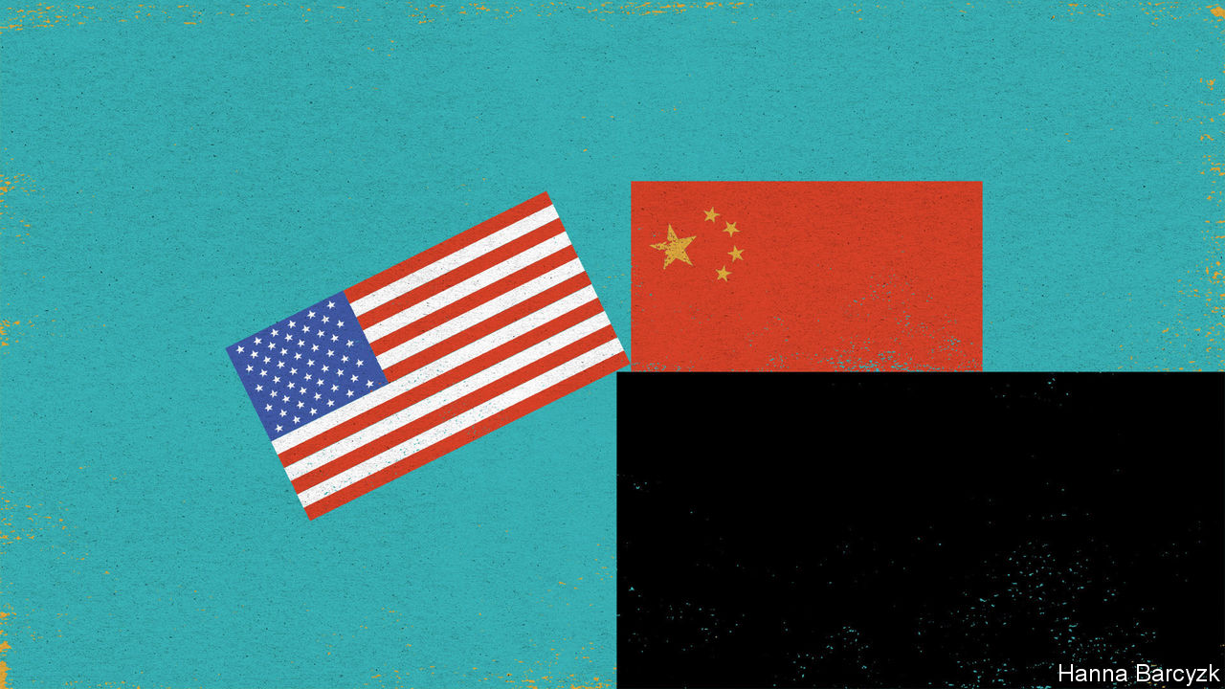

WHOM WOULD China prefer as America’s next president? That is a hard question, without an uplifting answer. In elite circles in Beijing, both President Donald Trump and his rival, Joe Biden, a former vice-president, are spoken of with distrust and condescension. Rather unusually, both candidates are known quantities. Each man has spent many hours with President Xi Jinping. During the first term of the Obama administration, when Mr Xi was heir-apparent to the leadership of China with the formal rank of vice-president, Mr Biden, as his opposite number, was tasked with taking his measure. Visiting China in 2011, Mr Biden hailed their numerous meetings in various countries and their “mutual respect”. Mr Trump has gone further, calling Mr Xi his “very, very good friend”. Few in Beijing are fooled. Mr Trump and Mr Biden may share a capacity for talking (and talking) in pursuit of a deal. But Mr Xi’s grim, security-first worldview leaves little room for foreign friendships, let alone with garrulous Americans.

Chinese disdain combines the political with the personal. In the unmarked villas, private dining rooms and scholarly retreats where—when it suits them—well-connected Chinese sometimes offer opinions to foreigners, Mr Trump is called ignorant, erratic and tiresome, but not without his uses. He is praised for an apparent indifference to ideology. He is complimented for his reluctance to condemn Chinese repression in such places as Xinjiang. People familiar with the thinking of Chinese generals assert, approvingly, that Mr Trump dislikes military adventures abroad.

Chinese leaders initially mistook Mr Trump for a pragmatic tycoon, a type they have met before. Now he is called a narcissist who cares only about his own interests, starting with his re-election. That cynicism informs China’s response to the trade war unleashed by Mr Trump, with wary but bipartisan support from members of Congress and some American business lobbies. Plenty of American businessfolk have swallowed qualms about Mr Trump’s tactics. They were glad to see him press China over its unfair market rules and industrial policies that promote local champions at the expense of foreign firms. Detecting that Mr Trump was more interested in China’s money than in making China change its ways, officials in Beijing agreed on a “phase one” trade deal built around purchases of American commodities. China has kept that deal alive, with state companies buying shiploads of soyabeans and other goods even as the two governments trade angry words about each other’s handling of covid-19, among other issues. China has yet to fulfil its threat to name American firms as “unreliable entities” ripe for punitive treatment, even after the Trump administration said it would put sanctions on China for imposing a national-security law on Hong Kong. Mr Trump’s supporters would doubtless call China’s caution a tribute to their president’s tariff-happy toughness. Maybe. But China is also buying itself time. Satisfying Mr Trump has effectively parked America’s bipartisan demands for structural reforms. That does not make Chinese elites relaxed, though. They fret that Mr Trump has been “kidnapped” by the truly ideological China hawks who surround him.

As for Mr Biden, in Beijing he is called a member of the former ruling establishment that saw economic interdependence with China as a source of stability, not danger. Mr Biden was a player in Obama-era campaigns to seek China’s help in tackling climate change and other global challenges. Yet, in China, there is strikingly little nostalgia for those days. Some grumble that such engagement rested on a mistaken American belief that China would converge politically with the West as it grew richer. Others recall how American politicians bragged that democracies had a creative edge that autocratic China would always lack. That is certainly a favourite Biden line, as in 2013 when he told Chinese students applying for visas at America’s embassy in Beijing that “innovation can only occur when you can breathe free.” The view in China is that its best scientists and tech firms are busy disproving such boasts, tipping America into a crisis of confidence and anti-China hysteria.

Just as bipartisan opinion in Washington has coalesced around alarm at China’s rise, an elite consensus has emerged in the Chinese capital. Especially in this summer of pandemic and street protests, America is called a nation in decline: a rich country too divided, selfish and racist to keep its citizens safe. Chinese elites see Mr Trump as a symptom and an agent of that decline. State media long refrained from direct attacks on Mr Trump. Not now. The Global Times, a nationalist tabloid, this month reported that Chinese netizens mockingly call him Chuan Jianguo, or “Build-up-the-country Trump”. Their joke, that he is a double-agent wrecking America to make China strong, prompts lines like “Comrade Chuan Jianguo, don’t blow your cover!” Does such scorn mean that China wants Mr Trump re-elected? There, elites are divided. At root, their debates turn on two questions: is American decline irreversible, and would its acceleration suit China just now?

## Two devils, both known

In national-security circles, many see advantages to four more years of turbulence, with Mr Trump weakening democracy at home and repelling allies in Asia and beyond. In contrast, elites focused on the economy fear the premature collapse of a global trading order that has profited China mightily. That prods some to hanker for Mr Biden. Such people think of him as a moderate who might slow economic decoupling, giving China time to diversify and become more self-reliant. Still another camp holds that America’s next government, of whichever party, will be filled with officials bent on keeping China down, but that Mr Biden’s team will be more competent, and thus more dangerous. Many Biden-sceptics in China note, with alarm, how the Democrat has taken to chiding Mr Trump for being soft on Chinese human-rights abuses. All camps are united by a bleakly defensive mood. Whoever becomes America’s next president, China does not expect to be friends.■

This article was downloaded by calibre from <https://www.economist.com/china/2020/06/13/elites-in-beijing-see-america-in-decline-hastened-by-trump>

|  |  |  |  |
| --- | --- | --- | --- |
| Previous | Articles | Sections | Next |

|  |  |  |
| --- | --- | --- |
| China | Sections | Europe |

Middle East & Africa

Industry in Africa: Will it bloom?

.

Burundi: “The Champion of Patriotism”

.

Covid-19 in the Middle East: An unwanted guest returns

.

Libya’s civil war: A warlord retreats

.

|  |  |  |
| --- | --- | --- |
| China | Sections | Europe |

|  |  |  |  |
| --- | --- | --- | --- |
|  | Articles | Sections | Next |

#### Production lions

# How manufacturing might take off in Africa

It won’t be the same as it was in East Asia

Jun 13th 2020 | HAWASSA

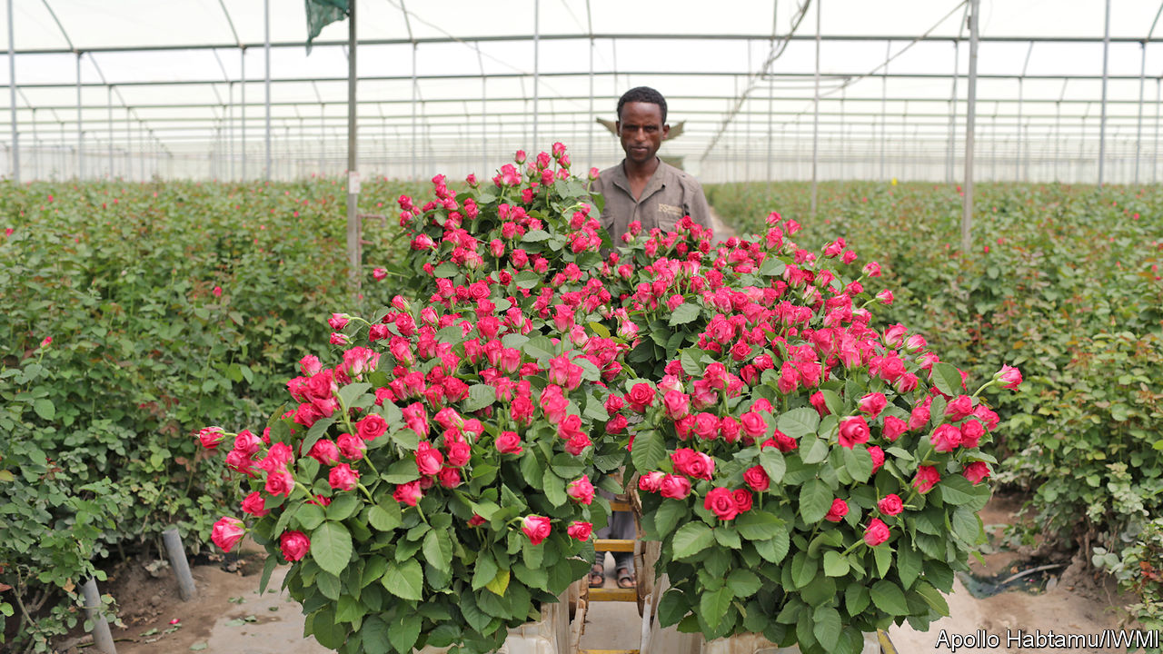

THE FATHER of development economics and the father of African nationalism did not take long to fall out. Arthur Lewis had made his name studying industrial revolutions. Kwame Nkrumah, Ghana’s first prime minister, had made his resisting British rule. On independence in 1957 Nkrumah invited Lewis to be his adviser.

It seemed a wise pick. Lewis was astute, respected, and trusted in anti-colonial circles. Later, he would win a Nobel prize for economics (the first black person to do so). In a landmark paper, he argued that in developing economies people were poor because they were in the wrong jobs: move them from subsistence farms into factories and commercial farms and the economy would grow.

But how to make it happen? Nkrumah wanted to throw money at factories. “I am a politician,” he explained, “and must gamble on the future.” Lewis urged balance. “If agriculture is stagnant,” he once wrote, “industry cannot grow.” He lasted only 15 months in the job. Meanwhile, it was the countries of East Asia, not Africa, that industrialised and grew rich.

The question of how to make African economies more productive is gaining new urgency amid a pandemic that is disrupting supply chains. Shortages of drugs and medical equipment are fuelling calls for the local production of essential goods. Tito Mboweni, South Africa’s finance minister, wants to “set up manufacturing to make what we need and stop relying on imports from China”. Uganda is trying to discourage imports. Ghana also says it is making import substitution a priority.

Yet a transformation of sorts had already begun well before covid-19. The proportion of Africans working on farms fell from 66% in 2000 to just under 58% in 2015. Most of these people flowed into informal services or petty manufacturing, such as taxis or roadside carpentry, where they earn more than farmers. They do not represent the industrial revolution of which policymakers dream. Yet beneath that broad trend lies a myriad of stories. Nigeria is slowly shaking off its dependence on oil exports. Rwanda hosts conferences and upmarket tourists. Lesotho, one of the few countries to have moved successfully into manufacturing, ships out its apparel along South African roads.

In Ethiopia Bonsa Buta spends his days in a tiny cubicle, a picture of the Virgin Mary stuck to the wall, entombed in a mountain of teff. The 86-year-old trader has been dealing in the grain since the days of Emperor Haile Selassie. The market has changed “incomparably”, he says. Ethiopians use injera, a spongy teff pancake, as plate, cutlery and tasty carbohydrate. Now many buy it ready-made rather than baking it at home. Making or selling injera employs more than 100,000 people.

Across Africa, goods once made at home are now being bought and sold. Rural Africans spend only 40% of their work hours on their farms, and the rest on side-businesses such as transport or trade. They buy nearly half the food they eat, as well as concrete blocks and tin sheets for their homes.

Commercialisation is most evident in the towns and cities. Appetite is growing for processed foods, meat, dairy foods and vegetables. “These kids are looking to try new things,” says Monica Musonda, a Zambian businesswoman who has launched an instant-noodle company. In Ghana, a self-anointed “Koko King” has turned millet porridge into a convenience food for harried commuters. Another entrepreneur has built a multinational drinks company by bottling traditional herbal bitters.

Expanding markets create economies of scale. Many of Africa’s manufacturers began life as trading firms, switching from imports to local production. The same logic is pulling foreign companies to the continent. Consultants at McKinsey estimate that Chinese firms handled 12% of Africa’s industrial production in 2017, employing several million people. Only a few were eyeing exports to the West. Instead, 93% of their revenues came from local and regional sales. Tian Tang, a Chinese business in Uganda, was founded by a trader importing suitcases; it now makes steel, plywood and mattresses. Another outfit chasing untapped demand is Roha, an American firm. In Ethiopia it built a factory making glass bottles for local brewers.

African growth is already being driven by internal consumption and investment, argues Carlos Lopes of the University of Cape Town. The expansion of regional trade would reinforce that dynamic, especially in industry. Manufactured goods make up only 19% of African countries’ exports to the rest of the world, but 43% of what they sell to each other.

Yet Africa will not get rich by producing only for itself. The countries south of the Sahara have less combined purchasing power than Germany. To find larger markets, firms must export to the world. As they learn to compete globally, they also become more productive.

Some argue that the key to East Asia’s early growth was an activist state, high investment and a relentless focus on manufactured exports. Africa has never come close to replicating it. An early wave of import substitution was derailed by a debt crisis. In the 1980s the state lost interest in industrial policy. Factories closed as the IMF and World Bank pressed governments to open their markets to foreign competition.

Unlike Africa, East Asia has little wealth buried beneath its soil, so it relied on sweat instead. At first, low wages gave it a competitive edge. Although Africa has millions of poor people, many African countries are unable to follow the Asian model because their labour costs are too high, according to researchers at the Centre for Global Development, a think-tank. However, wages in Asia have risen a lot in recent years. Since transport costs have fallen, many tasks can now be done thousands of miles apart. Garment firms in Africa stitch shirts from imported fabrics and buttons; carmakers piece together kits of parts. That makes it easier to get a foot on the industrial ladder, but harder to climb beyond the first rung.

So African countries are scouting out a new path. “The scope for classic labour-intensive, export-oriented industrialisation is narrower now,” says Yaw Ansu, who advises the minister of finance in Ghana. “But countries like us can compensate by basing our model on adding value to our agriculture and natural resources.” One example is Blue Skies, a company near Accra. Its workers dice fruit sold in European shops.

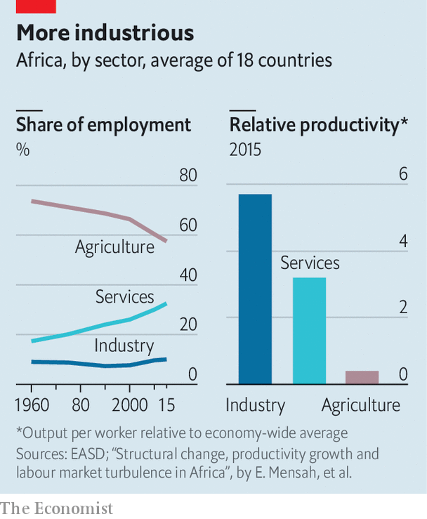

Another example is horticulture. In normal times, more than 400 tonnes of cut flowers are flown out of Nairobi every day, on average. In Ziway, an Ethiopian town, kilometre-long greenhouses sprawl like aircraft hangars beside the dust and donkey carts. Roses grow for transport to the Netherlands. Covid-19 has thrown many of these firms into crisis. But when travel and trade bounce back, so will opportunities.

This is not classic manufacturing, but it is not subsistence farming either. Economists at UNU-WIDER, a research institute, talk of these as “industries without smokestacks”. They include tourism and call centres. Africa’s diversity means there will be many routes to success.

Six years ago Roger Lee decided to open a new factory. As the boss of TAL Apparel, a clothing firm in Hong Kong, he already ran operations from China to Indonesia. In Ethiopia he found a supportive government, duty-free access to American markets and wages that were a tenth of what he paid in China. So he rented a shed at a new industrial park in Hawassa.

If Asian-style manufacturing is to take off anywhere in Africa, it might be in Ethiopia, which has some of the lowest wages in the world. Clothing firms like TAL employed 27,000 people in Hawassa before the covid crisis. One Asian factory-owner says the city reminds him of a Bangladeshi port when his uncles opened shop there three decades ago.

Yet Hawassa is an experiment, and much could still go wrong. Ethnic riots have caused shutdowns. Workers rarely meet production targets. Most are young women from the countryside. “They don’t have the mindset for working in a factory,” sighs a manager. Bosses show “no mercy”, says one 19-year-old, rushing from her shift to night class at a local college. It is hard to get time off for sickness or to sit an exam. Workers’ pay does not stretch far and rents are high, so they sleep four to a room.

The low wages that pull in investors also push workers away. In its first year of operation, attrition rates at the industrial park were roughly 100%. Chris Blattman of the University of Chicago and Stefan Dercon of the University of Oxford tracked new hires in Ethiopian factories and commercial farms. A third quit within three months, and 77% within a year.

The Ethiopian experience points to the paradoxes at the heart of Africa’s transformation. While economists worry about jobless millions, factory bosses struggle to find pliant labour. Workers arrive late and quit at harvest time. Contracts are hard to enforce. Markets gum up.

None of this would surprise a visitor from 18th-century Lancashire or 1990s Guangdong. In societies set to agrarian rhythms, the transition to industrial capitalism is a profound social rupture. It carries new notions of law, time and discipline, and creates new kinds of people: commercial farmers, docile workers, methodical managers. It means loss as well as gain. It should be no surprise when many people are indifferent or hostile to change.

The same hesitation is found in some African leaders, long cushioned by aid and oil money. “The urgency for economic transformation is not making them lose any sleep,” says Abebe Shimeles of the African Economic Research Consortium. Yet demographic destiny is pushing the continent towards a reckoning. Some 15m-20m young Africans are entering the workforce each year. Without good jobs, many may take their grievances to the streets.

Some economists such as Dani Rodrik at Harvard University argue that automation, competition and shifting demand are closing the door to countries wanting to copy Asia’s miracle. Yet not everyone needs a factory job. Many Africans will move from subsistence farms to commercial ones, or from living alongside a game reserve to guiding tourists around one. Economic transformation, of a distinctively African kind, is a prize worth chasing. ■

This article was downloaded by calibre from <https://www.economist.com/middle-east-and-africa/2020/06/13/how-manufacturing-might-take-off-in-africa>

|  |  |  |  |
| --- | --- | --- | --- |
|  | Articles | Sections | Next |

|  |  |  |  |
| --- | --- | --- | --- |
| Previous | Articles | Sections | Next |

#### “The Champion of Patriotism”

# Burundi’s outgoing president dies, possibly of covid-19

Few will mourn Pierre Nkurunziza, whose regime murdered and tortured opponents

Jun 11th 2020 |

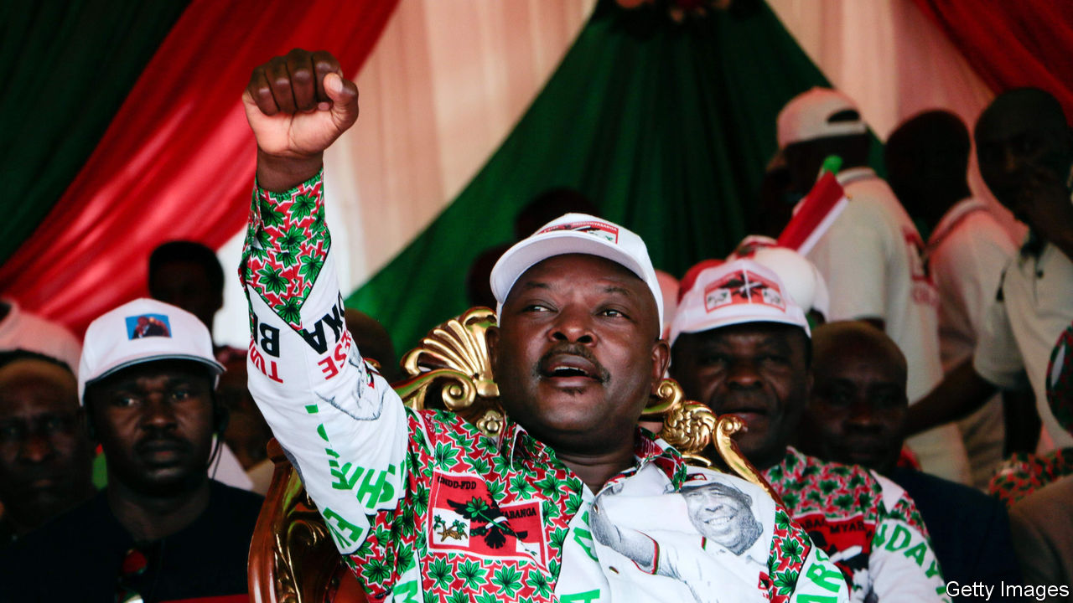

IN FOOTBALL, WROTE Jean-Paul Sartre, everything is complicated by the presence of the other team. Pierre Nkurunziza had ways of simplifying things. Burundi’s president, who died on June 8th, would travel with his football team, Hallelujah FC. At matches opponents would shy away from tackles. Some who did not were arrested—a terrifying experience in Mr Nkurunziza’s police state.

The despot’s foul play was apparent off the pitch, too. He became president in 2005, at the end of a civil war, ushering in hope that the country of 11m people could, like neighbouring Rwanda, enjoy some stability. But in 2015, at the end of his term limit, Mr Nkurunziza refused to go. His obstinacy set off tit-for-tat violence, assassinations, a failed coup and the displacement of 400,000 people.

“People hate him,” says a journalist in the country. “During his reign so many people died.” Mr Nkurunziza’s regime murdered and tortured opponents. Corruption and punitive taxes have further impoverished Burundians, 72% of whom live on less than the equivalent of $1.90 per day.

The president agreed not to run for a fourth term in elections in May. Instead he agreed to a new job title: Paramount Leader, Champion of Patriotism and Leadership Core. The vote was rigged in favour of Évariste Ndayishimiye, who is not scheduled to take office until August. Pascal Nyabenda, the speaker of the national assembly and Mr Nkurunziza’s first choice as successor, should fill in as interim president.

Mr Nkurunziza had wanted to run the country from behind the scenes. Now possible rivalry between an interim president and the president-elect could create instability. Then there is the regional picture. Rwanda, Burundi and Uganda have long waged proxy wars in eastern Congo. A power vacuum in Burundi presents a chance for further meddling in its affairs.

The president’s death may, though, allow the country to face up to another pressing issue. He ignored covid-19 and turfed out experts from the World Health Organisation, saying that God would protect Burundi. This may have been his downfall. The government says he died of a heart attack, but local sources whisper that he succumbed to covid-19. His wife was reportedly in Kenya for treatment. His death gives Burundi a chance to tackle the pandemic—and, perhaps, of a bit less foul play. ■

This article was downloaded by calibre from <https://www.economist.com/middle-east-and-africa/2020/06/11/burundis-outgoing-president-dies-possibly-of-covid-19>

|  |  |  |  |
| --- | --- | --- | --- |
| Previous | Articles | Sections | Next |

|  |  |  |  |
| --- | --- | --- | --- |
| Previous | Articles | Sections | Next |

#### An unwanted guest returns

# The Middle East is fighting a second wave of covid-19

Countries that thought they beat the coronavirus discover they have not

Jun 13th 2020 | BEIRUT

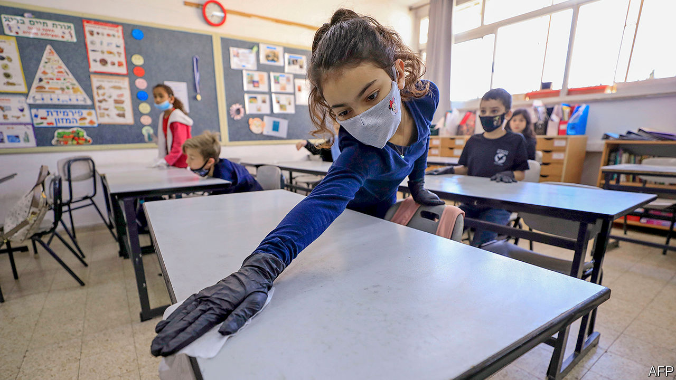

ACROSS THE Middle East months of closures are giving way to an almost carefree normal. Bars and restaurants in Tel Aviv are packed, with barely a nod to social distancing. Shisha cafés in Jordan’s capital, Amman, among the first businesses shut in March because of their perceived health risks, are full of patrons puffing away. Mask-wearing in Beirut has noticeably dropped since the government imposed a $33 fine for going barefaced. From Tehran to Tunis, many people seem to have declared the covid-19 pandemic finished.

But the pandemic is not finished with them. Several countries have seen, if not yet a second wave, at least a worrying resurgence of cases. Infections and deaths have jumped in Iran, where authorities thought they had tamed one of the world’s worst outbreaks. Schools have become a vector for infection in Israel. In Saudi Arabia, where the first wave never broke, doctors report an unexpected surge in hospitalisations and deaths. However, governments are reluctant to shut down again just as their economies are sputtering back to life. Stopping a second wave may be harder than it was dealing with the first.

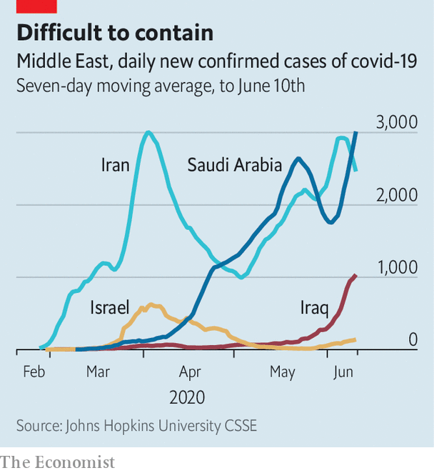

Iran was one of the first countries battered by covid-19. New cases peaked in April at around 3,000 a day (see chart). The president, Hassan Rouhani, resisted a full lockdown, fearing the damage it would do to an economy reeling from years of American sanctions. Even his government’s disorderly response helped tame the outbreak, though, and by May cases had dropped enough for restrictions to be largely lifted.

New infections are now back to their April peak. Some of this is due to better testing: after a slow start, the health ministry says it has checked more than 1m people for the virus. But the death toll is also rising, which suggests that the epidemic is indeed getting worse. Average deaths this month, now around 70 a day, are 40% higher than their lows in May. The government blames the increase on large gatherings such as weddings. Doctors say intercity travel is helping the virus spread between provinces. Again, though, Mr Rouhani says Iran cannot afford to shut down; universities reopened earlier this month.

Israel took a different tack. It halted international travel in early March and confined citizens to their homes for weeks. By late May, with fewer than 20 new cases a day and almost no deaths, the government felt it could declare victory. Since children seem less affected by the virus, schools were among the first places to reopen. Some pupils went back as early as May 3rd, with caps on class size and other protective measures (see picture).

Classes were short-lived. Daily cases have grown six-fold from their nadir last month, in part because of infections linked to schools, including more than 100 from a single one in Jerusalem. At least 300 students and teachers have tested positive; thousands of people are in quarantine because of possible exposure. More than 100 schools have been shut, and even where they have not, some parents are keeping their children at home. The health ministry believes it can isolate the new outbreaks, but laboratories are overwhelmed; some patients wait days for test results.

Lockdowns were even more onerous in the Gulf, where places such as Dubai and Saudi Arabia imposed 24-hour curfews for weeks at a time. This did not stop the virus. It continued to spread among the migrant workers who are most of the population in most Gulf states. Still, death tolls have been low: migrants tend to be young, and wealthy governments pay for covid-19 treatment. Life began to resume after the Eid al-Fitr holiday last month.

Since then the epidemic in Saudi Arabia has worsened. On May 20th, just before it entered lockdown during Eid, the kingdom logged ten deaths. By June 9th that had almost quadrupled, to 37. Some hospitals are filling up; the number of patients in intensive-care units has more than tripled. Three doctors died recently, the first reported fatalities among medical staff. The Red Sea city of Jeddah is back under curfew. The authorities have opened a new 500-bed field hospital in its convention centre.

Like their rivals in Iran, the Saudis blame the increased spread on locals ignoring social-distancing rules. Yet they hope to avoid another nationwide lockdown and may even go ahead with next month’s haj, the annual pilgrimage to Mecca, albeit with fewer pilgrims than normal.

None of this was supposed to happen so quickly. Dubai wants to reopen its airport next month for tourists and business travellers. Lebanon, desperate for hard currency, plans to do the same. Jordan hopes to promote domestic tourism this summer. Concerns over public health drove most Arab countries into lockdown this spring. Few think they can afford to do it again. ■

This article was downloaded by calibre from <https://www.economist.com/middle-east-and-africa/2020/06/13/the-middle-east-is-fighting-a-second-wave-of-covid-19>

|  |  |  |  |
| --- | --- | --- | --- |
| Previous | Articles | Sections | Next |

|  |  |  |  |
| --- | --- | --- | --- |
| Previous | Articles | Sections | Next |

#### A warlord retreats

# Libya’s government regains control of western Libya

Taking the east will be harder

Jun 13th 2020 |

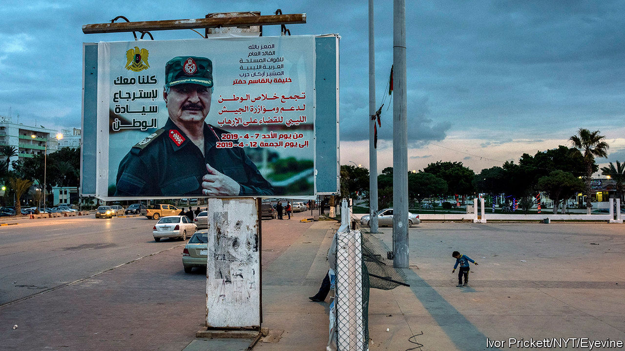

FOR OVER a year the UN-backed Government of National Accord (GNA) in Libya had been under siege by the forces of Khalifa Haftar, a renegade general. Then, all of sudden, it wasn’t. On June 3rd militias aligned with the GNA pushed General Haftar’s self-styled Libyan National Army (LNA) out of Tripoli’s international airport. The next day they took back Tarhouna, a city 90km to the south-east (see map). By June 7th the oilfields in Sharara were back in the GNA’s hands—and pumping for the first time since January. The militias are now fighting the LNA in Sirte, the gateway to General Haftar’s heartland in the east. Fight “for the whole of the homeland”, says Fayez al-Serraj, the GNA’s prime minister.

Mr Serraj, however, is not calling the shots. Drawn by Africa’s largest oil reserves and over 1,700km of Mediterranean coastline, foreign armies have piled into Libya. A surge of support from Turkey beginning in December saved Mr Serraj. It now determines how far the GNA advances. Russia, Egypt and the United Arab Emirates (UAE) have long backed the LNA and are trying to shore up its hold on the east. After six years of civil war, the division of Libya into a Turkish zone of influence in the west and a Russian zone in the east—in other words, de facto partition—looks increasingly likely. “We’re heading towards a frozen conflict,” says a diplomat in Tripoli.

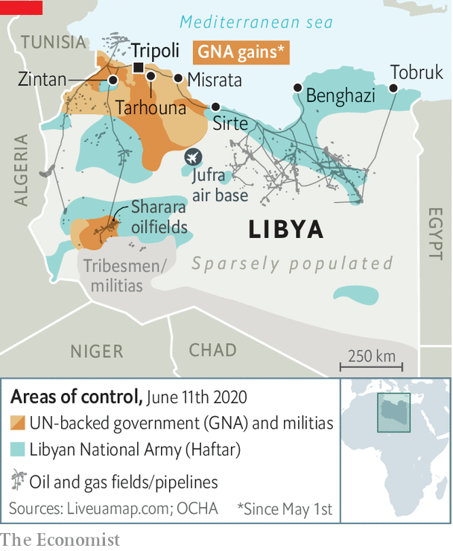

Russia and Turkey also back opposing sides in Syria, where they have learnt to co-ordinate their operations in order to avoid a big escalation. The risk is greater in Libya, at least for now. The Turks have frigates off the coast, warplanes and drones in the sky and mercenaries on the ground. Recep Tayyip Erdogan, Turkey’s president, wants the GNA to punch into the oilfields that lie beyond Sirte and take the airbase in Jufra. He believes this would give Mr Serraj a financial boost and a strategic buffer against General Haftar and other eastern predators. But last month Russia moved 14 warplanes to Jufra. Hundreds of mercenaries from the Wagner Group, a private-security firm with connections to the Kremlin, support General Haftar. Egypt has moved a column of tanks to (and, some say, across) its western border. It and the UAE see the war as a struggle against Islamism.

Libyans in the east are uneasy. “We’ve had enough of Turkish colonialism,” says Fawzia al-Furjani, a businesswoman in Benghazi, referring to centuries of Ottoman rule. But a growing number of people also question whether General Haftar, who in April hailed himself Libya’s military ruler, can be their saviour. His defeat in Tripoli, at the cost of hundreds of lives, has revived memories of the disastrous campaign he led against Chad in the 1980s.

Big eastern tribes are keeping their distance from him. Tribal elders in the south have declared for the GNA. Talk of a challenge to General Haftar is rife. Even his foreign supporters seem to be growing tired of his boasting. At the launch of a peace initiative in Cairo on June 6th, General Haftar shared the stage with Aguila Saleh, a less belligerent politician from the east. Last month Mr Saleh declared himself commander-in-chief of the LNA.

Despite the GNA’s victories, the situation in the west is also unstable. Mr Serraj says he wants to “construct a civil, democratic and modern state”, but the militias who fight for him are divided by tribe, city and ideology. The threat of General Haftar (not support for the GNA) was the glue that held them together. The jihadists among them want to push on to Benghazi, their home before General Haftar booted them out in 2017. The militias of Misrata, the strongest force in the west, want to dominate the region. Leaders from other cities, such as Zintan, would prefer to carve out their own fiefs from the land they have captured. Each has a separate line to Turkish commanders on the ground and foreign powers abroad. Mr Serraj may no longer be under siege, but his rule does not extend far beyond his glass office block in Tripoli. ■

This article was downloaded by calibre from <https://www.economist.com/middle-east-and-africa/2020/06/13/libyas-government-regains-control-of-western-libya>

|  |  |  |  |
| --- | --- | --- | --- |
| Previous | Articles | Sections | Next |

|  |  |  |
| --- | --- | --- |
| Middle East & Africa | Sections | Britain |

Europe

German economics: Hey, big spenders

.

Italy: The not-so-dolce vita

.

France: Raoultmania

.

Sweden: Who killed Olof Palme?

.

Charlemagne: The Sinatra doctrine

.

|  |  |  |
| --- | --- | --- |
| Middle East & Africa | Sections | Britain |

|  |  |  |  |
| --- | --- | --- | --- |
|  | Articles | Sections | Next |

#### Hey, big spenders

# Germany opens the money tap

The pandemic has converted it to the joys of deficit spending. This may not last

Jun 11th 2020 | BERLIN

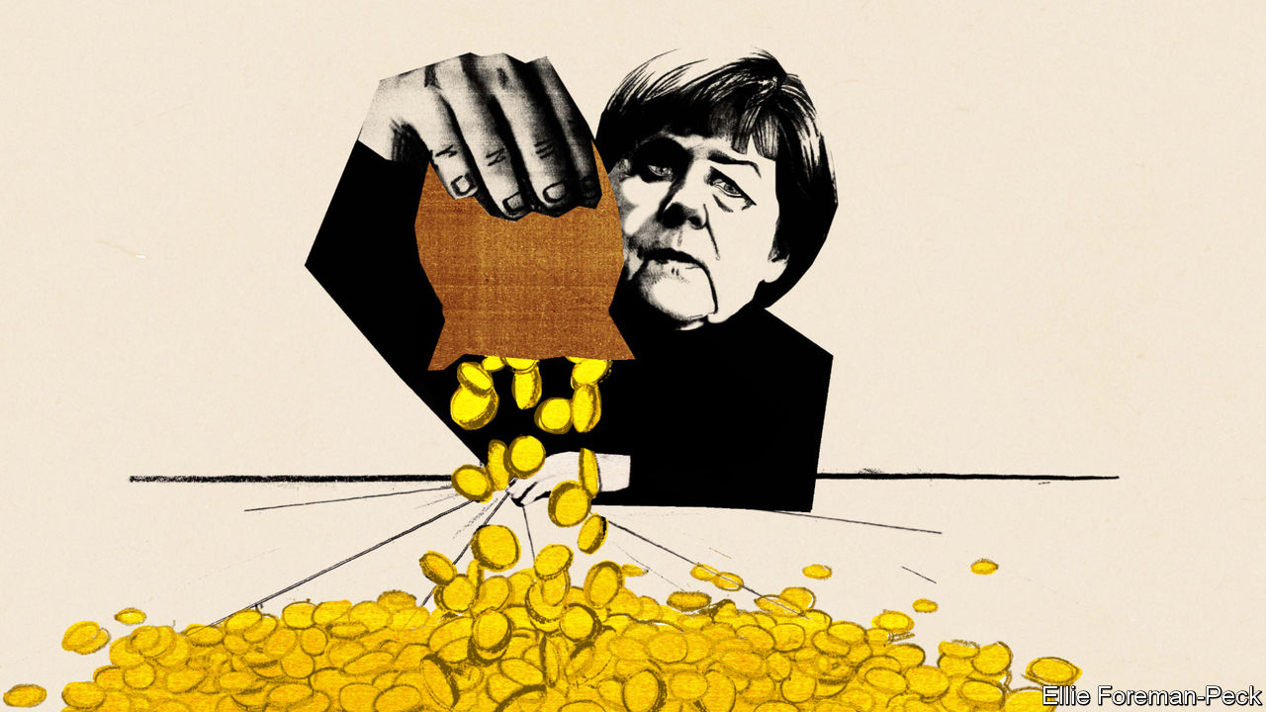

Editor’s note: Some of our covid-19 coverage is free for readers of The Economist Today, our daily [newsletter](https://my.economist.com/user#newsletter). For more stories and our pandemic tracker, see our [coronavirus hub](https://www.economist.com/news/2020/03/11/the-economists-coverage-of-the-coronavirus)

EVERY THURSDAY at 5pm three dozen of Germany’s most prominent economists brush their hair, clear their throats and Zoom into the finance ministry for 90 minutes of debate on whatever is on its officials’ minds. The sessions, which emerged from an informal discussion about the covid-19 crisis in March, have inspired several policy measures. (Olaf Scholz, the finance minister and vice-chancellor, is sometimes in the chair.) They also show how far Germany has moved from its caricature as a deficit-obsessed tightwad.

On June 3rd the coalition announced a stimulus package worth at least €130bn ($148bn). This follows a €123bn supplementary budget passed in March. Fresh borrowing could reach 6% of GDP this year. Meanwhile, Germany has agreed with France that the EU should issue €500bn in common debt to fund investments in member states hard hit by covid-19. Outsiders who have long despaired of German rigidity find themselves in the strange position of being surprised on the upside.

In 2008 German politicians warned of “crass Keynesianism”, before grudgingly passing a stimulus. This time the response has been quicker, bigger and better designed. Benefit rises and cuts to value-added tax aim to boost consumption, and €50bn has been set aside for investment, much of it green-tinged. Politicians have ignored (as they did not in 2009) the lobbying of Germany’s mighty auto industry for subsidies for people to buy cars, other than the electric sort. In 2010-12 the euro zone, at Germany’s behest, inscribed austerity into bail-outs and even national constitutions, like Germany’s (currently suspended) “debt brake”, which limits borrowing. Now Germany is signing up for big, multi-year transfers. Strikingly, this triumph of discretionary pump-priming over rule-following is fine with voters: 73% back “taking on large amounts of debt”. What happened?

The catalyst, of course, is the virus. Germany faces a deep recession: manufacturing and exports are in a hole, and 7.3m workers are on Kurzarbeitergeld (furlough pay), compared with 1.5m at the peak in 2009. At the European level it is easier to mobilise support for countries struck by a pandemic than for (perceived) overspenders. And the revival in support for the government, which six months ago seemed to have run out of steam, creates space to act.

Yet the groundwork had already been laid. Economic thinking in Germany has undergone a dramatic shift in recent years, says Jens Südekum, a professor at Heinrich Heine University Düsseldorf. Older economists schooled in rule-based “ordoliberalism” have partly yielded to a younger set, often educated abroad, with a grounding in empirical economics and views that sit squarely in the international mainstream. Between 2010 and 2015 the share of German economists who told a survey that fiscal policy could help stabilise economies doubled. And as commentators, the new wave have shaped lively debates on matters like Germany’s “black zero” (ie, no deficit) rule.

The pragmatism of the new generation earns them a hearing among policymakers, says Christian Odendahl, an economist at the Centre for European Reform. Under Mr Scholz and his chief economist, Jakob von Weizsäcker, the finance ministry has become a salon of sorts; the weekly Zoom calls cap constant email back-and-forths. This atmosphere is cultivated by officials like Wolfgang Schmidt, an old ally from Mr Scholz’s home town of Hamburg, and Jörg Kukies, a former Goldman Sachs banker. Mr Kukies helped assemble the Franco-German plan, inspired in part by an old think-tank document on American federalism he urged Mr Scholz to read.

However buzzing the scene around Mr Scholz, the last word remains with his boss, Chancellor Angela Merkel. Mr Scholz’s lieutenants claim for him great powers of persuasion in his long talks with the chancellor. Yet at home and abroad Mrs Merkel’s authority has also waned as her chancellorship, which will expire after next year’s election, winds down. This leaves space for others to make a mark.

Will the changes last? Not necessarily. Mr Scholz sits inside the Social Democratic Party (SPD) but like Mrs Merkel’s Christian Democrats (CDU) he argues that Germany can afford its largesse because it paid down debt in years of plenty. In this austere telling, disputed by many economists, the current splurge is a vindication of fiscal rectitude, rather than its negation. “It’s not a U-turn, it’s an extraordinary situation that needs a comparable response,” says Lars Feld, an economics professor at the University of Freiburg. Lukas Haffert at the University of Zurich notes that this year’s experience makes it harder for critics of the debt brake to argue that it impedes deficit spending in crises. And the patience of the CDU’s conservative wing will have its limits. An early test will be over the pace of debt reduction. “Consolidating too early would be a disaster,” says Mr Südekum.

The European argument is a little different. Mr Scholz has taken to grand talk of Hamiltonian moments, fiscal union and handing tax powers to the EU. The fact that Germany’s spending will only widen the gulf with its partners—the Bundesbank forecasts a 6% fall in GDP this year, far gentler than France and Italy—strengthens the case for big intra-EU transfers. German exporters also need European custom. True, when Europe’s leaders begin debating the fund on June 19th, it is Mrs Merkel rather than Mr Scholz who will be negotiating.

But the clock is ticking on her chancellorship. Mr Scholz will probably secure the SPD’s nomination to campaign to succeed her next year. If so, he will not offer his CDU rival an open goal by promising to ignore the old budget rules. But he may be emboldened to push the debate beyond traditional fiscal concerns, such as Germany’s investment gap, its worryingly large share of low-paid jobs and its role in Europe. If nothing else, that would mark a change. ■

This article was downloaded by calibre from <https://www.economist.com/europe/2020/06/11/germany-opens-the-money-tap>

|  |  |  |  |
| --- | --- | --- | --- |
|  | Articles | Sections | Next |

|  |  |  |  |
| --- | --- | --- | --- |
| Previous | Articles | Sections | Next |

#### The not-so-dolce vita

# Italy struggles to reopen for tourism

Restaurants offer no-touch menus, but tourists remain elusive

Jun 13th 2020 | PORTOFINO

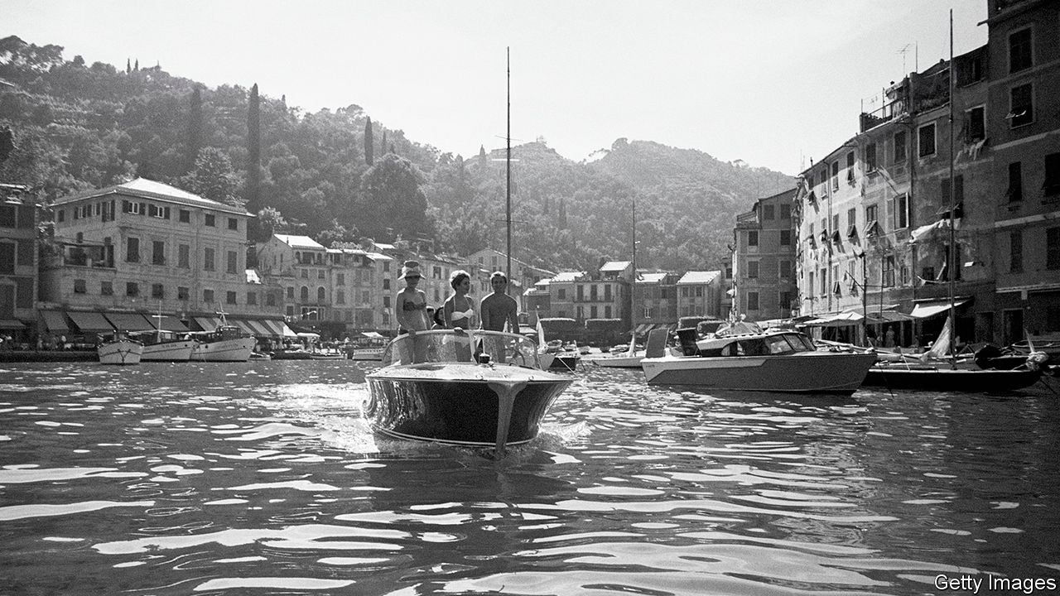

GAETANO MUSSINI, the boss of a waterfront boat-hire business, surveys the few hundred people, many of them expensively dressed, ambling in the sun or lounging at tables outside Portofino’s bars and restaurants. “It feels as if we’ve gone back in time, to the 1960s,” he says.

Rarely since then can Portofino, an elegant resort on the Italian riviera, have been as sparsely peopled on a Saturday afternoon: when the very rich moved on to more exotic locations, the day-trippers moved in. Portofino may now be reliving its dolce vita years, but it is doing so with hand gel and surgical masks at the ready. “Stand here” signs are sprayed on the quayside at socially distanced intervals near where the ferries dock. And at the Caffè Excelsior patrons are handed a QR code so they can study the menu on their smartphones without having to handle a paper one.

Directly and indirectly, tourism contributes around 13% to Italy’s GDP. In Liguria, the region in which Portofino is located, it accounts for 14-15%, says Giovanni Berrino, the regional tourism councillor. During lockdown, he estimates, local hotels lost 95% of their normal turnover. But they still have the prime summer months ahead, and much will depend on how many holiday-makers can be lured to the region between now and mid-September. Mr Berrino believes tourists eager to maintain social distancing may be keener to holiday in the countryside than to crowd onto beaches. “We are lucky to have mountains and forests too,” he says.

The central government hopes to bribe Italians into taking “staycations” with a discount of up to €500 ($568) off their hotel bills. Aldo Werdin, the local head of the hoteliers’ association, says his members wanted a system like the one that lets tourists from outside the EU claim back the VAT on their purchases. It was to have been for everyone. But Italy’s left-populist government decided to limit it to Italian residents with household incomes of under €40,000 a year. Like many of its recovery measures, it seems unnecessarily complicated. If endorsed by parliament, 80% of the discount will come from the hoteliers, who will be able to deduct it from their tax bills. The tourists will get the remaining 20% as a personal tax credit. “It’s better than nothing,” sighs Mr Berrino. “But I can’t see it moving big numbers.” The key question, he says, is whether Italy can lure back foreign tourists who, in Liguria last year, contributed half of the sector’s turnover.

“See that stretch of quayside over there?” asks Mr Mussini in Portofino. “That’s for the private yachts.” It is empty. A few are expected later in June. But not one cruise ship has yet reserved a berth this summer. A few French tourists have appeared in Portofino since Italy opened its borders on June 3rd. But Germans will not be able to come to Italy easily by car until the Swiss and Austrians open their frontiers, on June 15th and 16th respectively. Any Britons now face 14 days’ quarantine on their return. It seems unlikely that many American or east Asian tourists can be tempted to Italy before next year.

That will deal a crushing blow to its many self-employed tourist guides who, on June 9th, demonstrated in several cities. They received two government payments of €600 each for March and April, but many were excluded from a third in May. They assume they will not work again before next March. They are seeking state support until then. But so are a lot of others. ■

Editor’s note: Some of our covid-19 coverage is free for readers of The Economist Today, our daily [newsletter](https://my.economist.com/user#newsletter). For more stories and our pandemic tracker, see our [coronavirus hub](https://www.economist.com/news/2020/03/11/the-economists-coverage-of-the-coronavirus)

This article was downloaded by calibre from <https://www.economist.com/europe/2020/06/13/italy-struggles-to-reopen-for-tourism>

|  |  |  |  |
| --- | --- | --- | --- |
| Previous | Articles | Sections | Next |

|  |  |  |  |
| --- | --- | --- | --- |
| Previous | Articles | Sections | Next |

#### Raoultmania

# A French doctor finds fame promoting malaria pills for covid-19

Populists embrace Didier Raoult; studies suggest he is wrong

Jun 13th 2020 | MARSEILLE

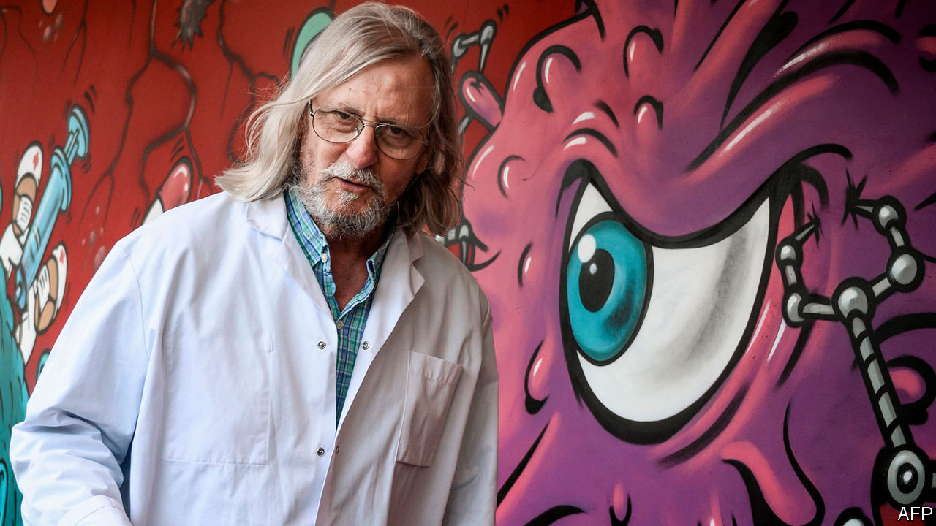

IN LATE MARCH, outside a brand-new medical institute on a busy boulevard in Marseille, a single-file queue snaked along the pavement. Amid a national shortage of covid-19 tests, local residents had heard that the city’s Institut Hospitalier Universitaire, linked to the main public hospital, was offering to test anybody with even mild symptoms. Word had also spread that the institute’s director, Didier Raoult, was successfully treating patients there with hydroxychloroquine, used to treat malaria, along with an antibiotic. Today, Mr Raoult says coolly that covid-19 has “almost totally disappeared” from Marseille.

A contrarian microbiologist with long druid-like silver hair, Mr Raoult has become a cult figure in France’s second-biggest city. A fan tattooed an image of the professor on his arm. A former patient drove a publicity van emblazoned with the doctor’s face around the city. L’Olympique de Marseille, the local football club, displayed a banner declaring “Marseille and the world behind Prof. Raoult!!!”

On one level, Marseille’s new hero reflects a natural yearning for hope at a time of anguish, and for clarity in the face of scientific uncertainty. Mr Raoult has treated nearly 4,000 patients. His most recent study put those who tested positive for covid-19 on the two-drug cocktail. It reported no deaths among those aged under 74, and said 98.7% were “cured”.

Yet the controversy over Mr Raoult’s treatment also exposes deep fractures in French society. The capital’s elite ridicules the professor—“a charlatan who thinks he is God”, sniffed a philosopher. The Paris medical establishment pours scorn on his results. They are not randomised clinical trials but hospital-based observational studies, lacking a control group. He represents none of the Paris-based French health bodies. As if to confirm his capricious nature, note his critics, Mr Raoult walked out of President Emmanuel Macron’s scientific advisory council.

Populists, meanwhile, have claimed him as one of theirs, a sort of gilet jaune in a white coat. He is “to medicine what we are to politics”, declared Jordan Bardella, deputy leader of the National Rally (formerly the National Front). The professor has a serious research record, winning a top prize in part for his discovery of the first giant virus. But Mr Raoult’s cocky, consensus-defying self-promotion—he calls himself “a star of infectious diseases”—makes him a poster boy for those drawn to showmanship. Donald Trump and Jair Bolsonaro are fans of his antimalarial drug.

Mindful of this following, Mr Macron flew to Marseille during lockdown to listen to the professor. Three large randomised controlled trials, in Britain, America and Spain, found no benefit from hydroxychloroquine in treating covid-19. The French government, meanwhile, has zigzagged on authorising clinical trials. The Marseillais, however, are undeterred. A poll shows that only 39% of the French have a positive image of Mr Raoult, but in the region around Marseille he scores 60%. ■

Editor’s note: Some of our covid-19 coverage is free for readers of The Economist Today, our daily [newsletter](https://my.economist.com/user#newsletter). For more stories and our pandemic tracker, see our [coronavirus hub](https://www.economist.com/news/2020/03/11/the-economists-coverage-of-the-coronavirus)

This article was downloaded by calibre from <https://www.economist.com/europe/2020/06/13/a-french-doctor-finds-fame-promoting-malaria-pills-for-covid-19>

|  |  |  |  |
| --- | --- | --- | --- |
| Previous | Articles | Sections | Next |

|  |  |  |  |
| --- | --- | --- | --- |
| Previous | Articles | Sections | Next |

#### Who killed Olof Palme?

# Sweden unmasks a prime minister’s assassin

The case is closed, with no conspiracy exposed

Jun 11th 2020 |



ON FEBRUARY 28TH 1986, when Olof Palme, Sweden’s prime minister, was assassinated, terrorism was a remote concern in his country. It took police five hours to set up barriers. He and his wife had been walking through downtown Stockholm, unprotected, after seeing a film. The leader of the Social Democratic party since 1969, Palme was a pillar of Sweden’s welfare state and the architect of its leftist foreign policy, bashing America’s war in Vietnam and courting third-world socialist governments. He also went after apartheid, so for decades speculation swirled that South African agents might have murdered him. In March Swedish investigators met intelligence services in Pretoria, and later announced they would make their findings public on June 10th.

As in many Swedish thrillers, the denouement was unsatisfying. The case’s chief prosecutor, Krister Petersson, said he had concluded that Palme was murdered by Stig Engstrom, a graphic designer and centre-right municipal activist. After the shooting, Engstrom had approached police as a witness, claiming to have left his office at Skandia, an insurance company, just as Palme and his wife were passing. But his story changed repeatedly over the years. Engstrom died in 2000, so the case has now been closed.

The resolution has frustrated Swedes, in part because no new evidence has been revealed. The murder weapon has never been found. Engstrom’s political convictions were anti-socialist, and he suffered from alcoholism and a troubled marriage. But he was not a suspect until a new team took over the investigation in 2017.

The news also seemed too arbitrary an end for such a towering figure in Swedish history. As education minister in the 1960s, Palme symbolised the country’s relaxed attitude to radical youth by making informal visits to student strikers. As infrastructure minister he oversaw the conversion from driving on the left to the right of the road. As prime minister he expanded the welfare state into a global model, with big increases in pensions, disability allowances, child care, subsidised housing and the universal health-care system. He introduced free admission to university. Some of this has been retrenched; much has not.

On the international scene, it was Palme who established Sweden’s role as an international human-rights gadfly. He bucked cold-war divisions by cultivating cordial relations with Cuba and the Soviet Union, and made Sweden a haven for Americans dodging the war in Vietnam. He incarnated the Scandinavian belief that some version of democratic socialism was humanity’s unquestioned destination. As the British journalist Andrew Brown wrote of living in Sweden at the time, “The happiness and the tragedy of Palme’s years was that when Swedes looked round the world, they assumed that everyone must share Swedish ideas of decency, too.”

Palme’s personal life hewed ostentatiously to his egalitarian convictions. He and his wife lived in a modest home where journalists who came to interview him might find themselves helping to cook dinner. That informality ultimately contributed to his death. For many Swedes, Palme’s murder remains the moment at which the old socialist dream died. It seems perverse for something so important to depend not on a global conspiracy, but on the squalid actions of an insignificant individual. ■

This article was downloaded by calibre from <https://www.economist.com/europe/2020/06/11/sweden-unmasks-a-prime-ministers-assassin>

|  |  |  |  |
| --- | --- | --- | --- |
| Previous | Articles | Sections | Next |

|  |  |  |  |
| --- | --- | --- | --- |
| Previous | Articles | Sections | Next |

#### Charlemagne

# Europe’s “Sinatra doctrine” on China

The EU wants to go its own way

Jun 13th 2020 |

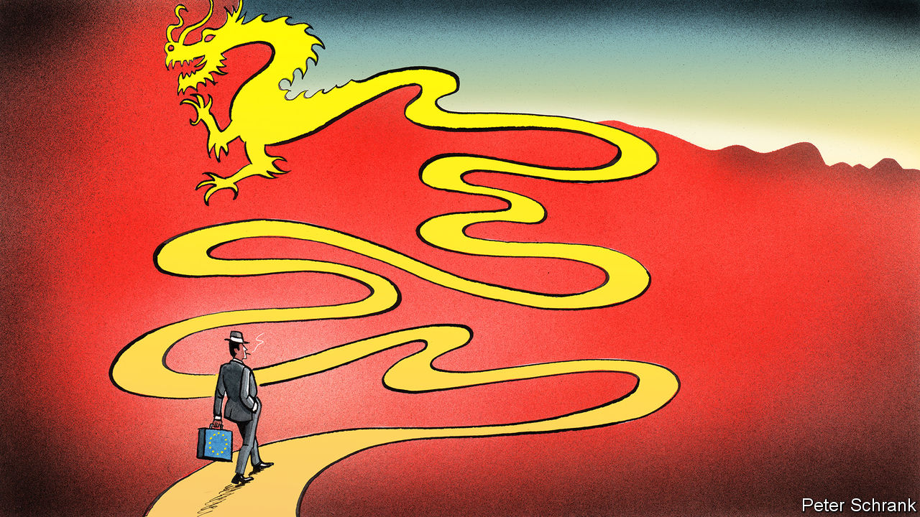

CLICHÉS ABOUND when discussing China’s relations with Europe. It is easy for someone to slip in Napoleon’s view on the country’s sleeping habits, or Zhou Enlai’s take on the historiography of the French revolution. Full marks for effort, then, to Josep Borrell, the EU’s foreign-policy chief, who turned to a less frequently cited source of inspiration to explain the bloc’s policy on China: “We have to be like Frank Sinatra, no? ‘My way’.”

When it comes to China, the primary concern of the EU and its members is to avoid being sucked into a superpower struggle between America and its geopolitical rival. For that, the EU has to develop its own independent position on China, argues Mr Borrell. Many European foreign-policy grandees agree on this basic point. The tricky part is deciding what this position should actually be. A summit this September in Leipzig was supposed to be a demonstration of the EU’s unified direction, with the EU’s 27 leaders banding together across from China’s president, Xi Jinping. Instead, it was ditched at the start of this month. Officially, coronavirus was the reason. But insiders blame other factors: a desire to avoid a difficult stand-off over Hong Kong, and the fact that, on the EU side, a shared view on China is hard to come by.

At the moment, there is unity only in confusion. Countries are split, both internally and externally. Some have no policies on China whatsoever. Others have a position, but a schizophrenic one, with blasé foreign ministries pulling in one direction, while sceptical intelligence agencies heave in the other. (One diplomat offered a clear-eyed appraisal of his government’s strategy on China: “Nonsense”.) Germany has the closest ties with China, which bought €96bn of German exports in 2019, nearly half the EU’s total. But the country struggles to conceive a relationship that goes beyond economics, argues Ulrich Speck from the German Marshall Fund, a think-tank. For France, China is a chance to bulk up the EU into a true geopolitical actor (magnifying French power in the process). A “17+1” group of small countries from central, eastern and southern Europe meets Chinese officials in the hope of receiving Chinese investment. The odd hawk, such as Sweden, which was the lone voice demanding sanctions against China over its recent attempts to control Hong Kong, further complicates the picture. Cobbling these opinions into a unified vision is difficult.

So far, the EU has solved this problem by treating China as a geopolitical chimera. In 2019 the European Commission labelled China a “systemic rival”—diplomat-speak for an authoritarian brute, with little time for Western norms—as well as a partner on some topics and a competitor on others. Such a frame was “to a degree a cop-out from the start,” says Janka Oertel of the European Council on Foreign Relations, a think-tank. It is hard for a country to be an existential challenge one day and a partner the next. The EU has to decide which tendency is dominant, sooner than it had imagined.

Some areas of agreement exist. A realisation that China will not play fair in business is now more or less universal. European businesses complain that China, rather than opening up its markets, is now “one economy, two systems”, with European companies unable to compete with domestic rivals unfairly boosted by the Chinese government. “Europe is open, China is not,” sums up one senior EU diplomat.

Brussels is trying to be tougher in response. A proposal to let the commission block takeovers of European businesses by companies that receive unfair support from foreign governments will be put forward this month. At the start of the last decade, the suggestion that Eurocrats might cast an eye over foreign investment would have led to claims of a dirigiste French plot from the bloc’s zealous free-traders. Now the Dutch, usually the most buccaneering when it comes to trade, cast themselves as proud godparents of the policy, having previously proposed a similar one.

Chinese attempts to drive a wedge between EU countries have failed. A small China-friendly country, such as Greece, is useful in a body that moves by unanimity in foreign policy. But the quid pro quo of such dealings—lashings of Chinese investment—has often failed to materialise, grumble members of the “17+1” group. Direct investment from China into the EU was €12bn ($13.5bn) in 2019. The EU spends almost five times this figure just on subsidising its farmers. Buying friends on such a rich continent is not cheap.

## I bit off more than I could chew

External pressure may solidify the bloc, rather than split it. A brewing cold war between America and China justifies the EU’s own Sinatra doctrine. (It is not Sinatra’s first foray into global politics: Mikhail Gorbachev’s spokesman used a similar analogy when the Soviet Union promised to stop interfering in eastern Europe.) Such autonomy is the very purpose of the EU, whose goal is to allow countries not to be “a Chinese or American colony”, argues Enrico Letta, a former prime minister of Italy. In one sense, such talk is overblown. America, for all its current flaws, is a democracy whose concerns about China are shared by Europeans. Independence does not mean equidistance between the two powers, caution diplomats. At the same time, they argue, the EU is determined to avoid being trapped in a united Western front against China, or forced to pick a side in a conflict in which the EU wants no part.

Dodging that choice marks the beginning of a policy, not its completion. Independence raises more questions than it answers. Will the EU let Chinese companies such as Huawei, a telecoms giant that is barred from America, build crucial infrastructure? What would the EU do if China invades Taiwan? Stuck between an isolationist America and an authoritarian China, the EU casts itself as the last bastion of the liberal order. Yet it has not drawn a line at China’s tightening chokehold on Hong Kong. Nor, even, at China’s internment camps for Uighur Muslims. “What does it take to really rattle Europeans?” asks Ms Oertel. It is a question the EU will have to answer if it goes its own way. ■

This article was downloaded by calibre from <https://www.economist.com/europe/2020/06/13/europes-sinatra-doctrine-on-china>

|  |  |  |  |
| --- | --- | --- | --- |
| Previous | Articles | Sections | Next |

|  |  |  |
| --- | --- | --- |
| Europe | Sections | International |

Britain

Remembering slavery: Pillaried

.

Ozophilia: The Tories’ promised land

.

Quarantine rules: Mumbo jumbo

.

Sleep under lockdown: Bedtime story

.

Courts in a pandemic: Rough justice

.

The pee problem: Causing a stink

.

Social insurance: The great risk shift

.

Bagehot: Battle for the working class

.

|  |  |  |
| --- | --- | --- |
| Europe | Sections | International |

|  |  |  |  |
| --- | --- | --- | --- |
|  | Articles | Sections | Next |

#### Black Lives Matter protests

# The Colston statue and Britain’s legacy of slavery

Its toppling helps to redress Britain’s selective historical memory

Jun 13th 2020 | BRISTOL

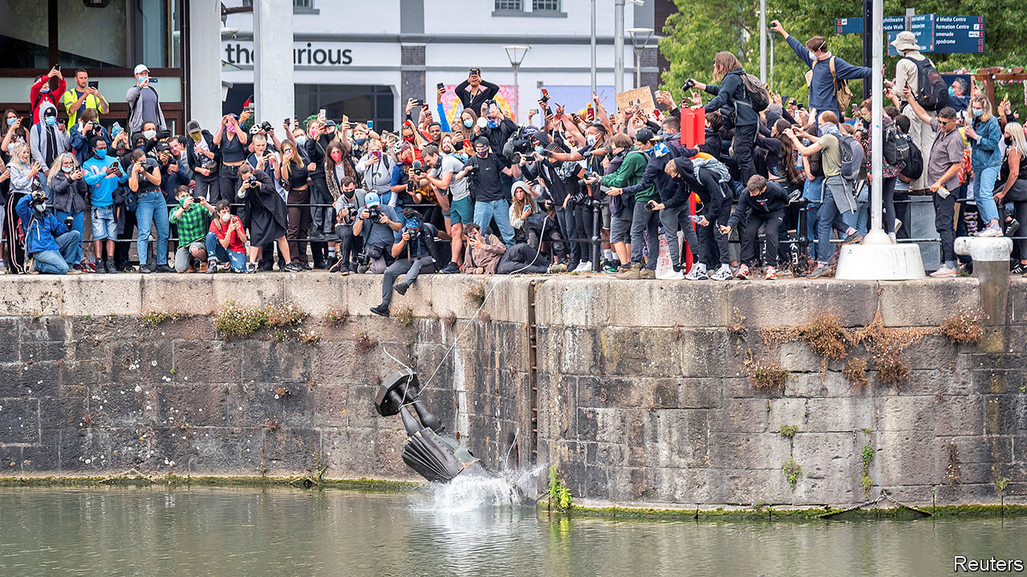

LIKE GENERATIONS before them, the grey-haired men of the Colston Society processed into a church in Bristol in 2017 for their annual service in memory of Edward Colston, 296 years after he died. Prayers were said, hymns sung, “Colston buns” gobbled down. But, as the Bristol Post reported at the time, the service wasn’t advertised on the church’s website. An opaque reference by the vicar helped explain why. Colston was, he said, a man who “like all of us, with the benefit of hindsight, may have done things differently”.

On June 7th Colston drew a crowd again. These particular Bristolians, though, had less need of such understatement. They knew that the man long venerated as “one of the most virtuous and wise sons” of the city gave huge sums of money to charity. They also knew that he made much of it by trading slaves. As part of the global protests against racism triggered by the killing of George Floyd in Minneapolis on May 25th, they toppled the city’s statue of Colston and dumped it in the harbour.

Like the statue’s subject, its self-appointed removers were saluted as heroes by some and castigated as criminals by others. Priti Patel, the home secretary, wants them prosecuted for criminal damage.

Other historical figures were soon under attack. The authorities removed the statue of Robert Milligan, another slaver, from London’s docklands. Graffiti on Winston Churchill’s plinth in Parliament Square accused him of being a racist. The long-running campaign to remove the statue of Cecil Rhodes from outside Oriel College, Oxford, roared back to life. The Labour Party announced on June 9th that the councils it controls in England and Wales will reassess the “appropriateness” of their monuments.

But the Colston saga is especially interesting for the story it tells about Britain’s selective historical memory. The statue was not put up until 1895, a century and a half after his death and long after Britain had abolished the slave trade in its colonies. Yet Colston was revered; the plaque fixed to the plinth made no mention of slavery. On annual memorial days throughout the century that followed, Bristol’s schoolchildren remembered Colston as a philanthropist not a slaver. “It’s a city where it’s easy to forget,” says Richard Stone, a historian at Bristol University.

This collective amnesia is not confined to Colston. As Olivette Otele, the university’s first professor of slavery, points out, it is symptomatic of a wider neglect of Britain’s prominent role in the slave trade, in favour of celebrating later abolitionists such as William Wilberforce. “It is a very partial story,” she says. “We often talk about abolition, but it was 300 years of slavery and abolition came at the end.”

Distance partly explains it. Much of the human suffering took place thousands of miles from the merchants’ smart houses in Glasgow, Liverpool and Bristol. In what historians term “the triangular trade”, the same ships ferried goods to Africa, trafficked slaves from there to the Americas and returned laden with commodities.

At least 2,000 slave-trading voyages left Bristol, which dominated the trade in the early 18th century before it was eclipsed by Liverpool. Even then, it continued to grow rich on the proceeds of tobacco and sugar harvested by slaves. In the city today, physical evidence of the trade is abundant, but obscured. For instance, the first generation of grand townhouses on Queen Square was built during—and financed by—the city’s slave-trading boom. “What does slavery look like in Bristol?” asks Mr Stone, pointing at the tree-lined cobbled streets. “It looks like this. Look at a lot of the city and that’s what you’ll be seeing.” Ms Otele is leading a project to unearth how the proceeds of the trade were spent in the city.

Even after a new biography of Colston was published in 1920, restating the extent of his culpability as deputy governor of the Royal African Company, which trafficked 84,000 people to slavery during his tenure, the city’s annual festivities continued to focus exclusively on his philanthropy. Generations of children attended schools named after him or went on trips to Colston Hall, a music venue that will soon be renamed. “You know the name before you know what it means,” says Marvin Rees, the city’s mixed-race mayor. “In my time growing up here, it’s not something you learned about...Politicians didn’t talk about it. Journalists didn’t talk about it. And between the two, they undermined people’s ability to talk about it.”

That began to change only in 1996, when Bristol hosted a “festival of the sea” that failed to acknowledge the city’s role in the slave trade. Following an outcry, a group of academics and activists set up a walking trail of slavery sites; the council named a bridge after a slave, Pero Jones. Yet plenty of Bristolians resisted removing Colston’s statue. Richard Eddy, a Tory councillor, even opposed adding a second, more balanced, plaque as a “slap in the face for true Bristolians”. Many white residents, in particular, struggled to cast aside the idea of a beneficent father figure they learned about at school. “I don’t think it’s quite Stockholm syndrome, but they were taught to revere this man,” says Mr Stone. “It’s unsettling for them to find out he isn’t saintly.”

But, as the activists proved this week, history is never over. The empty plinth already attracts crowds; the absence of a memorial is itself a memorial. Spurred on by the protest, Colston’s Girls School took down its own statue of the slaver and is considering changing its name. Activists hope a new slavery museum and a broader school curriculum will follow. For his part, Mr Rees’s priority remains dealing with the city’s present-day racial inequalities. As he puts it, “guilt don’t feed people, it doesn’t give people jobs.”

In the early hours of June 11th, the authorities winched Colston’s statue from the harbour, feet first. Soon, it will be on display again—in a museum, adorned not with hagiography but with the placards the protesters left behind. ■

This article was downloaded by calibre from <https://www.economist.com/britain/2020/06/13/the-colston-statue-and-britains-legacy-of-slavery>

|  |  |  |  |
| --- | --- | --- | --- |
|  | Articles | Sections | Next |

|  |  |  |  |
| --- | --- | --- | --- |
| Previous | Articles | Sections | Next |

#### Britain and Australia

# Why the Conservative Party adores Australia

The explanation for rampant Ozophilia

Jun 13th 2020 |



ALTHOUGH ITS members occasionally launch into “Land of Hope and Glory”, the Conservative Party lacks an official anthem. “Australia”, a song by The Kinks released in 1969, would be a good pick. It satirises the aspirations of the “ten-pound poms” who took up the offer of cut-rate passage out of stuffy post-war Britain for a new life by the beach: “No class distinction, no drug addiction… No one hesitates at life or beats around the bush in Australia.”

As Britain and Australia begin negotiations on a trade deal, the Tories are in the grip of Ozophilia. Boris Johnson, who picked up a pair of skimpy shorts and a widened vocabulary on his gap year at Geelong grammar school, holds Australia up as a model of prosperity outside the European Union. The government is creating an “Australian-style” immigration system, which will discriminate by skills and qualifications. The prime minister has even attempted to rebrand an ugly no-deal exit from the EU as an “Australian” deal.

Sir Lynton Crosby, an Australian political adviser, and his protégé Isaac Levido, have been teaching the Conservative Party how to win elections for the past decade. Tony Abbott, the former Australian prime minister, is a star of the Tory conference fringe. Alexander Downer, an erstwhile Australian high commissioner who advocates taking a tough line on Europe, is chairman of Policy Exchange, a think-tank close to Downing Street. Conservatism is developing an Australian accent. Mr Johnson has repainted the Tories as a classless, plain-speaking, macho outfit not unlike Scott Morrison’s Liberal Party.

Rich, stable and not led by Donald Trump, Australia is at present a more attractive template than America, which has long fascinated British politicians of both right and left. The Five Eyes intelligence partnership, which also includes New Zealand, Canada and America, is increasingly important. And Britain and Australia think ever more alike about the risks of doing business with China.

Often the most unyielding Brexiteers are the keenest on Australia. For them, restoring trade ties to the Commonwealth (which Britain mostly cut when it joined the European Economic Community in 1973) is one of the great opportunities created by Britain’s departure from the EU. Shortly after the Brexit vote in 2016, a poll found that Leavers gave priority to a trade deal with Australia; for Remainers, the country was not even among the top five. In “How We Invented Freedom and Why It Matters”, Daniel Hannan, a former MEP and star of the Eurosceptic circuit, describes the “Anglosphere” as a “civilisational model” in need of rescue.

Australia’s popularity among Conservatives reflects its allure to Britons in general. No other country is regarded so favourably, according to YouGov, a pollster. That is a product of Australia’s recent history as a destination for Brits to escape their rainy island. Post-war émigrés were promised a technicolour workers’ paradise of high wages, plentiful houses and sun. Until 1966 the country followed a “white Australia” policy, which appealed to some. Australia’s modern points-based immigration system is a hit with British focus groups partly because so many participants have relatives who moved there, says Jill Rutter of British Future, a think-tank specialising in migration. “Wanted Down Under”, a popular daytime television show, features would-be emigrants exploring the Australian labour market. A recent tourism ad featuring Kylie Minogue was described as “a little bit of escapism” for Brexit-weary Brits.

But Australia is decreasingly white and no longer very British—only 5% of its inhabitants were born there. Most Australian foreign-policy hands know that the future lies in the Indo-Pacific. Trade negotiations are likely to be hard-nosed and uncomfortable for British farmers. Britain’s negotiators can certainly cut their teeth on an Australian deal, says Dmitry Grozoubinski, a former Australian trade official and director of ExplainTrade, a consultancy, but the British should not imagine that any combination of deals with distant lands can substitute for EU membership. ■

This article was downloaded by calibre from <https://www.economist.com/britain/2020/06/13/why-the-conservative-party-adores-australia>

|  |  |  |  |
| --- | --- | --- | --- |
| Previous | Articles | Sections | Next |

|  |  |  |  |
| --- | --- | --- | --- |
| Previous | Articles | Sections | Next |

#### Shutting the stable door

# Britain’s new quarantine rules are a head-scratcher

Boris Johnson’s government closes down as Europe opens up

Jun 13th 2020 |

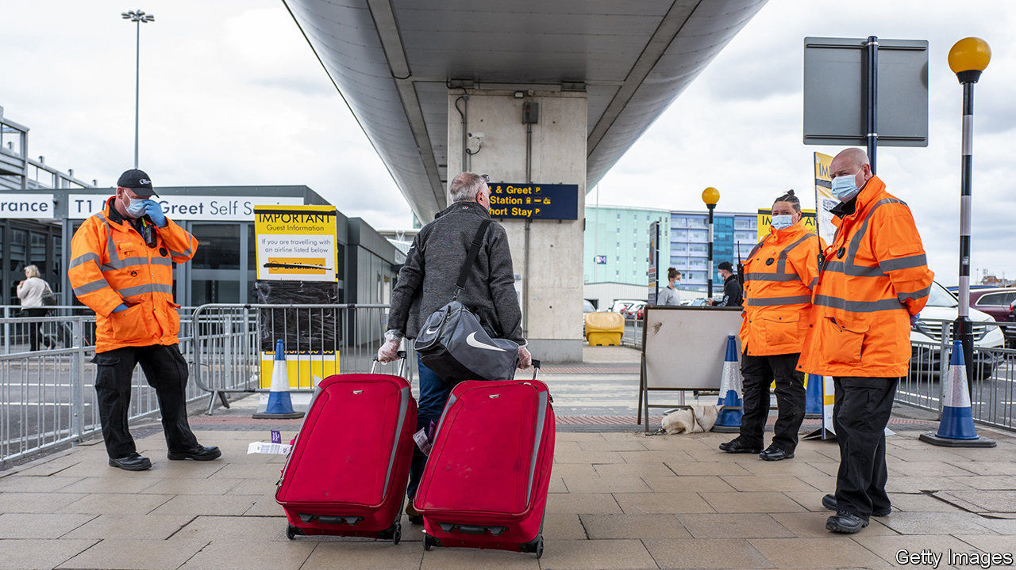

THROUGHOUT APRIL and May, as most countries closed their borders and imposed strict limits on who could enter, Britain remained defiantly open. Now, as much of Europe starts opening up again, Britain is again going in the opposite direction. Under rules introduced on June 8th, anybody entering Britain at any port must fill in a form with their contact details and self-isolate for a fortnight. They will be allowed to take public transport from the airport, to shop for groceries and to leave the country again. Public Health England, a government agency, will phone people to ask if they are complying. Rule-breakers face a £1,000 fine.

Other European countries that imposed quarantines are either unwinding them or tailoring regulations according to the risk level in the passenger’s country of origin. Britain’s rules apply wherever people come from, including countries that have the virus under control. “If we had different rules for different countries, it may complicate matters,” says a Home Office spokesman.

Businesses are bewildered. Border officers are befuddled. Even the government’s scientists are stumped: they note that few countries’ infection rates are higher than Britain’s. Michael O’Leary, the boss of Ryanair, Europe’s largest airline, reckons that Britons know the rules are “rubbish”. That may be so, but they are also holding off booking summer holidays in large numbers whilst returning holidaymakers are also required to quarantine themselves. About six in ten Britons go on a foreign holiday in a normal year. But a YouGov poll found that just 16% of Brits are planning an international trip in the next six months.

Border officers charged with implementing the rules say they can neither understand nor enforce them. Guidance was not published until late on the Friday before they went into force, says Lucy Moreton of the ISU, the immigration officials’ union, adding that staff had been “promised time to digest the information and a brief training programme”. Officials are not checking whether the forms filled in by arriving passengers are true, “only that it’s broadly credible, so long as they have not put something completely dopey, such as Buckingham Palace”.

But the greatest confusion is within the travel industry, which must plan ahead. The government is due to review the rules every three weeks, starting on June 29th. John Holland-Kaye, who runs Heathrow, Britain’s busiest airport, thinks it is unlikely that much will change on that date. “So a lot of holiday companies have made the call that 20th July will be the opening-up date,” he says, citing Virgin Atlantic, which plans to resume operations from that date. That “is really a gamble in the absence of any information”.

Airlines, tour operators and holidaymakers want an explanation for the government’s perplexing policy. A better idea might be to ask YouGov. “I know that some newspapers are obviously opposed to it, for whatever reason,” says the Home Office spokesman. But “the polling shows 63% [of Britons] support these measures.” The government says it is following “the science”. Psephology is a science too. ■

Editor’s note: Some of our covid-19 coverage is free for readers of The Economist Today, our daily [newsletter](https://my.economist.com/user#newsletter). For more stories and our pandemic tracker, see our [coronavirus hub](https://www.economist.com/news/2020/03/11/the-economists-coverage-of-the-coronavirus)

This article was downloaded by calibre from <https://www.economist.com/britain/2020/06/13/britains-new-quarantine-rules-are-a-head-scratcher>

|  |  |  |  |
| --- | --- | --- | --- |
| Previous | Articles | Sections | Next |

|  |  |  |  |
| --- | --- | --- | --- |
| Previous | Articles | Sections | Next |

#### Bedtime story

# Britons are dreaming more

And the dreams are more vivid too

Jun 13th 2020 |

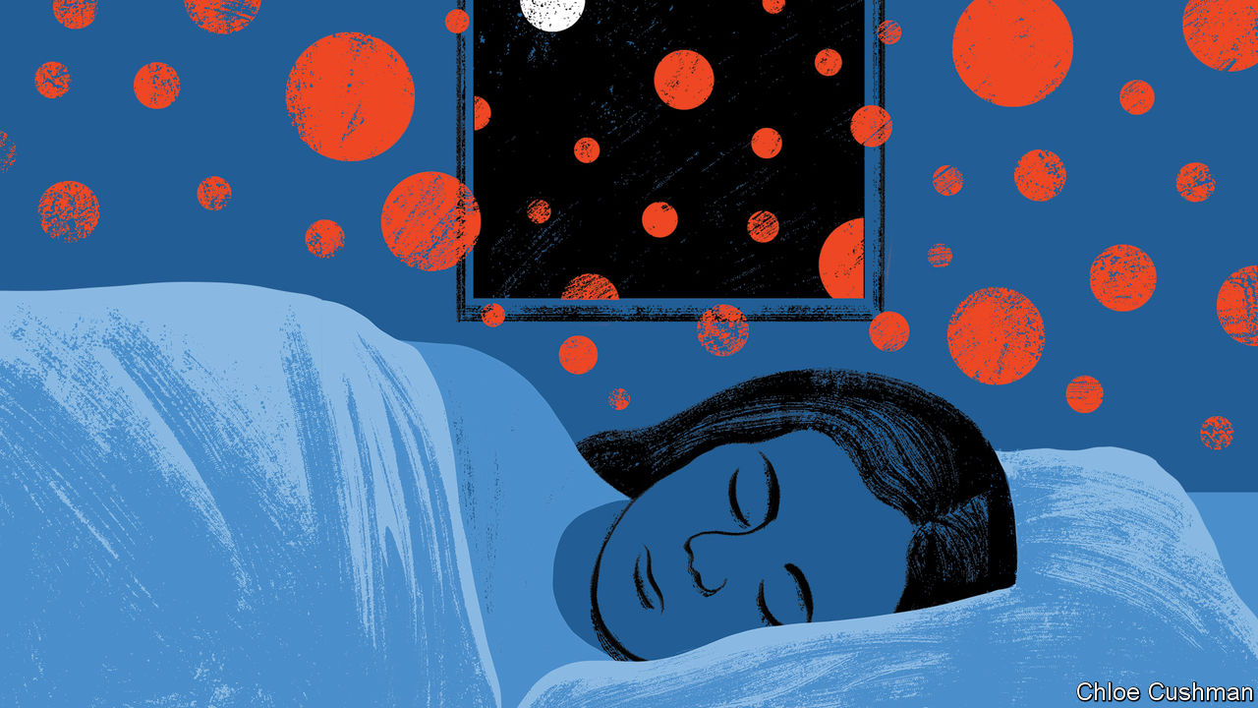

FEW WORDS in the English language are more terrifying than “I had a weird dream last night.” They tend to be followed by a series of pointless vignettes and the question, “So, what do you make of it?”

Lots of Britons have probably had to sit through a conversation like this since the lockdown started. That is because, according to a study by King’s College London and Ipsos Mori, a pollster, some 40% of people report having more vivid dreams during the lockdown than they usually would.

The changes in people’s domestic arrangements are probably largely responsible. For many, day-to-day life is stressful and busy. Four out of five people use an alarm to wake up. School and work start too early in the morning. About a third of Brits have poor sleep, according to the National Health Service. But over the past 12 weeks, as much of the country has stayed home, people have been sleeping more. The timing of the extra sleep matters: dreaming occurs when the body is in something called REM sleep, which occurs mainly towards the end of the night, says Dr Guy Leschziner of Guy’s Hospital (no relation). People who have been catching an extra hour in the morning will have had deeper dreams. And because they are waking up more gently, they are more likely to remember their dreams, says Dr Hugh Selsick of the Royal London Hospital.

That may be only part of the explanation. Some people suffering from depression or post-traumatic stress disorder report increased dreaming and nightmares too. Doctors believe this is a way for the mind to deal with difficult things. Even for those who are not finding the covid-19 crisis difficult, it is distinctly odd. “It might be that vivid dreams reported by the participants in our survey are therapeutic, and that they may help us process the extraordinary reality” that we are living in, says Dr Ivana Rosenzweig of King’s College, who advised on the study.

Weird dreams are normal during and after periods of collective trauma. Researchers found that the 9/11 attacks in 2001 made Americans’ dreams more intense. Charlotte Beradt, a Jewish writer in Berlin, documented the night-time confections of Germans in “The Third Reich of Dreams”. Dr Russell Foster of the Sleep & Circadian Neuroscience Institute at Oxford says that when Boris Johnson was struck with covid-19, he dreamed of the prime minister. He is not sure whether that was out of concern for Mr Johnson or concern for the country. “All of this is conjecture,” he says, “but what you can say with certainty is you would expect vivid dreams in times of stress. It’s the brain trying to make sense of the emotional world.”

When life does eventually return to normal, with children to feed and clothe and drop off at school, and trains and buses to catch to work, Britons can expect to sleep less and dream less, and to remember their dreams less. But there are things they can do to improve their sleep, like keeping to a routine and avoiding phones before bed. And there are things employers can do to ensure their workers are well rested, and therefore more productive, too. Dr Foster suggests replacing high-sugar snacks with small protein-rich ones and lighting offices brightly enough to match employees’ circadian rhythms. For many of the nation’s tired workers, a good night’s sleep would be a dream come true. ■

Editor’s note: Some of our covid-19 coverage is free for readers of The Economist Today, our daily [newsletter](https://my.economist.com/user#newsletter). For more stories and our pandemic tracker, see our [coronavirus hub](https://www.economist.com/news/2020/03/11/the-economists-coverage-of-the-coronavirus)

This article was downloaded by calibre from <https://www.economist.com/britain/2020/06/13/britons-are-dreaming-more>

|  |  |  |  |
| --- | --- | --- | --- |
| Previous | Articles | Sections | Next |

|  |  |  |  |
| --- | --- | --- | --- |
| Previous | Articles | Sections | Next |

#### Rough justice

# How to get jury trials back on track

Social distancing has slashed court capacity. Radical solutions are needed

Jun 13th 2020 |

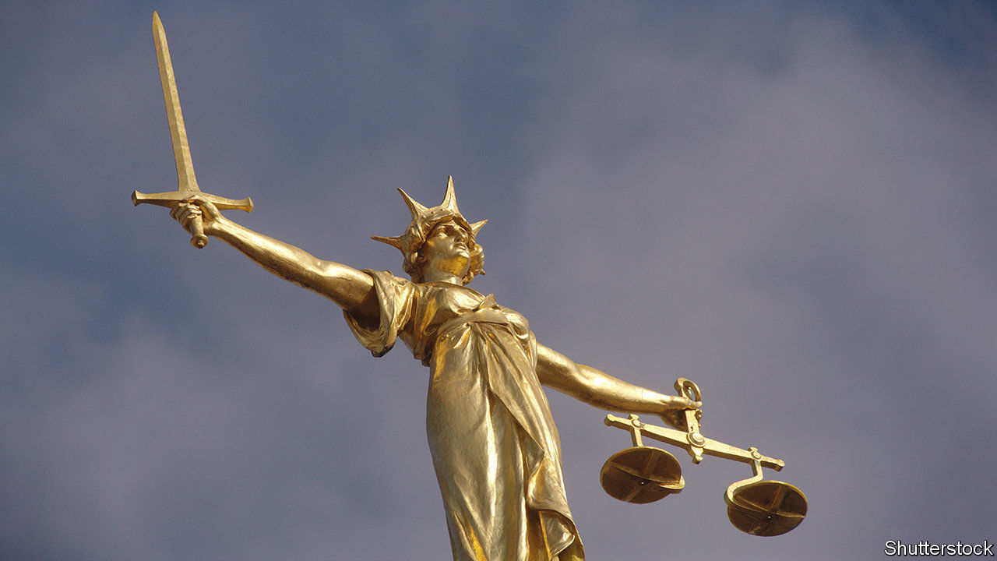

UNLIKE MANY other depictions of Lady Justice, the statue that stands atop the Old Bailey, England’s most famous criminal court, does not wear a blindfold. Her “maidenly form” alone is said to guarantee her impartiality. She should, however, consider a mask. In the courtrooms below, each juror gets one as they take their seats. “This building has never been cleaner in its 100-year history,” the judge assures them.

Because of the pandemic, many hearings in England and Wales have switched from courtrooms to front rooms. The Supreme Court is entirely remote. Lawyers are now accustomed to telephone and video hearings. When the High Court heard a preliminary argument in the Duchess of Sussex’s privacy claim against the Mail on Sunday on April 24th, Meghan Markle and Prince Harry listened in from Los Angeles.

Yet there is a glaring exception to this tale of digital adaptation. Jury trials were postponed indefinitely, since few thought it suitable for jurors to convict their peers by Microsoft Teams. A handful of courts—including the Old Bailey—resumed such trials on May 18th. The courts service hopes to open most criminal courts by July.

Even optimistic estimates suggest they will be able to hear only half as many trials as usual. As well as the judge, jury and sometimes several defendants, each trial involves a phalanx of barristers and solicitors, court officials, witnesses, victims, relatives, journalists and the merely nosy. Keeping them apart is tricky. Trials that usually take up a single courtroom might now require three: one for the hearing, one for jury deliberation and one for observers to watch via video link. As the judge in the Old Bailey case adds, “we’re all going to have to be patient.”

For defendants waiting to plead their innocence or victims desperate for their day in court, patience is in short supply. Prior to the pandemic, most victims waited more than a year to see justice done; in some parts of the country, a two-year wait was the norm. Thanks in part to cost-cutting measures limiting the number of days judges can sit, criminal courts had a backlog of 37,000 cases—a queue which is now growing by about 1,000 cases a month.

Innovation is in order. One option is to shrink the size of the jury, perhaps to seven members. That is unlikely to help much, since courts would still require overspill space for observers and jury deliberations. A more radical alternative would be trial by judge alone, but lawyers and even many judges rule that out. “Justice must not only be done and be seen to be done, but feel to be done,” says Simon Davis of the Law Society, which represents solicitors. A third idea is to establish makeshift courtrooms in bigger venues. There is talk of requisitioning empty London theatres. “You can imagine some of our criminal-barrister friends loving that,” quips one observer.

The best solution may be the one most remain unwilling to countenance: online jury trials. Justice, a legal charity, has run experiments showing how they could work. In the next test, designed to overcome objections that jurors might struggle with technology or lack room at home, jurors will all log on from a church hall, with someone on hand to help with IT. A similar set-up in a sports hall would allow dozens of jurors to hear different cases simultaneously. In the end, the judiciary will need to weigh up opposing principles of justice. In-person jury trials may be the ideal, but justice delayed is justice denied. ■

Editor’s note: Some of our covid-19 coverage is free for readers of The Economist Today, our daily [newsletter](https://my.economist.com/user#newsletter). For more stories and our pandemic tracker, see our [coronavirus hub](https://www.economist.com/news/2020/03/11/the-economists-coverage-of-the-coronavirus)

This article was downloaded by calibre from <https://www.economist.com/britain/2020/06/13/how-to-get-jury-trials-back-on-track>

|  |  |  |  |
| --- | --- | --- | --- |
| Previous | Articles | Sections | Next |

|  |  |  |  |
| --- | --- | --- | --- |
| Previous | Articles | Sections | Next |

#### Sanitation

# Lockdown and the toilet problem

A nation is caught short

Jun 13th 2020 |

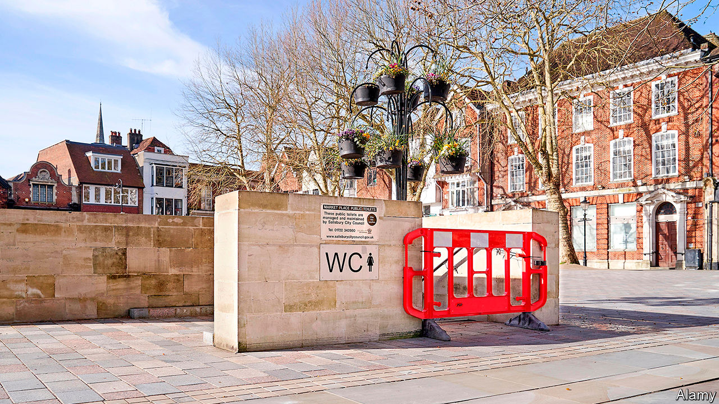

IT WAS A mortifying moment. Crouched in a bush, Katie was confronted by a dog owner whose hound had discovered her al fresco lavatory. The woman remonstrated loudly that (pooch practices notwithstanding), Katie shouldn’t relieve herself in a public place. “It was quite embarrassing and awkward as I was mid-pee, and I just tried to explain it was a desperate situation,” she recalls.

Relieving oneself in public is an offence, but lockdown has closed most public toilets as well as cafés and pubs. That makes long outings difficult for all sorts of people, including menstruating women and those reluctant to relieve themselves in public. Emma Curtis suffers from irritable bowel syndrome, exacerbated by the anxiety the covid-19 crisis has caused. She hasn’t been able to join her family for walks along the coast in Dorset near her home as a result.

Many are less inhibited, and throw caution and bodily fluids to the wind. Beauty spots have been sullied by urine and worse. Takeaway pints and the warm weather do not help. David Vincent, a retired chef living near Saundersfoot Beach in Pembrokeshire, complains that “the amount of people using the beach as a loo is unprecedented.” Stuart Fox runs the White Horse Inn in Dover. People have been using the bins in an alleyway behind the pub for their own human waste. Complaints to the council have gone unanswered, so “it’s just been a case of us throwing out hot buckets of bleachy water to minimise the stench.”

Public incontinence is encouraging councils to try to keep people away from popular venues. After complaints of “large gatherings, public nuisance, public urination and littering on our seafront,” Brighton and Hove council restricted access to the main beach by blocking access to the promenade at certain points. Brian Perry, a retired mental-health worker, launched an online petition asking the government to close Blackpool to visitors. The city “has been invaded by people leaving our town filthy not taking notice of spacing [and] urinating in the streets”, he complained. Within four days he collected more than 14,000 signatures.

Hackney Council in London reopened its park toilets on May 30th and cleans them seven times a day. But on sunny weekends the parks are jammed and queues long. In London Fields alone, 72 fines at £150 a pop were issued for littering or public urination over the last weekend in May; more than 300 fines have been issued across the borough since the start of the lockdown, around 90% for urination. The mayor, Philip Glanville, tweeted that public urinators were “morally culpable”. The council has issued so many fines that at one point it ran out of paper, presumably a concern shared by the guerilla defecators.

This article was downloaded by calibre from <https://www.economist.com/britain/2020/06/13/lockdown-and-the-toilet-problem>

|  |  |  |  |
| --- | --- | --- | --- |
| Previous | Articles | Sections | Next |

|  |  |  |  |
| --- | --- | --- | --- |
| Previous | Articles | Sections | Next |

#### Social insurance

# Who bears risk—people or government?

Covid-19 is drawing the state back into the insurance business

Jun 13th 2020 |

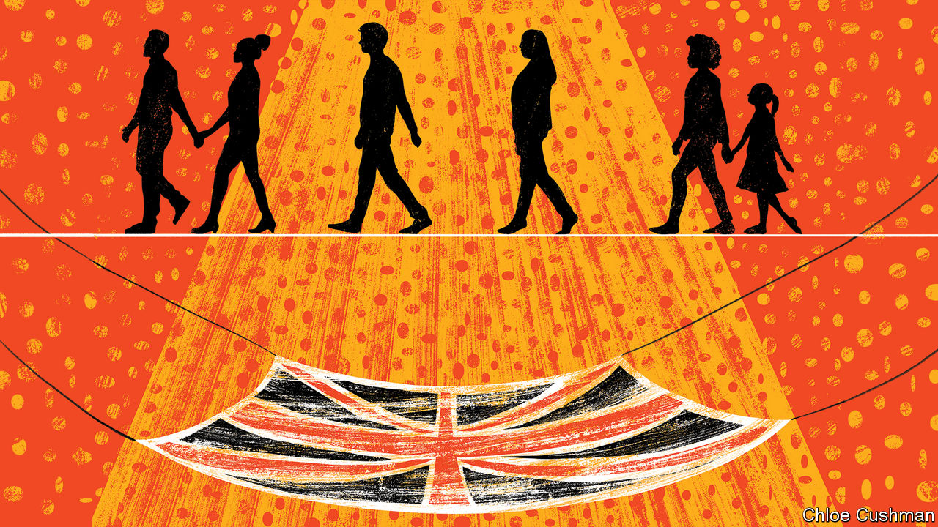

RARELY, IF EVER, has a proposal moved from policy paper to implementation in a matter of days. The Coronavirus Job Retention Scheme was first proposed by the Resolution Foundation, a think-tank, on March 19th as the scale of the hit to the economy from the pandemic became clearer. Four days later, on March 23rd, Rishi Sunak, the chancellor, made the furlough scheme the centrepiece of the government’s economic response to the virus. Initially due to run for just three months, it will now be in place until at least October and is currently paying 80% of the wages, up to £2,500 ($3,200) a month, of nearly 9m British workers. It costs the Treasury about the same each month as the National Health Service (NHS).

Viewed through a narrow lens, the furlough scheme is simply a pragmatic response to an unprecedented economic shock, whereby the government is bearing an unusually large share of the risks posed by the covid-19 crisis. But through a wider lens it can be seen as a reversal of a long trend which has shifted the burden of risk onto individuals.

In the first half of the 20th century the state took it upon itself to protect people against, for instance, unemployment and ill-health, establishing compulsory unemployment insurance in 1911 and the NHS in 1948. In the 1980s, when Britons got fed up with the high tax rates levied in part to pay for this, the national mood shifted and the direction of travel changed.

Jacob Hacker, a political scientist, has observed the government and corporations dumping risk back on individuals in America and dubbed this phenomenon the “great risk shift”. In Britain, defined-benefit (DB) schemes, whereby workers pay a set percentage of their income each month in return for a certain level of annual income based on their salary when they retire, used to be the norm in the private sector. Workers in a DB system are, so long as the firm stays afloat, guaranteed their income no matter how long they live or how the investment portfolios perform. Such schemes are now mostly closed to new members and have been replaced by defined-contribution schemes into which people pay with no certainty about what they will get out of them. Individuals, not firms or the government, bear the risk if they live longer than expected or the asset market performs worse than expected.

Work, too, has become more precarious. Construction workers, for example, are now much more likely to be self-employed than in the 1980s, even if they work only for one firm, which often leaves them with meaner benefits if they fall sick. Courier firms often require employees to provide their own vehicles, and bear the risk if they go wrong. Zero-hour contracts, under which the employer does not guarantee a period of paid employment, are welcomed for their flexibility by many but have been abused by unscrupulous employers.

Volatility is a risk for workers, especially if they are poorly paid. The nearer the breadline you are, the more harmful its consequences are. A study by the Resolution Foundation of income volatility found that four in five low-paid workers (defined as earning around £10,000 a year) experienced volatile monthly earnings, compared with just two in three higher-paid workers (defined as an income of around £35,000). About two in five workers suffer what they term “persistent volatility”, with significant changes in their monthly income at least six times a year. And the state does less to protect those who find themselves out of work than it used to. Clare McNeil, of the Institute of Public Policy Research, a left leaning think tank, argues that the reduced levels of unemployment support are the “most vivid” example of the risk shift. The value of the main out-of-work benefit, as a share of average earnings, fell from more than 30% in the late 1960s to under 15% by 2019.

The shift that the furlough scheme represents may be no more than a break in a long-term trend, or it may presage a more significant reversal. Britain’s new political geography, with the government’s majority reliant on the so-called “red wall” of 50 former Labour seats in Wales, the Midlands and the north, points to a different policy agenda. Welfare spending runs at £2,300 per working-age person in those seats, compared with £1,600 in other Conservative areas, while average earnings are £44 a week lower. “I’m not sure people in the red wall are as happy bearing risk as our older coalition was,” says a Tory MP. Social care is one area where the direction of travel may be towards collectivising risk. A report in 2019 from Policy Exchange, a centre-right think-tank, with a foreword from Jacob Rees-Mogg, a right-leaning cabinet member, called for long-term social care to be funded through general taxation rather than by individuals.

Some free-market Tories now worry that a larger state, which carries more of the risk burden of society, will be a lasting consequence of the pandemic. Robert Colvile of the Centre for Policy Studies, a free-market think-tank, argues that resilience matters as much as risk. Spreading wealth more widely is one alternative to a state-funded safety-net. Those with assets to fall back on are better able to bear risks and, Mr Colvile says, “the old popular capitalism arguments about spreading home- and share-ownership are just as relevant today.” But that argument may be less politically appealing to this Conservative government than it was to previous ones.■

This article was downloaded by calibre from <https://www.economist.com/britain/2020/06/13/who-bears-risk-people-or-government>

|  |  |  |  |
| --- | --- | --- | --- |
| Previous | Articles | Sections | Next |

|  |  |  |  |
| --- | --- | --- | --- |
| Previous | Articles | Sections | Next |

#### Bagehot

# Johnson and Starmer fight for the working-class vote

Labour has a chance of recapturing the territory it lost

Jun 13th 2020 |

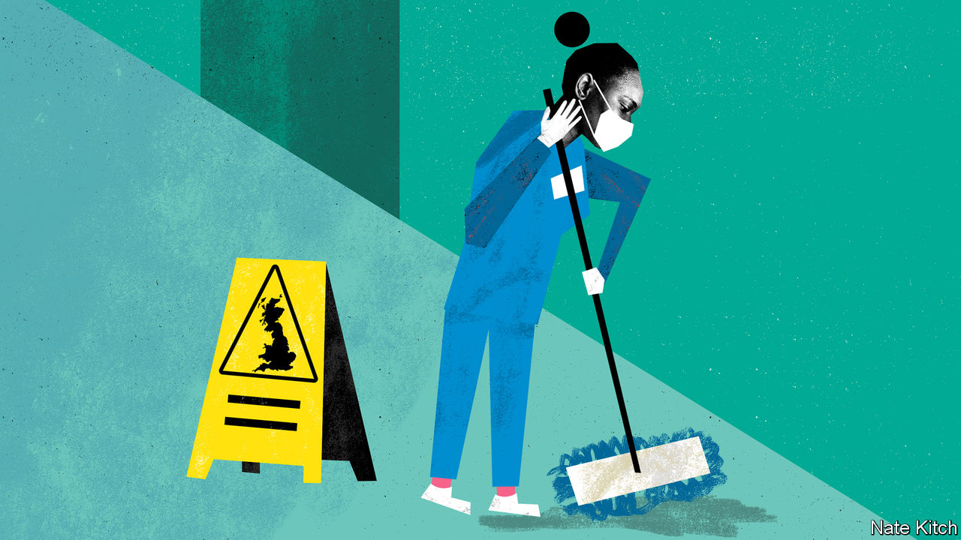

THE BLACK LIVES MATTER movement has convulsed British politics. Large crowds have marched in Whitehall and Bristol. Statues of former slave-owners have been felled and others are in the felling-line. It sometimes looks as if Britain is turning into America—and that the major galvanising force in politics will soon be race rather than class.

But race is nothing like as divisive in Britain as it is in the United States. America fought a bloody civil war to abolish slavery in 1861-65, whereas Britain abolished the slave trade by Act of Parliament in 1807. Race has intensified as a dividing line in American politics in recent decades, with the Democratic Party becoming the party of minorities (and white elites) and the Republican Party becoming the party of the white backlash. British politics has, thank God, avoided this. Britain’s first black prime minister could well be a Conservative: the party has black high-flyers such as Kwasi Kwarteng and Bim Afolami.

The fact that both those rising stars of the Conservative Party were educated at Eton is not a coincidence. Class remains a more powerful force in British society than it is in many other countries, and class identities will continue to matter more than racial identities in determining voting behaviour. The workers matter much more than the wokers.

The divisions that education and accent cleave run deep in British society. Nearly three-quarters of Britons say that it is “very” or “fairly” difficult to move between classes, compared with 65% a decade ago. A majority of Britons still identify as “working-class”. Politicians’ attempts to bury the issue have failed. Sir John Major trumpeted the idea that Britain is a “classless society”. Tony Blair declared that he was building a post-class meritocracy. David Cameron tried to pretend that he and his wife were members of classless Middle England despite the blue blood that runs in their veins. But class struck back: both Brexit and the 2019 election were decided, to a striking degree, by working-class voters in Britain’s equivalent of “flyover country”.

The same people will decide the outcome of the next election. Young people and urban ethnic minorities tend to vote Labour. Older people and rural folk are Conservative. The provincial working class are today’s swing voters. They have been moving towards the Tories over the past decade, a shift that turned into a stampede in 2019. But, as Boris Johnson said on the morning after the election, they have not given the Tories their votes—they have merely lent them. Mr Johnson hoped to make the deal permanent by focusing on repairing provincial Britain. But covid-19 has changed all that by derailing Mr Johnson’s agenda and exposing his weaknesses as an administrator.

At the same time, the Labour Party is also getting a lot smarter when it comes to winning over the workers. In 2019 Jeremy Corbyn lost the working-class vote to the Tories not just because he dithered over Brexit but also because, as a privileged fantasist brought up in a manor house in Shropshire, he addressed himself to an imaginary working class of revolutionary proletarians mass-produced in the mines and the factories. By contrast, Sir Keir Starmer, the party’s new leader, is determined to address the real working class. That is why he has been careful not to get carried away with Black Lives Matter: during a radio interview this week he said that Edward Colston’s statue should have been removed by democratic deliberation rather than crowd action. And that is why he has appointed Claire Ainsley as his head of policy.

Ms Ainsley’s appointment is one of Sir Keir’s most important decisions as leader so far. As executive director of the Joseph Rowntree Foundation and as author of a thoroughly researched book, “The New Working Class”, she spent years studying real workers. She argues that a distinctive new version has grown up beside the old industrial working class. Four in five jobs are now in the service sector, many of them (particularly in cleaning, catering, social care and retailing) poorly paid. The new workers toil in a much more fragmented world than the old working class, often in isolation and bound by individual contracts. They are also much more ethnically diverse. But ethnic diversity doesn’t align them with urban progressives. Ms Ainsley identifies four key values that resonate with the new working class: family, fairness, hard work and decency. Her priorities are bread-and-butter policies such as statutory sick leave for casual workers, tax breaks for companies that emphasise job security and more visible policing in areas of high crime.

Recapturing these people will be far from easy for Labour. The new working class lacks the sense of collective class identity that the old one had, and in some areas Labour may find itself torn between their interests and values, and those of the young metropolitans whose vote it relies on. Transgender rights, for instance, will be a tricky area. The Conservative Party will not give up its new territory without a fight. It has been thinking about Britain’s new class structure for longer than Labour has: during Mr Corbyn’s policy Ice Age Ms Ainsley even acted as an adviser to a Conservative-leaning think-tank, Onward. Tory wonks such as Rachel Wolf, one of the co-authors of the last manifesto, and Munira Mirza, the head of the policy unit, have been fashioning policies for the just-about-managing for years, while groups such as Blue Collar Conservatism help ground policymaking in reality.

But a fight for the workers is just what Britain needs. For far too long the British working class has been subjected to two indignities: being sentimentalised by the left and being written out of history by the right. Britain has much repairing to do on many fronts in the next few years, including facing up to its responsibility for the slave trade. But thanks to the new realism that is gripping both the left and the right on the subject of class, millions of people who work in Britain’s casualised service economy have a good chance of being part of this reconstruction. ■

This article was downloaded by calibre from <https://www.economist.com/britain/2020/06/13/johnson-and-starmer-fight-for-the-working-class-vote>

|  |  |  |  |
| --- | --- | --- | --- |
| Previous | Articles | Sections | Next |

|  |  |  |
| --- | --- | --- |
| Britain | Sections | Technology ... |

International

Black Lives Matter: So other people would be also free

.

Autocrats denounce America: We love to see you burn

.

|  |  |  |
| --- | --- | --- |
| Britain | Sections | Technology ... |

|  |  |  |  |
| --- | --- | --- | --- |
|  | Articles | Sections | Next |

#### So other people would be also free

# The killing of George Floyd has sparked global soul-searching

Protests have broken out in dozens of countries

Jun 11th 2020 | AMSTERDAM, JOHANNESBURG, MELKSHAM, MEXICO CITY, PARIS AND SÃO PAULO

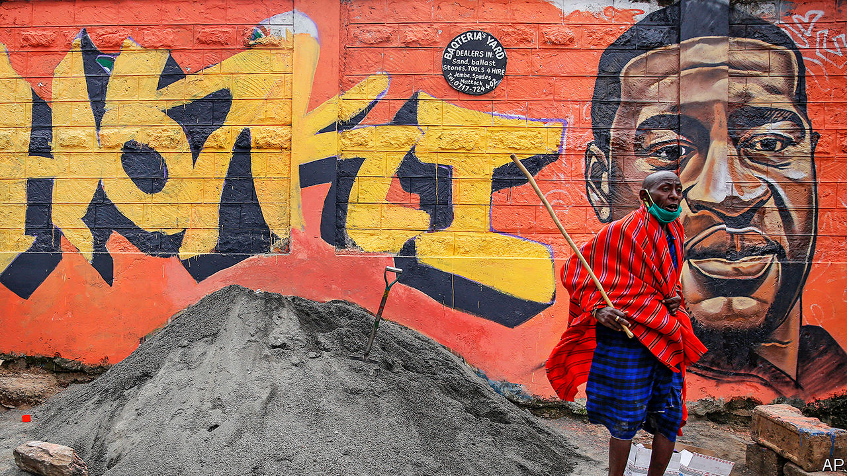

LOCAL POLICE arrested Giovanni López, a 30-year-old Mexican bricklayer, in Ixtlahuacán de los Membrillos, a town near Guadalajara, on May 4th. Why they detained him is unclear. The next morning his family found him dead in a nearby hospital, with bruises on his head and a bullet in his ankle. His name did not go viral; no politician lamented his death.

Christian López, who filmed his brother’s arrest, stayed silent at first. He would later claim that messengers acting on behalf of the local mayor threatened to kill his family if the footage went public. But then came the killing of George Floyd in Minneapolis, and the anti-police, anti-racism backlash that has swept the world. “I saw it and thought, this is the same thing that happened to my brother,” he says. On June 1st he went to the press.

The chief prosecutor in the state of Jalisco, where the death occurred, faced a barrage of questions. On June 4th a march in Guadalajara, marking a month since Giovanni’s death, turned violent. Calls demanding #Justiciaparagiovanni increased. The three officers connected with Giovanni’s death were arrested. The mayor’s role is under investigation. Protests have since spread to Tijuana and the state of Veracruz against two local pre-Floyd police killings, of Oliver López (no relation) in March and Carlos Andrés Navarro in May.

Mr Floyd’s death has provoked protests around the world. Why his death set off a global movement whereas countless other unjust killings did not is hard to say. Mr Floyd was American, of course, and the world pays more attention to the United States than to Mexico or any other country. His death was filmed in excruciating detail. It happened at a time when billions of people were cooped up and frustrated at home, thanks to covid-19. Lockdowns have surely made the global mood more combustible.

But the important points are that police brutality is rife in many countries and minorities fear discrimination everywhere. That is why Mr Floyd’s fate resonated. Just as women on every continent found common cause in the #MeToo movement, despite the range of their experiences, so protesters around the world have united around the cry that black lives matter.

At their simplest the protests mark people’s antipathy towards cops who beat or kill those whom they vowed to protect. Protests have spread throughout Mexico, where nine in ten homicides go unpunished and many police moonlight for the other side. The country’s most notorious unsolved crime, the disappearance and presumed murder in 2014 of 43 student teachers in the town of Ayotzinapa, is thought to have been orchestrated by police paid by drug gangs.

Some of the global anger is directed at the United States. Protests have erupted outside American embassies from Spain to South Africa. Nana Akufo-Addo, Ghana’s president, tweeted that: “Black people, the world over, are shocked and distraught.” President Cyril Ramaphosa of South Africa said: “The killing of George Floyd has opened up deep wounds for us all.”

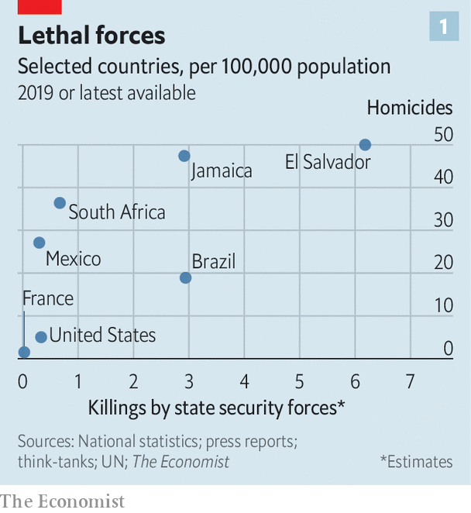

Many protesters would agree. But many also seethe that their leaders condemn police abuse in Minnesota while allowing or even encouraging it at home. America’s police kill more people than those of any other rich democracy, but cops in some developing countries are much more lethal (see chart 1). So plenty of the protests around the world are about local abuses as well.

On June 8th in Mathare, a poor part of Nairobi, about 200 Kenyans marched against police atrocities. Since a covid-19 curfew was introduced in Kenya’s capital on March 27th police have killed 15 people, according to the country’s Independent Police Oversight Authority. “[T]he poor people of this country have come together to say no to police killings...and also stand in solidarity with the global protest against police excesses,” Juliet Wanjera, a member of the Mathare Social Justice Centre, an NGO, has told journalists.

Since 2012 there have been more than 40,000 complaints against the South African Police Service for alleged crimes including rape and murder, with just 531 convictions. Security forces have killed at least 11 people during South Africa’s lockdown, in place since March 27th, and more than 200,000 have been arrested. Mr Ramaphosa has said merely that authorities have been guilty of “over-enthusiasm”.

That will not wash with many South Africans. The killing on April 10th of Collins Khosa, a 40-year-old man from Alexandra, a township in Johannesburg, by soldiers, has prompted particular outrage. According to his family, Mr Khosa was targeted for drinking a beer even though he was on his own property. (Buying alcohol was illegal in April and May, as per lockdown regulations, but drinking it was not.)

Some analysts worry that police abuse in America may make it easier for others to follow suit. “It will certainly be very easy for leaders in Africa, those with their own dictatorial tendencies, to justify future behaviour by referencing the actions of the US administration in the last few weeks,” argues Idayat Hassan of the Centre for Democracy and Development, a think-tank in Abuja, Nigeria. Police brutality in developing countries rarely prompts a global reaction. The killing by Zimbabwean security forces of 17 protesters in January 2019 did not lead to mass protests elsewhere.

In the state of Rio de Janeiro (population 6.3m), police killed 1,810 people last year, nearly twice as many as in the United States (population 328m). Police say most of the dead are gunmen from favelas, informal settlements that are often controlled by criminals. But watchdogs point to a rise in extrajudicial killings, including massacres of more than ten people, fuelled by warlike police operations, sometimes with snipers in helicopters. Images of smiling children killed by police all too often appear on people’s televisions. They include eight-year-old Agatha, shot by a stray bullet last September while riding in a van with her mother, and 14-year-old João Pedro, killed in a botched police raid last month.

Brazilians in more than ten cities took to the streets on June 7th to mourn their deaths and to protest against the government of Jair Bolsonaro, a populist who campaigned on promises to give immunity to police who kill. He said last year that a bill to this effect would cause criminals to “die in the streets like cockroaches”. Congress rejected the measure, but Brazil’s trigger-happy police are rarely prosecuted. Still, on June 5th a Supreme Court judge banned most police operations in favelas for the remainder of the pandemic.

Of the 6,220 people killed by Brazil’s police in 2018, three out of four were black. In Indonesia, #BlackLivesMatter has found new relevance as #PapuanLivesMatter. Indonesia runs half of the island of New Guinea, and controls it almost as if it were an occupying power. Papuans—whose skin is darker than that of other Indonesians—face bleak economic prospects and violence at the hands of security forces.

In 2019 a Papuan student dormitory in Surabaya in eastern Java was besieged by a mob claiming its inhabitants had thrown the national flag into a gutter. Some taunted them as “monkeys”. Rather than dispersing the mob, riot police stormed the dorm with tear-gas and arrested 43 Papuans. That and similar actions in other cities were the catalyst last summer for huge demonstrations by young Indonesians in support of Papuans. In recent days calls have grown for Indonesians to denounce the discrimination that Papuans suffer.

## A determined people

Even where police brutality is rarer, attention has turned to domestic racism. In Melksham, a small town in England, 120 people gathered on June 7th to protest against it. Some 97% of the town’s inhabitants are white. It has not seen a major protest since woollen-mill workers rioted in 1802. “White privilege doesn’t mean your life hasn’t been hard,” Botan Williams, the event’s 15-year-old organiser, told the crowd, “it just means your skin colour isn’t one of the things making it harder.”

Throughout Britain demonstrators have echoed their American counterparts, chanting “hands up, don’t shoot” at (unarmed) police. Placards named black victims of British police violence: Mark Duggan, Rashan Charles and Edson Da Costa. Black people are just 3% of the population in England and Wales but 12% of prisoners. Black men are stopped and searched at nine times the rate of white men.

Similarly in Australia Aboriginals and Torres Strait islanders are just over 3% of the overall population but 29% of those in prison. An indigenous female Australian is more likely to be behind bars than a non-indigenous male. Scott Morrison, the conservative prime minister, says: “There is no need to import things happening in other countries here to Australia” because “Australia is a fair country...[it] is not the United States.” Protesters were unconvinced. Indigenous Australians are poorer and less healthy—and have less access to housing, land, education and social workers—than other Australians.

The first demonstration in France since Mr Floyd’s death brought 20,000 people carrying “Black Lives Matter” banners to the main Paris courthouse on June 2nd. It centred on a French controversy: the death in 2016 of Adama Traoré, a 24-year-old who was pinned to the ground by police officers during his arrest. A medical report released on the morning of the demonstration suggested that he was asphyxiated. The Floyd protests carry particular resonance in the banlieues, high-rise estates where friction between the police and residents, many of them of immigrant origin, frames daily life. This distrust can erupt into confrontation, violence and, occasionally, death. There were 19 deaths in France during police operations last year.

France is the first European country where the protests have changed policy. Earlier this year, after a motorbike courier died of asphyxiation during his arrest in Paris, President Emmanuel Macron asked Christophe Castaner, his interior minister, to come up with ways to “improve police ethics”. On June 8th those proposals were hastily put together. Mr Castaner acknowledged racism within the police force, and said that choke holds would be banned. France would take a “zero tolerance” approach to racism, he declared.

Before the protests, New Zealand was mulling whether to equip more of its usually unarmed police with guns. Evaluation of a six-month trial was to have been completed by the end of June. But on June 9th the head of police said he had received over 4,000 letters in a week, and that the plan would be permanently scrapped.

Some Europeans have deplored American racism while failing to see the parallels in their own countries. Europe’s biggest Black Lives Matter rallies were in Germany. Signs in English were far more prominent than German ones. In Spain, too, demonstrators mostly condemned American racism, with only cursory mentions of Europe’s treatment of African migrants. There were few mentions of Europe’s widespread religious discrimination against Muslims.

Europeans are sometimes complacent about racism. Granted, European police shoot far fewer people than American police do. But this is largely because they are less likely to be shot at. Last year 48 police were killed—most of them shot— in the line of duty in America; in Britain one was.

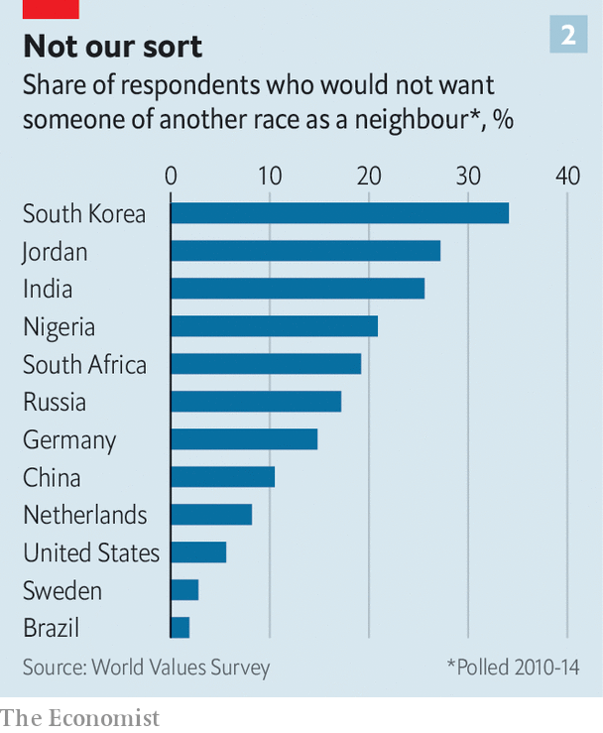

Measuring prejudice is hard. Racist attitudes have been socially unacceptable nearly everywhere for decades, so many who harbour them will not admit it to pollsters. But some do. And according to a recent international World Values Survey, more Germans and Dutch say they would not want “people of another race” as neighbours than Americans (see chart 2).

Ethnic profiling by police is illegal in most countries, but common. Members of minorities (especially young men) are routinely frisked and asked for identification when out in public. In private, many police admit to taking account of race when deciding whom to stop, noting that some groups, for a variety of reasons, commit more crimes than others. Such profiling makes life much harder for those who happen to belong to those groups, the vast majority of whom are law-abiding.

Many people do not care. Brazilians knew what to expect when they elected Mr Bolsonaro. Two-thirds of Germans think racial profiling is an acceptable tool of policing, according to a poll in 2017 by YouGov. “The worst thing about it,” says Sony Kapoor, an Indian-born Briton who lives in Norway, “is the smugness of Europeans who think they don’t harbour the same sort of racism as Americans.” ■

This article was downloaded by calibre from <https://www.economist.com/international/2020/06/11/the-killing-of-george-floyd-has-sparked-global-soul-searching>

|  |  |  |  |
| --- | --- | --- | --- |
|  | Articles | Sections | Next |

|  |  |  |  |
| --- | --- | --- | --- |
| Previous | Articles | Sections | Next |

#### We love to see you burn

# Autocrats gleefully decry America’s racial turmoil

Similar protests in China, Russia or Iran would be ruthlessly crushed

Jun 13th 2020 | HONG KONG

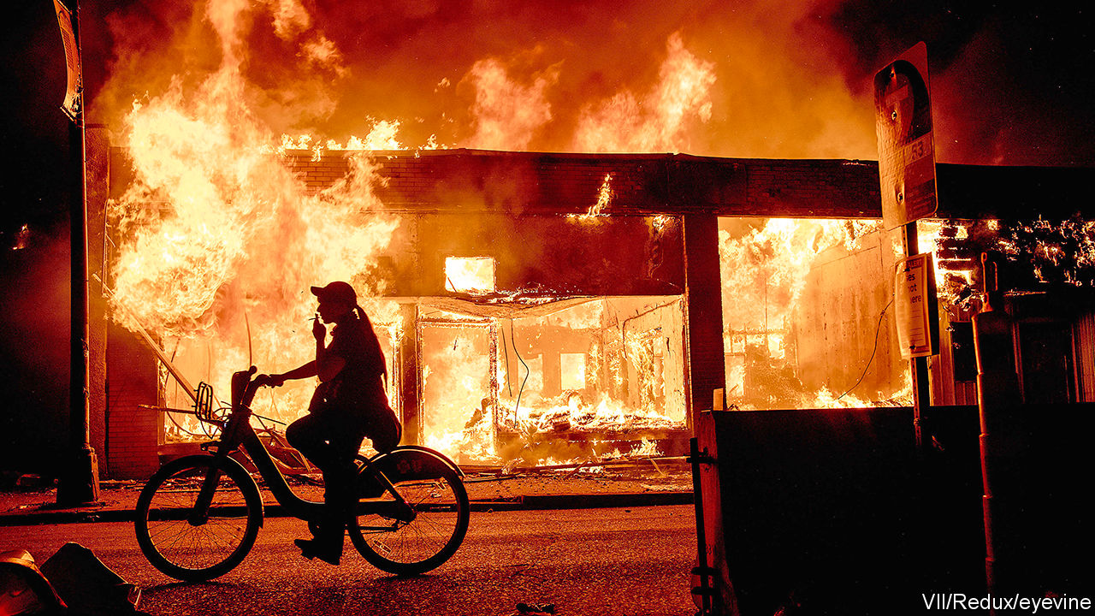

ANTI-AMERICAN AUTOCRATS are enjoying the spectacle. All around the world, America is being derided for its brutal police and ill-treatment of minorities. For regimes with much worse records, what could be sweeter?

For China the timing was delicious. On May 28th its parliament rubber-stamped a proposal to impose a draconian security law on Hong Kong. America denounced this infringement of Hong Kongers’ freedoms. Mike Pompeo, the secretary of state, met Chinese democrats. The editor of Global Times, a party-controlled tabloid, sneered that Mr Pompeo should “stand with the angry people of Minneapolis, just like you did with people of Hong Kong”. China’s top spokeswoman tweeted: “I can’t breathe.”

Chinese state media loudly lament America’s bias against blacks. They say little about Chinese bias against them, let alone the internment of perhaps 1m Muslims in Xinjiang for such crimes as praying and having big beards. Torched shops and club-wielding cops in America fill Chinese screens. Anyone in mainland China who dared to mark the anniversary on June 4th of the slaughter of pro-democracy protesters near Tiananmen Square risked arrest.

Russian state mouthpieces have adopted a similar tone. “The key values of the Free World are shattering under the blows of police batons and burning in the flames of looted shops,” went a voice-over on Russia’s main TV channel. To pump up the tension it showed the closing scene of a film, “Brother-2”, in which a Russian hero, flying back from America, listens to a rock song, “Goodbye America”. To the movie it added real news footage of American cars on fire and a police van ramming a crowd.

Russia’s propaganda, like China’s, tries to persuade viewers that America is irredeemably racist and that mass protests mean anarchy. Dmitry Kiselev, Russia’s propagandist-in-chief, drew parallels with Ukrainian protesters who rose against a Kremlin-backed government in 2014. “Here is a woman urinating on top of an overturned police vehicle,” he intoned against a backdrop of American street chaos. “When the state abandons its law enforcers, it is a bad symptom.”

Iran’s leaders have piled in, too. “A cop kneeling on a black man’s neck and letting him choke to death...is the nature of the American government. They have done the same to such countries as Iraq, Afghanistan and Syria,” said Ayatollah Ali Khamenei, the country’s supreme leader.

Yet autocrats’ propaganda is not always persuasive. Russians know Mr Putin wants to distract attention from his lawless security services and unfathomably rich cronies. And democracies adapt better to popular complaints. America is prosecuting the cop who killed Mr Floyd and rethinking police tactics. Hong Kongers know that none of the police who beat up pro-democracy demonstrators last year will be punished. An official report into the protests was a whitewash.

This article was downloaded by calibre from <https://www.economist.com/international/2020/06/13/autocrats-gleefully-decry-americas-racial-turmoil>

|  |  |  |  |
| --- | --- | --- | --- |
| Previous | Articles | Sections | Next |

|  |  |  |
| --- | --- | --- |
| International | Sections | Business |

Technology Quarterly

Artificial intelligence and its limits: Reality check

.

Data: Not so big

.

The business world: Algorithms and armies

.

Brain scan: An AI for an eye

.

Computing hardware: Machine, learning

.

Automobiles: Road block

.

The future: Autumn is coming

.

|  |  |  |
| --- | --- | --- |
| International | Sections | Business |

|  |  |  |  |
| --- | --- | --- | --- |
|  | Articles | Sections | Next |

#### Artificial intelligence and its limits

# An understanding of AI’s limitations is starting to sink in

After years of hype, many people feel AI has failed to deliver, says Tim Cross

Jun 13th 2020 |

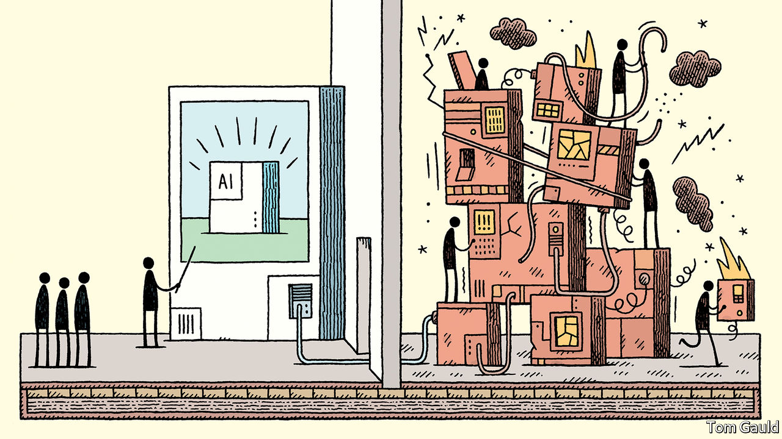

IT WILL BE as if the world had created a second China, made not of billions of people and millions of factories, but of algorithms and humming computers. PwC, a professional-services firm, predicts that artificial intelligence (AI) will add $16trn to the global economy by 2030. The total of all activity—from banks and biotech to shops and construction—in the world’s second-largest economy was just $13trn in 2018.

PwC’s claim is no outlier. Rival prognosticators at McKinsey put the figure at $13trn. Others go for qualitative drama, rather than quantitative. Sundar Pichai, Google’s boss, has described developments in AI as “more profound than fire or electricity”. Other forecasts see similarly large changes, but less happy ones. Clever computers capable of doing the jobs of radiologists, lorry drivers or warehouse workers might cause a wave of unemployment.

Yet lately doubts have been creeping in about whether today’s AI technology is really as world-changing as it seems. It is running up against limits of one kind or another, and has failed to deliver on some of its proponents’ more grandiose promises.

There is no question that AI—or, to be precise, machine learning, one of its sub-fields—has made much progress. Computers have become dramatically better at many things they previously struggled with. The excitement began to build in academia in the early 2010s, when new machine-learning techniques led to rapid improvements in tasks such as recognising pictures and manipulating language. From there it spread to business, starting with the internet giants. With vast computing resources and oceans of data, they were well placed to adopt the technology. Modern AI techniques now power search engines and voice assistants, suggest email replies, power the facial-recognition systems that unlock smartphones and police national borders, and underpin the algorithms that try to identify unwelcome posts on social media.

Perhaps the highest-profile display of the technology’s potential came in 2016, when a system built by DeepMind, a London-based AI firm owned by Alphabet, Google’s corporate parent, beat one of the world’s best players at Go, an ancient Asian board game. The match was watched by tens of millions; the breakthrough came years, even decades, earlier than AI gurus had expected.

As Mr Pichai’s comparison with electricity and fire suggests, machine learning is a general-purpose technology—one capable of affecting entire economies. It excels at recognising patterns in data, and that is useful everywhere. Ornithologists use it to classify birdsong; astronomers to hunt for planets in glimmers of starlight; banks to assess credit risk and prevent fraud. In the Netherlands, the authorities use it to monitor social-welfare payments. In China AI-powered facial recognition lets customers buy groceries—and helps run the repressive mass-surveillance system the country has built in Xinjiang, a Muslim-majority region.

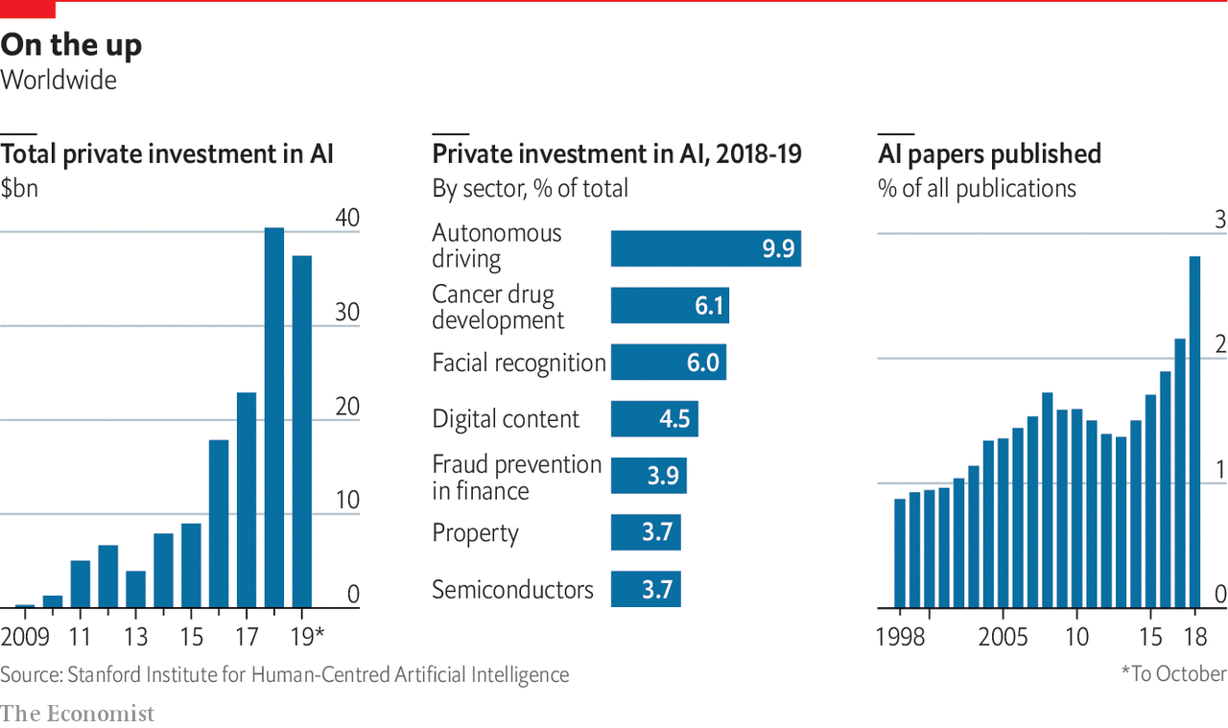

AI’s heralds say further transformations are still to come, for better and for worse. In 2016 Geoffrey Hinton, a computer scientist who has made fundamental contributions to modern AI, remarked that “it’s quite obvious that we should stop training radiologists,” on the grounds that computers will soon be able to do everything they do, only cheaper and faster. Developers of self-driving cars, meanwhile, predict that robotaxis will revolutionise transport. Eric Schmidt, a former chairman of Google (and a former board member of The Economist’s parent company) hopes that AI could accelerate research, helping human scientists keep up with a deluge of papers and data.

In January a group of researchers published a paper in Cell describing an AI system that had predicted antibacterial function from molecular structure. Of 100 candidate molecules selected by the system for further analysis, one proved to be a potent new antibiotic. The covid-19 pandemic has thrust such medical applications firmly into the spotlight. An AI firm called BlueDot claims it spotted signs of a novel virus in reports from Chinese hospitals as early as December. Researchers have been scrambling to try to apply AI to everything from drug discovery to interpreting medical scans and predicting how the virus might evolve.

## Dude, where’s my self-driving car?

This is not the first wave of AI-related excitement (see timeline in next [article](https://www.economist.com/technology-quarterly/2020/06/13/for-ai-data-are-harder-to-come-by-than-you-think)). The field began in the mid-1950s when researchers hoped that building human-level intelligence would take a few years—a couple of decades at most. That early optimism had fizzled by the 1970s. A second wave began in the 1980s. Once again the field’s grandest promises went unmet. As reality replaced the hype, the booms gave way to painful busts known as “AI winters”. Research funding dried up, and the field’s reputation suffered.

Many of the grandest claims made about AI have once again failed to become reality

Modern AI technology has been far more successful. Billions of people use it every day, mostly without noticing, inside their smartphones and internet services. Yet despite this success, the fact remains that many of the grandest claims made about AI have once again failed to become reality, and confidence is wavering as researchers start to wonder whether the technology has hit a wall. Self-driving cars have become more capable, but remain perpetually on the cusp of being safe enough to deploy on everyday streets. Efforts to incorporate AI into medical diagnosis are, similarly, taking longer than expected: despite Dr Hinton’s prediction, there remains a global shortage of human radiologists.

Surveying the field of medical AI in 2019, Eric Topol, a cardiologist and AI enthusiast, wrote that “the state of AI hype has far exceeded the state of AI science, especially when it pertains to validation and readiness for implementation in patient care”. Despite a plethora of ideas, covid-19 is mostly being fought with old weapons that are already to hand. Contacttracing has been done with shoe leather and telephone calls. Clinical trials focus on existing drugs. Plastic screens and paint on the pavement enforce low-tech distancing advice.

The same consultants who predict that AI will have a world-altering impact also report that real managers in real companies are finding AI hard to implement, and that enthusiasm for it is cooling. Svetlana Sicular of Gartner, a research firm, says that 2020 could be the year AI falls onto the downslope of her firm’s well-publicised “hype cycle”. Investors are beginning to wake up to bandwagon-jumping: a survey of European AI startups by MMC, a venture-capital fund, found that 40% did not seem to be using any AI at all. “I think there’s definitely a strong element of ‘investor marketing’,” says one analyst delicately.

This Technology Quarterly will investigate why enthusiasm is stalling. It will argue that although modern AI techniques are powerful, they are also limited, and they can be troublesome and difficult to deploy. Those hoping to make use of AI’s potential must confront two sets of problems.

The first is practical. The machine-learning revolution has been built on three things: improved algorithms, more powerful computers on which to run them, and—thanks to the gradual digitisation of society—more data from which they can learn. Yet data are not always readily available. It is hard to use AI to monitor covid-19 transmission without a comprehensive database of everyone’s movements, for instance. Even when data do exist, they can contain hidden assumptions that can trip the unwary. The newest AI systems’ demand for computing power can be expensive. Large organisations always take time to integrate new technologies: think of electricity in the 20th century or the cloud in the 21st. None of this necessarily reduces AI’s potential, but it has the effect of slowing its adoption.

The second set of problems runs deeper, and concerns the algorithms themselves. Machine learning uses thousands or millions of examples to train a software model (the structure of which is loosely based on the neural architecture of the brain). The resulting systems can do some tasks, such as recognising images or speech, far more reliably than those programmed the traditional way with hand-crafted rules, but they are not “intelligent” in the way that most people understand the term. They are powerful pattern-recognition tools, but lack many cognitive abilities that biological brains take for granted. They struggle with reasoning, generalising from the rules they discover, and with the general-purpose savoir faire that researchers, for want of a more precise description, dub “common sense”. The result is an artificial idiot savant that can excel at well-bounded tasks, but can get things very wrong if faced with unexpected input.

Without another breakthrough, these drawbacks put fundamental limits on what AI can and cannot do. Self-driving cars, which must navigate an ever-changing world, are already delayed, and may never arrive at all. Systems that deal with language, like chatbots and personal assistants, are built on statistical approaches that generate a shallow appearance of understanding, without the reality. That will limit how useful they can become. Existential worries about clever computers making radiologists or lorry drivers obsolete—let alone, as some doom-mongers suggest, posing a threat to humanity’s survival—seem overblown. Predictions of a Chinese-economy-worth of extra GDP look implausible.

Today’s “AI summer” is different from previous ones. It is brighter and warmer, because the technology has been so widely deployed. Another full-blown winter is unlikely. But an autumnal breeze is picking up. ■

This article was downloaded by calibre from <https://www.economist.com/technology-quarterly/2020/06/13/an-understanding-of-ais-limitations-is-starting-to-sink-in>

|  |  |  |  |
| --- | --- | --- | --- |
|  | Articles | Sections | Next |

|  |  |  |  |
| --- | --- | --- | --- |
| Previous | Articles | Sections | Next |

#### Data

# For AI, data are harder to come by than you think

When in doubt, roll your own

Jun 11th 2020 |

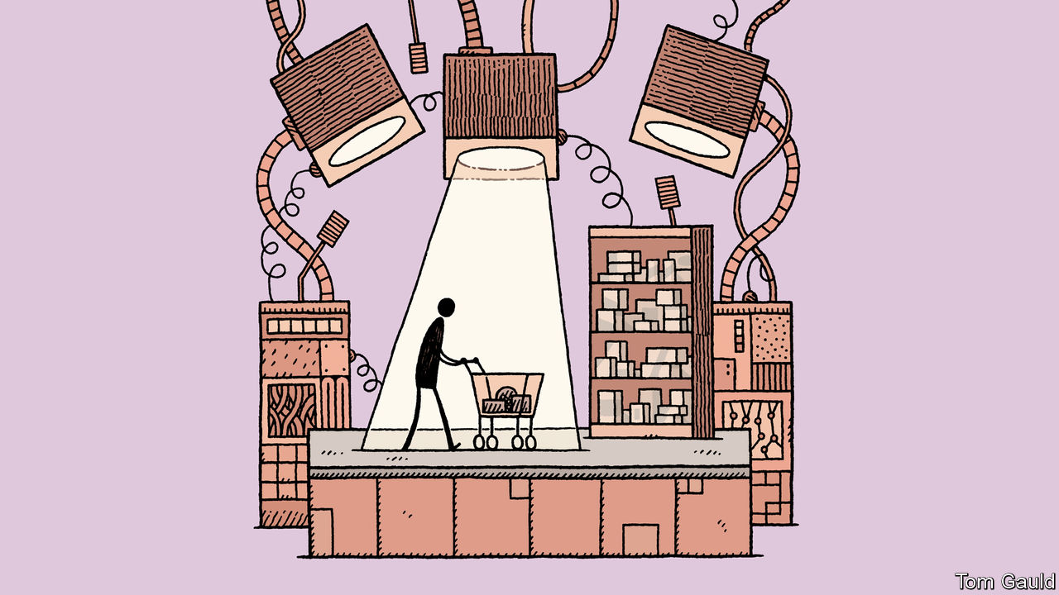

AMAZON’S “GO” STORES are impressive places. The cashier-less shops, which first opened in Seattle in 2018, allow app-wielding customers to pick up items and simply walk out with them. The system uses many sensors, but the bulk of the magic is performed by cameras connected to an AI system that tracks items as they are taken from shelves. Once the shoppers leave with their goods, the bill is calculated and they are automatically charged.

Doing that in a crowded shop is not easy. The system must handle crowded stores, in which people disappear from view behind other customers. It must recognise individual customers as well as friends or family groups (if a child puts an item into a family basket, the system must realise that it should charge the parents). And it must do all that in real-time, and to a high degree of accuracy.

Teaching the machines required showing them a lot of “training data” in the form of videos of customers browsing shelves, picking up items, putting them back and the like. For standardised tasks like image recognition, AI developers can use public training datasets, each containing thousands of pictures. But there was no such training set featuring people browsing in shops.

Some data could be generated by Amazon’s own staff, who were allowed into test versions of the shops. But that approach took the firm only so far. There are many ways in which a human might take a product from a shelf and then decide to choose it, put it back immediately or return it later. To work in the real world, the system would have to cover as many of those as possible.

In theory, the world is awash with data, the lifeblood of modern AI. IDC, a market-research firm, reckons the world generated 33 zettabytes of data in 2018, enough to fill seven trillion DVDs. But Kathleen Walch of Cognilytica, an AI-focused consultancy, says that, nevertheless, data issues are one of the most common sticking-points in any AI project. As in Amazon’s case, the required data may not exist at all. Or they might be locked up in the vaults of a competitor. Even when relevant data can be dug up, they might not be suitable for feeding to computers.

Data-wrangling of various sorts takes up about 80% of the time consumed in a typical AI project, says Cognilytica. Training a machine-learning system requires large numbers of carefully labelled examples, and those labels usually have to be applied by humans. Big tech firms often do the work internally. Companies that lack the required resources or expertise can take advantage of a growing outsourcing industry to do it for them. A Chinese firm called MBH, for instance, employees more than 300,000 people to label endless pictures of faces, street scenes or medical scans so that they can be processed by machines. Mechanical Turk, another subdivision of Amazon, connects firms with an army of casual human workers who are paid a piece rate to perform repetitive tasks.

Cognilytica reckons that the third-party “data preparation” market was worth more than $1.5bn in 2019 and could grow to $3.5bn by 2024. The data-labelling business is similar, with firms spending at least $1.7bn in 2019, a number that could reach $4.1bn by 2024. Mastery of a topic is not necessary, says Ron Schmelzer, also of Cognilytica. In medical diagnostics, for instance, amateur data-labellers can be trained to become almost as good as doctors at recognising things like fractures and tumours. But some amount of what AI researchers call “domain expertise” is vital.

The data themselves can contain traps. Machine-learning systems correlate inputs with outputs, but they do it blindly, with no understanding of broader context. In 1968 Donald Knuth, a programming guru, warned that computers “do exactly what they are told, no more and no less”. Machine learning is full of examples of Mr Knuth’s dictum, in which machines have followed the letter of the law precisely, while being oblivious to its spirit.

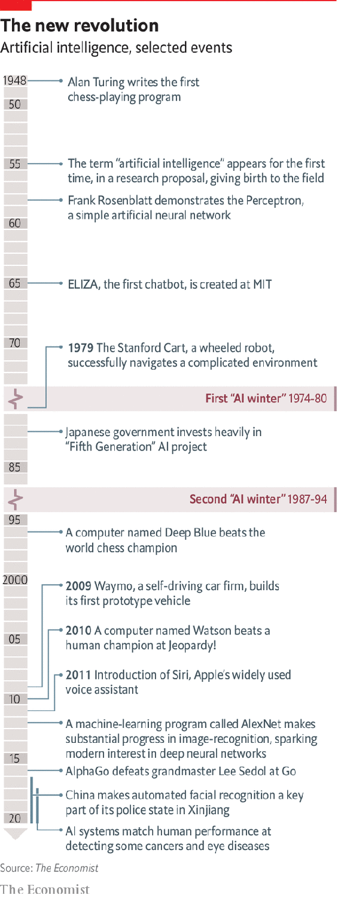

In 2018 researchers at Mount Sinai, a hospital network in New York, found that an AI system trained to spot pneumonia on chest x-rays became markedly less competent when used in hospitals other than those it had been trained in. The researchers discovered that the machine had been able to work out which hospital a scan had come from. (One way was to analyse small metal tokens placed in the corner of scans, which differ between hospitals.)

Since one hospital in its training set had a baseline rate of pneumonia far higher than the others, that information by itself was enough to boost the system’s accuracy substantially. The researchers dubbed that clever wheeze “cheating”, on the grounds that it failed when the system was presented with data from hospitals it did not know.

## Different kind of race

Bias is another source of problems. Last year America’s National Institute of Standards and Technology tested nearly 200 facialrecognition algorithms and found that many were significantly less accurate at identifying black faces than white ones. The problem may reflect a preponderance of white faces in their training data. A study from IBM, published last year, found that over 80% of faces in three widely used training sets had light skin.

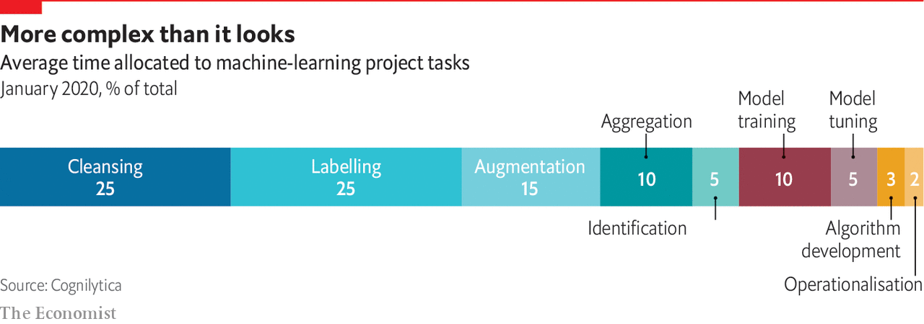

Such deficiencies are, at least in theory, straightforward to fix (IBM offered a more representative dataset for anyone to use). Other sources of bias can be trickier to remove. In 2017 Amazon abandoned a recruitment project designed to hunt through CVs to identify suitable candidates when the system was found to be favouring male applicants. The post mortem revealed a circular, self-reinforcing problem. The system had been trained on the CVs of previous successful applicants to the firm. But since the tech workforce is already mostly male, a system trained on historical data will latch onto maleness as a strong predictor of suitability.

Humans can try to forbid such inferences, says Fabrice Ciais, who runs PwC’s machine-learning team in Britain (and Amazon tried to do exactly that). In many cases they are required to: in most rich countries employers cannot hire on the basis of factors such as sex, age or race. But algorithms can outsmart their human masters by using proxy variables to reconstruct the forbidden information, says Mr Ciais. Everything from hobbies to previous jobs to area codes in telephone numbers could contain hints that an applicant is likely to be female, or young, or from an ethnic minority.

If the difficulties of real-world data are too daunting, one option is to make up some data of your own. That is what Amazon did to fine-tune its Go shops. The company used graphics software to create virtual shoppers. Those ersatz humans were used to train the machines on many hard or unusual situations that had not arisen in the real training data, but might when the system was deployed in the real world.

Amazon is not alone. Self-driving car firms do a lot of training in high-fidelity simulations of reality, where no real damage can be done when something goes wrong. A paper in 2018 from Nvidia, a chipmaker, described a method for quickly creating synthetic training data for self-driving cars, and concluded that the resulting algorithms worked better than those trained on real data alone.

Privacy is another attraction of synthetic data. Firms hoping to use AI in medicine or finance must contend with laws such as America’s Health Insurance Portability and Accountability Act, or the European Union’s General Data Protection Regulation. Properly anonymising data can be difficult, a problem that systems trained on made-up people do not need to bother about.

The trick, says Euan Cameron, one of Mr Ciais’s colleagues, is ensuring simulations are close enough to reality that their lessons carry over. For some well-bounded problems such as fraud detection or credit scoring, that is straightforward. Synthetic data can be created by adding statistical noise to the real kind. Although individual transactions are therefore fictitious, it is possible to guarantee that they will have, collectively, the same statistical characteristics as the real data from which they were derived. But the more complicated a problem becomes, the harder it is to ensure that lessons from virtual data will translate smoothly to the real world.

The hope is that all this data-related faff will be a one-off, and that, once trained, a machine-learning model will repay the effort over millions of automated decisions. Amazon has opened 26 Go stores, and has offered to license the technology to other retailers. But even here there are reasons for caution. Many AI models are subject to “drift”, in which changes in how the world works mean their decisions become less accurate over time, says Svetlana Sicular of Gartner, a research firm. Customer behaviour changes, language evolves, regulators change what companies can do.

Sometimes, drift happens overnight. “Buying one-way airline tickets was a good predictor of fraud [in automated detection models],” says Ms Sicular. “And then with the covid-19 lockdowns, suddenly lots of innocent people were doing it.” Some facial-recognition systems, used to seeing uncovered human faces, are struggling now that masks have become the norm. Automated logistics systems have needed help from humans to deal with the sudden demand for toilet roll, flour and other staples. The world’s changeability means more training, which means providing the machines with yet more data, in a never-ending cycle of re-training. “AI is not an install-and-forget system,” warns Mr Cameron. ■

This article was downloaded by calibre from <https://www.economist.com/technology-quarterly/2020/06/11/for-ai-data-are-harder-to-come-by-than-you-think>

|  |  |  |  |
| --- | --- | --- | --- |
| Previous | Articles | Sections | Next |

|  |  |  |  |
| --- | --- | --- | --- |
| Previous | Articles | Sections | Next |

#### The business world

# Businesses are finding AI hard to adopt

Not every company is an internet giant

Jun 13th 2020 |

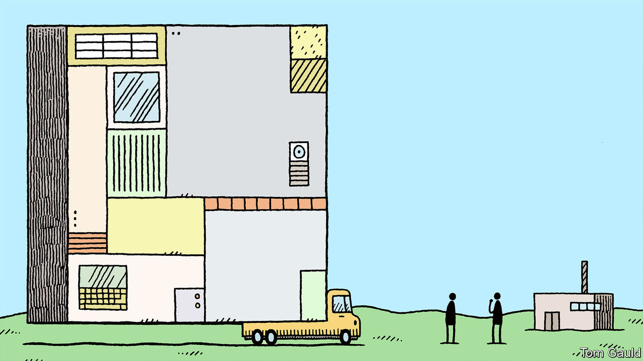

“FACEBOOK: THE INSIDE STORY”, Steven Levy’s recent book about the American social-media giant, paints a vivid picture of the firm’s size, not in terms of revenues or share price but in the sheer amount of human activity that thrums through its servers. 1.73bn people use Facebook every day, writing comments and uploading videos. An operation on that scale is so big, writes Mr Levy, “that it can only be policed by algorithms or armies”.

In fact, Facebook uses both. Human moderators work alongside algorithms trained to spot posts that violate either an individual country’s laws or the site’s own policies. But algorithms have many advantages over their human counterparts. They do not sleep, or take holidays, or complain about their performance reviews. They are quick, scanning thousands of messages a second, and untiring. And, of course, they do not need to be paid.

And it is not just Facebook. Google uses machine learning to refine search results, and target advertisements; Amazon and Netflix use it to recommend products and television shows to watch; Twitter and TikTok to suggest new users to follow. The ability to provide all these services with minimal human intervention is one reason why tech firms’ dizzying valuations have been achieved with comparatively small workforces.

Firms in other industries woud love that kind of efficiency. Yet the magic is proving elusive. A survey carried out by Boston Consulting Group and MIT polled almost 2,500 bosses and found that seven out of ten said their AI projects had generated little impact so far. Two-fifths of those with “significant investments” in AI had yet to report any benefits at all.

Perhaps as a result, bosses seem to be cooling on the idea more generally. Another survey, this one by PwC, found that the number of bosses planning to deploy AI across their firms was 4% in 2020, down from 20% the year before. The number saying they had already implemented AI in “multiple areas” fell from 27% to 18%. Euan Cameron at PwC says that rushed trials may have been abandoned or rethought, and that the “irrational exuberance” that has dominated boardrooms for the past few years is fading.

There are several reasons for the reality check. One is prosaic: businesses, particularly big ones, often find change difficult. One parallel from history is with the electrification of factories. Electricity offers big advantages over steam power in terms of both efficiency and convenience. Most of the fundamental technologies had been invented by the end of the 19th century. But electric power nonetheless took more than 30 years to become widely adopted in the rich world.

Reasons specific to AI exist, too. Firms may have been misled by the success of the internet giants, which were perfectly placed to adopt the new technology. They were already staffed by programmers, and were already sitting on huge piles of user-generated data. The uses to which they put AI, at least at first—improving search results, displaying adverts, recommending new products and the like—were straightforward and easy to measure.

Not everyone is so lucky. Finding staff can be tricky for many firms. AI experts are scarce, and command luxuriant salaries. “Only the tech giants and the hedge funds can afford to employ these people,” grumbles one senior manager at an organisation that is neither. Academia has been a fertile recruiting ground.

A more subtle problem is that of deciding what to use AI for. Machine intelligence is very different from the biological sort. That means that gauging how difficult machines will find a task can be counter-intuitive. AI researchers call the problem Moravec’s paradox, after Hans Moravec, a Canadian roboticist, who noted that, though machines find complex arithmetic and formal logic easy, they struggle with tasks like co-ordinated movement and locomotion which humans take completely for granted.

For example, almost any human can staff a customer-support helpline. Very few can play Go at grandmaster level. Yet Paul Henninger, an AI expert at KPMG, an accountancy firm, says that building a customer-service chatbot is in some ways harder than building a superhuman Go machine. Go has only two possible outcomes—win or lose—and both can be easily identified. Individual games can play out in zillions of unique ways, but the underlying rules are few and clearly specified. Such well-defined problems are a good fit for AI. By contrast, says Mr Henninger, “a single customer call after a cancelled flight has…many, many more ways it could go”.

What to do? One piece of advice, says James Gralton, engineering director at Ocado, a British warehouse-automation and food-delivery firm, is to start small, and pick projects that can quickly deliver obvious benefits. Ocado’s warehouses are full of thousands of robots that look like little filing cabinets on wheels. Swarms of them zip around a grid of rails, picking up food to fulfil orders from online shoppers.

Ocado’s engineers used simple data from the robots, like electricity consumption or torque readings from their wheel motors, to train a machine-learning model to predict when a damaged or worn robot was likely to fail. Since broken-down robots get in the way, removing them for pre-emptive maintenance saves time and money. And implementing the system was comparatively easy.

The robots, warehouses and data all existed already. And the outcome is clear, too, which makes it easy to tell how well the AI model is working: either the system reduces breakdowns and saves money, or it does not. That kind of “predictive maintenance”, along with things like back-office automation, is a good example of what PWC approvingly calls “boring AI” (though Mr Gralton would surely object).

There is more to building an AI system than its accuracy in a vacuum. It must also do something that can be integrated into a firm’s work. During the late 1990s Mr Henninger worked on Fair Isaac Corporation’s (FICO) “Falcon”, a credit-card fraud-detection system aimed at banks and credit-card companies that was, he says, one of the first real-world uses for machine learning. As with predictive maintenance, fraud detection was a good fit: the data (in the form of credit-card transaction records) were clean and readily available, and decisions were usefully binary (either a transaction was fraudulent or it wasn’t).

## The widening gyre

But although Falcon was much better at spotting dodgy transactions than banks’ existing systems, he says, it did not enjoy success as a product until FICO worked out how to help banks do something with the information the model was generating. “Falcon was limited by the same thing that holds a lot of AI projects back today: going from a working model to a useful system.” In the end, says Mr Henninger, it was the much more mundane task of creating a case-management system—flagging up potential frauds to bank workers, then allowing them to block the transaction, wave it through, or phone clients to double-check—that persuaded banks that the system was worth buying.

Because they are complicated and open-ended, few problems in the real world are likely to be completely solvable by AI, says Mr Gralton. Managers should therefore plan for how their systems will fail. Often that will mean throwing difficult cases to human beings to judge. That can limit the expected cost savings, especially if a model is poorly tuned and makes frequent wrong decisions.

The tech giants’ experience of the covid-19 pandemic, which has been accompanied by a deluge of online conspiracy theories, disinformation and nonsense, demonstrates the benefits of always keeping humans in the loop. Because human moderators see sensitive, private data, they typically work in offices with strict security policies (bringing smartphones to work, for instance, is usually prohibited).

In early March, as the disease spread, tech firms sent their content moderators home, where such security is tough to enforce. That meant an increased reliance on the algorithms. The firms were frank about the impact. More videos would end up being removed, said YouTube, “including some that may not violate [our] policies”. Facebook admitted that less human supervision would likely mean “longer response times and more mistakes”. AI can do a lot. But it works best when humans are there to hold its hand. ■

This article was downloaded by calibre from <https://www.economist.com/technology-quarterly/2020/06/13/businesses-are-finding-ai-hard-to-adopt>

|  |  |  |  |
| --- | --- | --- | --- |
| Previous | Articles | Sections | Next |

|  |  |  |  |
| --- | --- | --- | --- |
| Previous | Articles | Sections | Next |

#### Brain scan

# The potential and the pitfalls of medical AI

A pioneering ophthalmologist highlights plenty of both

Jun 13th 2020 |

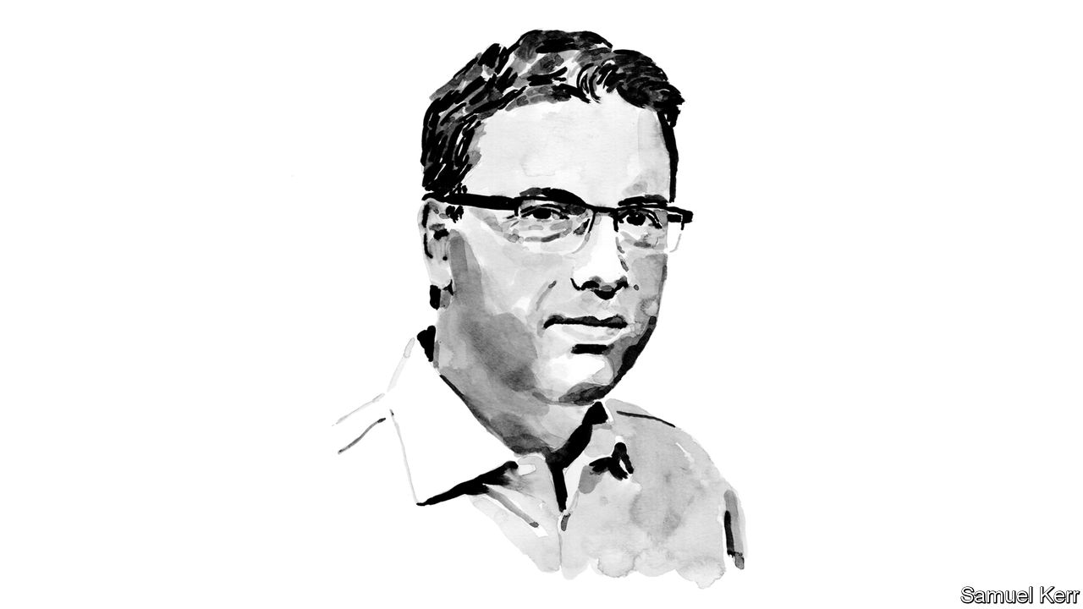

THE BOOKS strewn around Pearse Keane’s office at Moorfields Eye Hospital in London are an unusual selection for a medic. “The Information”, a 500-page doorstop by James Gleick on the mathematical roots of computer science, sits next to Neal Stephenson’s even heftier “Cryptonomicon”, an alt-history novel full of cryptography and prime numbers. Nearby is “The Player of Games” by the late Iain M. Banks, whose sci-fi novels describe a utopian civilisation in which AI has abolished work.

Dr Keane is an ophthalmologist by training. But “if I could have taken a year or two from my medical training to do a computer-science degree, I would have,” he says. These days he is closer to the subject than any university student. In 2016 he began a collaboration with DeepMind, an AI firm owned by Google, to apply AI to ophthalmology.

In Britain the number of ophthalmologists is not keeping up with the falling cost of eye scans (about £20, or $25, from high-street opticians) and growing demand from an ageing population. In theory, computers can help. In 2018 Moorfields and DeepMind published a paper describing an AI that, given a retina scan, could make correct referral decisions 94% of the time, matching human experts. A more recent paper described a system that can predict the onset of age-related macular degeneration, a progressive disease that causes blindness, up to six months in advance.

But Dr Keane cautions that in practice, moving from a lab demonstration to a real system takes time: the technology is not yet being used on real patients. His work highlights three thorny problems that must be overcome if AI is to be rolled out more quickly, in medicine and elsewhere.

The first is about getting data into a coherent, usable format. “We often hear from medics saying they have a big dataset on one disease or another,” says Dr Keane. “But when you ask basic questions about what format the data is in, we never hear from them again.”

Then there are the challenges of privacy and regulation. Laws guarding medical records tend to be fierce, and regulators are still wrestling with the question of how exactly to subject AI systems to clinical trials.

Finally there is the question of “explainability”. Because AI systems learn from examples rather than following explicit rules, working out why they reach particular conclusions can be tricky. Researchers call this the “black box” problem. As AI spreads into areas such as medicine and law, solving it is becoming increasingly important.

One approach is to highlight which features in the model’s input most strongly affect its output. Another is to boil models down into simplified flow-charts, or let users question them (“would moving this blob change the diagnosis?”). To further complicate matters, notes Dr Keane, techies building a system may prefer one kind of explainability for testing purposes, while medics using it might want something closer to clinical reasoning. Solving this problem, he says, will be important both to mollify regulators and to give doctors confidence in the machines’ opinions.

But even when it is widely deployed, AI will remain a backroom tool, not a drop-in replacement for human medics, he predicts: “I can’t foresee a scenario in which a pop-up on your iPhone tells you you’ve got cancer.” There is more to being a doctor than accurate diagnosis.

This article was downloaded by calibre from <https://www.economist.com/technology-quarterly/2020/06/13/the-potential-and-the-pitfalls-of-medical-ai>

|  |  |  |  |
| --- | --- | --- | --- |
| Previous | Articles | Sections | Next |

|  |  |  |  |
| --- | --- | --- | --- |
| Previous | Articles | Sections | Next |

#### Computing hardware

# The cost of training machines is becoming a problem

Increased complexity and competition are part of it

Jun 11th 2020 |

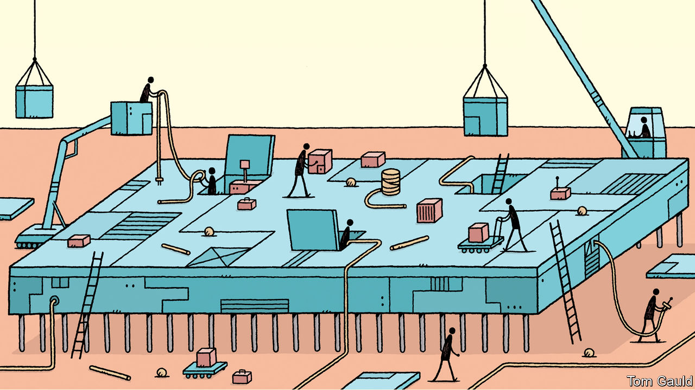

THE FUNDAMENTAL assumption of the computing industry is that number-crunching gets cheaper all the time. Moore’s law, the industry’s master metronome, predicts that the number of components that can be squeezed onto a microchip of a given size—and thus, loosely, the amount of computational power available at a given cost—doubles every two years.

For many comparatively simple AI applications, that means that the cost of training a computer is falling, says Christopher Manning, the director of Stanford University’s AI Lab. But that is not true everywhere. A combination of ballooning complexity and competition means costs at the cutting edge are rising sharply.

Dr Manning gives the example of BERT, an AI language model built by Google in 2018 and used in the firm’s search engine. It had more than 350m internal parameters and a prodigious appetite for data. It was trained using 3.3bn words of text culled mostly from Wikipedia, an online encyclopedia. These days, says Dr Manning, Wikipedia is not such a large data-set. “If you can train a system on 30bn words it’s going to perform better than one trained on 3bn.” And more data means more computing power to crunch it all.

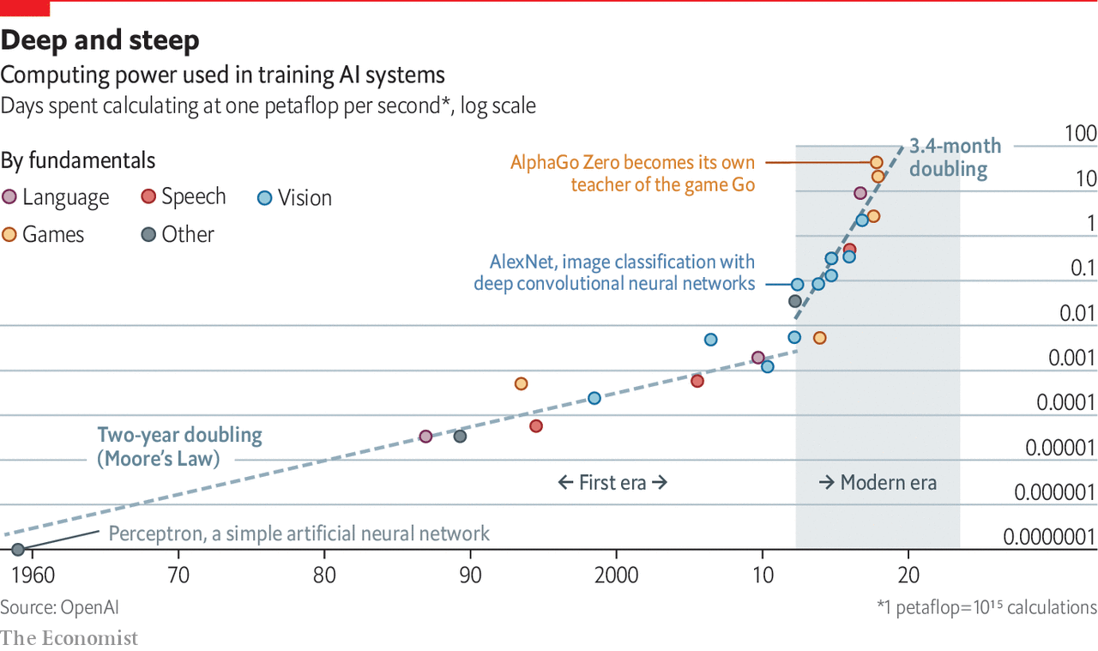

OpenAI, a research firm based in California, says demand for processing power took off in 2012, as excitement around machine learning was starting to build. It has accelerated sharply. By 2018, the computer power used to train big models had risen 300,000-fold, and was doubling every three and a half months (see chart). It should know—to train its own “OpenAI Five” system, designed to beat humans at “Defense of the Ancients 2”, a popular video game, it scaled machine learning “to unprecedented levels”, running thousands of chips non-stop for more than ten months.

Exact figures on how much this all costs are scarce. But a paper published in 2019 by researchers at the University of Massachusetts Amherst estimated that training one version of “Transformer”, another big language model, could cost as much as $3m. Jerome Pesenti, Facebook’s head of AI, says that one round of training for the biggest models can cost “millions of dollars” in electricity consumption.

## Help from the cloud

Facebook, which turned a profit of $18.5bn in 2019, can afford those bills. Those less flush with cash are feeling the pinch. Andreessen Horowitz, an influential American venture-capital firm, has pointed out that many AI startups rent their processing power from cloud-computing firms like Amazon and Microsoft. The resulting bills—sometimes 25% of revenue or more—are one reason, it says, that AI startups may make for less attractive investments than old-style software companies. In March Dr Manning’s colleagues at Stanford, including Fei-Fei Li, an AI luminary, launched the National Research Cloud, a cloud-computing initiative to help American AI researchers keep up with spiralling bills.

The growing demand for computing power has fuelled a boom in chip design and specialised devices that can perform the calculations used in AI efficiently. The first wave of specialist chips were graphics processing units (GPUs), designed in the 1990s to boost video-game graphics. As luck would have it, GPUs are also fairly well-suited to the sort of mathematics found in AI.

Further specialisation is possible, and companies are piling in to provide it. In December, Intel, a giant chipmaker, bought Habana Labs, an Israeli firm, for $2bn. Graphcore, a British firm founded in 2016, was valued at $2bn in 2019. Incumbents such as Nvidia, the biggest GPU-maker, have reworked their designs to accommodate AI. Google has designed its own “tensor-processing unit” (TPU) chips in-house. Baidu, a Chinese tech giant, has done the same with its own “Kunlun” chips. Alfonso Marone at KPMG reckons the market for specialised AI chips is already worth around $10bn, and could reach $80bn by 2025.

“Computer architectures need to follow the structure of the data they’re processing,” says Nigel Toon, one of Graphcore’s co-founders. The most basic feature of AI workloads is that they are “embarrassingly parallel”, which means they can be cut into thousands of chunks which can all be worked on at the same time. Graphcore’s chips, for instance, have more than 1,200 individual number-crunching “cores”, and can be linked together to provide still more power. Cerebras, a Californian startup, has taken an extreme approach. Chips are usually made in batches, with dozens or hundreds etched onto standard silicon wafers 300mm in diameter. Each of Cerebras’s chips takes up an entire wafer by itself. That lets the firm cram 400,000 cores onto each.

Other optimisations are important, too. Andrew Feldman, one of Cerebras’s founders, points out that AI models spend a lot of their time multiplying numbers by zero. Since those calculations always yield zero, each one is unnecessary, and Cerebras’s chips are designed to avoid performing them. Unlike many tasks, says Mr Toon at Graphcore, ultra-precise calculations are not needed in AI. That means chip designers can save energy by reducing the fidelity of the numbers their creations are juggling. (Exactly how fuzzy the calculations can get remains an open question.)

All that can add up to big gains. Mr Toon reckons that Graphcore’s current chips are anywhere between ten and 50 times more efficient than GPUs. They have already found their way into specialised computers sold by Dell, as well as into Azure, Microsoft’s cloud-computing service. Cerebras has delivered equipment to two big American government laboratories.

“Moore’s law isn’t possible any more”

Such innovations will be increasingly important, for the AIfuelled explosion in demand for computer power comes just as Moore’s law is running out of steam. Shrinking chips is getting harder, and the benefits of doing so are not what they were. Last year Jensen Huang, Nvidia’s founder, opined bluntly that “Moore’s law isn’t possible any more”.

## Quantum solutions and neuromantics

Other researchers are therefore looking at more exotic ideas. One is quantum computing, which uses the counter-intuitive properties of quantum mechanics to provide big speed-ups for some sorts of computation. One way to think about machine learning is as an optimisation problem, in which a computer is trying to make trade-offs between millions of variables to arrive at a solution that minimises as many as possible. A quantum-computing technique called Grover’s algorithm offers big potential speed-ups, says Krysta Svore, who leads the Quantum Architectures and Computation Group at Microsoft Research.

Another idea is to take inspiration from biology, which proves that current brute-force approaches are not the only way. Cerebras’s chips consume around 15kW when running flat-out, enough to power dozens of houses (an equivalent number of GPUs consumes many times more). A human brain, by contrast, uses about 20W of energy—about a thousandth as much—and is in many ways cleverer than its silicon counterpart. Firms such as Intel and IBM are therefore investigating “neuromorphic” chips, which contain components designed to mimic more closely the electrical behaviour of the neurons that make up biological brains.

For now, though, all that is far off. Quantum computers are relatively well-understood in theory, but despite billions of dollars in funding from tech giants such as Google, Microsoft and IBM, actually building them remains an engineering challenge. Neuromorphic chips have been built with existing technologies, but their designers are hamstrung by the fact that neuroscientists still do not understand what exactly brains do, or how they do it.

That means that, for the foreseeable future, AI researchers will have to squeeze every drop of performance from existing computing technologies. Mr Toon is bullish, arguing that there are plenty of gains to be had from more specialised hardware and from tweaking existing software to run faster. To quantify the nascent field’s progress, he offers an analogy with video games: “We’re past Pong,” he says. “We’re maybe at Pac-Man by now.” All those without millions to spend will be hoping he is right. ■

This article was downloaded by calibre from <https://www.economist.com/technology-quarterly/2020/06/11/the-cost-of-training-machines-is-becoming-a-problem>

|  |  |  |  |
| --- | --- | --- | --- |
| Previous | Articles | Sections | Next |

|  |  |  |  |
| --- | --- | --- | --- |
| Previous | Articles | Sections | Next |

#### Automobiles

# Driverless cars show the limits of today’s AI

They, and many other such systems, still struggle to handle the unexpected

Jun 13th 2020 |

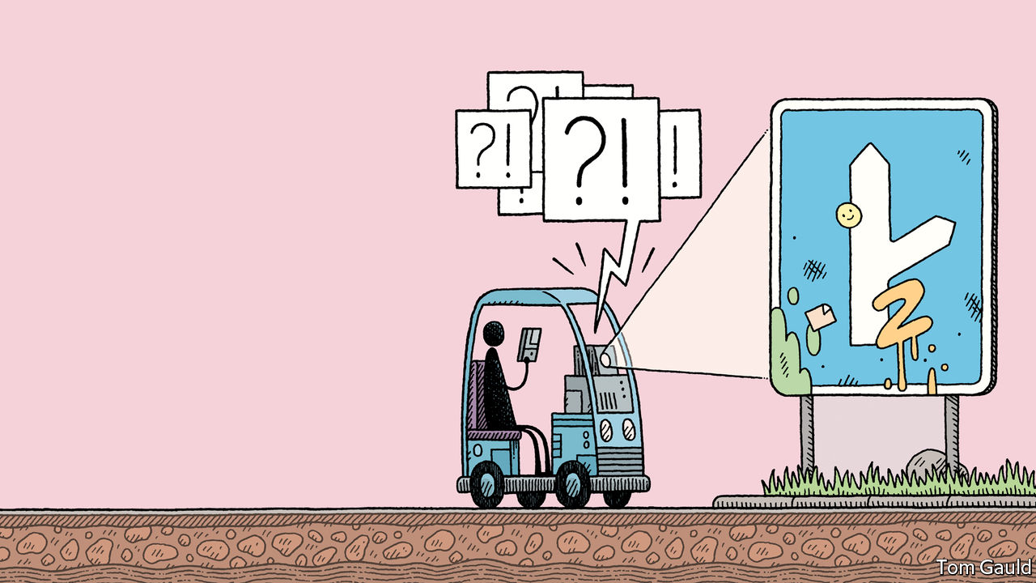

IN MARCH Starsky Robotics, a self-driving lorry firm based in San Francisco, closed down. Stefan Seltz-Axmacher, its founder, gave several reasons for its failure. Investors’ interest was already cooling, owing to a run of poorly performing tech-sector IPOs and a recession in the trucking business. His firm’s focus on safety, he wrote, did not go down well with impatient funders, who preferred to see a steady stream of whizzy new features. But the biggest problem was that the technology was simply not up to the job. “Supervised machine learning doesn’t live up to the hype. It isn’t actual artificial intelligence akin to c-3PO [a humanoid robot from the “Star Wars” films]. It’s a sophisticated pattern-matching tool.”

Policing social media, detecting fraud and defeating humans at ancient games are all very well. But building a vehicle that can drive itself on ordinary roads is—along with getting computers to conduct plausible conversations—one of the grand ambitions of modern AI. Some imagined driverless cars could do away with the need for car ownership by letting people summon robotaxis at will. They believe they would be safer, too. Computers never tire, and their attention never wanders. According to the WHO, over a million people a year die in car accidents caused by fallible human drivers. Advocates hoped to cut those numbers drastically.

And they would do it soon. In 2015 Elon Musk, the boss of Tesla, an electric-car maker, predicted the arrival of “complete autonomy” by 2018. Cruise, a self-driving firm acquired by General Motors in 2016, had planned to launch self-driving taxis in San Francisco by 2019. Chris Urmson, then the boss of Waymo, a Google subsidiary widely seen as the market leader, said in 2015 that he hoped his son, then 11 years old, would never need a driving licence.

But progress has lagged. In 2018 a self-driving car being tested by Uber, a ride-hailing service, became the first to kill a pedestrian when it hit a woman pushing a bicycle across a road in Arizona. Users of Tesla’s “Autopilot” software must, despite its name, keep their hands on the wheel and their eyes on the road (several who seem to have failed to do so have been killed in crashes). The few firms that carry passengers, such as Waymo in America and WeRide in China, are geographically limited and rely on human safety drivers. Mr Urmson, who has since left Waymo, now thinks that adoption will be slower and more gradual.

## Black swans and bitter lessons

Self-driving cars work in the same way as other applications of machine learning. Computers crunch huge piles of data to extract general rules about how driving works. The more data, at least in theory, the better the systems perform. Tesla’s cars continuously beam data back to headquarters, where it is used to refine the software. On top of the millions of real-world miles logged by its cars, Waymo claims to have generated well over a billion miles-worth of data using ersatz driving in virtual environments.

The problem, says Rodney Brooks, an Australian roboticist who has long been sceptical of grand self-driving promises, is deep-learning approaches are fundamentally statistical, linking inputs to outputs in ways specified by their training data. That leaves them unable to cope with what engineers call “edge cases”—unusual circumstances that are not common in those training data. Driving is full of such oddities. Some are dramatic: an escaped horse in the road, say, or a light aircraft making an emergency landing on a highway (as happened in Canada in April). Most are trivial, such as a man running out in a chicken suit. Human drivers usually deal with them without thinking. But machines struggle.

One study, for instance, found that computer-vision systems were thrown when snow partly obscured lane markings. Another found that a handful of stickers could cause a car to misidentify a “stop” sign as one showing a speed limit of 45mph. Even unobscured objects can baffle computers when seen in unusual orientations: in one paper a motorbike was classified as a parachute or a bobsled. Fixing such issues has proved extremely difficult, says Mr Seltz-Axmacher. “A lot of people thought that filling in the last 10% would be harder than the first 90%”, he says. “But not that it would be ten thousand times harder.”

Mary “Missy” Cummings, the director of Duke University’s Humans and Autonomy Laboratory, says that humans are better able to cope with such oddities because they can use “top-down” reasoning about the way the world works to guide them in situations where “bottom-up” signals from their senses are ambiguous or incomplete. AI systems mostly lack that capacity and are, in a sense, working with only half a brain. Though they are competent in their comfort zone, even trivial changes can be problematic. In the absence of the capacity to reason and generalise, computers are imprisoned by the same data that make them work in the first place. “These systems are fundamentally brittle,” says Dr Cummings.

This narrow intelligence is visible in areas beyond just self-driving cars. Google’s “Translate” system usually does a decent job at translating between languages. But in 2018 researchers noticed that, when asked to translate 18 repetitions of the word “dog” into Yoruba (a language spoken in parts of Nigeria and Benin) and then back into English, it came up with the following: “Doomsday Clock is at three minutes to twelve. We are experiencing characters and dramatic developments in the world, which indicate that we are increasingly approaching the end times and Jesus’ return.”

Gary Marcus, a professor of psychology at New York University, says that, besides its comedy value, the mistranslation highlights how Google’s system does not understand the basic structure of language. Concepts like verbs or nouns are alien, let alone the notion that nouns refer to physical objects in a real world. Instead, it has constructed statistical rules linking strings of letters in one language with strings of letters in another, without any understanding of the concepts to which those letters refer. Language processing, he says, is therefore still baffled by the sorts of questions a toddler would find trivial.

How much those limitations matter varies from field to field. An automated system does not have to be better than a professional human translator to be useful, after all (Google’s system has since been tweaked). But it does set an upper bound on how useful chatbots or personal assistants are likely to become. And for safety-critical applications like self-driving cars, says Dr Cummings, AI’s limitations are potentially show-stopping.

Researchers are beginning to ponder what to do about the problem. In a conference talk in December Yoshua Bengio, one of AI’s elder statesmen, devoted his keynote address to it. Current machine-learning systems, said Dr Bengio, “learn in a very narrow way, they need much more data to learn a new task than [humans], they need humans to provide high-level concepts through labels, and they still make really stupid mistakes”.

## Beyond deep learning

Different researchers have different ideas about how to try to improve things. One idea is to widen the scope, rather than the volume, of what machines are taught. Christopher Manning, of Stanford University’s AI Lab, points out that biological brains learn from far richer data-sets than machines. Artificial language models are trained solely on large quantities of text or speech. But a baby, he says, can rely on sounds, tone of voice or tracking what its parents are looking at, as well as a rich physical environment to help it anchor abstract concepts in the real world. This shades into an old idea in AI research called “embodied cognition”, which holds that if minds are to understand the world properly, they need to be fully embodied in it, not confined to an abstracted existence as pulses of electricity in a data-centre.

Biology offers other ideas, too. Dr Brooks argues that the current generation of AI researchers “fetishise” models that begin as blank slates, with no hand-crafted hints built in by their creators. But “all animals are born with structure in their brains,” he says. “That’s where you get instincts from.”

Dr Marcus, for his part, thinks machine-learning techniques should be combined with older, “symbolic AI” approaches. These emphasise formal logic, hierarchical categories and top-down reasoning, and were most popular in the 1980s. Now, with machine-learning approaches in the ascendancy, they are a backwater.

But others argue for persisting with existing approaches. Last year Richard Sutton, an AI researcher at the University of Alberta and DeepMind, published an essay called “The Bitter Lesson”, arguing that the history of AI shows that attempts to build human understanding into computers rarely work. Instead most of the field’s progress has come courtesy of Moore’s law, and the ability to bring ever more brute computational force to bear on a problem. The “bitter lesson” is that “the actual contents of [human] minds are tremendously, irredeemably complex…They are not what should be built in [to machines].”

“This less ambitious stuff—I think that’s much more realistic”

Away from the research labs, expectations around driverless cars are cooling. Some Chinese firms are experimenting with building digital guide rails into urban infrastructure, in an attempt to lighten the cognitive burden on the cars themselves. Incumbent carmakers, meanwhile, now prefer to talk about “driver-assistance” tools such as automatic lane-keeping or parking systems, rather than full-blown autonomous cars. A new wave of startups has deliberately smaller ambitions, hoping to build cars that drive around small, limited areas such as airports or retirement villages, or vehicles which trundle slowly along pavements, delivering packages under remote human supervision. “There’s a scientific reason we’re not going to get to full self-driving with our current technology,” says Dr Cummings. “This less ambitious stuff—I think that’s much more realistic.” ■

This article was downloaded by calibre from <https://www.economist.com/technology-quarterly/2020/06/13/driverless-cars-show-the-limits-of-todays-ai>

|  |  |  |  |
| --- | --- | --- | --- |
| Previous | Articles | Sections | Next |

|  |  |  |  |
| --- | --- | --- | --- |
| Previous | Articles | Sections | Next |

#### The future

# Humans will add to AI’s limitations

It will slow progress even more, but another AI winter is unlikely

Jun 13th 2020 |

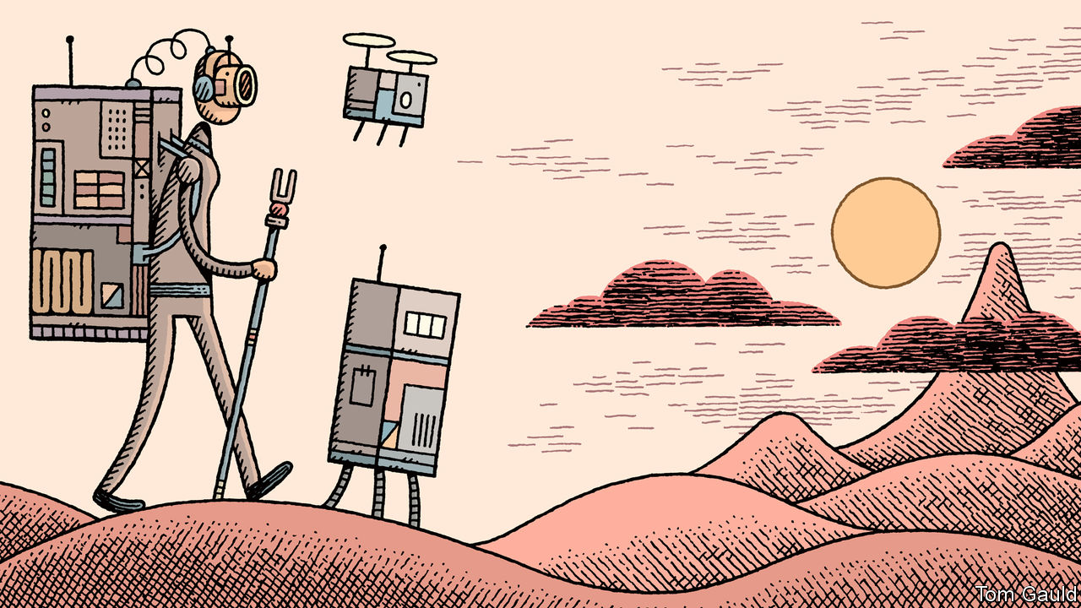

IN 1958 A psychologist and computer-science researcher named Frank Rosenblatt gave a public demonstration of his Perceptron, the distant ancestor of modern machine-learning algorithms. The Perceptron had been developed on a 9-tonne IBM 704, a mainframe computer with less power than a modern television remote control. Its party trick was its ability to learn, without any direct programming, to recognise cards printed on the left from those printed on the right.

America’s navy, which funded the work, hoped the Perceptron would be “the embryo of an electronic computer that…will be able to walk, talk, see, write, reproduce itself and become conscious of its own existence”. The machine would be able to “recognise people and call out their names” and “instantly translate speech in one language to speech or writing in another”.

A sure way to fail is to set expectations too high. In 1969 a widely read book by Marvin Minsky and Seymour Papert, two AI researchers, described how, in contrast to the grand promises, the Perceptron was constitutionally incapable of performing certain elementary tasks. Research into neural networks languished for a decade.

The history of AI is of periodic bouts of overexcitement interspersed with “AI winters”, in which limits become apparent, enthusiasm drains away and funding is slashed. In 1973 the British government abandoned nearly all AI research, citing the field’s failure to meet its “grandiose objectives”. After Minsky and Papert’s book, the focus of AI research turned to “symbolic” approaches that focused on formal logic and rigid, top-down reasoning. Once again, early progress caused much excitement before the unmet promises piled high enough to cause another backlash in the 1980s. Funding cuts closed research projects. American officials dismissed efforts at AI as little more than “clever programming”.

The current bout of enthusiasm has been the biggest yet. Some researchers therefore worry that, as the limits of modern AI become apparent, a correspondingly big bust is coming. In 2018 Filip Piekniewski, an AI researcher at Accel Robotics, a shop-automation startup, likened the excitement around deep learning to a stockmarket just before the bubble bursts. It is impossible to tell precisely when a crash will happen, wrote Dr Piekniewski, but it is “almost certain that it will at some point.”

Perhaps. But disillusionment, if it comes, could arise not just from the growing realisation of modern AI’s technical limitations, but from how they interact with its strengths. Although this report has focused on areas in which AI falls short, there are good reasons for the excitement surrounding it. The ability to spot patterns in tranches of data, sometimes with superhuman accuracy, has a thousand uses. Governments and businesses are rushing to adopt it, in ways that will directly affect ordinary people.

In authoritarian countries those people will have little choice about what is done to them by AI. China already offers a blueprint for AI-enhanced control, most clearly in the police state it has built, with the help of facial recognition, in Xinjiang. In democracies, though, ordinary people—or their representatives—will have some say. They are unlikely to be uncritically welcoming.

On February 5th, for instance, a Dutch court ruled that syRI, an AI-powered system designed to detect tax and social-benefit fraud, was unlawful. The system was designed to inhale reams of data from various government departments and spot odd-looking patterns within them that might reveal mischief. The court held that the Dutch government had failed to balance its obligation to crack down on fraud with its obligation to protect the privacy of its citizens. The campaigners who had brought the case pointed out that the Netherlands is hardly the only place using AI in such ways. Britain and Australia are running similar systems. Researchers hoping to apply AI to covid-19 might reflect on a poll which suggested that around half of Americans would refuse to install a location-tracking contact-tracing app on their phones.

As people become familiar with AI’s peculiar mix of power and fragility they may be reluctant to trust it with important decisions. A study in 2019 from the New York University School of Law and the AI Now Institute examined predictive-policing algorithms. These tell police forces where best to deploy their officers, based on trends from historical crime data. The researchers found 13 jurisdictions, including Chicago and New Orleans, whose police have a history of racist behaviour, were investigating the technology. Training algorithms on racially biased data, say the researchers, risks reinforcing those same biases, this time backed by the potent techno-mystique of “artificial intelligence”. Even in China, there is disquiet: one recent poll found 74% of respondents unhappy about the growing use of facial-recognition for identification.

AI researchers are starting to grapple with these sorts of problems. Two years ago, Google published a set of “AI principles”, saying systems should be “socially beneficial”, “avoid creating or reinforcing unfair bias”, and “be built and tested for safety”. Microsoft and Facebook, have made similar promises. The field of “AI safety”, which wrestles with these questions, is nascent but growing. AI’s incubation among the internet giants means investigations into its broader effects have lagged behind questions about the bottom line. “So much of the development in machine learning has been around ads and social media,” says one executive. “So the focus has been…on accuracy and less on ethics or consequences.”

Facebook employs over 15,000 human content moderators

Indeed, social media is an example of an anti-AI backlash that is already under way. Dismayed by the conspiracy theories and misinformation promoted by algorithms that prioritise “engagement” over all else, countries are passing laws to force firms to blunt their worst impacts. AI is creating jobs, not destroying them: Facebook employs over 15,000 human content moderators to police its algorithms, twice the number it had in 2017.

Brad Smith, the president of Microsoft, has said that instead of asking what AI can do, humans need to think about what it should do. The technological limits of naive, fallible AI, in other words, will lead humans to impose additional political and social limits upon it. Clever algorithms will have to fit into a world that is full of humans, and, in theory at least, run by them. Artificial intelligence is both powerful and limited. As that realisation spreads, some of the dreams of high summer will fade in the autumnal chill. ■

This article was downloaded by calibre from <https://www.economist.com/technology-quarterly/2020/06/13/humans-will-add-to-ais-limitations>

|  |  |  |  |
| --- | --- | --- | --- |
| Previous | Articles | Sections | Next |

|  |  |  |
| --- | --- | --- |
| Technology ... | Sections | Finance & economics |

Business

Business and race in America: The great awakening?

.

Hacking: Basin motives

.

Bartleby: Tale of the century

.

Japan’s bullying bosses: Anger management

.

Turkish companies: Hard landing

.

Virgin: Still smiling, captain?

.

Schumpeter: The great game

.

|  |  |  |
| --- | --- | --- |
| Technology ... | Sections | Finance & economics |

|  |  |  |  |
| --- | --- | --- | --- |
|  | Articles | Sections | Next |

#### Business and race in America

# Bosses say they want to tackle racial injustice

American firms say they want to become more diverse

Jun 11th 2020 | NEW YORK



“I AM BOTH impatient and disgusted.” So declares a letter on race sent on June 1st by Mary Barra, chief executive of General Motors (GM), to all of its suppliers. She is outraged by the killing of George Floyd, the latest in a long string of deaths of unarmed black Americans at the hands of the police. The response of business to the problem should be to “stop asking why and start asking what”, she wrote. Ms Barra put GM’s thousands of suppliers on notice that the firm will not tolerate racism and will stand up against injustice.

It is a sentiment that is echoing across USA Inc. Ken Frazier, Merck’s boss, declared, “This African-American man, who could be me or any other African-American man, was being treated as less than human.” Racial flare-ups are commonplace in America, but the intensity and breadth of the corporate response this time seems different. On June 8th, Arvind Krishna, IBM’s boss, sent a letter to Congress advocating changes to how policing is done, making clear that his firm will not make its facial-recognition software available for racial profiling. Darren Walker, head of the Ford Foundation, a philanthropic organisation, has spoken to two dozen CEOs recently and reports that “everyone is riveted…the murder of George Floyd has gripped the psyche of white Americans like nothing I’ve seen in my lifetime.” A huge number of firms, including The Economist, recognise they need to do more.

Jeffrey Sonnenfeld of Yale University’s School of Management observes that executives used to shy away from controversial topics like race. They are acting now because, “overwhelmingly, people across races have taken on this cause.” A poll published on June 9th by Edelman, a public-relations firm, finds that nearly two-thirds of Americans, including 57% of whites, are “very” or “extremely” concerned about systemic racism.

Are bosses to be taken seriously? There is a long history of corporate waffle and “race washing” that has deflected short-term crises but yielded little substantive change inside firms. The survey by Edelman finds big majorities of blacks and whites expressing hostility towards “performative activism”—posturing—and insisting that firms now making statements about tackling racism “need to follow it up with concrete action” to avoid being seen as exploitative.

Despite these concerns, there are signs that USA Inc is at last serious about tackling racism. Evan Sharp of Russell Reynolds, an executive-search firm, notes that statements on race are going beyond platitudes to be “more intentional and specific”. Linda Hill of Harvard Business School thinks there is “something different about this time”, perhaps because the pandemic has reminded everyone of interdependency: “We are all more empathetic.”

Good intentions of bosses aside, untangling the problem of race and corporate America requires addressing four questions. First, what is the evidence that blacks are disadvantaged in the workplace? Second, how much is business to blame rather than society as a whole? Third, do any such disadvantages impact how businesses perform? And finally, what if anything can business do to improve matters?

Finding definitive numbers on the ethnic make-up of individual firms is impossible because companies hide such data for fear of public shaming or racial-discrimination lawsuits. The federal government requires firms to reveal this data to bureaucrats but it is not made public. No firm is required to reveal pay inequities by race. Only a handful of technology firms, including Intel, voluntarily make data on pay and ethnicity open for scrutiny.

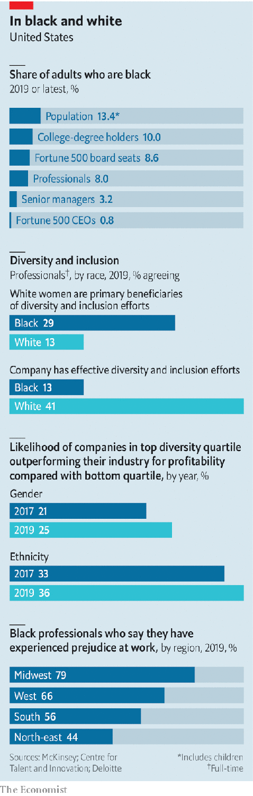

Even so, the picture painted by public data is grim (see chart). Black people make up over 13% of America’s population. However, only four current Fortune 500 CEOs are black (and none are female), and there have been only 17 in the past two decades. Less than 3% of senior corporate jobs and under 8% of all white-collar jobs are held by African-Americans. They comprise just 3% of Silicon Valley’s workforce. Black unemployment is persistently twice that of whites. And the black-white wage disparity, which extends from blue-collar workers to those holding advanced degrees, has grown over the past 20 years.

On the second question, the usual corporate position has been that racial inequity is a problem for society to solve. After all, it is the legacy of slavery and Jim Crow laws that impoverished generations of black Americans. On this view, only government can take on poverty, lousy schools and a flawed justice system. But even that argument does not excuse discrimination at America’s most respected firms. In 2000 Coca Cola was forced by a class-action lawsuit to remedy racist corporate practices. In 2018 Starbucks shut all its coffee shops in America to train workers on racial sensitivity after a national scandal arising from the ejection of black patrons from an outlet in Philadelphia. Texaco, an oil giant now part of Chevron, paid $176m to settle a racial-discrimination suit in 1996. Angela Vallot, brought in then as Texaco’s chief diversity officer, believes there has been “an awful lot of denial” about racism at work.

## Black livelihoods matter

More troubling is evidence that some firms tolerate racism or punish those pushing for more diversity. Research published in the Harvard Business Review pointed to evidence that women and minorities are being penalised for promoting diversity within firms. There is also evidence that the few CEOs from racial minorities are disproportionately and unfairly blamed for poor performance of their firms.

A related argument offered by some for corporate inaction maintains that if there is a race problem facing American business, market forces should be able to solve it. Simon Freakley, chief executive of AlixPartners, a consultancy, rejects this argument: “It’s utterly unrealistic for anybody to bifurcate a societal problem…it’s also a business issue because business exists in society, with employers, customers, suppliers and stakeholders.” Mr Walker thinks such views are “naive and in denial about the hold of racism on our culture, including our business culture.”

Because black and white people in America typically attend different churches, live in different neighbourhoods and attend different schools, business is the main place where races mix, notes Raël Nelson James of Bridgespan, a consultancy. She points to research suggesting that three-quarters of whites have no black people in their social circle. Mr Sharp says that mixing at work “allows the opportunity to have difficult conversations on topics like race.” As 3M, a multinational with headquarters near where Mr Floyd was killed in Minneapolis, acknowledges, “businesses have a responsibility to help lead.”

The case for action becomes stronger when considering the third question about racism’s business impact. Sundiatu Dixon-Fyle and colleagues at McKinsey, a consultancy, have analysed racial and gender diversity at firms in 15 countries from 2014 to 2020. Across three separate reports, they find that the top quartile of firms measured on employee diversity outperform the bottom quartile on metrics such as operating profit margins. Ms Dixon-Fyle explains that the returns to diversity are stronger on race than on gender, and appear to be increasing over time.

It is hard to disentangle causation from correlation because of inadequate disclosure by firms, cautions Stephanie Creary of the Wharton School. Even so, diversity brings benefits. Ms Hill points to many studies suggesting that diverse teams are better at innovation, noting, “You don’t get innovation without diversity and conflict, and that means leaders need to build a capability for creative abrasion.”

## In bad company

Failing to act against racism inside the corporation can also harm companies in several ways. A recent paper in the American Economic Journal scrutinised ethnic prejudice at firms, and found that discriminators are willing to forgo 8% of earnings in order to avoid working with someone of a different ethnicity. This clearly works against the interests of shareholders.

There is also a growing reputational risk. The survey by Edelman found that over half of whites expect brands to take a stand on racial justice and over two-thirds of Republicans say a company’s response to the recent race protests will determine whether its brand keeps or gains trust. Paul Weiss, an American law firm, faced a backlash last year when it emerged that its new class of partners were all white. Brad Karp, its chairman, responded to the furore by transforming the firm’s management of diversity and inclusion, including introduction of artificial intelligence to detect implicit bias among managers doing performance reviews. “It’s not about money but mentorship and opportunities…the culture must be a welcoming one,” he says.

That points to the final question: what should firms do? Start with what they should not do. Bosses should not place faith in race-based quotas. “Affirmative action has not worked in corporate America,” declares Michele Meyer-Shipp of KPMG, a consultancy. She says black professionals do not want the scales tipped in their favour because “when they get a seat at the table they will not have the voice or sense of belonging.” Firms that have promoted women into the “old boys’ club” should not rest on their laurels. Ms Nelson James says that “affirmative action may have missed the mark by helping white women but not measuring the effect on the most marginalised group.” A recent study by the Centre for Talent Innovation, a think-tank, found that 29% of blacks felt that white women were the main beneficiaries of corporate-diversity efforts, and only 13% felt these schemes were effective at all.

Bosses also need to avoid the mirage of meritocracy. Ms Hill argues that few firms are true meritocracies, pointing to ample research suggesting that managers tend to trust and empower people similar to themselves. “This is how systemic racism works inside organisations,” she says.

That points to the first prescription: firms serious about advancing blacks must focus efforts on race. Ms Vallot argues that because race is difficult to talk about, diversity discussions have “watered down the topic” by including gender and other issues. A headhunter sees a box-ticking mindset undermining progress: “OK, we got a woman, so we are not un-diverse.”

Experts recommend creating a diversity strategy specifically for black employees, implementing clear and consistent standards for promotion and securing a firm commitment from the top to overcome bias among middle managers. This has to be “owned by the CEO and made a strategic priority, not hived off to outside consultants or a chief diversity officer,” insists Ms Vallot. Microsoft, Intel and Johnson & Johnson have tied executive pay to specific diversity metrics, but this is rare.

That points to the importance of metrics and measurement. Ms Vallot insists firms must have goals and targets (as distinct from legal quotas) broken down by race for attraction and promotion. If those are missed, managers must explain the reasons. Why did promising executives leave the firm? Did they have mentors? Mauricio Gutierrez, boss of NRG Energy, says his firm is studying pay equity and notes that most hiring managers require four-year or advanced degrees even though most jobs require technical skills not taught in those degree programmes. Because many talented minority applicants cannot afford such degrees, he wants to end such blanket requirements.

The toughest part is teaching old dogs new tricks. Managing newly diverse teams is harder initially than working with people from a similar background. Ms Meyer-Shipp thinks it is crucial to teach managers how to lead inclusively, or else their “affinity bias” may undermine corporate efforts. She observes that white managers are often hesitant to give black employees candid and frequent feedback. This backfires when the workers who think they are doing well suddenly get sacked. Challenged about this, the managers typically use euphemisms like “she just wasn’t exuding enough executive presence.”

Corporate America at last looks determined to take on racism in business. Josh Bolten, head of the Business Roundtable, which represents big American firms, says that there is even “widening shareholder appreciation that the corporation needs to serve something more than the immediate financial return to the shareholders.” Ms Meyer-Shipp sees a tipping point, with recent events a “wake-up call as the lack of progress on race is evident.”

The last week had echoes of tumultuous years such as 1918, 1935 and 1968, when America’s economy and its fabric were shaken, reckons Mr Walker. It may lead to a great awakening at USA Inc. “The unprecedented convergence of health, economic and social crises has happened in a way that I am left feeling hopeful about corporate America realising the potential of greater diversity.”■

This article was downloaded by calibre from <https://www.economist.com/business/2020/06/11/bosses-say-they-want-to-tackle-racial-injustice>

|  |  |  |  |
| --- | --- | --- | --- |
|  | Articles | Sections | Next |

|  |  |  |  |
| --- | --- | --- | --- |
| Previous | Articles | Sections | Next |

#### Basin motives

# Sleuths uncover a particularly brazen case of cyber-mischief

Targets included judges, MPs, journalists and ordinary people going through messy divorces

Jun 13th 2020 |

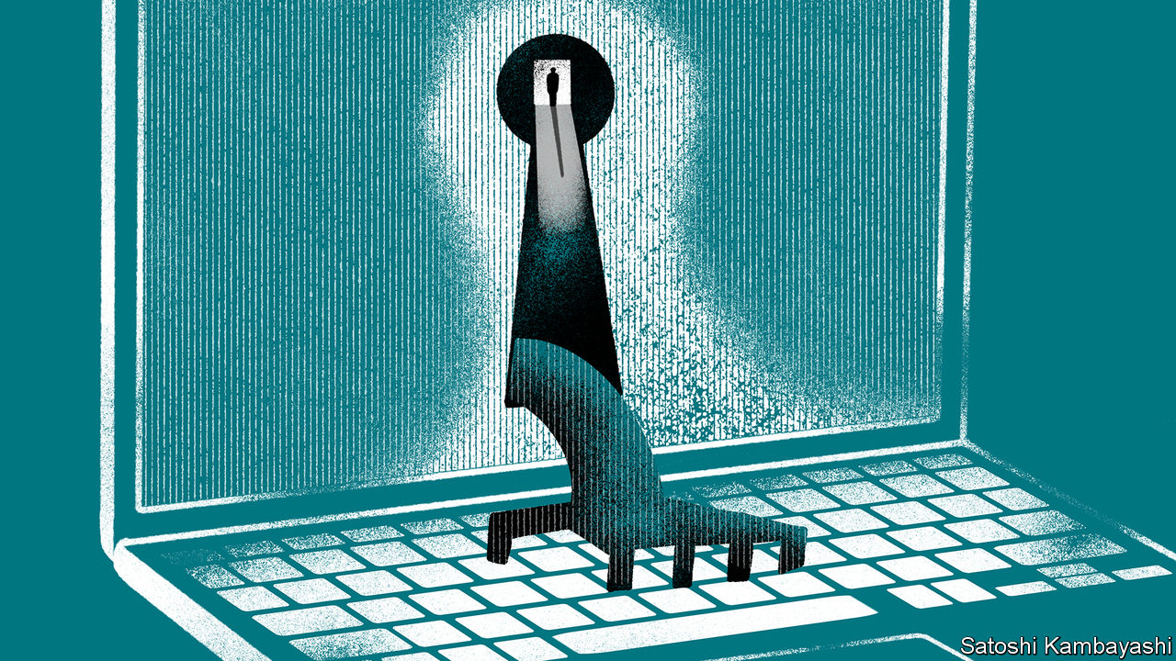

COMPANIES SUFFER hacking attacks on a daily basis. The most recent known victim was Honda, which announced that its computers had been locked down by ransomware on June 9th. Stories about the firms suspected of doing the hacking, though, are rarer. Also on June 9th CitizenLab, part of the Munk School of Government at the University of Toronto, said that it had unearthed one of the biggest-known groups of such workaday, mercenary hackers, which it has dubbed “Dark Basin”.

This outfit has targeted thousands of people at hundreds of organisations all over the world, carrying out what Norton LifeLock, a cyber-security firm that worked with CitizenLab, describes as “financial, political and industrial espionage”. Its targets have included company bosses, judges, journalists, members of various parliaments, government officials and ordinary people in the midst of a divorce in America, Mexico and elsewhere.

Most of the attacks involved “phishing” attempts, in which hackers try to trick targets into handing over usernames and passwords. Emails that appear to come from friends or colleagues contain links that, when clicked on, reveal convincing replicas of legitimate sites such as social networks or email providers. Anyone attempting to log in would be handing their username and password to the attackers. Some victims were bombarded almost daily with carefully crafted emails whose details suggested the hackers knew quite a bit about them. Others were followed in the real world at the same time they were being stalked online.

Attributing hacks to a specific actor is tricky. But a combination of technical breadcrumbs, linguistic cues, public boasting by the hackers themselves and the fact that the attacks happened during the Indian working day, led CitizenLab to point the finger at a company based in New Delhi, BellTroX InfoTech Services. The firm purports to offer everything from medical-transcription services to “penetration testing”, a legitimate form of hacking in which experts are contracted by a company looking to test its electronic defences.

BellTroX’s boss, Sumit Gupta, has been in trouble before. Along with several American private investigators, he was indicted on a separate set of hacking charges in California in 2015. Soon after CitizenLab’s report was released, BellTroX’s website disappeared. (Requests for comment went unanswered, though Mr Gupta has told Reuters, a news agency, that he provided nothing more than “technical support”.)

While CitizenLab is willing to point the finger at the suspected hackers, it is less sure about who did the hiring. Some of the targets were involved in a campaign called “ExxonKnew”, which alleges that ExxonMobil, an oil firm, spent decades deliberately playing down the severity of climate change. (In 2019 ExxonMobil won a court case in New York on the matter.) However, CitizenLab did not accuse the firm of commissioning the attacks and an ExxonMobil spokesman denied the firm had knowledge of, or was involved in, the hacks.

Another group of targets appear to have been journalists covering Wirecard, a German payments-processing firm embroiled in an accounting scandal (on June 5th police raided its offices in Munich). Attacks seem also to have been made against hedge funds with a short position in Wirecard’s stock. Once again, the report does not allege that Wirecard commissioned the attacks. (Wirecard says it has not been in contact with a hacker group from India.)

John Scott Railton, one of the report’s authors, says that the brazen nature of the hacking suggests those responsible were not worried about legal consequences. Hacking-for-hire holds appeal for anyone aiming to play dirty, he says, and may have become a standard tool for private investigators. “These kinds of services allow their clients to cause trouble from a distance, in a different jurisdiction, with minimal friction and not much chance of getting caught.” Businesses—and anyone caught up in a bad-tempered divorce—beware.■

This article was downloaded by calibre from <https://www.economist.com/business/2020/06/13/sleuths-uncover-a-particularly-brazen-case-of-cyber-mischief>

|  |  |  |  |
| --- | --- | --- | --- |
| Previous | Articles | Sections | Next |

|  |  |  |  |
| --- | --- | --- | --- |
| Previous | Articles | Sections | Next |

#### Bartleby

# Lessons from 100 columns

Management in theory and practice is found wanting

Jun 13th 2020 |

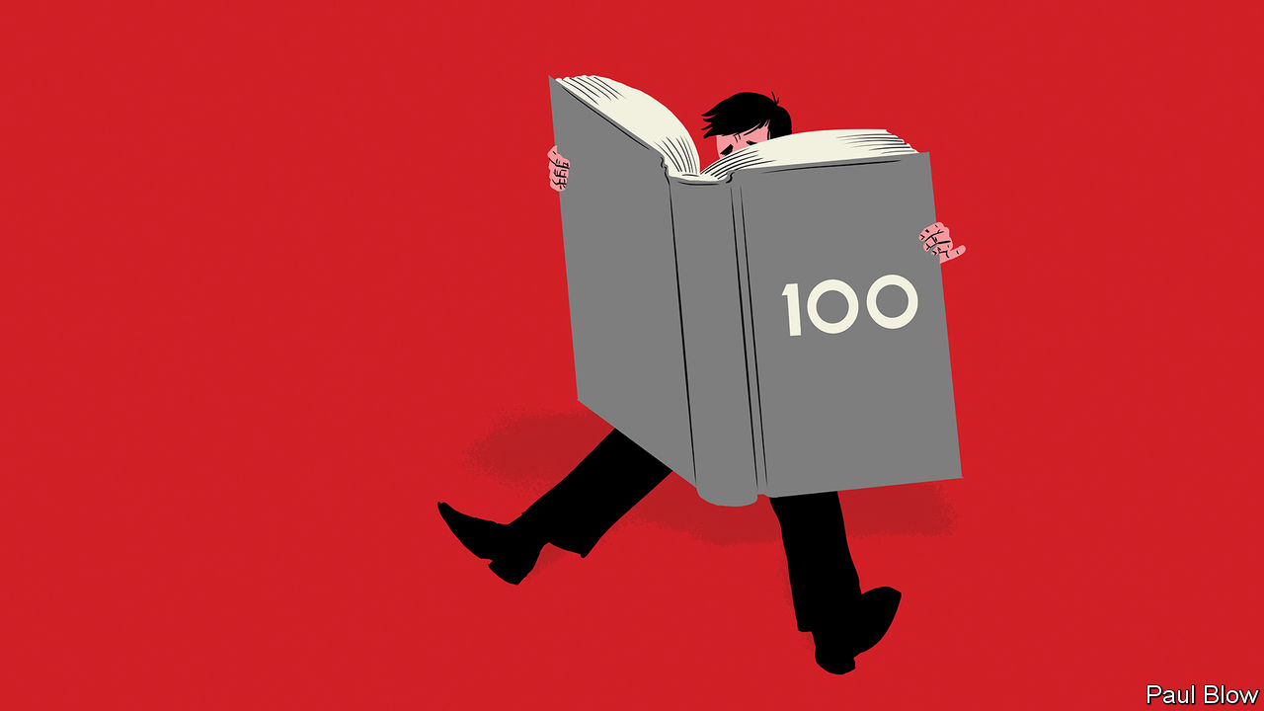

WHEN A CRICKETER reaches 100 runs, they have the chance to reflect on what they have achieved, but also to take a “fresh guard” so they are ready for the challenges that await. So a 100th Bartleby column represents a chance to consider what this writer has learned so far, and how much he still needs to find out.

Perhaps the most remarkable discovery was how much is written about management. Back at The Economist’s offices, books are piled high by Bartleby’s desk; so many that it would be impossible to read them all. Either the laws of supply and demand are broken, or there is a huge appetite to learn how to manage.

Admittedly, many of these books are hard to read. The authors use “architect” as a verb and “learnings” as a noun. They randomly Capitalise every Other word. And they are overly fond of PEAs (pointless esoteric acronyms).

The sheer variety of advice suggests that the task of managing people in the modern era is rather difficult. Early management theory was largely concerned with maximising the output of manufacturing workers, and tended to treat people as recalcitrant cogs in a machine. The output of such workers was easy to measure; it was all a matter of producing more widgets per hour.

The modern economy is dominated by the service sector where measuring productivity is difficult. Volume and speed may not be the best measures. A call-centre worker may handle 20 conversations per hour but if most customers go away dissatisfied, the time has not been well used. Creative workers may get their ideas by reading a book, or reflecting during a long walk.

So gurus now suggest managers should be coaches—like Phil Jackson of the Chicago Bulls basketball team or Jürgen Klopp of Liverpool Football Club. The tone should be more guidance counsellor than regimental sergeant-major. Many high-skilled workers have been treated this way for some time. The approach is now being tried further down the corporate hierarchy.

The trouble is that humans come with many different personality types and not all respond to the same coaching strategies. Some need the reassurance of a daily chat with their boss; others will regard that as tiresome interference. Some may respond well to constructive criticism; for others it may destroy their morale. No single approach can possibly be right (good news for writers of management books, who can keep churning them out).

Another big problem is the typical corporate structure. A system created in the 20th century for mass-manufacturing companies is lingering into the 21st, just because nobody can reimagine it. It was a command-and-control system in which middle managers communicated guidance from top executives to the workforce. Modern technology has eliminated the need for this function.

As usual, the technology sector has been the leader with “agile” teams made up of colleagues from across the organisation collaborating on short-term projects. Perhaps managers should be more agile, in charge of some projects and merely team members for others? And if remote working becomes more common, how will that affect management structures? How do you build a relationship between supervisor and employee if the two never meet?

At the top, a focus solely on shareholder value, associated with the 1990s boom, is no longer appropriate. The modern senior executive must be a statesman (or woman), dealing not just with shareholders but wider society. They must be attuned to the views of their employees and customers, in case the company finds itself in the middle of a social or political conflict. And they have to navigate these minefields while simultaneously generating sufficient profit growth to fend off attacks from activist shareholders.

The monetary rewards of managers are linked to financial targets, rather than these broader criteria. The task for the next few years is to find ways to measure the executive’s success in dealing with staff and other stakeholders, when clear yardsticks are hard to find.

Indeed, lack of clarity is the besetting sin of managers (and management theory). Bartleby has had much opportunity to mock the jargon used in corporate statements. If managers cannot express themselves clearly, that suggests to staff that they are not thinking clearly either. So here is a plea to executives. Next time you write a memo, show it to a relative and ask if they understand it. If they don’t, throw it in a bin and start again.

This article was downloaded by calibre from <https://www.economist.com/business/2020/06/13/lessons-from-100-columns>

|  |  |  |  |
| --- | --- | --- | --- |
| Previous | Articles | Sections | Next |

|  |  |  |  |
| --- | --- | --- | --- |
| Previous | Articles | Sections | Next |

#### Anger management

# Japan’s bullying bosses

A new law seeks to curb abusive executives

Jun 13th 2020 | TOKYO

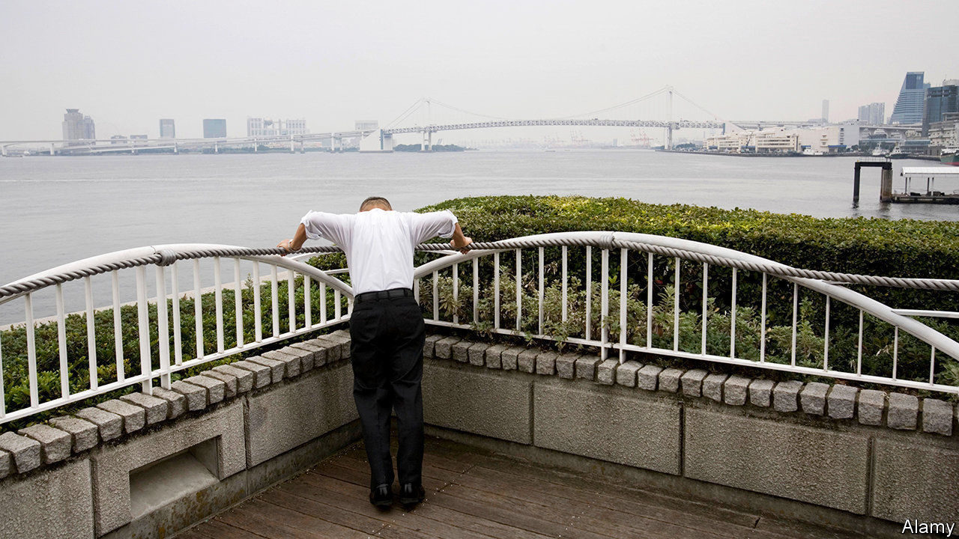

AS HONDA SOICHIRO built his company from a small producer of engines to attach to bicycles into a global carmaking giant, he developed a reputation as a talented engineer and a maverick executive. He was also known to be an exacting boss, even a violent one. “When he got mad, he blindly reached for anything lying around, and started throwing whatever was in reach randomly at people,” one former executive later recalled. Such fiery tempers remain all too common among Japanese managers. A Japanese psychologist even coined a term to describe the particular abuse that the country’s supervisors pile upon some of their employees: pawahara, or power harassment.

Complaints of harassment in the workplace have been growing in recent years, hitting a record high of 82,797 in 2018, up from 32,242 a decade earlier. In 2016 the country’s labour ministry found that a third of Japanese workers had experienced power harassment in the past three years. The trend worried the government enough to spur recent passage of anti-harassment legislation. As of June 1st, Japanese firms are required to have clear policies in place and to create internal systems for reporting and verifying claims of abuse.

At the extreme end, workplace bullying can still include physical violence of the sort displayed by Honda. More typically, it manifests itself in all manner of verbal, emotional and psychological abuse. Japan’s labour ministry defines six categories of power harassment: physical attacks, mental attacks, social isolation, excessive demands, demeaning demands and privacy infringements. Suicides linked to power harassment are not uncommon. Cases cut across sectors and classes. One MP from the ruling Liberal Democratic Party resigned from the party after a recording surfaced that allegedly captured her hitting an assistant as well as calling him “baldy”.

Although bad bosses are a universal phenomenon, Japanese workplaces can be particularly conducive to the worst sort of behaviour. Hierarchies are rigid and deeply rooted. What bosses see as tough love can come across as hurtful to junior employees, especially as behavioural norms change between generations, says Inao Izumi of Cuore C Cube, the consultancy that first defined pawahara. The inflexibility of Japan’s labour market compounds the problem. “People can’t easily quit if they hate their boss and companies can’t easily fire bad bosses,” says Rochelle Kopp of Japan Intercultural Consulting.

Critics counter that the new law is both too vague and too toothless to help put-upon workers. Small and medium-sized firms do not have to comply until 2022. The law does not apply to part-time workers, who make up more than a third of the Japanese labour force. Nor does it specify punishments for harassers, leaving it up to companies to decide what action to take. “The law merely warns offenders—it’s like a yellow card,” says Kaneko Masaomi of the Workplace Harassment Research Institute. Until bad bosses have to worry about being sent off the pitch, their untoward actions are unlikely to stop.■

This article was downloaded by calibre from <https://www.economist.com/business/2020/06/13/japans-bullying-bosses>

|  |  |  |  |
| --- | --- | --- | --- |
| Previous | Articles | Sections | Next |

|  |  |  |  |
| --- | --- | --- | --- |
| Previous | Articles | Sections | Next |

#### Hard landing

# Life is tough for Turkish businesses

But the pandemic may bring opportunity as well as woes

Jun 13th 2020 | ISTANBUL



KALE GROUP, an aerospace and construction conglomerate, had been making and assembling engine parts for America’s F-35 stealth fighter jet since 2005. But when Turkey’s president, Recep Tayyip Erdogan, purchased a missile-defence system from Russia last year, the American government booted its NATO ally from the F-35 programme. Turkey’s air force has ordered 100 of the planes but has taken delivery of none. Turkish firms lost contracts worth an estimated $9bn. Kale was among those most affected. And then came covid-19.

Doing business in Turkey takes guts. In the past five years, the country has endured several episodes that have dented business confidence: dozens of big terror attacks, a violent coup attempt followed by a crackdown against dissidents, a currency crisis, diplomatic rows with Europe and America, and seven tense, divisive elections. But nothing has blindsided companies as badly as the pandemic.

A serious recession is under way. Exports have plummeted despite a weakening lira and unemployment is poised to reach record highs. A tourism industry that brings in $35bn is bracing for its worst year in decades. Kale has stayed the course, completing existing work on the F-35, supplying Turkey’s budding defence sector and producing components for civilian planes, but continues to face turbulence.

As lockdowns affected global supply chains, Kale has struggled to source materials from abroad. At home, cash-strapped customers are cancelling orders. “We’re operating at between 50% and 70% capacity,” says Zeynep Bodur Okyay, the firm’s boss. The company has not cut jobs. Mr Erdogan’s government has banned companies from making lay-offs for six months.

Despite the gloom, there may be room for optimism for some firms. Multinationals had begun to rethink their reliance on China even before the pandemic struck, and are more likely to do so now. Turkey should be in a position to reap the rewards. Low labour costs, made even lower by a weak lira, proximity to European markets and a customs union with the EU, mean Turkey can strengthen its position in global supply chains, says Alicia Garcia-Herrero of Bruegel, a Brussels think-tank.

Turkish textile producers saw some evidence of this at the start of the year. Gurmen, a maker of menswear, saw orders increase by about 4-6% compared with a year ago in both January and February, when the lockdown in China forced European retailers to look for producers elsewhere. Turkey’s clothing sector as a whole saw an uptick of nearly 7% in exports over the same period compared with 2019, before a plunge of nearly 28% in March, when the pandemic struck home.

Turkish businesses will still need to attract outside investment. The instability of recent years, as well as the loss of central-bank independence and the takeover of key institutions by often under-qualified government loyalists, has led Western investors to give Turkey a wide berth. Chinese ones are cautious. To date, China has invested less in Turkey than in Venezuela. Unless it fixes its institutions, especially the central bank and judiciary, and relations with America and Europe, foreigners will stay away, leaving Turkish firms to recover from the pandemic on their own.■

Editor’s note: Some of our covid-19 coverage is free for readers of The Economist Today, our daily [newsletter](https://my.economist.com/user#newsletter). For more stories and our pandemic tracker, see our [coronavirus hub](https://www.economist.com/news/2020/03/11/the-economists-coverage-of-the-coronavirus)

This article was downloaded by calibre from <https://www.economist.com/business/2020/06/13/life-is-tough-for-turkish-businesses>

|  |  |  |  |
| --- | --- | --- | --- |
| Previous | Articles | Sections | Next |

|  |  |  |  |
| --- | --- | --- | --- |
| Previous | Articles | Sections | Next |

#### Still smiling, captain?

# Virgin looks for help

Richard Branson’s business empire faces pandemic disruption

Jun 13th 2020 |

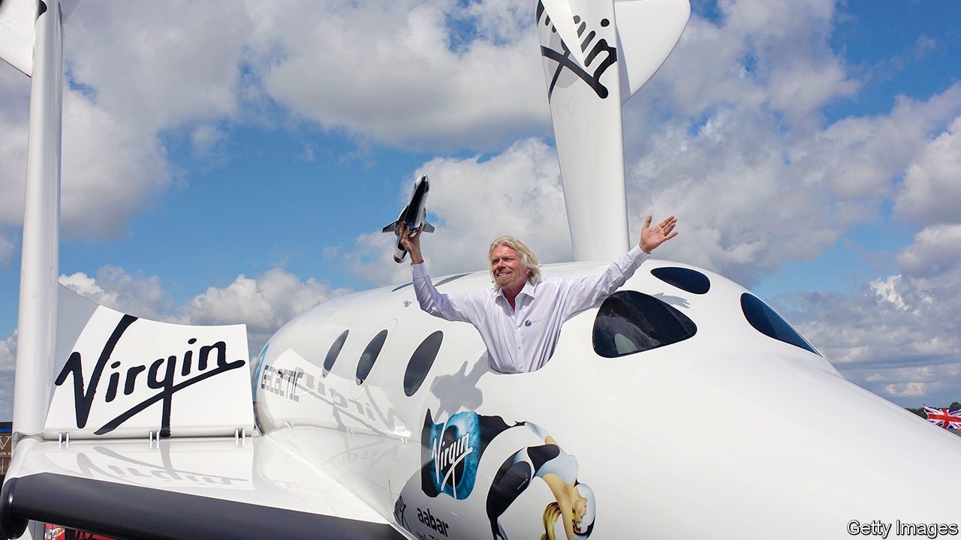

NO OTHER BUSINESS figure holds a candle to Sir Richard Branson when it comes to public-relations stunts. Not all of the British entrepreneur’s capers go off without a hitch, however: he was once rescued by an RAF helicopter when his speedboat capsized while attempting a record-breaking Atlantic crossing. His record in business with his Virgin-branded empire is also studded with successes and failures, among the latter being Virgin Cola, Virgin Brides (an attempt to disrupt the wedding industry) and Virgin Cars (a short-lived online retailer). Through thick and thin the bearded tycoon has hustled on, armed with a high-profile brand and a cheesy perma-grin. At the end of 2019 his empire was estimated to be worth over £4bn ($5.1bn)

That, though, was before covid-19. The Virgin group was heavily exposed to virus-induced shutdowns: among its businesses are two airlines, hotels, gyms and a cruise line. (Other interests include banking, mobile-phone and broadband networks and space tourism.) In March Sir Richard—who owns Virgin outright—said its travel, leisure and wellness businesses faced “a massive battle to survive and save jobs”.

His carefully crafted image as the corporate world’s lovable outsider has taken a hit. Critics cried hypocrisy when Virgin Atlantic (VA), a long-haul airline, asked the British government for a bail-out; Sir Richard had said a decade earlier, when arch-rival BA posted a record loss, that weak firms should be allowed to die. They also noted that a rescue for a tax exile might be a bit rich. Sir Richard and the group’s parent company are both domiciled in the tax- and disclosure-light British Virgin Islands. (Virgin says he moved there for lifestyle reasons, not tax, and that the main operating companies pay tax in Britain.)

The government’s rejection of a bail-out has forced managers to come up with a plan to shore up VA. The shareholders (Virgin, with 51%, and Delta, an American airline, with 49%) will defer taking fees, such as royalties; private investors are being courted for loans; the airline is hoping to renegotiate aircraft leases. It is cutting 3,150 jobs and closing hubs at Gatwick and Newark, New Jersey; and it is back in talks over a government loan, or a guarantee that would tempt credit-card firms to release frozen booking payments. A spokesman says VA “remains in a stable position”.

Virgin is also looking to revive Virgin Australia, the country’s second-largest airline until it slid into administration in April, rendering Virgin’s 10% stake worthless. Two private-equity firms are sniffing around. Final bids are due by June 22nd. Virgin may co-invest in a recapitalisation. Neither airline was in rude health even before covid-19. VA lost £26m in 2018, the last year for which it has filed accounts. It has hired a restructuring firm to work on options, including a contingency plan for a “pre-packaged” bankruptcy.

A business that hopes to operate at a higher altitude may act as saviour: Sir Richard’s space-tourism venture, Virgin Galactic, which was floated in New York last year. In recent weeks a Branson-controlled BVI firm, Vieco 10, has sold 37.5m Galactic shares, raising $560m but cutting the tycoon’s stake from over 50% to around 30%.

The proceeds will be used across the Virgin group to cushion the blow from the pandemic. They exceed the $360m in extra liquidity that Virgin’s managers, led by Josh Bayliss, reckon will be needed over the next year to ensure that all the businesses can keep trading. But that estimate has already been raised once, and the group acknowledges that more will be needed for 2021-22. Moreover, Sir Richard may be loth to cut his stake in Galactic further. The business, currently valued at $3.4bn, is still widely seen as promising, despite being beset by delays. Some 600 would-be space travellers have paid $80m in deposits.

Covid could have come at a better time for Virgin. If it had struck just after the sale of Virgin America, another airline, to Alaska Air Group in 2016, the group would have been flush with the proceeds of over £800m. Instead, it came “deep in the investment cycle”, Mr Bayliss says. Virgin does not tend to sit on gains from sales for long, thanks to its owner’s restless desire to keep trying new things.

Some of these nascent businesses looked bright before covid but are now beleaguered. The first ship in the Virgin Voyages cruise line, a joint venture with Bain Capital, sits off the Florida coast, diverted there while en route to a launch event in New York when the virus struck. The price tag for that vessel and three more being built is €3bn ($3.4bn). Virgin says the fleet has sufficient funding and it now hopes to launch in October.

The newish hotels business, with properties opened or planned in several American cities, has also been clobbered. Of the three already up and running, only Chicago is currently taking bookings. Some of Virgin’s older businesses are feeling acute pain, too. Virgin Active, which operates 238 gyms in eight countries, was shuttered in March. Sites are reopening, but the need for social distancing will limit their appeal.

Despite these tribulations, Mr Bayliss is confident Virgin can weather the storm. There are no plans to change the business model, which is essentially to run Virgin as a family office for Sir Richard, with two main parts: Virgin Group Holdings, which builds businesses, brings in partners and then partially or wholly divests; and a licensing business, which extracts royalty fees from Virgin-branded firms, often long after Sir Richard has sold out. Some 35 businesses around the world pay to use its brand; Virgin owns equity in under half of them. Royalty income for 2018 was £94.3m, a third higher than four years earlier.

The future, Mr Bayliss argues, lies in “inverting” the old Virgin way, which put holding stakes above brand income. Royalties, he says, provide “steady, recurring liquidity, like an annuity”, whereas the returns from investing only in assets can be “lumpier”. “The value of the brand is greater and more enduring than the value of the investment capital on its own,” he says.

How valuable that brand will be once the crisis abates remains to be seen. Between now and then, a prized asset or two may have to be sold. It would not be the first time. Sir Richard has a history of sacrificing businesses to keep the empire afloat. In 1992, after a vicious fight with BA, he was forced to offload his beloved Virgin Records—the label behind bands from the Sex Pistols to Simple Minds. He later admitted to weeping when the sale closed. ■

Editor’s note: Some of our covid-19 coverage is free for readers of The Economist Today, our daily [newsletter](https://my.economist.com/user#newsletter). For more stories and our pandemic tracker, see our [coronavirus hub](https://www.economist.com/news/2020/03/11/the-economists-coverage-of-the-coronavirus)

This article was downloaded by calibre from <https://www.economist.com/business/2020/06/13/virgin-looks-for-help>

|  |  |  |  |
| --- | --- | --- | --- |
| Previous | Articles | Sections | Next |

|  |  |  |  |
| --- | --- | --- | --- |
| Previous | Articles | Sections | Next |

#### Schumpeter

# Tencent has used stealth to become a gaming superpower

How to stay out of the Sino-American clash of clans

Jun 13th 2020 |

TENCENT, THE world’s biggest gaming company, gives away most of its video games for nothing. Lest anyone think that the Chinese tech giant, which has a market value of $580bn, has a heart of gold, think again. It makes most of its gaming sales by encouraging players to buy virtual clothing, weapons, explosives and the like. These are usually cheap but prices increase depending on their cosmetic appeal or effectiveness in blasting an opponent to smithereens. For reasons known only to gamers, they willingly pay. During the lockdown in China, gaming revenues soared.

In the real world, that same scattershot purchasing model is one that Tencent has used to build, stealthily, a bridgehead in the global gaming industry. This year it has taken stakes in two Japanese games developers. Last year it took control of Supercell, a Finnish creator in which it had already invested about $8.6bn. It owns 100% of Riot Games, American publisher of “League of Legends”, and in the past decade has amassed stakes in more than a dozen other of the world’s hottest game developers, including Epic, owner of the smash hit “Fortnite”. According to Technode, which reports on Chinese tech firms, in that time it has made more than 100 other investments in fintech and artificial intelligence, particularly in America. It has stakes in household names such as Tesla, Uber, Snapchat and Spotify, and opens its chequebook for digital pioneers in India and the rest of Asia. Yet unlike other Chinese-owned, globe-spanning firms such as Huawei and TikTok, it rarely faces the sort of public backlash that has grown common as a result of America’s tensions with China. Its unique approach to international gaming helps explain why.

Until recently, Tencent’s gaming acquisitions overseas looked more like disparate bets than part of a strategic master-plan, which helped keep them under the radar. That is because Tencent’s main focus has always been China, where WeChat, its chat service-turned-superapp of 1.2bn users, drives traffic for gaming, streaming services such as music and video, digital payments and business services, as well as generating copious advertising. Gaming has long been Tencent’s biggest cash generator. Though its share of revenues is falling as Tencent diversifies into the business market and fintech, its high profitability remains crucial for keeping the wheels of the digital leviathan running. The company controls more than half of China’s $33bn gaming market, and has helped pioneer gaming on smartphones, where China leads the world. For foreign gaming companies that receive its cash, one of the main attractions has been to go into partnership with Tencent to bring their games into China.

Notwithstanding the first-quarter surge, gaming growth in the Middle Kingdom is no longer setting the blistering pace of a few years ago and, as so often in China, the state has intruded. In 2018-19 the gaming industry was kneecapped by President Xi Jinping’s crackdown on online addiction, blood, butchery, boobs and bums (there are rules for how much skin a female avatar can show). Faced with domestic headwinds, David Dai of Bernstein, an equity-research firm, says Tencent will quintuple gaming revenue from overseas from a pittance last year to about $3.5bn in 2021. It will do that by building on partnerships with foreign firms in which it holds stakes to make mobile games for the global market. Last year one of its studios developed a mobile version of “Call of Duty”, Activision Blizzard’s PC and console blockbuster. It was the biggest launch of a mobile game ever. This year, it is working with Riot to launch a smartphone version of “League of Legends”, the most popular desktop game in history. Ultimately, as a Tencent insider puts it, the dream is to “go it alone”; ie, to produce a Tencent game somewhere in the world that is a global hit.

If that happens, Tencent’s higher profile will generate a bigger risk of geopolitical flak, even if gaming is hardly a strategic threat to anyone. Yet the way it operates its sprawling empire may provide it with cover. Tencent stands apart from many Chinese firms by the freedom it gives the companies it invests in to act with autonomy, to compete fiercely against each other (and Tencent itself), and by promising to keep most of their data out of its clutches. This is particularly true in gaming, says Steven Messner, a specialist on Chinese gaming at pc Gamer, an industry publication. “It is not in the business of telling companies what to do.”

Some investors would like it to be more proactive in knitting its disparate strands together, to cash in more effectively on people’s data and boost its advertising revenues. Some grumble on Reddit, a fire-hose of gamer chat (in which Tencent also owns a stake), about the risks its acquisitions pose of bringing China’s bossy regulations to their anarchic pastime. But so far its global gaming investments have been spared the scrutiny from American authorities which other big Chinese firms have faced. If they focus at all on Tencent, it is on WeChat, because of allegations it is used to support surveillance and censorship in China. Yet WeChat is not used with gaming in the rest of the world. One reason for the China hawks’ relaxed attitude may be because of Tencent’s strategically ambiguous and hands-off approach to its gaming assets.

## Brother, can you spare a Tencent?

In fact, Tencent could be a force for good if it promotes mobile gaming globally. More than two-thirds of Chinese gamers play on their smartphones, compared with just over a third of American ones; the latter have five years of catching up to do. Tencent also hopes to develop cloud-gaming, in which 5G smartphones and faster connectivity enable players to stream games as easily as films, and increase use of augmented and virtual reality in mobile gaming. The trouble is that its partner in both endeavours in China is Huawei, which will raise hackles in America. Expect to hear more about Tencent’s global gaming prowess in the future. Tencent, of course, will hope that this attention is not because it, too, gets caught up in Sino-American bangs and explosions.■

This article was downloaded by calibre from <https://www.economist.com/business/2020/06/13/tencent-has-used-stealth-to-become-a-gaming-superpower>

|  |  |  |  |
| --- | --- | --- | --- |
| Previous | Articles | Sections | Next |

|  |  |  |
| --- | --- | --- |
| Business | Sections | Science & ... |

Finance & economics

Crude oil: After the fall

.

America’s jobs market: Acute or chronic?

.

India’s economy: Moody moment

.

The yuan: The 24-body problem

.

Bank provisions: Pandemic pendulum

.

Buttonwood: Pumping iron

.

Free exchange: Stony the road

.

|  |  |  |
| --- | --- | --- |
| Business | Sections | Science & ... |

|  |  |  |  |
| --- | --- | --- | --- |
|  | Articles | Sections | Next |

#### After the fall

# Investment in oil supply has collapsed. It may not roar back

Plunging investment, a battered cartel and a new fight over oil supply

Jun 13th 2020 | NEW YORK

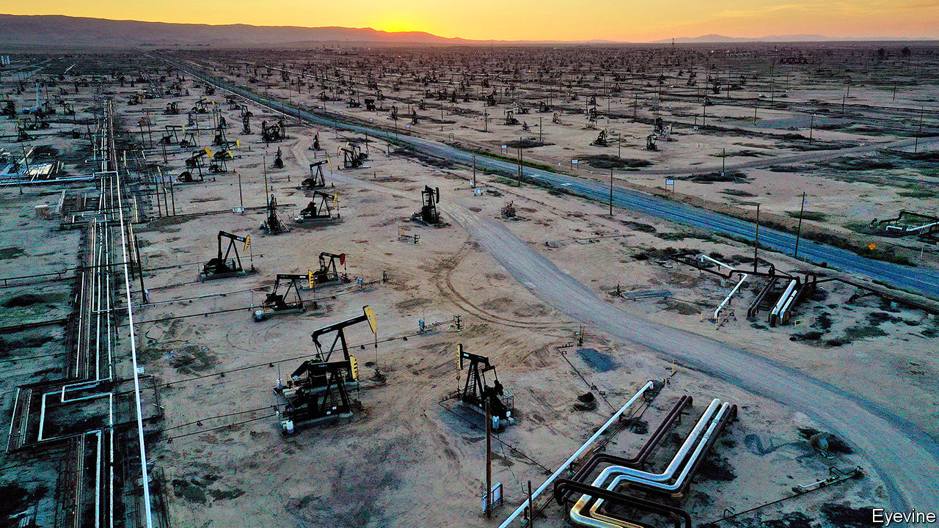

IN APRIL, WITH the world in lockdown from covid-19 and oil demand sinking faster than at any time in history, oil producers from Dhahran to the Delaware basin made the only possible choice: cut supply, fast. American output fell by about 2m barrels a day between March and May. The Organisation of the Petroleum Exporting Countries (OPEC) and its allies agreed to reduce supply by a record 9.7m barrels a day in May and June. The cuts helped propel the price of a barrel of Brent crude from less than $17 in mid-April to $42 on June 5th.

On June 6th, with demand still fragile, the OPEC alliance extended the cuts by a month. It is one thing to see supply drop when the oil market is engulfed by crisis. The more interesting question is how quickly supply will climb as normality returns. Production will respond, of course, as demand rises for jet fuel, petrol and diesel. If prices remain over $40, some shale firms and petrostates may boost output this summer. In the longer term, though, supply faces other constraints.

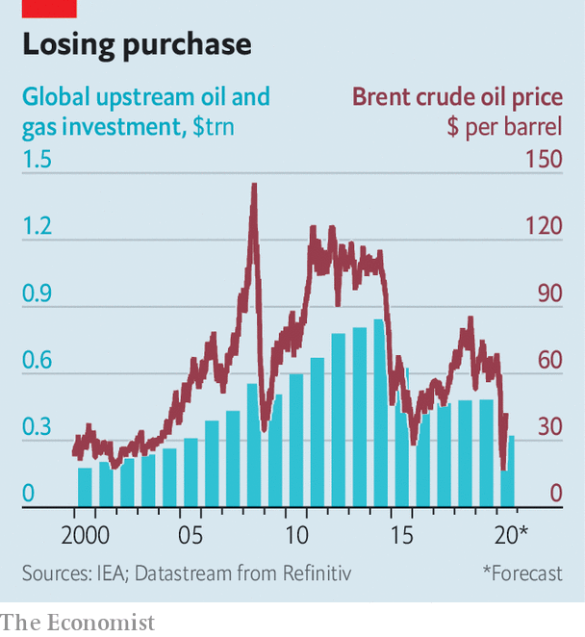

Global investment in future supply has collapsed. The International Energy Agency (IEA), an intergovernmental forecaster, estimates that upstream investment this year will fall to its lowest since 2005 (see chart). Goldman Sachs, a bank, expects production outside OPEC to stagnate in the 2020s, due not to geology or even demand, but lack of investment. Bernstein, a research firm, thinks that non-OPEC supply, which accounts for about 60% of global output, may peak in 2025, and then only at around last year’s level.

That would mark a dramatic shift. Because oil reserves are depleted continuously, producers have usually operated under the tenet of drill or die. An analyst once asked Lee Raymond, then the chief executive of Exxon, what kept him up at night. “Reserve replacement,” he responded.

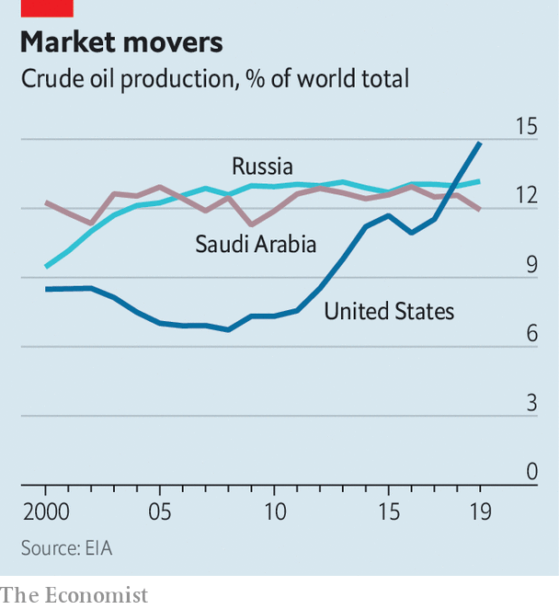

The obsession with booking reserves, not surprisingly, supported the growth of supply. In the mid-2000s, as some fretted that the world might run out of oil, both listed and state-backed firms scoured the world for projects. Over the past decade, fracking has unleashed supply across America’s heartland, transforming the country into the world’s largest oil producer (see chart). Big projects in Norway and off the coast of Brazil, where oil lies beneath a thick layer of salt below the sea floor, helped boost supply, too.

Investment began falling, though, even before the pandemic. A crash in prices from 2014 to 2016 had sapped appetite for big, risky projects. Even after prices climbed in 2017 poor returns made investors less interested in reserve replacement than cash flow. Companies have squeezed suppliers and found ways to pump more oil from existing fields. ExxonMobil and Chevron are among the giants to invest in America’s shale basins, where output is relatively easy to ramp up and down.

Oil producers can now credibly say they are able to wring more value from their capital budgets. Still, the decline in investment was steep enough to stir debate over future supply. Upstream spending on oil and gas last year was 43% below that in 2014, according to the IEA. Bernstein examined the 50 biggest listed energy companies outside OPEC and the former Soviet Union. In 2019 they reinvested an average of 64% of their operating cash flow. The long-term average was 87%.

The pandemic has exacerbated matters. Producers have shut in wells, delayed projects and slashed investment further. Rystad Energy, a data firm, estimates that of the 3m barrels a day that were shut in last month, mainly in America and Canada, 10-15% will never restart. The IEA predicts that investment in supply will be 33% lower this year than in 2019 and 62% lower than the high in 2014. There is less fat to trim than there was five years ago, the IEA reckons. That means declining investment may have a greater impact on supply.

Some companies, such as ExxonMobil, remain focused on growth. But it is not clear when a broader surge in capital spending will come. Returns for many firms have fallen below the cost of capital, points out Neil Beveridge of Bernstein. Investors are unlikely to favour a return to rapid expansion; the energy sector’s performance has been poor, the rebound in demand is uncertain and greener regulation may be in the offing. In a sign of the times, JPMorgan Chase, America’s biggest bank, demoted Mr Raymond from his role as its board’s lead independent director in May, under pressure from climate activists. Michele Della Vigna of Goldman Sachs argues that the historic cycle of high prices, investment and supply may be breaking.

As for American shale, analysts are feverishly watching rig counts, pipeline data and shut-ins for signs of a surge in supply. Shin Kim of S&P Global Platts, a data firm, expects it to tick up briefly this summer, as prices recover. But there is consensus that growth in the 2020s will be muted compared with the boom. Shale output is vast and wells’ production declines are steep. Improvements to productivity have slowed. Investors can find better returns elsewhere.

This bodes well for OPEC and its allies, which have been battered in the past decade. In 2014-16 it waged a failed price war to wipe out American frackers. Since then the cartel and its partners, led by Russia, have propped up oil prices enough to sustain shale, but not enough to support many members’ domestic budgets. In March Saudi Arabia urged Russia to slash output; Russia refused, loth to let Americans free-ride on OPEC-supported prices. The ensuing price war was spectacularly ill-timed, as it coincided with the biggest drop in oil demand on record.

The desire to chasten American frackers remains, though. OPEC controls about 70% of the world’s oil reserves, more than its 40% market share would suggest, points out Martijn Rats of Morgan Stanley, a bank. If the world’s appetite for oil shrinks due to changing habits, cleaner technology or greener regulations, countries with vast reserves risk having to leave oil below ground. “OPEC will defend its market share more firmly in the future,” predicts Mr Rats. Even better, then, if state-owned firms can depend on their rivals’ paltry investment to limit supply for them. ■

This article was downloaded by calibre from <https://www.economist.com/finance-and-economics/2020/06/13/investment-in-oil-supply-has-collapsed-it-may-not-roar-back>

|  |  |  |  |
| --- | --- | --- | --- |
|  | Articles | Sections | Next |

|  |  |  |  |
| --- | --- | --- | --- |
| Previous | Articles | Sections | Next |

#### Acute or chronic?

# What the early 1980s implies for unemployment today

A past recession may prove a useful guide to the recovery

Jun 11th 2020 |

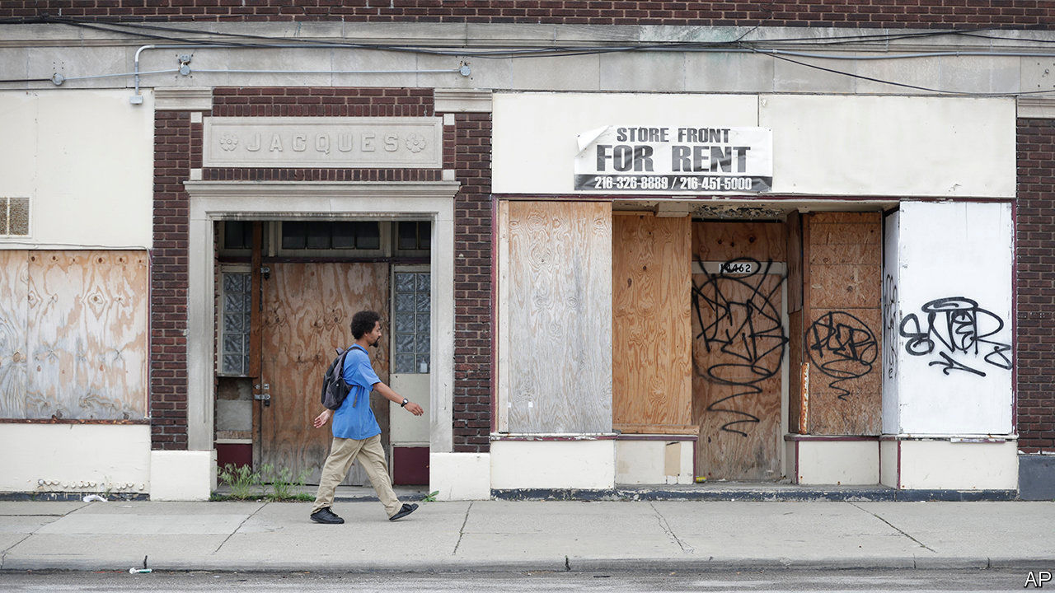

ALTHOUGH AMERICA’S unemployment rate shocked almost everyone by falling in May, 20m workers remain out of a job because of the coronavirus pandemic. The official unemployment rate is 13.3%, though that rises to about 16% if you count people who say they are employed but absent from work. Many commentators worry that a large chunk of the unemployed will have no job to go back to, even as lockdowns ease and stimulus payments land in bank accounts. In a podcast hosted by Joe Biden, the presumptive Democratic nominee for president, Andrew Yang, a former rival, said that “I’m privy to the thinking of many major company CEOs, and they are telling people confidentially that they are not going to hire back a lot of the people that they’ve furloughed or let go.” Will Mr Yang be proved right?

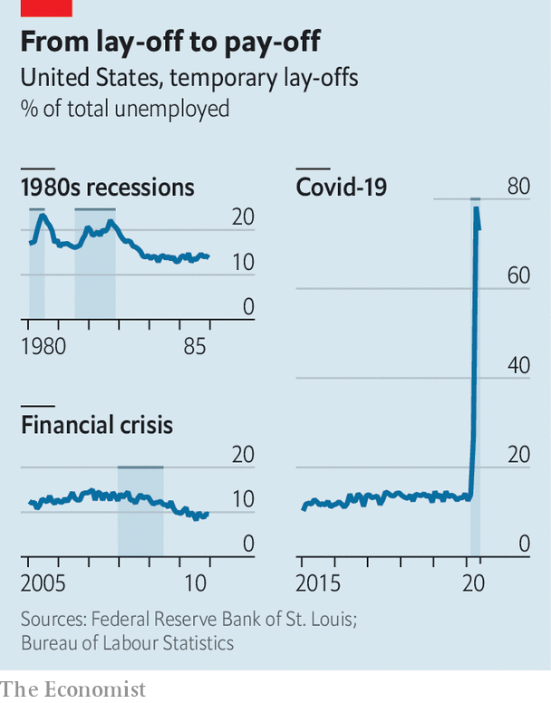

The question matters because it affects the strength of the recovery. You can return to an old job right away, but finding a new one usually takes time. People resuming their old jobs are also likely to be more productive, because they know the ropes, which allows them to earn higher wages, at least at first. Research suggests that those eventually recalled by their employer see no loss in pay—but those who are permanently sacked see a loss of monthly earnings of up to 12% in their next job. Unemployment fell much more quickly after the recession that ended in 1982 than after the financial crisis in 2007-09, in part because a higher share of people who lost their jobs were laid off only temporarily (see chart).

The experience of the early 1980s could be a useful guide to the recovery from the pandemic. That recession too was the result of a policy that sacrificed short-term economic growth in order to defeat an enemy. (Rather than lockdowns imposed to crush a virus, though, interest rates had been raised to crush inflation.) If bosses think that government policies that restrain activity are temporary, reckon analysts at Goldman Sachs, a bank, they may decide to minimise permanent lay-offs, which are disruptive for their businesses. In May roughly three-quarters of laid-off workers reckoned they would eventually be recalled. Evidence from notices issued by large firms in advance of large lay-offs paints a similar picture.

As Mr Yang suggested on the podcast, workers may be mistaken in their belief that their plight is temporary. Yet the evidence suggests some are already being called back. The rise in employment in May of 2.5m—the largest month-on-month increase ever, by far—is unlikely to have been the result of lots of workers finding new positions. Job search takes time, after all. It is also hard to square the huge rise in employment with the much smaller pick-up in job postings on recruitment websites, suggesting that many bosses simply recalled ex-workers instead of advertising afresh. The number of temporarily unemployed people also fell by 2.7m in May—though some may have become permanently jobless, or may have moved out of the labour force altogether.

Recovery is still a long way off. The unemployment rate is well above the peak reached after the financial crisis. Employment for some groups, such as ethnic minorities, has risen by less than for others. And it seems a fair bet that the pandemic will destroy many jobs. As some lockdowns ended, employment in food services and drinking establishments accounted for more than half the overall rise in May. But a post-pandemic economy will probably involve less demand for services that require close person-to-person contact than in pre-virus days. Moreover, many economists expect bankruptcies to rise as companies, facing low revenues, exhaust their cash piles. Still, after weeks of dreadful economic news, the jobs market may at least have turned a corner. ■

This article was downloaded by calibre from <https://www.economist.com/finance-and-economics/2020/06/11/what-the-early-1980s-implies-for-unemployment-today>

|  |  |  |  |
| --- | --- | --- | --- |
| Previous | Articles | Sections | Next |

|  |  |  |  |
| --- | --- | --- | --- |
| Previous | Articles | Sections | Next |

#### Moody moment

# India avoids junk status

Rating agencies seem more optimistic than Indian commentators

Jun 13th 2020 |

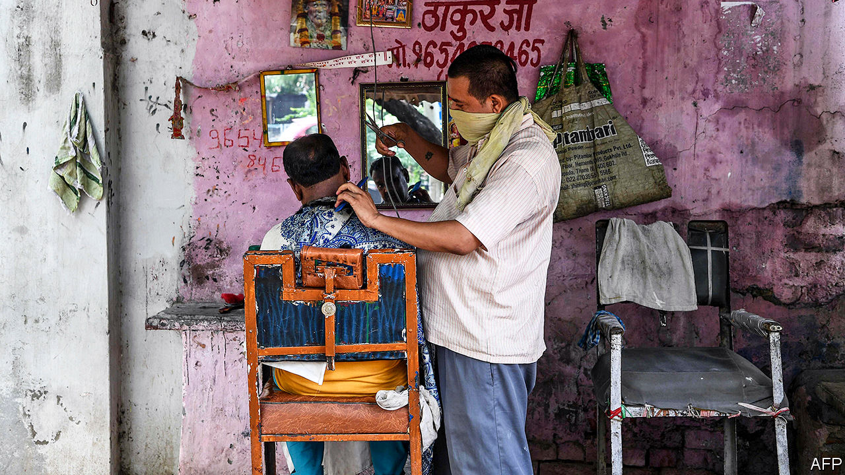

LARGE AND leaky, India’s lockdown became “localised” this week. In the parts of the country hit hardest by covid-19, restrictions remain. Elsewhere, they have been largely relaxed. People can visit places of worship, but cannot touch idols. They can go outside to shopping malls, but not the gaming arcades or cinemas inside. In Punjab, mall-goers can buy clothes but cannot try them on first.

The lockdown, which began on March 25th, has failed to stop the virus—the caseload continues to grow alarmingly. But it has succeeded in halting the economy. The number of people in work fell to 282m in April, compared with an average of over 400m last year, reckons the Centre for Monitoring Indian Economy (CMIE), a research firm, which asks people if they were employed that day (unlike the official data, which ask if people were employed at any time that week). India’s carmakers did not make a single sale to retailers in April. A gauge of services activity based on a survey of purchasing managers fell to 5.4, the lowest ever recorded for either services or manufacturing anywhere, according to IHS Markit, which conducts the surveys in over 40 countries.

Employment, car sales and services improved in May: a step back from the “abyss”, as CMIE put it. But GDP will still shrink by 4% in the year ending March 2021, according to Moody’s, a rating agency. It was no surprise, then, that it cut India’s credit rating on June 1st for the first time since 1998. The government’s debt, Moody’s pointed out, is 30 percentage points higher than in a typical economy with the same rating. That vulnerability was once offset by unusually fast growth. But even before the pandemic, momentum was slipping. Growth fell from 8.3% in the year ending March 2017 to 4.2% in the last fiscal year. The crisis, Moody’s said, merely “amplified” vulnerabilities stemming from the government’s inability to clean up a troubled banking system, improve poor infrastructure or revise rules that constrict the markets for labour, land and products.

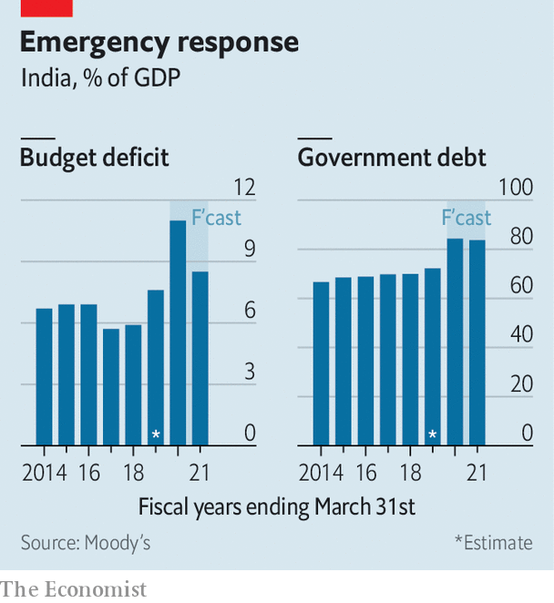

The cut brought Moody’s rating down to the lowest tier of investment grade, the same as Fitch and S&P. It also had knock-on effects. Because the sovereign rating puts a cap on the country’s corporate credit scores, Moody’s also swiftly lowered the rating on 37 Indian companies. These included many of the country’s most successful private firms, such as Reliance Industries, Tata Consultancy Services and HDFC Bank.

Any further downgrade into “junk” status would be humiliating for the government. It will therefore be relieved that its hastily assembled response to the economic crisis, a mix of financial relief, fiscal restraint and liberalising reform, seems at least to have convinced S&P to hold fire. Despite India’s economic turmoil, the agency reaffirmed its rating this week and said that it did not expect to change it soon.

S&P noted that the government had been “relatively conservative” in its spending measures this year, relying heavily on credit guarantees, not direct expenditures. It has also taken the “rare step” of combining relief efforts with longer-term reform, notes Andrew Wood, S&P’s lead analyst. Most notably, several states under the control of the Bharatiya Janata Party led by Narendra Modi, the prime minister, have eased labour laws, allowing firms with more than 100 workers to make lay-offs without the state’s permission. The reform has been advertised as temporary. But if it works, it may persist and spread to other states, argues Capital Economics, a consultancy. That could encourage investment and growth in the long term.

The rating agencies have not always been highly regarded in India. In 2017 Arvind Subramanian, then India’s chief economic adviser, accused them of “poor standards” that flattered China and underrated India. But, if anything, global rating firms are now more optimistic about India than some well-informed Indians. Moody’s forecast of -4% growth (and S&P’s of -5%) seem positively rosy compared with that of -12.5% (without further stimulus) from Pronab Sen, a former chief statistician. Mr Subramanian thinks true growth this year could be as low as -8%, although the official data may not reflect that.

To the agencies, and every other analyst of the country, India has always been a paradox. Its economy is large but its people are poor. Its institutions are strong enough to warrant an investment-grade rating, but its policymaking is not. Its public debt is high, its foreign debt modest. To these long-standing paradoxes, some observers add another. India, they say, is like a Monet painting. Up close, it’s a big old mess. But from afar it still has the power to beguile. ■

Editor’s note: Some of our covid-19 coverage is free for readers of The Economist Today, our daily [newsletter](https://my.economist.com/user#newsletter). For more stories and our pandemic tracker, see our [coronavirus hub](https://www.economist.com/news/2020/03/11/the-economists-coverage-of-the-coronavirus)

This article was downloaded by calibre from <https://www.economist.com/finance-and-economics/2020/06/13/india-avoids-junk-status>

|  |  |  |  |
| --- | --- | --- | --- |
| Previous | Articles | Sections | Next |

|  |  |  |  |
| --- | --- | --- | --- |
| Previous | Articles | Sections | Next |

#### The 24-body problem

# The yuan has been one of the world’s most stable major currencies

That is partly by design, and partly through luck

Jun 13th 2020 | SHANGHAI

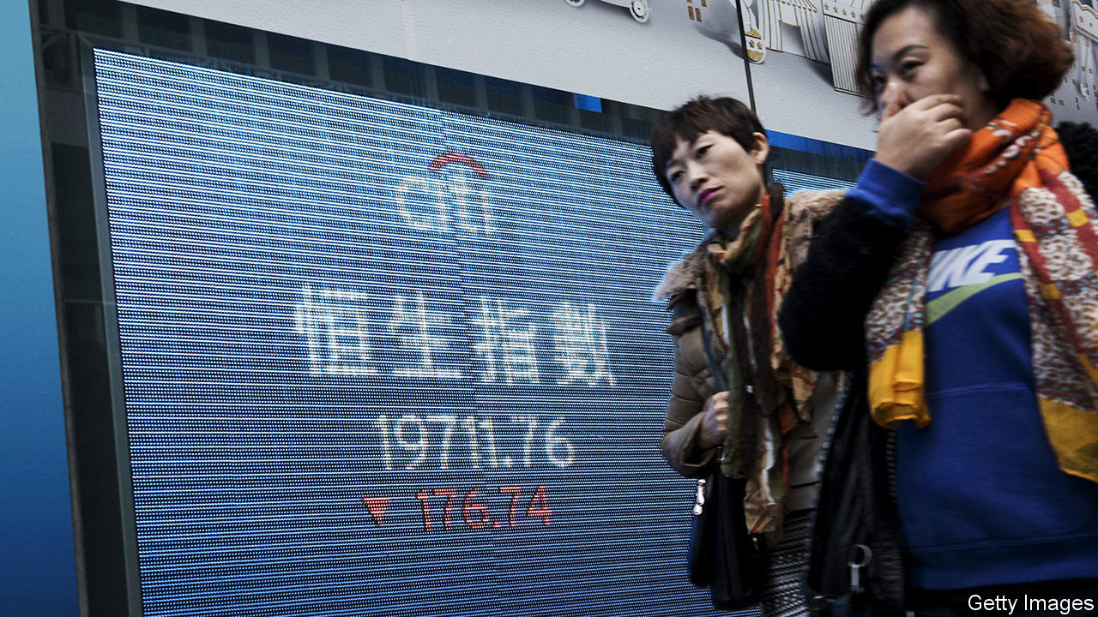

IN THE “Three-Body Problem”, a popular Chinese science-fiction novel, the planet Trisolaris lurches between climatic stability and chaos as it follows an unpredictable orbit around the three suns in its star system. The solution, the inhabitants conclude, is to invade the Earth, so as to enjoy its smooth single-sun orbit. China’s central bank has been making a similar monetary voyage, in reverse.

For years the yuan revolved around the dollar. That benefited China, but it also stored up problems, which were exposed most dramatically in 2015, when it suffered massive capital outflows. Since then the central bank has steadily moved the yuan to a multi-currency orbit, tracking 24 in all. In economic terms, this is known as a currency-basket regime. In Trisolaris terms it looks like a “long Stable Era”, desirable but ultimately doomed.

Our planet’s inhabitants tend to analyse the yuan in comparison with the biggest currency in our solar system. So its recent depreciation against the dollar attracted much attention, especially in late May, when the People’s Bank of China (PBOC) set the yuan’s daily reference rate at 7.13 to the dollar, the weakest since 2008. Amid ever-increasing tensions with America, many economists predicted further depreciation, though the yuan has strengthened against the greenback so far in June.

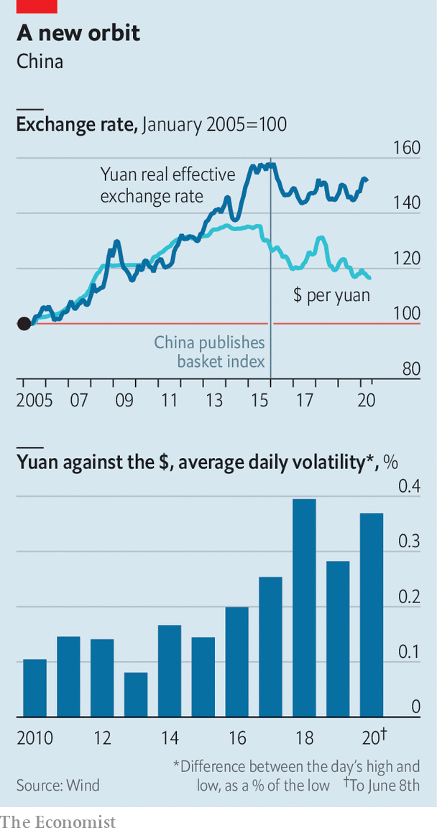

But the singular focus on the dollar misses something important. At the end of 2015 China started announcing the yuan’s exchange rate against a basket of currencies. It took a while to work out the kinks in the new system, but the evidence is that the yuan has been among the most stable currencies in the world since mid-2016. Its real effective exchange rate—its value against the currencies of its trading partners, adjusted for inflation—has risen by just 0.2% over the past four years, anchored by the official basket (see chart).

The yuan’s stability is partly by design. Every morning the PBOC sets its reference rate on the basis of two variables: the previous day’s close against the dollar and the need to limit changes against the basket. The formula tends to push the yuan towards the middle of the pack. For instance, if the dollar is generally weak, the yuan will strengthen against it, but depreciate against other currencies—exactly what has happened in June. The PBOC also adds a third variable, the “counter-cyclical adjustment factor”, when it deems that the yuan is moving too much. This discretionary tweak is its way of leaning against what it defines as herd behaviour in markets.

Every day the yuan can move up or down by 2% from its reference rate against the dollar. Although it has never hit that limit, China has grown comfortable with allowing bigger swings within it. Over the longer term, this may have contributed to stability. On any given day, it is not obvious where the yuan will end up, pressing traders to take both sides of the market.

The basket regime seems to have allowed the PBOC to stop conducting heavy-handed intervention. Foreign-exchange reserves have held steady at around $3.1trn since mid-2016, implying that the yuan faces no great appreciation or depreciation pressure. But the PBOC has also become more targeted in its intervention. When the yuan has been weak, it has called on state-owned commercial banks to sell forward dollars in foreign-exchange swaps, to signal that the yuan will strengthen in the future. One strategist is convinced, albeit without any hard evidence, that the PBOC also has a team of traders who push the yuan around, wrong-footing other investors. And the biggest intervention of all is China’s capital controls, which remain very tight.

The yuan’s stability of the past few years has also been partly the result of good fortune. In that time the dollar, the euro and the yen—the three biggest suns in the yuan’s universe—have themselves been unusually stable against each other. If they were to veer off in wildly different directions, China’s basket regime would be tested. A better course for the world’s second-largest economy would be a truly free float, making the yuan one of the global monetary system’s suns, not a mere planet. For now, Chinese officials show little inclination to undertake such a voyage. ■

This article was downloaded by calibre from <https://www.economist.com/finance-and-economics/2020/06/13/the-yuan-has-been-one-of-the-worlds-most-stable-major-currencies>

|  |  |  |  |
| --- | --- | --- | --- |
| Previous | Articles | Sections | Next |

|  |  |  |  |
| --- | --- | --- | --- |
| Previous | Articles | Sections | Next |

#### Pandemic pendulum

# Why are bank bosses sounding more optimistic about loan losses?

They were hyper-prudent in April. Now the worst-case scenario might be off the cards

Jun 13th 2020 |

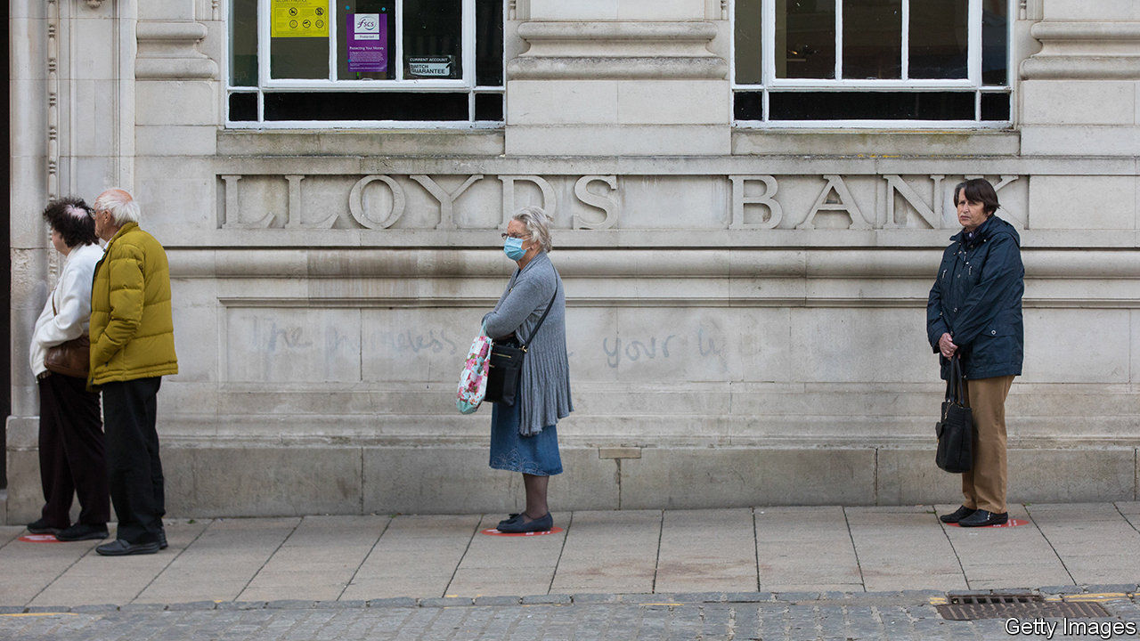

GAUGING HOW badly the coronavirus has damaged the economy is tricky. Pessimists diagnose a far worse recession than that which followed the financial crisis. Optimists predict a sharp recovery, pointing to robust banks and housing markets.

One way to form a view is to look at banks’ loan-loss provisions—the buffers they set aside to cover losses from loans they reckon might soon default. By that standard it seems as if the patient is recovering much faster than first thought possible. On June 9th James Gorman, who runs Morgan Stanley, America’s sixth-largest bank, hinted that its loan-loss charges for the second quarter would be lower than in the first, because “the worst is behind us”. Gordon Smith, co-president of JPMorgan Chase, the largest bank, said that delinquency rates were “meaningfully better” than expected. Even some of Europe’s bankers seem less gloomy.

That is a stark change from just a few weeks ago. In mid-April, as they reported their first-quarter results, America’s top four lenders unveiled $24.1bn in provisions for credit losses, a jump of $18.7bn compared with the first quarter of 2019. JPMorgan increased its provision by nearly $6.9bn, hitting in one quarter the level it had reached in six during the financial crisis. Europe’s lenders also booked bad news.

Why the mood swing? To predict losses, most banks enter economic forecasts into models. The prospects for 2020 are hardly rosy, but it seems at least that economies are no longer in free fall. Employment rose in America in May. Factories in Asia have reopened. The lifting of lockdowns in the West has not yet caused a second wave of infections. Uncertainty forced banks to be hyper-prudent in April. Now the worst-case scenario seems off the cards.

Relief may be premature, though. Central-bank and government action has bought borrowers time. Cheap state-backed loans are keeping firms and households afloat. No one knows how many borrowers will find themselves overburdened with debt when normal payment terms resume later in the year. That is especially true of consumer borrowers, up to a fifth of whom have asked for payment holidays.

If unemployment persists and companies go bust, as many economists expect, many more loans will sour. Roberto Frazzitta of Bain, a consultancy, predicts that 2021 will see a surge of non-performing loans as big as that in the financial crisis, if not bigger. This will be compounded by accounting: as customers’ balance-sheets worsen, the probability of default will rise, and regulators will demand that this be reflected in loss provisions, even if loans are still performing. Some losses will eventually be absorbed by government guarantees. But the European Banking Association still expects losses to eat up to 3.8 percentage points of European banks’ core tier-one capital ratio (the average buffer for banks in the region is 14.8%).

Higher provisions could have three consequences, on both sides of the Atlantic. It may lead investors to question banks’ ability to pay dividends (Europe’s have suspended them, but America’s still dole them out). It may prompt banks to refine their standard loss-prediction models by using more alternative data, says Ian Shipley of Oliver Wyman, a consultancy. And it may lead to calls for weaker lenders to consolidate, in order to improve their resilience. That would be a hard pill to swallow, but could prove a handy cure. ■

This article was downloaded by calibre from <https://www.economist.com/finance-and-economics/2020/06/13/why-are-bank-bosses-sounding-more-optimistic-about-loan-losses>

|  |  |  |  |
| --- | --- | --- | --- |
| Previous | Articles | Sections | Next |

|  |  |  |  |
| --- | --- | --- | --- |
| Previous | Articles | Sections | Next |

#### Buttonwood

# The reasons behind the spectacular rally in metal prices

Quite a lot of the story seems to be about China

Jun 13th 2020 |

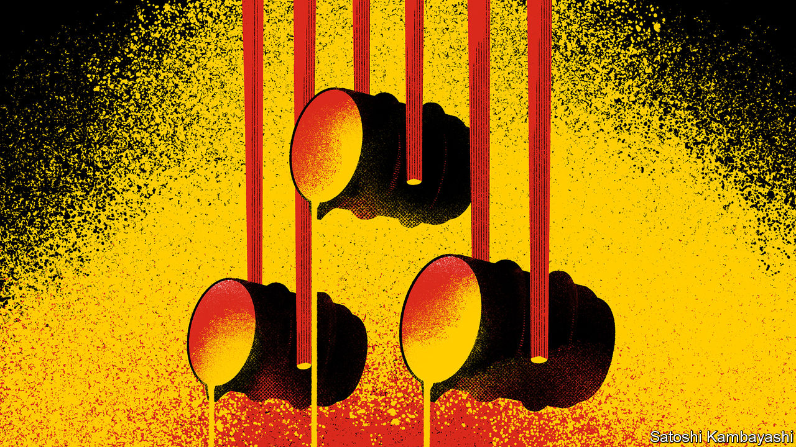

TOO SOON. That is the judgment a lot of investors apply to the recent across-the-board surge in asset prices. For it is not just the stockmarket that has rallied. The prices of industrial raw materials have also risen sharply in the past month or so. Iron ore has increased from $80 a tonne to over $100. Copper prices are also up 25%. This is remarkable. The global economy is only just reopening. It feels a bit early for a commodity boom.

It is tempting to see parables here. Perhaps the metals rally is a template for the post-virus economy, in which supply bottlenecks push prices up as activity gets going again. Perhaps it shows how mindlessly the ocean of liquidity created by the Federal Reserve and the European Central Bank has washed into financial markets of all kinds. For the “too-soon” school it is a sign that optimism is running ahead of reality. Perhaps it is. But quite a lot of the commodity story seems to be about China.

China’s role is both curious and obvious. It is curious because China’s economy is meant to have become more reliant on consumer spending and less on building booms financed by ever-larger dollops of debt. It is obvious because, notwithstanding this stated goal, China is still the world’s biggest buyer of industrial commodities. Almost all the seaborne trade in iron ore goes there. If metal prices are going up, it is a fair bet that something is happening in China.

And so it is. Steel mills are working flat out. In the first week of June, China’s steel blast furnaces were operating at 92% of capacity. That is a good deal above the 80-85% rates considered normal. Much of the steel manufactured in China is for buildings and for infrastructure, such as bridges, railways and subway lines. Sure enough, indicators of construction activity look strong. Sales of excavators are up by a fifth so far this year, compared to a year earlier. A pipeline of orders had already been building before the pandemic struck. In its aftermath, construction has been given an extra push by the government’s efforts to gin up the economy. China-watchers say lessons have been learned. There has been a greater focus than in the past on selecting worthwhile projects, says Sean Darby, a Hong Kong based analyst for Jefferies, an investment bank.

The supply response to this has been led by Australia, the world’s largest exporter of iron ore. It swiftly took steps to contain the virus at the outset. It has managed, at the same time, to keep its mines in the ore-rich Pilbara region open. Exports of ore have risen this year. This contrasts with Brazil, where the spread of the virus has crippled production. Such bottlenecks are one reason for higher prices. And there is a bigger picture. The mining industry suffered a brutal reckoning in 2014-16, after a decade-long boom fuelled, yes, by China. Investment was cut; mines were closed; debts were paid. The result is that the industry does not have the chronic over-capacity of many other cyclically sensitive ones—think European banks or global carmakers.

There is a speculative element to the rise in metal prices, too. Buying or selling copper futures is a popular way to express a view about the world economy. Indeed copper can be all about belief, says Max Layton of Citigroup, a bank. Many of the bets laid on it are by trading algorithms, which mechanically respond to financial signals that have worked well in the past. The dollar, which has fallen by 6% against a basket of currencies since March, is usually part of the semaphore. A weaker dollar allows for easier terms of finance in emerging markets. Anything that helps emerging-market economies is generally good for commodity prices. So the algorithms buy.

The complex of price changes becomes self-reinforcing. Higher ore prices bring higher-cost producers back to the market. But their profit margins are then squeezed as their home currency appreciates, because that raises the cost of labour in dollars, in which commodities are priced. To restore margins, prices must go up. Moreover, marginal costs rise when the prices of steel (used for mining parts) and oil (used for energy and chemicals) go up. These higher costs push up prices further, says Mr Layton.

A pattern in markets is that a lot happens by rote. China’s response to a weak economy is to build; investors’ response to the Fed’s easing is to buy stocks; the algorithms’ response to a weaker dollar is to buy commodities. Higher prices beget higher prices. The sceptics, the too-sooners, note that this also works in reverse. Quite so. But the momentum is now with the believers.

This article was downloaded by calibre from <https://www.economist.com/finance-and-economics/2020/06/13/the-reasons-behind-the-spectacular-rally-in-metal-prices>

|  |  |  |  |
| --- | --- | --- | --- |
| Previous | Articles | Sections | Next |

|  |  |  |  |
| --- | --- | --- | --- |
| Previous | Articles | Sections | Next |

#### Free exchange

# Economic research documents black Americans’ struggle for equality

History shows that progress towards equality is followed by a racist backlash

Jun 11th 2020 |

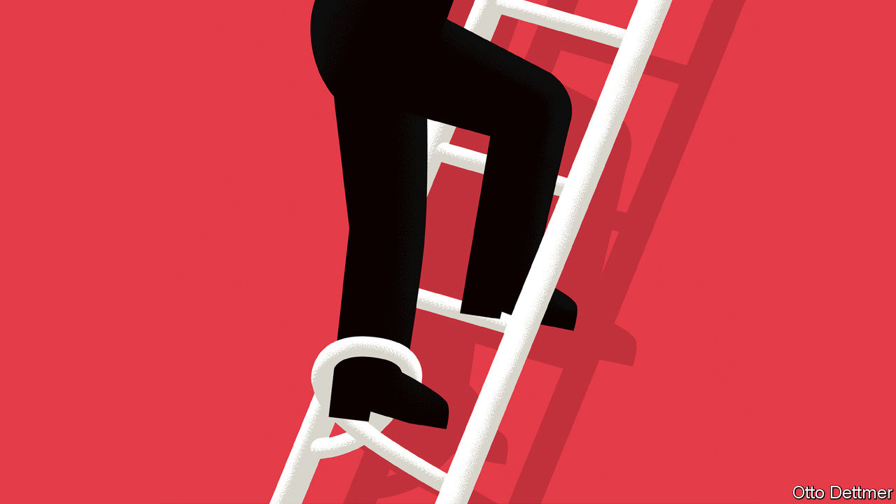

THE DEATH of George Floyd at the hands of the Minneapolis police has focused minds around the world on America’s glaring, stubborn racial inequalities. The income of the median black household is less than 60% of the white one. The median white American has a net worth about ten times that of the typical black American—a gap that has not budged since 1990. Injustice began with the original sin of slavery. But as a growing body of scholarship reveals, injustice has endured because racism and discrimination have, too. Over the course of America’s history, dearly won progress towards equality has been followed by a racist backlash.

The cycle of progress and regression began as soon as slavery ended. As the civil war drew to a close, many northern Republicans envisioned a reconstruction of the South, which raised black southerners to a position of equality with other Americans. In 1867 Congress ordered southern states to form new governments, and the occupying federal army protected newly freed (male) slaves’ right to vote, leading to a sharp increase in the number of black elected officials. Representation made a big difference to the lives of black Americans. Research by Trevon Logan of Ohio State University finds that each new black politician raised per-head tax revenue at the county level by 20 cents, for instance, money that then tended to be spent on education or land redistribution. Black officials delivered real benefits for constituents. In places with more of them, land tenancy was more common than exploitative sharecropping, and literacy rates among black people were higher.

Reconstruction proved less radical and enduring than its most ardent supporters had hoped, though. Resistance by white southerners, often violent, eroded the northern commitment to reform. Military intervention across the South ended by 1877, and restrictions on black rights quickly followed. Suresh Naidu of Columbia University finds that the introduction of poll taxes and literacy tests intended to lower black voting reduced turnout and shifted vote share towards the Democratic Party—then the party of white supremacy in the South. Suppression of black political power was followed by less redistribution and investment in black education. Using data from the censuses of 1870 and 1880, Mr Naidu estimates that the migration of black workers induced by disenfranchisement, and the resulting shifts in local economies, implies that the loss of the vote may have reduced income per black worker by 19%.

Southern whites limited the post-bellum economic prospects of black Americans in other ways as well. Lisa Cook of Michigan State University has studied the effects of outbreaks of racist violence, such as riots and lynchings, between 1870 and 1940. She concludes that the state’s tolerance of that violence led to a substantial decline in the relative economic performance of black Americans—including, importantly, inventive activity. Violent outbreaks reduced the number of patents filed by black inventors by 1% per year, resulting in 1,100 missing patents: a blow to both America’s productivity and the economic status of black workers.

Many black Americans left in search of opportunity. Over the 20th century a Great Migration unfolded, in which millions of black families left the South for northern cities. Movement began in earnest during the first world war, when northern manufacturers’ demand for labour soared and the flow of immigrants from Europe was interrupted. Employers began to recruit in the South. Some black workers followed family members up north. Analysing the period from 1910 to 1930, William Collins of Vanderbilt University and Marianne Wanamaker of the University of Tennessee estimate that real earnings of black men rose from 44% to 47% of those of white men as a consequence. By 1930, the share was five percentage points higher than it otherwise would have been.

The promise of migration was shattered by white residents’ hostility to new arrivals, however. The Great Migration prompted discriminatory policies and waves of racial violence in northern cities. It also induced white households to migrate. Allison Shertzer and Randall Walsh of the University of Pittsburgh estimate that each new black arrival in a northern neighbourhood was followed by the departure of 1.9 white residents in the 1910s and 3.4 white residents in the 1920s. About half of the rise in segregation in northern cities in the 1920s can be explained by this white flight, they suggest. The pattern continued after the second world war, finds Leah Boustan of Princeton University. Between the 1940s and the 1970s, she reckons, after controlling for other factors, 2.7 white residents left northern city centres for every new black arrival.

## Out from the gloomy past

The response to black migration set the stage for many of today’s lingering inequalities. As white households left, cities’ tax bases shrank, and so did public investment. Waves of urban rioting in the 1960s—a response, in part, to discrimination, and to the neglect of increasingly black cities—further weakened the economies of city centres and led to big rises in spending on policing. In 1940 black children growing up in the north did much better than those in the South, says Ellora Derenoncourt of Princeton University. That advantage has disappeared today. And a quarter of the gap in intergenerational-income mobility between blacks and whites in northern cities can be explained by the white response to black migration, she reckons.

A large and growing literature links the still-yawning racial gaps in income, employment and wealth to the segregated communities, racial violence and unequal investment that have been a feature of American society for so long. The past, unfortunately, is not even past. Black communities still face obstacles when casting ballots, differential treatment from the police, and unequal access to high-quality public goods, like education. To make real progress towards racial equality in America, it is not just police behaviour that needs to change. The cycle of inequality and poor outcomes needs to be broken, and decades of damage remedied. ■

This article was downloaded by calibre from <https://www.economist.com/finance-and-economics/2020/06/11/economic-research-documents-black-americans-struggle-for-equality>

|  |  |  |  |
| --- | --- | --- | --- |
| Previous | Articles | Sections | Next |

|  |  |  |
| --- | --- | --- |
| Finance & economics | Sections | Books & arts |

Science & technology

Planetary monitoring: Something’s in the air

.

Laboratory mice: Here’s one I prepared earlier

.

Nasal probiotics: No entry!

.

The search for a covid-19 treatment: Testing times

.

|  |  |  |
| --- | --- | --- |
| Finance & economics | Sections | Books & arts |

|  |  |  |  |
| --- | --- | --- | --- |
|  | Articles | Sections | Next |

#### Planetary monitoring

# A plan to turn the atmosphere into one, enormous sensor

It will watch for storms, earthquakes, volcanos—and missile launches

Jun 13th 2020 |



WHEN AN EARTHQUAKE rocked Nepal in 2015, geophysicists were surprised to find that they could see its reflection in the ionosphere, a layer of the atmosphere beyond about 75km above Earth’s surface. Ground-based instruments saw changes in the density of free electrons in this electrically charged zone. These rippled outward from the point in the ionosphere directly above the earthquake’s epicentre.

Similar effects have been observed with other phenomena, both natural (hurricanes, volcanoes and the passage of meteors) and artificial (blasting associated with mining operations). All of these things cause electrical changes in the sky that can be detected hundreds of kilometres away.

Such observations have led David Lewis, a programme manager at America’s military-research organisation DARPA (the Defence Advanced Research Projects Agency), to wonder just how much information can be wrung out of the atmosphere in this way. That has led him to set up a new DARPA programme called AtmoSense—short for “Atmosphere as a Sensor”. This is now sorting through bids from hopeful academic institutions, and companies large and small, to put together a system to do the wringing.

## Sense and sensibility

The ionosphere’s reaction to happenings on the ground is simple in principle but complex in practice. Events like earthquakes produce disturbances in the lower atmosphere. These can take the form of sound waves, shock waves or slower-moving phenomena called atmospheric gravity waves. Such oscillations generally spread out in all directions, including upward towards the ionosphere.

Before they get there, these waves are travelling through electrically neutral gas. This makes them hard to track remotely since there are no electrical effects, such as radio emissions, for detectors to exploit. That changes, though, when they arrive. The movements of high-altitude charged particles (electrons and the electrically charged atoms, called ions, that give the ionosphere its name) in response to passing waves can be picked up in several ways. One is from their effect on GPS satellite-signal reception (which is how the Nepalese earthquake was detected). Another is by the use of ionosondes, a special type of radar that bounces radio waves off this layer of the atmosphere. The third is to use radio waves to stimulate the ionosphere, so that it glows. This is akin to creating an artificial aurora, and makes ionospheric motions visible. Observing ionospheric waves in these ways may answer questions about what sets those waves in motion. But that means gathering lots of data, in order to understand what is going on.

One of AtmoSense’s first goals will be to locate and study phenomena at or close to Earth’s surface—storms, earthquakes, volcanic eruptions, mining operations and “mountain waves”, which are winds associated with mountain ranges. The aim is to see if atmospheric sensing can outperform existing methods: seismographs for earthquakes, Doppler weather radar for storms and so on.

After that, the project will go on to try to gather data beyond the capabilities of current sensors. Radar, for example, can track the positions of storms, but AtmoSense may be able to indicate as well how much energy a storm is releasing, and thus determine whether it is weakening or strengthening. Seismology may be enhanced, too. According to Colonel Lewis, “there might be precursors to earthquakes that are not picked up on the ground. There might be all sorts of information.” That holds out the tantalising prospect of being able to issue earthquake warnings.

## Ripples in the air

The armed forces, who are paying for the project, are particularly interested in gaining insight into activities like missile launches and underground nuclear tests. These should certainly be within the system’s grasp when it is fully developed. But it might also be possible to pick up lesser events, too.

If a meteor’s shock waves can be tracked across the ionosphere, for example, how about those of a hypersonic missile? Or an aircraft? Previous work suggests that events as small as a tonne of explosives going off can be detected. With the right sensors and filters it may be possible to track tinier disturbances still. Colonel Lewis will be looking into new ways of doing this, as well as trying to upgrade the old ones. Among the new methods under consideration are instruments carried by high-altitude drones and balloons, both of which can linger in the upper atmosphere for days at a time.

The first 27 months of the programme will be dedicated to understanding the science behind ripples in both the ionosphere and the electrically neutral atmosphere below it, and then building computer simulations of what is going on. These will be tested to see if they can replicate accurately effects seen in the past.

Once the team have a better understanding of the basic science, they will proceed to the second stage: field trials. This will involve three tests at three-month intervals in which researchers attempt to locate pertinent events, such as storm cells, mining operations and earthquakes. If that works, the project will then move on to matters of military interest by spying on missile launches, tracking aircraft and even watching underground bunkers being dug. The result, if all goes well, may be the world’s first true panopticon. ■

This article was downloaded by calibre from <https://www.economist.com/science-and-technology/2020/06/13/a-plan-to-turn-the-atmosphere-into-one-enormous-sensor>

|  |  |  |  |
| --- | --- | --- | --- |
|  | Articles | Sections | Next |

|  |  |  |  |
| --- | --- | --- | --- |
| Previous | Articles | Sections | Next |

#### Laboratory mice

# An animal model of covid-19 is now available

Another is on its way

Jun 13th 2020 |

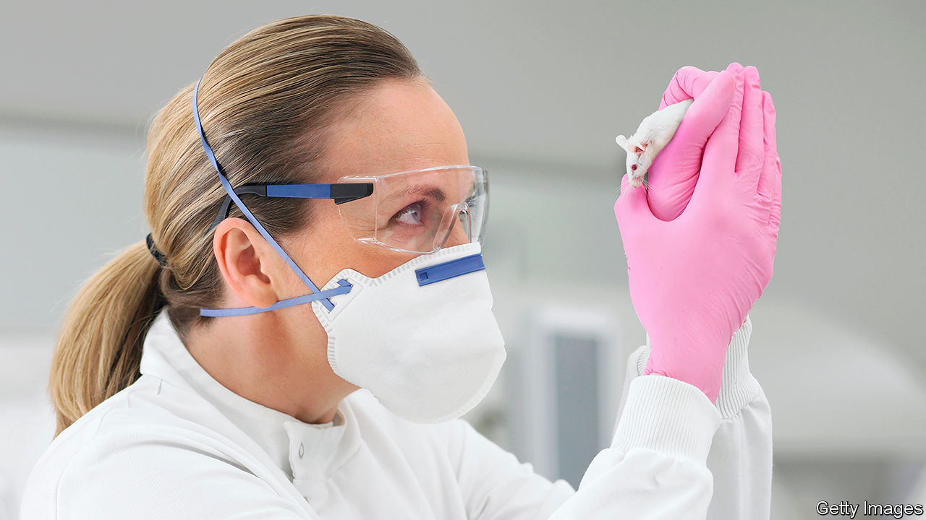

MICE ARE, as it were, the guinea pigs of science. And these days they are often genetically engineered guinea pigs, to boot. The emergence of covid-19, for example, has created demand for laboratory animals that have human versions of a protein called the ACE2 receptor. This molecule is the hook that SARS-CoV-2, the virus which causes covid-19, uses to attach itself to a cell before entering and turning that cell into a virus factory. The murine version of ACE2 is, however, the wrong shape for the virus to link up with. That means unmodified mice cannot catch the infection. Hence the need for genetic engineering.

The first version of such a mouse has recently become available courtesy of the Jackson Laboratory, a not-for-profit biomedical research institution in Maine that specialises in breeding laboratory mice. By luck, the team that produced it had a head start. The original SARS virus (now known as SARS-CoV-1), which came close to causing a pandemic in 2003, also uses ACE2 as its point of entry. As a consequence Stanley Perlman and Paul McCray of the University of Iowa, who were researching SARS, created a mouse with human ACE2 receptors in 2007.

That project was eventually put on ice. But not before Dr Perlman had given some semen from his modified mice to the Jackson Lab. On hearing about the virus in early January researchers there, led by Cat Lutz, quickly thawed out this stored semen and started work. Five months later they have created enough of Dr Perlman’s mice to start making them widely available.

The Perlman mice are, however, not quite perfect for the job. Though their genome has had human ACE2 added, the mouse variety has not been subtracted. This means they make both versions of the protein. Also, the human version of the gene is in the wrong place in the cell nucleus. The ACE2 gene’s proper home is the X chromosome, one of the sex chromosomes. In Perlman mice it is elsewhere. That could change its activity.

Help may be on its way, though, from Wang Youchun at the National Institutes for Food and Drug Control in Beijing. As they describe in this week’s Cell Host & Microbe, Dr Wang and his colleagues have excised the murine version of the ACE2 gene completely from their own mice and substituted the human version in exactly the same place. They did this using CRISPR/Cas9 gene-editing technology, a technique unavailable to Dr Perlman back in 2007.

## Spot-on

Dr Wang’s initial tests of the new mouse suggest it generates ACE2 receptor molecules in all of the parts of the body where researchers think the virus makes its initial attacks in human beings. They show, too, that SARS-CoV-2 replicates well in the animals’ lungs and tracheas, and also in their digestive systems—another part of the human body that seems susceptible to SARS-CoV-2 infection. In the case of the digestive systems, however, the dose of virus needed to establish a gut infection is ten times that needed to start a respiratory-tract infection. Dr Wang suspects that this might be important. If alimentary-canal infection requires an equivalently large initial dose of viruses in people, as well, then that might make it easier to stop it happening in human intestines, by the practice of good food hygiene.

One further result of Dr Wang’s investigation was the discovery that the virus also replicates in the brains of his mice. This suggests it may be making use of human nervous tissue for replication in a way that is not currently being detected, but is suspected by some researchers because one symptom of some people who have the illness is loss of the sense of smell.

Curiously, despite their propensity to infection by SARS-CoV-2, Dr Wang’s mice, unlike Dr Perlman’s, do not show obvious symptoms when infected. Given the apparently high rate of symptomless infection in human beings, that, too, may be a pertinent observation.■

Editor’s note: Some of our covid-19 coverage is free for readers of The Economist Today, our daily [newsletter](https://my.economist.com/user#newsletter). For more stories and our pandemic tracker, see our [coronavirus hub](https://www.economist.com/news/2020/03/11/the-economists-coverage-of-the-coronavirus)

This article was downloaded by calibre from <https://www.economist.com/science-and-technology/2020/06/13/an-animal-model-of-covid-19-is-now-available>

|  |  |  |  |
| --- | --- | --- | --- |
| Previous | Articles | Sections | Next |

|  |  |  |  |
| --- | --- | --- | --- |
| Previous | Articles | Sections | Next |

#### Nasal probiotics

# The nose, it seems, is protected by bacterial guards

They are similar to some of the bugs found in yogurt

Jun 13th 2020 |

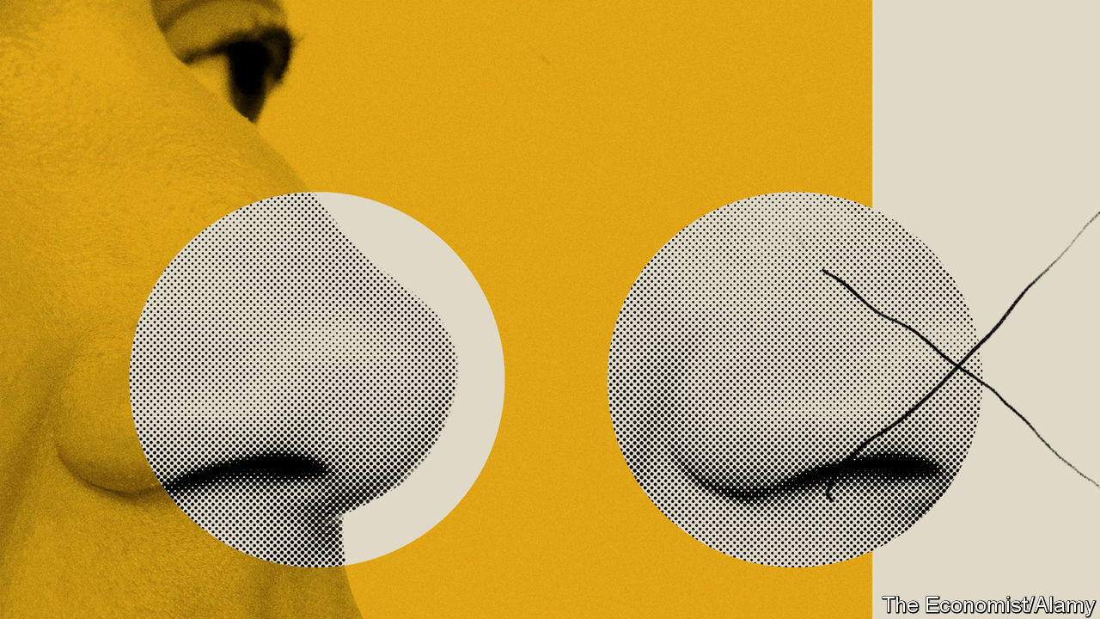

PEOPLE ARE familiar with the idea of probiotic bacteria, which, if consumed as part of someone’s diet, are supposed to enhance the health of the gut. The gut is home to zillions of microbes of many varieties, and if this microbial ecosystem gets out of balance illness can, indeed, result. Whether consuming probiotic-rich foods such as yoghurts really does promote health is a contested area of science. But the idea that they might do so is plausible.

One commonly promoted probiotic is Lacticaseibacillus casei (known as Lactobacillus casei until April 15th, when its name was changed by the International Committee on Systematics of Prokaryotes in response to a report which suggested that the genus Lactobacillus should be broken up). Now, evidence of the pathogen-fighting abilities of this bug comes from another direction—a study of the nose by Sarah Lebeer of the University of Antwerp.

Dr Lebeer and her colleagues took samples from 100 healthy people and 225 who were suffering from chronic sinus infections. These revealed an intriguing difference between the groups’ bacterial floras. Nearly 80% of the upper-respiratory-tract bacteria collected from healthy people were members of the genus Lacticaseibacillus. In those who suffered chronic infections the proportion was 55%.

That suggested members of Lacticaseibacillus might, indeed, have some protective effect. But correlation is not causation so, to investigate further, the team carried out some experiments using tissue cultures. They pitted various types of Lacticaseibacilli that they had found in their samples against common bacterial pathogens such as Staphylococcus aureus and Haemophilus influenzae.

As they describe in a paper published in Cell Reports, they discovered that the bug best able to stand its ground against these threats was a strain of L. casei called AMBR2. In particular, it was able to cling on to surfaces it had colonised using anchor-like structures that are known as fimbriae and which protrude from its cell walls. It also seemed to have a secret weapon, because it inhibited, presumably by chemical means, the growth and multiplication of its opponents as they came near. It was thus able to defend its turf more effectively than other Lacticaseibacilli.

In light of all this Dr Lebeer wonders if L. casei AMBR2 might be used as a treatment for chronic sinus conditions. As a first step towards testing this idea, she and her colleagues conducted a small trial to see if it was safe. They arranged for 20 healthy volunteers to spray a powder made of dried L. casei AMBR2 into their noses twice a day for two weeks, to check for adverse effects. They noted none. They also looked at whether the strain was able to colonise the nose when so administered, and found that the number of AMBR2 in the nasopharyngeal mix had indeed increased after the treatment was complete. Based on all this, Dr Lebeer suggests that developing a nasal probiotic therapy from this bacterium has the potential to help people with chronic sinus infections, and is something that ought to be explored.■

This article was downloaded by calibre from <https://www.economist.com/science-and-technology/2020/06/13/the-nose-it-seems-is-protected-by-bacterial-guards>

|  |  |  |  |
| --- | --- | --- | --- |
| Previous | Articles | Sections | Next |

|  |  |  |  |
| --- | --- | --- | --- |
| Previous | Articles | Sections | Next |

#### The search for a covid-19 treatment

# Hydroxychloroquine is embroiled in yet more controversy

And so is the idea of peer review

Jun 13th 2020 |

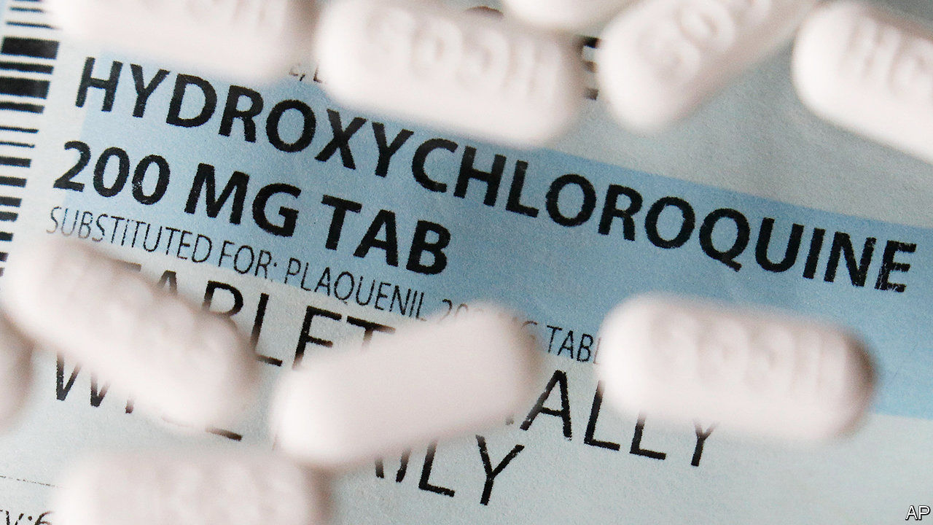

ONCE PRAISED as a miracle cure for covid-19, an antimalarial drug called hydroxychloroquine has rarely been out of the headlines since the start of the pandemic. It was hoped it might find a new use as a therapy in patients who are unwell with the novel coronavirus. But in recent weeks a scientific picture has emerged of a treatment that does not appear to be helping patients at all, and might even be causing harm.

Whether it helps seems clear now: it doesn’t. When it comes to the harm, though, it turns out that the scientific literature may be misleading. On June 4th the Lancet, a respected medical journal, retracted a high-profile paper published only a month previously. This had suggested that hydroxychloroquine and its analogue, chloroquine, actually increased the death rate in hospitals when taken by those with covid-19. This led the World Health Organisation to halt its trials of the drug. It also caused considerable concern to patients and to those enrolled on other such trials.

Towards the end of May, however, scientists started to question the reliability of the data that had been used. The New England Journal of Medicine had retracted a separate paper looking at blood pressure medicines in covid-19 which relied on data from the same firm, Surgisphere, that provided the data set for the Lancet article.

Surgisphere, based in Chicago, had said in the Lancet paper that 671 hospitals on six continents had provided data. The data set had been said to include almost 100,000 detailed patient records. On June 2nd the Lancet said that an independent audit of the data was under way, and wrote that “serious scientific questions” had been brought to its attention. The editor of the New England Journal of Medicine expressed similar concern, and said the authors had been asked to provide evidence their data were reliable.

The Economist was unable to contact Surgisphere for comment. All content has been removed from its website. However the firm’s site had stated that its mission was to harness the power of data analytics to “improve the lives of as many people as possible”. The firm said it used machine learning, artificial intelligence and big data to empower hospitals to make better decisions. Science, a leading academic journal, approached the paper’s authors for comment on June 8th, but they did not respond.

Many are wondering, more broadly, what could go so badly wrong as to lead to two retractions of papers at well-known medical journals. There are calls for the Lancet to publish the comments they received on the article during the process of peer review.

One irony of the affair is that concerns about the rush to publish science during the pandemic had been focused on preprints. These are papers posted online without independent scrutiny. Yet it is two peer-reviewed journals of repute that have found themselves in difficulty. Whether this incident will shift the balance of power in scientific publishing remains to be seen.

Editor’s note: Some of our covid-19 coverage is free for readers of The Economist Today, our daily [newsletter](https://my.economist.com/user#newsletter). For more stories and our pandemic tracker, see our [coronavirus hub](https://www.economist.com/news/2020/03/11/the-economists-coverage-of-the-coronavirus)

This article was downloaded by calibre from <https://www.economist.com/science-and-technology/2020/06/13/hydroxychloroquine-is-embroiled-in-yet-more-controversy>

|  |  |  |  |
| --- | --- | --- | --- |
| Previous | Articles | Sections | Next |

|  |  |  |
| --- | --- | --- |
| Science & ... | Sections | Economic & ... |

Books & arts

Rethinking capitalism: Free but fair

.

Authenticity in architecture: Living wills

.

Johnson: Snide and prejudice

.

“Brideshead Revisited” at 75: The Flyte club

.

Home Entertainment: Pop goes postal

.

Home Entertainment: In the summer kitchen

.

|  |  |  |
| --- | --- | --- |
| Science & ... | Sections | Economic & ... |

|  |  |  |  |
| --- | --- | --- | --- |
|  | Articles | Sections | Next |

#### Rethinking capitalism

# Two authors wrestle with inequality and the allure of populism

Martin Sandbu and Gene Sperling support free markets—but fear their power

Jun 13th 2020 |

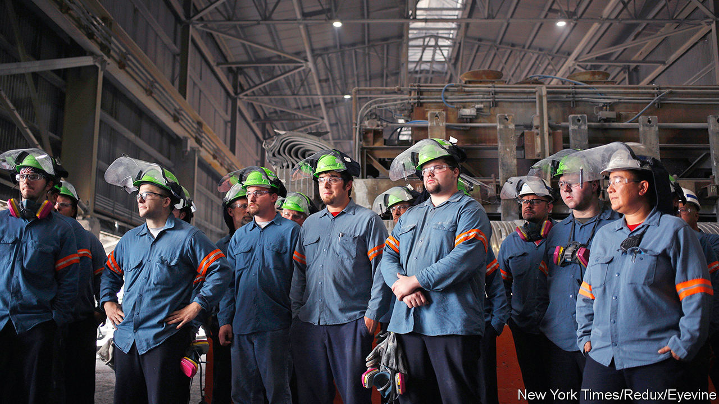

The Economics of Belonging. By Martin Sandbu. Princeton University Press; 296 pages; $24.95 and £20.

Economic Dignity. By Gene Sperling.Penguin; 384 pages; $28 and £23.99.

BEFORE COVID-19 struck, the rich world’s economies were in a paradoxical state. In many countries jobs were as plentiful as they had ever been. On many measures inequality had not risen much over the preceding decade, or had risen more slowly than in past economic expansions. And yet political systems were gripped by a populist backlash which, at least in part, reflected an indignant reaction against perceived economic injustice. The liberals who had constructed the old order were suffering a crisis of confidence.

The establishment’s ideas factories were whirring. How, exactly, should populists be disarmed—and which of their complaints had merit? The results are now being rebranded as ways to rebuild economies after the pandemic. Two new books fall into this category. In “The Economics of Belonging” Martin Sandbu, a columnist at the Financial Times, excoriates policymakers for unforced errors over recent decades and sets out an agenda for correcting course. In “Economic Dignity” Gene Sperling, a former top economic adviser to Presidents Bill Clinton and Barack Obama, argues for a new value system to underpin American economic policy.

Mr Sandbu’s book is in some respects the more optimistic of the two. He rejects the fatalistic argument that populism is a straightforward revolt against immigration and progressive cultural attitudes. Economic insecurity always triggers angst about culture and suspicion of outsiders, he points out. Fixing the economy, in other words, will heal cultural divides. The key is to get the economic diagnosis right. Trade, immigration and globalisation more broadly are easy scapegoats for lost manufacturing jobs and growing geographical inequality. But it is technological change that has really caused the rise of a service- and knowledge-based economy. The solution, thinks Mr Sandbu, is for governments to forge social contracts fit for technologically advancing economies, not to try to turn back the clock.

Yet his policy proposals do not reflect the “compensate the losers” redistribution for which economists frequently reach. Instead, he favours increasing workers’ productivity and bargaining power so that they are never too dependent on a single employer. To that end, monetary policy must put greater emphasis on keeping labour markets running hot, so that firms compete for workers rather than workers for jobs. Tax-free earnings allowances should be replaced with a small universal basic income, to reinforce safety-nets without laying poverty traps. And governments should direct investments in the knowledge economy, such as publicly funded research, towards places that have been left behind.

Mr Sandbu claims this agenda is not left-wing, and does not require an increase in government spending as a share of GDP. But it does require a recognition that individuals must not completely lose control over their economic fate to market forces. Otherwise, as they endeavour to wrench it back, they may be swayed by extremists.

## Darkness visible

Mr Sperling’s book is—perhaps unsurprisingly—more partisan. For him, policy failures have been the fault of small-government fundamentalists, chiefly in the Republican Party, who have failed to appreciate that there is more to life than GDP and the free market. He argues for what political philosophers might call a “sufficientarian” approach to economic policymaking, whereby everyone is entitled to a basic minimum. This is not calibrated in dollars, as advocates of a universal basic income might recommend. Instead it is measured in “economic dignity”, which includes sufficiently high pay, time to spend with family members (or take care of them), and the peace of mind that comes from adequate health care and a strong safety-net.

The notion that some spheres of life should be beyond the reach of the economy or the state is a powerful one with a rich heritage. It motivates the concept of rights, which are usually considered immune both to utilitarian calculus—what Mr Sperling calls “aloof welfare economics”—and even to some individual choices. Most people agree, for example, that no one should be able to sell themselves into slavery, or bargain away their right to a free trial. But Mr Sperling mostly dodges the hardest parts of establishing such a philosophy: defining its boundaries and proving that it is feasible to organise society in a way that protects the dignity of everyone simultaneously. Save for one inconclusive chapter on whether it is in fact possible for all work to have true meaning, Mr Sperling tends to intuit the answer to these questions, while pouring scorn on those who cast doubt.

As a result it can seem as if he has taken a Democratic wish-list of ideas and bolted on the dignity justification. Some of these ideas are sensible. He might have used any number of values, including fairness, justice and efficiency, to argue for reform of American health care, or to object to the exploitative practices of for-profit colleges. Others, such as a disdain for stock buy-backs and a desire for more barriers to entry for careworkers, are less appealing—and not helped much by invoking dignity.

Mr Sandbu is more interested in justifying his proposals from several angles. Like Mr Sperling, he wants a higher minimum wage. But not just on distributive grounds—he says it would spur firms to invest in training their workers (the sort of argument that sounds plausible but needs proof to be convincing). Sometimes his economic logic ties him in knots, as with his discussion of wealth taxes. Mr Sandbu supports them on grounds of efficiency as well as fairness, arguing that they will encourage the rich to take entrepreneurial risks. But he hurries over the fact that the paper he cites in support of this view imagines a world in which wealth taxes replace all other taxes on capital—including the corporate taxes which a few pages later he wants to raise, too.

On a fundamental level, these books are similar in attitude. Messrs Sandbu and Sperling both combine a basic support for free markets with a fear of their power. It is precisely because incentives are so potent that competitive forces must not be allowed to go haywire, as when firms gain an edge by reclassifying their workers as contractors, or by moving to tax havens. Such races-to-the-bottom define many of the policy failures of recent history.

And both books highlight the moral blind spots that many liberals and economists think have been exposed by the era of globalisation (and perhaps by the pandemic, too). Clarifying those problems, and finding solutions that avoid compromising too much on freedom and free markets, is crucial work. ■

This article was downloaded by calibre from <https://www.economist.com/books-and-arts/2020/06/13/two-authors-wrestle-with-inequality-and-the-allure-of-populism>

|  |  |  |  |
| --- | --- | --- | --- |
|  | Articles | Sections | Next |

|  |  |  |  |
| --- | --- | --- | --- |
| Previous | Articles | Sections | Next |

#### Living wills

# In the world of architecture, death is not always fatal

Witness a new building in Leipzig by Oscar Niemeyer—who died in 2012

Jun 13th 2020 | LEIPZIG



IN PLAGWITZ, THE old industrial quarter of Leipzig, Ludwig Koehne stands in the middle of a giant sphere designed by Oscar Niemeyer in 2011, the year before the Brazilian architect died at the age of 104. The vaulted, part-glazed upper deck of the orb is due to open later this year as a restaurant, its cosier underbelly as a bar. “I wanted posthumous fidelity to the original design,” says Mr Koehne, a German entrepreneur. “The building had to have the master’s signature.”

The Niemeyer Sphere, as Mr Koehne calls it, perches on a narrow supporting tower at the edge of a two-storey building that houses the canteen of his two companies, Kirow Ardelt, which makes cranes, and HeiterBlick, a tram manufacturer. The smooth, brilliant-white dome contrasts with weathered, angular bricks of deep crimson—the result of an elaborate construction effort involving Jair Valera, longtime head of Niemeyer’s office in Rio, and the structural engineers and on-site architects assembled by Mr Koehne in Germany.

Alongside a project in southern France, this will count as the last work by Niemeyer, the progenitor of sensual architectural curves that complemented modernism’s unrelenting cubes. The completion of the sphere is a tribute to his vision—but it also highlights the collaborative nature of his profession and the slippery notion of authenticity. It always takes more than a single genius to make a beautiful building, which is one reason why, in the world of architecture, death is not always fatal.

The long hiatus between Niemeyer’s death and the opening of the sphere is not unprecedented. The IBM building in Chicago, designed by Mies van der Rohe, was finished two years after he died. For Le Corbusier’s church in Firminy in France, the gap was a whopping 41 years.

Exceptional as these posthumous cases seem, the teamwork they require is routine. “Most buildings are the product of lots of unrecognised labour,” says Donald McNeill of the University of Sydney, who has researched the methods of global architecture firms. He sees the popular focus on star architects as a simplification by the media and marketeers. Big projects, he says, are “the result of work by designers, engineers and even the clients”.

## Their master’s voice

And, often, other architects. Rem Koolhaas, a Dutch architect, has noted the role of the American practitioners who in the 1950s helped big-name Europeans build legendary skyscrapers in New York. Emery Roth co-operated with Walter Gropius on the MetLife building, Philip Johnson lent van der Rohe a hand on the Seagram building, and Wallace Harrison oversaw Le Corbusier’s (and Niemeyer’s) input to the UN headquarters. Mr Koolhaas himself collaborated with Ole Scheeren on China Central Television’s HQ in Beijing; the so-called Gherkin in London is generally attributed to Lord Norman Foster, but Ken Shuttleworth drew the initial sketches. “There is a real difference between how architecture operates and how it is perceived,” comments Hilde Heynen of the Catholic University of Leuven in Belgium.

In the case of the Leipzig orb, the story began in 2007 when Mr Koehne visited Brasilia and was wowed by Niemeyer’s designs for the presidential residence, which was completed in 1960, and the city’s cathedral, finished in 1970. Four years later, mulling the idea of a restaurant—his canteen cook deserved a bigger stage, he says—Mr Koehne wrote to Niemeyer and was invited to Rio. Before long he received an email with sketches, side elevations and cross-sections. “It was all there, the tower as a supporting shaft, the sphere with two levels—just like it stands here now.”

But “the physics of the design were insane,” Mr Koehne thought. “How are we going to build this?” It took another two years to find the right structural engineers and several more to make meaningful progress. In the meantime, Niemeyer died. Luckily, Mr Valera was on hand and wanted to finish the project. “I knew Oscar extremely well,” he says. “That made it easy for me to know what he would have done”—which, Mr Valera recalls, always included listening to the client. His own role does not detract from the building’s authenticity, he insists: “This is a piece of architecture by Oscar Niemeyer—it was his idea.” ■

This article was downloaded by calibre from <https://www.economist.com/books-and-arts/2020/06/13/in-the-world-of-architecture-death-is-not-always-fatal>

|  |  |  |  |
| --- | --- | --- | --- |
| Previous | Articles | Sections | Next |

|  |  |  |  |
| --- | --- | --- | --- |
| Previous | Articles | Sections | Next |

#### Johnson

# Language is a telling clue to unacknowledged racial attitudes

Overt racism is declining, but studies show that unconscious bias remains widespread

Jun 13th 2020 |

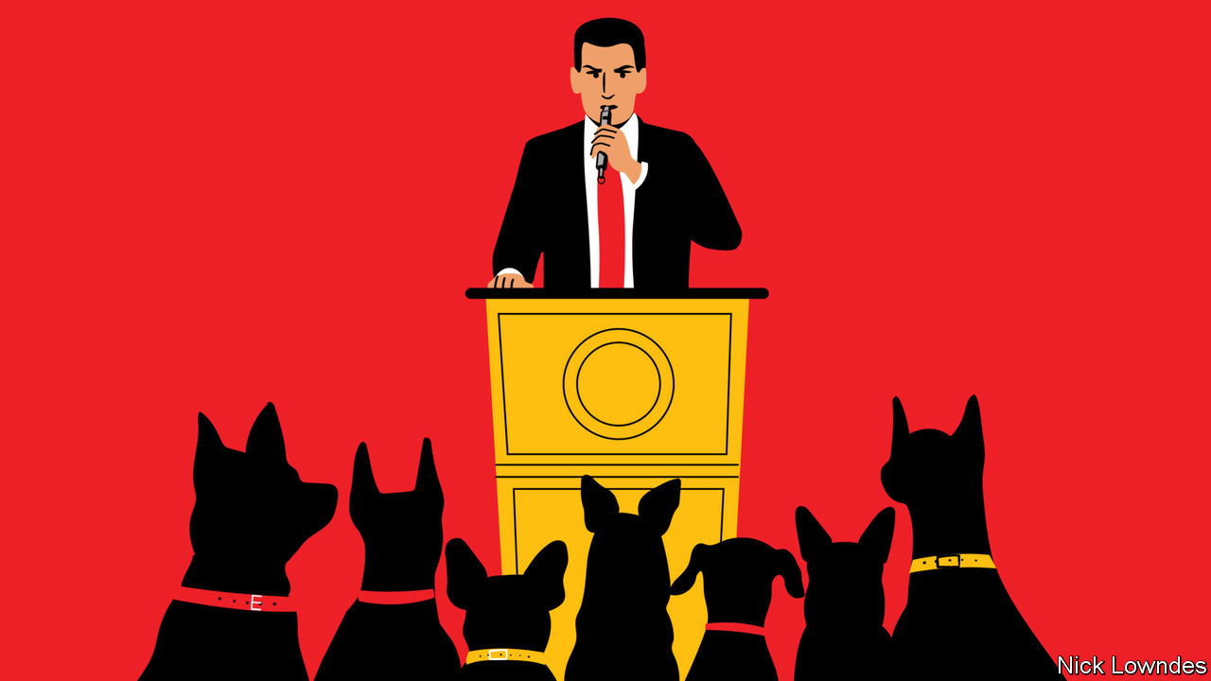

“WHEN THE looting starts, the shooting starts,” tweeted Donald Trump (invoking a slogan from the 1960s), when unrest broke out after the killing of George Floyd. “THUGS”, the president wrote, were disrespecting Mr Floyd’s memory. Mr Trump likes “thugs”, tweeting it often. He almost always does so when some matter of race is at issue—either the treatment of African-Americans or in reference to “illegals” and “gang members”, implicitly Latinos.

Are “looting” and “thugs” a kind of racist code? Many people detect a “dog-whistle” which, without saying anything explicitly racist, the president intends listeners to hear. Mr Trump forcefully disagrees. In 2015 he tweeted: “They now say using the word ‘thug’ is, like so many other words, not politically correct (even though Obama uses it). It is racist. BULL!” Plenty of people approve of calling thugs thugs, and object to being labelled racists for doing so.

The intentional dog-whistle is not unknown. But people can allude to race without realising it, too. Explicit racism is declining in America, as a pile of evidence shows. For instance, there is a widespread reluctance to admit racist attitudes that many Americans were once perfectly comfortable with. On the other hand, unconscious and semi-conscious prejudice is alive and well. When people use racially linked language, without overt slurs or other racist tropes, linguists call it “racialisation”.

Some ingenious research has teased out the links between prejudice and language. A classic method for fingering implicit bias asks subjects to take a quick-fire, button-pushing test that associates positive or negative words with white and black faces. In one such study (at implicit.harvard.edu), 58% of online test-takers are slower to associate positive language with black faces than with white ones. Just 14% display the opposite tendency.

Or consider more deliberate forms of language, formulated by people who are generally unlikely to consider themselves racist—journalists. A study by Dana Mastro of the University of California at Santa Barbara looked at hundreds of news reports in three big American papers (the New York Times, the Los Angeles Times and usa Today) about professional athletes accused of crimes. Such articles were more accusatory of the alleged perpetrators when they were black. They were more likely to provide context and humanising detail when the accused were white.

Praise can be racialised, too. Crystal Dunn Soubrier, a black player for America’s women’s football team, wrote recently that commentators attribute her ability to play in several positions to athleticism, never to her reading or study of the game. This seems a persistent pattern in sportswriting. Kelly Wright, a doctoral student of linguistics at the University of Michigan, used machine-learning to predict an athlete’s race based on words that appear in an article containing their name. Purely relying on the language of news reports, the model was able to predict that Ronda Rousey, a wrestler, was white with a 96% certainty, whereas there was only a 3% probability that Eric Berry, a National Football League player, was white. So it went with other athletes; the algorithm’s guesses were almost always loaded starkly towards black or white.

When racialisation happens, words do not change their dictionary definition; rather, they take on associations with other words. Brains are statistical machines, in which learning involves a gradual strengthening or weakening of different synapses. Introduce one concept and related concepts are “primed”, or made more quickly available to the consciousness. Just because these associations are hard to prove conclusively does not make them less real.

The difference between “racist” and “racialised” helps explain why Americans often talk fruitlessly past each other when discussing words such as “thug”. With overt racism waning, it has become painfully obvious to some people—though not all—that the submerged part of the iceberg, implicit racial beliefs and associations, plays a bigger role than was once realised. Overcoming those is particularly difficult because of their semi-conscious nature.

A long struggle has made “racist” one of the worst things you can be. That counts as a great success, but the corollary is that the remaining problems are hard to talk about. Some fear being branded racist just for trying. Seeing the bias in even innocently intended language is a first step towards understanding that there is still work to do.

This article was downloaded by calibre from <https://www.economist.com/books-and-arts/2020/06/13/language-is-a-telling-clue-to-unacknowledged-racial-attitudes>

|  |  |  |  |
| --- | --- | --- | --- |
| Previous | Articles | Sections | Next |

|  |  |  |  |
| --- | --- | --- | --- |
| Previous | Articles | Sections | Next |

#### The Flyte club

# Published 75 years ago, “Brideshead Revisited” set off a lasting cult

Evelyn Waugh’s ode to aristocratic languor mourned Britain’s past—and coloured its future

Jun 11th 2020 |



IN THE WEEKS after VE day, as British voters prepared to swap Winston Churchill for the Labour Party, the country’s fiction leapt into a radiant past. Published 75 years ago, at the end of May 1945, Evelyn Waugh’s “Brideshead Revisited” offered not a Utopian vision of the future but a wistful dream of vanished faith and grace. In his seventh novel, a writer formerly known for mordant satire evoked—with a glamorous alloy of lyricism and rueful irony—a lost domain of “peace and love and beauty”, smashed by modernity, democracy and war.

At first glance, no story could have suited the progressive climate of 1945 worse than Waugh’s “sacred and profane memories of Captain Charles Ryder”, a middle-class, middlebrow artist turned lukewarm army officer. A chance billet sends Ryder back to the great house owned by the old, dysfunctional Catholic family who had bewitched him when he met Sebastian Flyte, its younger son, at Oxford in the 1920s. The levelling forces of the new age take the form of his junior officer, Hooper, whose outlook fuses practicality with the anti-aristocratic disdain shared, then and now, by many on both the British left and free-enterprise right.

To the romantic reactionary Waugh, the undignified future belonged to Hooper, with his trademark, cheery chirp of “Rightyoh”. “We possess nothing certainly except the past,” muses Ryder. With divine grace as his underlying theme and the time-encrusted splendours of the English Catholic elite as his frame, Waugh set out to give that past a last hurrah.

But this swansong heralded a strange rebirth. “Brideshead” sold very well—and critics adored it. “Most of the reviews have been adulatory except where they were embittered by class resentment,” Waugh wrote. Sceptics included Edmund Wilson of the New Yorker, who excoriated the “mere romantic fantasy” of this “Catholic tract” disfigured by “shameless and rampant” snobbery. Yet even he predicted a triumph—and the novel duly became a bestseller in America, too. Waugh affected to find the book’s success across the Atlantic “upsetting because I thought it in good taste before and now I know it can’t be”.

It turned out that an age of change loved escaping into faded glories. In a preface written in 1959, Waugh noted that amid the wartime austerity of 1944 it had been “impossible to foresee…the present cult of the English country house”, many of which had in the intervening years found salvation in tourism. Brideshead today would not be derelict, he speculated, but “open to trippers”, and better maintained than Lord Marchmain, its fictional master, ever managed. On the brink of the 1960s the author thought his book had been “a panegyric preached over an empty coffin”.

Still, Waugh, who died in 1966, might have been shocked by the next stage in this zombie afterlife. Directed by Charles Sturridge and Michael Lindsay-Hogg, with a star-strewn cast including Laurence Olivier, Anthony Andrews (pictured left) and Jeremy Irons (right), an 11-hour television adaptation of his novel began to air in Britain in October 1981. This lavish feast of nostalgia set off a national cult. Students and others mimicked the languid extravagance of doomed, drunken Sebastian, toting his teddy bear at Oxford, and his spoiled pals.

Smokestack industries were dying under Margaret Thatcher’s government; unemployment soared and inner cities rioted. But in many living rooms, the aristocracy was back in vogue. The fairy-tale nuptials of Prince Charles and Lady Diana Spencer fed the mood. “We have really touched a nerve,” said Derek Granger, the producer of the series. After PBS broadcast it in America early in 1982, Bloomingdale’s in New York filled its windows with Flyte-style fashion. The Brideshead backwash lingered. In 1985 the National Gallery in Washington scored a hit with its “Treasure Houses of Britain” exhibition. David Cannadine, a British historian, denounced the “neonostalgic, pseudopastoral, manufactured world” on display in a critique headlined “Brideshead Re-Revisited”.

In Britain hardly any members of this new Flyte club actually belonged to the sparse upper classes. They came from the bourgeois middle and, after some play-acting at university, went back to it. For most, Brideshead mania left no lasting trace. For a fateful few, it did.

## Teddy bears’ picnic

Waugh’s novel scoffs at the Bullingdon Club, a notorious Oxford drinking society, and its “cretinous porcine” hearties. The Bullingdon, though, revived in the TV show’s wake and recruited two future British prime ministers, Boris Johnson and David Cameron. More widely, a Flyte-flavoured pursuit of charm and panache spread across the gilded crust of British society. The novel’s waspish choric figure, the gay aesthete Anthony Blanche, warns Ryder against charm as “the great English blight” that “kills anything it touches. It kills love; it kills art.” But Brideshead chic promoted a genial, born-to-rule insouciance that elevated repartee above accomplishment, and cloaked the grubby business of winning and keeping power.

This tendency towards a kind of louche, showy entitlement did not begin with the drama. Yet according to David Kynaston, perhaps the pre-eminent historian of post-war Britain, “the TV adaptation did have some specific effect” on attitudes. He sums up the sentiments that “Brideshead” channelled: “No need any longer, despite all the Thatcher talk of meritocracy, to feel guilty about hereditary privilege. And OK to knock/despise the working class…An end, in short, to worthiness.”

The cult of the British country house, real and imaginary, lives on. The National Trust, a charity that looks after many of them, has 5.6m members, more than the population of Finland. “Downton Abbey”, one of Brideshead’s TV offspring, ran for six much-watched seasons. And even in Brexit-era Britain, a sense of entitlement, ironclad in charm, can still clear a path to the top of politics—witness Mr Johnson’s quip-fuelled and scandal-proof rise. For some, Waugh’s bittersweet elegy became a sort of handbook of patrician showmanship. As Ryder remarks when the noble house is reduced to a drab barracks: “The builders did not know the uses to which their work would descend.” ■

This article was downloaded by calibre from <https://www.economist.com/books-and-arts/2020/06/11/published-75-years-ago-brideshead-revisited-set-off-a-lasting-cult>

|  |  |  |  |
| --- | --- | --- | --- |
| Previous | Articles | Sections | Next |

|  |  |  |  |
| --- | --- | --- | --- |
| Previous | Articles | Sections | Next |

#### Home Entertainment

# “Give Up” is a fitting pandemic soundtrack—in more ways than one

The album by the Postal Service shows that great things can be accomplished at a distance

Jun 13th 2020 |



THE THRILL is gone. Even over Zoom, millions have discovered, work stubbornly remains work. But if isolation seems a grind, have a listen to “Give Up” by the Postal Service, a collaboration in 2003 between Ben Gibbard of the indie band Death Cab for Cutie, and Jimmy Tamborello, aka Dntel, a pioneering electronica producer. Not only do its lyrics anticipate today’s claustrophobia; the way the album was made is itself a salutary tale of long-distance ingenuity.

Living at opposite ends of America’s west coast, the two men were unable to meet in person. So Mr Tamborello would record beats on CDs and post them to Mr Gibbard, who added instrumentation and vocals. Back and forth the CDs went, new layers added with each mailing, until after a year they had amassed an album’s worth of material. In honour of the deliveries that made their teamwork possible, they decided to call themselves the Postal Service.

The United States Postal Service (USPS) responded with a cease-and-desist letter. But the two sides came to an arrangement: in exchange for some promotional work, the Postal Service could keep the name. The USPS would even sell their records on its website—though it insisted on a morality clause voiding the agreement should the duo do anything truly shocking.

The resulting album is a gem. Mr Tamborello’s signature glitchy sounds are built into rhythms plundered from dance music, which Mr Gibbard’s guitar and vocals turn into energetic yet charming pop songs. Some of his lyrics deal with pop staples—young love and break-ups—but the melancholic turns elevate the record above cliché, and make it resonate now.

Take the song “We Will Become Silhouettes”, which recounts being trapped inside after a nuclear strike. “I wanted to walk through the empty streets/And feel something constant under my feet,” Mr Gibbard sings. “But all the news reports recommended that I stay indoors”: different disaster, same outcome. “Sleeping In” is about clinging to consoling dreams. “Recycled Air” evokes a yearning for air travel, and its anxieties, “knuckles clenched to white as the landing gear retract for flight”.

This genre-bending music looked forward to later developments in pop. But the Postal Service was ahead of its time in another way, too. Even before covid-19 confined them to their home studios, other artists were undertaking remote collaborations. For example, “Old Town Road”, a blend of country & western and hip-hop, was made from a beat that Lil Nas X, an American rapper, bought online from YoungKio, a Dutch music producer, for $30. Though they had never met, the track they made together enjoyed a record-breaking 19 weeks at the summit of the Billboard Top 100, and was certified diamond faster than any song before it. After your next dreary Zoom meeting, remember that great things have been accomplished at a distance. ■

This article was downloaded by calibre from <https://www.economist.com/books-and-arts/2020/06/13/give-up-is-a-fitting-pandemic-soundtrack-in-more-ways-than-one>

|  |  |  |  |
| --- | --- | --- | --- |
| Previous | Articles | Sections | Next |

|  |  |  |  |
| --- | --- | --- | --- |
| Previous | Articles | Sections | Next |

#### Home Entertainment

# Jam embodies resilience—and dogged optimism

Making it is a therapeutic ritual and a useful distraction for bored children

Jun 13th 2020 |



EVEN IN THIS strangest of summers, June marks the beginning of the jam calendar. As the first fruits come into season—pallid green strawberries turning ruby red, gooseberries swelling, apricots donning their downy fuzz—sweet-toothed hoarders set to work. Bread-making may be the culinary craze of the lockdown, but it helps to have something to slather on top.

Sugary yet reliable, jam’s history is sandwiched inside mankind’s. Versions of it were savoured by ancient Romans and Seljuk sultans alike; Joan of Arc ate one for courage before battles; sailors stockpiled it to combat scurvy. Jars of jam have accompanied Edmund Hillary to the summit of Mount Everest, explorers to the South Pole and astronauts into space. Russians and Ukrainians stir it into tea; Swedes serve it with fried herring. You can spread it on Brie, or add it to tarts, sponge-cakes and peanut-butter sandwiches.

Amid the pandemic, jam-making has found new purposes. It can keep bored children occupied (particularly if the fruit-picking is included), supply gifts for vulnerable neighbours or serve as a therapeutic ritual in muddled days. You do not, as you might fear, need a thermometer, beautiful gingham-topped jars or a preserving pan to make good jam. You need only time and a watchful eye.

Novices should start with raspberries, which are naturally high in pectin, a starchy gelling agent that helps the jam set. (Later you can progress to marmalade, quince jelly and chutney.) Purists use a 1:1 ratio of sugar and fruit, but deviation is permissible. Warm the mixture on a low heat until the sugar is dissolved, then bring it to a rolling boil. Drop a dollop onto a chilled dish, leave it for about a minute and push a finger through. If it crinkles, the jam is ready to be decanted into jars. These can be sterilised in boiling water, the oven, even the dishwasher.

Whisking the gloop from the heat at precisely the right moment is vital, lest it solidify into a rigid blob. If this happens, you will be tempted to throw the pan out with the jam, and chuck in the towel for good measure. Don’t. Embrace the sweltering, syrupy heat of the summertime kitchen, and start again. It will be messy—transferring molten liquid from a bubbling cauldron into a jar takes deftness and patience. When you succeed, and wipe your brow in relief, you will leave a warm sticky smear across your forehead.

All this requires resilience; but then, that is what the stuff itself embodies. During the second world war the Women’s Institute in Britain preserved 5,000 tonnes of fruit to help sustain the hungry population. Jam is also a form of reassurance—those dusty jars kept at the back of a cupboard, just in case, are a silent comfort. Above all, it is an expression of dogged optimism, since preserves reflect a tacit intention to hang around long enough to reap the benefits. As Joanne Harris, a novelist, has put it, jam betokens “seasons that turn in the same place, in the same way, year after year, with sweet familiarity”. ■

This article was downloaded by calibre from <https://www.economist.com/books-and-arts/2020/06/13/jam-embodies-resilience-and-dogged-optimism>

|  |  |  |  |
| --- | --- | --- | --- |
| Previous | Articles | Sections | Next |

|  |  |  |
| --- | --- | --- |
| Books & arts | Sections | Graphic detail |

Economic & financial indicators

Economic data, commodities and markets

.

|  |  |  |
| --- | --- | --- |
| Books & arts | Sections | Graphic detail |

|  |  |  |  |
| --- | --- | --- | --- |
|  | Articles | Sections | Next |

# Economic data, commodities and markets

Jun 13th 2020 |

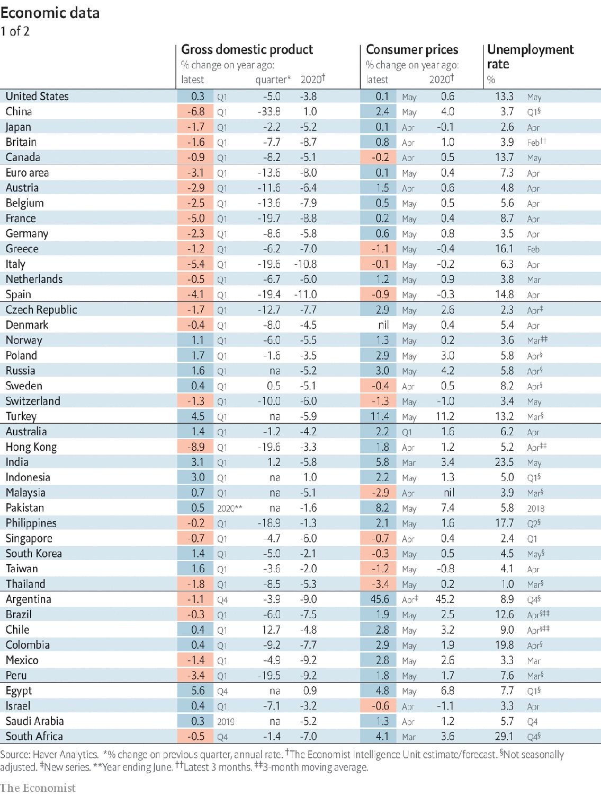

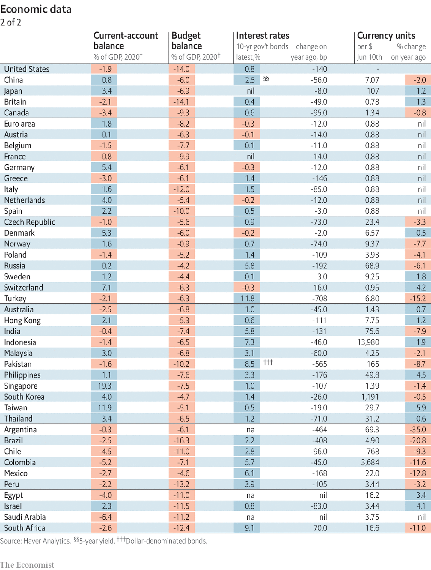

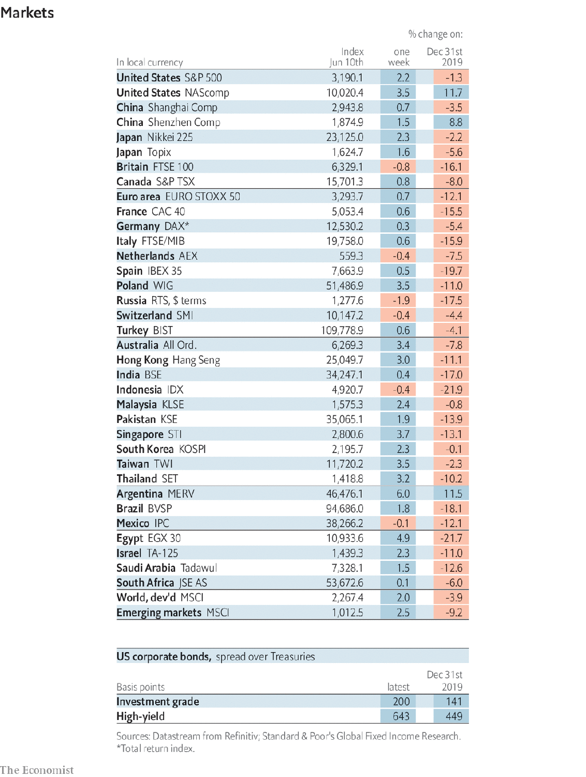

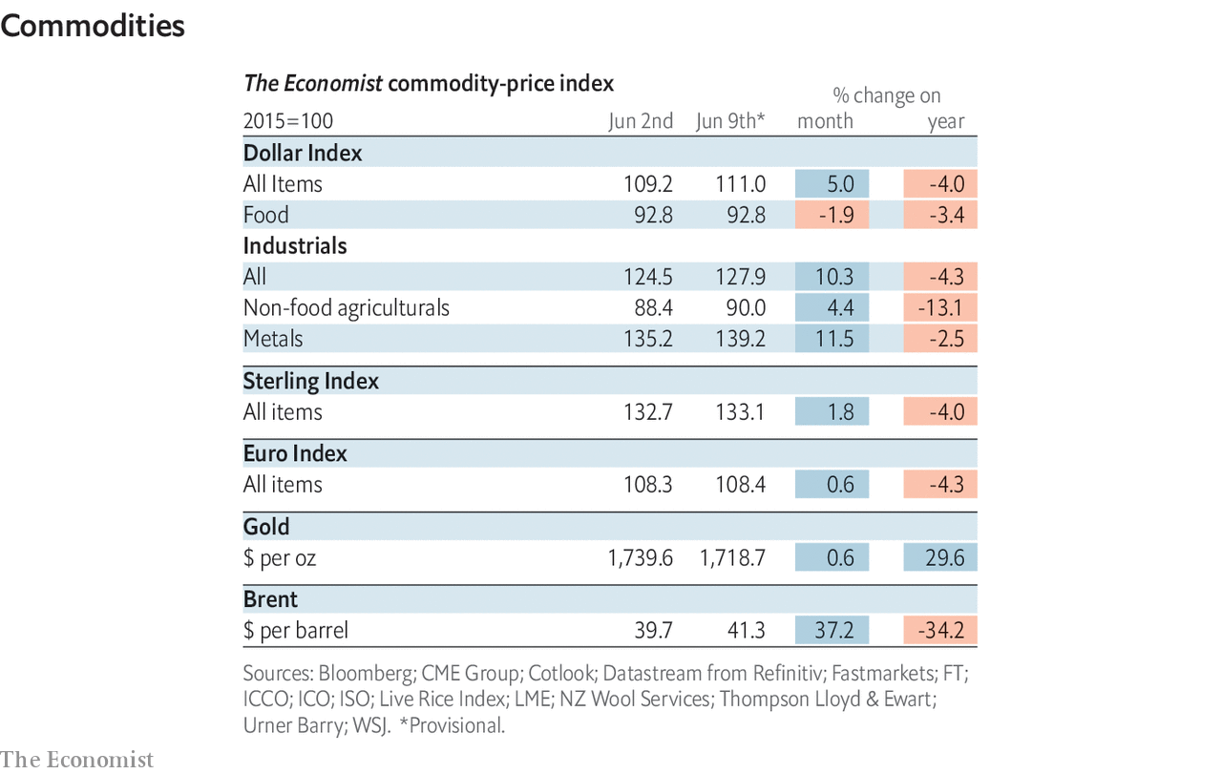

This article was downloaded by calibre from <https://www.economist.com/economic-and-financial-indicators/2020/06/13/economic-data-commodities-and-markets>

|  |  |  |  |
| --- | --- | --- | --- |
|  | Articles | Sections | Next |

|  |  |  |
| --- | --- | --- |
| Economic & ... | Sections | Obituary |

Graphic detail

Deforestation in Brazil: The roots of the problem

.

|  |  |  |
| --- | --- | --- |
| Economic & ... | Sections | Obituary |

|  |  |  |  |
| --- | --- | --- | --- |
|  | Articles | Sections | Next |

#### The roots of the problem

# A study names firms who buy products from areas with deforestation

Big agribusiness companies buy the bulk of soyabean output in municipalities where lots of trees have been cleared illegally

Jun 11th 2020 |

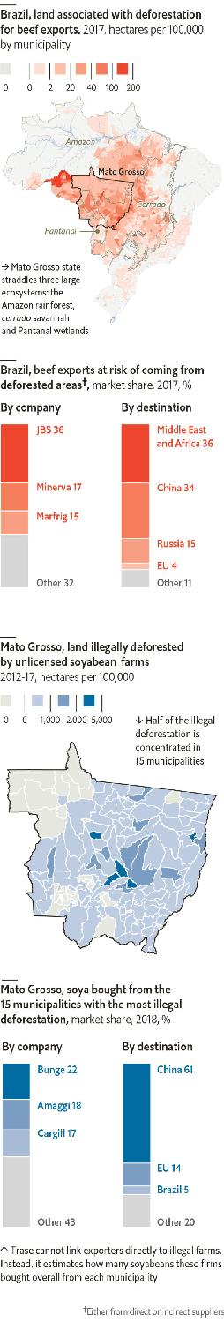

ONE OF THE factors slowing progress against climate change is a lack of corporate accountability. In the Amazon rainforest, which absorbs 3% of global carbon emissions, a France-size swathe of foliage has vanished since 1970. Nearly all deforestation in Brazil today is illegal. But we do not know which firms use suppliers that operate on illegally cleared land (see article). Even beef exporters are in the dark: they mostly record where their cattle were fattened, not where they were reared.

Fortunately, plausible deniability is becoming harder to sustain. Trase, a research organisation, has analysed Brazil’s supply chains, stretching from newly cleared land in the Amazon and cerrado (a leafy savannah) to ports overseas. In a forthcoming report, conducted with ICV and Imaflora, two Brazilian institutes, Trase finds that the bulk of soyabean exports from one state ravaged by illegal deforestation ends up in the hands of a few big companies, some of which trade on Western stockmarkets.

Trase scours satellite images to spot areas cleared for cattle or soyabeans. It cannot prove ties between specific exporters and farms. But it does produce regional estimates, using sites of slaughterhouses and soya processors, customs records and data on commodity flows between states.

For each of Brazil’s 5,570 municipalities, Trase estimates the share of local output bought by each company. It then allocates tree-clearing proportionally, so a firm that buys 20% of a municipality’s soya gets 20% of the area’s soya-based deforestation risk (the risk that farming occurs on deforested land). Such estimates may seem unfair, if they saddle scrupulous firms with risk that belongs to irresponsible competitors. Exporters say they are committed to transparency, and do publish reports on suppliers. But Trase reckons these data are not detailed enough to assess firms’ behaviour.

Trase’s new study focuses on soya from Mato Grosso, a state spanning the Amazon and cerrado that lists which farms have licences to clear land. This lets researchers separate legal and illegal deforestation. The study shows that 95% of tree-clearing on soya farms in the state in 2012-17 was illegal. Many recently razed areas have yet to be used for planting, but may be in future.

Among the 15 municipalities in the state with the most illegally deforested land, Trase estimates that nearly 60% of their total harvest was bought either by Amaggi, a private Brazilian firm, or by the American agribusiness giants Bunge and Cargill. Those companies all say that they adhere to a ban on soya-based deforestation in the Amazon from 2008, and that they do not buy from illegally cleared areas. Trase’s data do not show otherwise. But avoiding the fruits of illegal deforestation in these places must require meticulous discipline.

In Brazil, beef causes six times more deforestation than soya does. Trase has also studied the 20% of beef output that is exported (though it does not have data about legality). JBS, Minerva and Marfrig, Brazilian firms that Trase says combine for two-thirds of exporters’ deforestation risk, all say their direct suppliers avoid deforested land. Trase’s figures do not refute this.

However, these companies acquire a majority of their beef from firms that do not rear all of their cattle themselves. And these suppliers’ own suppliers are much harder to monitor. If exporters wish to prove they act responsibly from farm to fork, they will need to obtain and share data about their chains’ missing links. ■

Sources:Trase; Global Canopy; Stockholm Environment Institute; ICV; Imaflora

This article was downloaded by calibre from <https://www.economist.com/graphic-detail/2020/06/11/a-study-names-firms-who-buy-products-from-areas-with-deforestation>

|  |  |  |  |
| --- | --- | --- | --- |
|  | Articles | Sections | Next |

|  |  |  |
| --- | --- | --- |
| Graphic detail | Sections |  |

Obituary

Larry Kramer: Shout loud, save lives

.

|  |  |  |
| --- | --- | --- |
| Graphic detail | Sections |  |

|  |  |  |  |
| --- | --- | --- | --- |
|  | Articles | Sections | Next |

#### Shout loud, save lives

# Larry Kramer died on May 27th

The outspoken prophet of America’s AIDS epidemic was 84

Jun 13th 2020 |

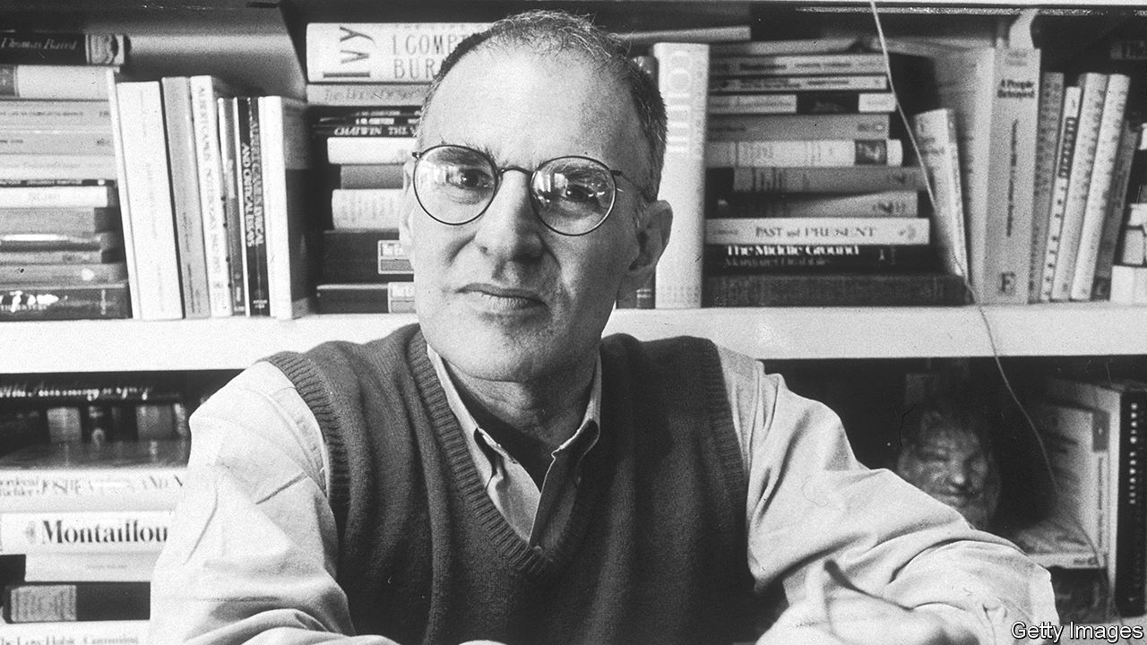

SUDDENLY, his face could change. From seeming calm, the brown eyes benevolent and almost shy, it twisted into a furious grimace. Out of the grimace came one scream: “PLAGUE!”

That stopped their stupidity, as the volunteers he had organised squabbled with each other. That focused minds. And he had plenty to yell about. The AIDS epidemic that had struck America in 1981 was being largely ignored, while thousands of gay men died. The right-wing Reagan government would not touch a “gay disease”. Medical research was unfunded and half-hearted. Yet millions of people, not only gays, were at risk. It was pressure from the organisations he founded, especially ACT UP in 1987, that caused HIV/AIDS to be treated like the emergency it was. Research was speeded up exponentially, and government took notice. The ruckus he caused made many people loathe him. But it saved lives.

The disaster of the 1980s was both general and personal. Too many of his friends in Greenwich Village were dead, or dying. They were tired all the time, with swollen lymph glands. They would wake up in swimming pools of sweat. The death-sign was the purple lesions of Kaposi’s sarcoma on their feet or on their faces. No one knew what caused this: promiscuity, poppers, back rooms, the baths, anal sex, semen, shit, saliva, sweat, blood, voodoo, drugs…They were all in the dark. The only clear thing was that their lives were killing them. All it seemed to take was one wrong fuck. No one knew how to treat it, either: chemotherapy, interferons, experimentals, were all useless. He was as scared as anyone. He expected, hoped, to be saved. But it seemed that gay men were being left to save themselves. He had to rally them.

In March 1983, in an article in the New York Native, a gay paper, he laid out the numbers as they were then. Already there were 1,112 cases of this new disease, and 418 deaths. In one month, mid-January to mid-February, 73 deaths. Some 86% of serious cases died within three years. And 72.4% of all such cases were in gay or bisexual men. “If this article doesn’t scare the shit out of you,” he cried, “we’re in real trouble. If this article doesn’t rouse you to anger, fury, rage, and action, gay men have no future on this earth.”

Many called this fearmongering. He thought it long past time. This community of gays, these people he so loved, were leaderless. They also had no one to represent them in the corridors of power. He would speak for them, and be their Moses. In 1981 he had started the Gay Men’s Health Crisis to draw attention to the plague. It was successful in some ways, but too mild for him. Instead of campaigning it became a band of carers, who bought shopping for the sick and walked their dogs. He was the only screamer. Certainly he too could be calm, and kind, even sweet, but this was war: rather than Moses now, he had to be Cassandra. After two years he left, prepared to be a loner if that was what it took. He had earned enough, as a film-production executive in the 1960s and 1970s (“Lawrence of Arabia”, “Women in Love”), to devote himself to agitation. His first act was his article in the New York Native.

Within a few years he had founded ACT UP to do what was needed: study, plan, protest and cause mayhem. Hundreds joined it, many of them sick already. Members disrupted mass at St Patrick’s cathedral and scattered the ashes of AIDS victims on the White House lawn. They invaded the New York Stock Exchange to urge traders to sell Burroughs-Wellcome shares because the pharma company was over-pricing AZT, the first drug to offer hope. They shut down the Food and Drug Administration’s offices because it approved new drugs too slowly. ACT UP combined drama with targeted research; it was militant and infuriating, but it probed in the right places. He led the way. In 1988 his open letter in the San Francisco Examiner to Anthony Fauci, director of the National Institute of Allergy and Infectious Diseases, calling him a murderer and a liar, set Dr Fauci thinking. After that, research picked up. By 1996, good progress then, an effective treatment appeared.

Foot-dragging health institutes and greedy pharma companies were not all he had to challenge. A large swathe of the gay community still refused to believe that their way of life encouraged the virus. Yet even before AIDS struck, he had been excoriating the world he belonged to. The culture of Proust, Tchaikovsky, Plato and Michelangelo, so creative and extraordinary, had become mindlessly physical. The welcome sexual liberation of the 1960s had gone too far. He caught the wave not long after he left Yale, completed his army service and hit New York: the relentless cruising, the bathhouse trysts, the party-orgies on Fire Island, parades of gorgeous gym-buffed bodies, pressure to perform and perform, as if his whole identity lay only in his cock. He satirised that world mercilessly in “Faggots” in 1978, a riot of buttocks and erections in which he, as middle-aged Fred Lemish, was astounded, horny, and lost.

So much unguarded sex had now been proved to make men sick. As important, it also made love impossible. Frenzied brief couplings did not bring the stability and mutual affection he had always longed for. He found these eventually in David Webster, whom he had first met in the late 1970s and married, when at last he could, in 2013. “The normal heart”, as W.H. Auden wrote, “craves…to be loved alone”. His own play about his AIDS struggles, “The Normal Heart” of 1985, included those words. He hoped the play would make people think, and read the flyer he handed out to everyone as they left the theatre. He hoped it would make them cry.

His campaigns never ended. After all, HIV/AIDS was still rampant in the world, and its treatment still hampered by ignorance. Many gays still resisted his argument for monogamy, and were outraged by his accusations. So, by his own lights, he had failed. A good leader should not make so many enemies.

One enemy, though, he had evaded. He did not catch AIDS himself. He had HIV, contracted, he thought, from an encounter in 1980, but it never developed further. He was lucky; though frail, he could keep going. To ward off infections, he wore large turquoise rings and several turquoise bracelets. But the really effective way to keep plagues off, he had learned, was just to stand up and yell. ■

This article was downloaded by calibre from <https://www.economist.com/obituary/2020/06/13/larry-kramer-died-on-may-27th>

|  |  |  |  |
| --- | --- | --- | --- |
|  | Articles | Sections | Next |